VIPPlay Agent Telemetry Platform
Complete Application Documentation

Product by r-Potential / FuzeBox AI
April 2026

A comprehensive guide covering every screen, feature, and the 100 CEO questions
this platform is designed to answer for agentic AI workforce management.

Table of Contents
1. Executive Summary
2. Platform Overview & Architecture
3. Application Flow Walkthrough
3.1 Dashboard (Home)
3.2 Process Views (Symmetry Dashboard)
3.3 Agent Telemetry & Management
3.4 Governance & Compliance
3.5 Insights & Analytics
3.6 Planning & Workforce
3.7 Configuration & Settings
3.8 Live Monitoring
4. The 100 CEO Questions - Complete Reference
4.1 Agent Lifecycle Management (Q1-Q6)
4.2 ROI & Financial (Q7-Q13)
4.3 Performance & Quality (Q14-Q21)
4.4 Reporting & Communication (Q22-Q26)
4.5 Team & Workforce (Q27-Q30)
4.6 Governance & Compliance (Q31-Q35)
4.7 Multi-Org & Scaling (Q36-Q40)
4.8 Extended Questions (Q41-Q100)
5. Route Map & Screen Index

1. Executive Summary
The VIPPlay Agent Telemetry Platform is a comprehensive monitoring and management system for AI agent workforces. It provides real-time visibility into agent performance, financial impact, quality metrics, governance compliance, and workforce planning -- everything a CEO, VP, or operations lead needs to manage AI agents like they would manage a team of people.
The platform answers 100 critical questions that executives ask when deploying AI agents, organized across seven categories: Agent Lifecycle, ROI & Financial, Performance & Quality, Reporting, Workforce, Governance, and Scaling. Every answer is backed by a specific screen or feature, documented in this guide with supporting screenshots.

Key Capabilities at a Glance
Capability | What It Shows | Key Screen
AI Workforce Dashboard | Narrative overview: agents, savings, attention items | Dashboard
Process Symmetry | Agent vs human split per job role, quality framework | Process Detail
Agent Telemetry | Per-agent metrics, cost, version history, defects | Agent Detail
Sigma Quality Scoring | Six Sigma quality scores with plain-English tooltips | Sigma Scorecard
Financial Impact | ROI waterfall, cost trends, budget tracking | Financial Impact
Risk Analysis (FMEA) | Failure modes ranked by severity x occurrence x detection | Risk Analysis
Governance & Audit | Full audit trail, override trends, compliance rules | Audit Trail
Live Monitoring | Real-time NOC view of all agents, events, alerts | Live Monitor
Workforce Planning | 12-month headcount projections under 3 scenarios | Workforce Planning
What-If Scenarios | Interactive scenario modeling for scaling decisions | Scenarios
Industry Benchmarks | Compare your metrics against industry averages | Benchmarks
Board Reports | One-click export for board presentations | Board Report

2. Platform Overview & Architecture

Technology Stack
Next.js 16.2 (App Router) with React 19 and TypeScript. Tailwind CSS 4 for styling with a custom VIP/luxury design system. Recharts for all data visualizations. Lucide React for iconography.

Design Philosophy
The platform follows a narrative-first design philosophy. Rather than presenting raw data tables, every screen leads with a plain-English answer to the question the user is asking. Technical details are available via progressive disclosure -- CEOs see the story, VPs see the breakdown, engineers see the raw data.
The platform uses four 'languages' to present information: Quality (sigma scores, error rates), Workforce (automation %, roles affected), Finance (ROI, costs, savings), and Compliance (audit status, governance rules). Users can toggle between Operations and Quality vocabulary.

Navigation Structure
The sidebar is organized around the CEO's mental model, not technical data structures:
Section | Contents
HOME | Dashboard, Live Monitor
MY AI AGENTS | Processes with nested agents (Sports Betting > Odds Scraper, etc.)
INSIGHTS | Financial Impact, Benchmarks, Correlations, What-If Scenarios, Model Comparison, AI Maturity, Build vs Buy
GOVERNANCE | Audit Trail, Risk Analysis, Unreviewed Decisions, Governance Rules
PLANNING | Board Report, Setup Wizard (Occupation Selector, Task Mapper)
CONFIGURE | Settings, Alerts, Budgets, Notifications, Integrations, Branding, Organisations

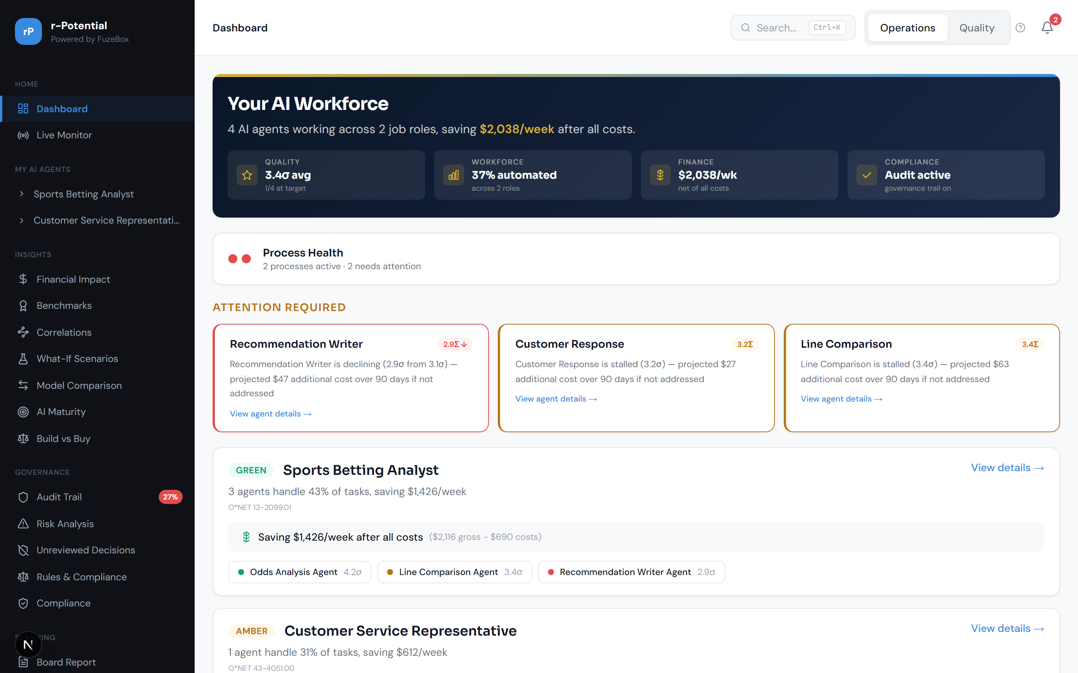
Figure 2.1 -- Dashboard showing the sidebar navigation structure

3. Application Flow Walkthrough
This section walks through every major area of the platform with annotated screenshots showing exactly what each screen provides and where to find answers to key questions.

3.1 Dashboard (Home)
The Dashboard is the entry point. It opens with a narrative hero banner summarizing the entire AI workforce: how many agents, how many job roles, total weekly savings after all costs. Four pill metrics show Quality (average sigma), Workforce (% automated), Finance (net savings/week), and Compliance (audit status).

Figure 3.1 -- Executive Dashboard with hero banner and attention cards

Below the hero, the Attention Required section highlights agents that need action, showing sigma scores, decline trends, and projected cost impact if not addressed. Process health cards show each job role with its agents, verdict (GREEN/AMBER/RED), and savings breakdown.
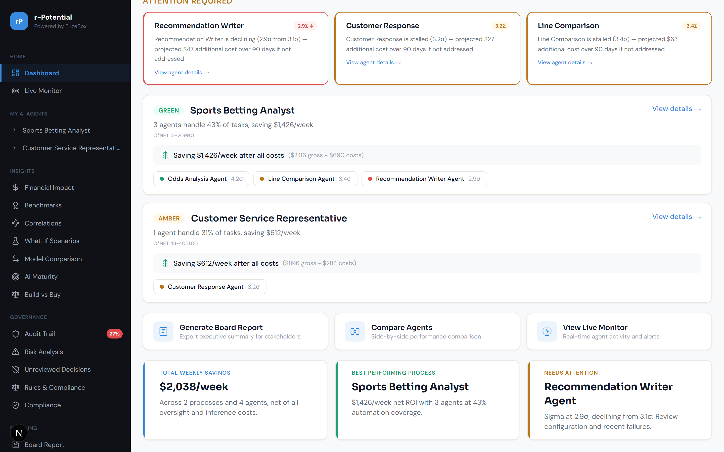
Figure 3.2 -- Dashboard scrolled: Process health cards and quick actions

3.1.1 Financial Impact (ROI & Costs)
The Financial Impact page (accessible via Insights > Financial Impact) combines the ROI calculator and cost trend dashboard into a single view. It shows the ROI waterfall chart breaking down gross value, agent costs, oversight costs, and net ROI per process. Cost trends show monthly spend patterns across inference, overhead, and training.
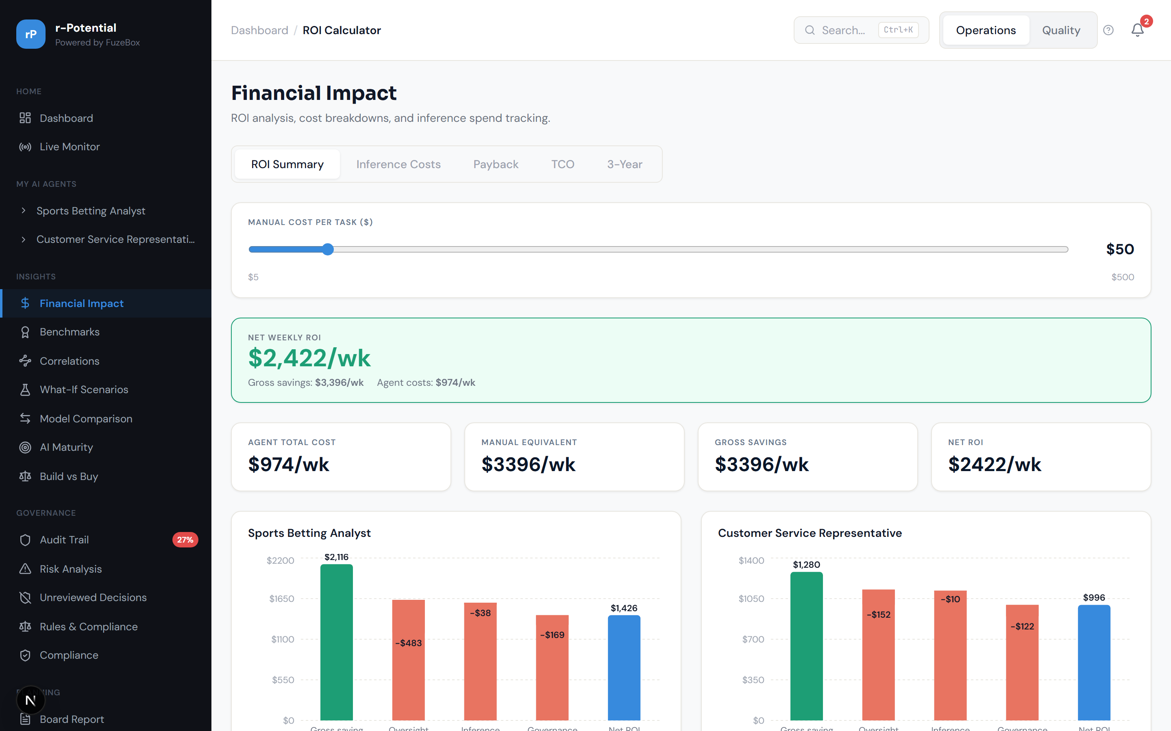
Figure 3.3 -- Financial Impact: ROI waterfall and cost analysis


Figure 3.4 -- Cost Trend Dashboard showing monthly spend breakdown

3.1.2 Benchmarks
The Benchmarks page shows cross-process comparison within your organization and industry-level benchmarking against averages and top-10% performers. Metrics compared include sigma scores, automation rates, ROI per agent, and governance compliance.
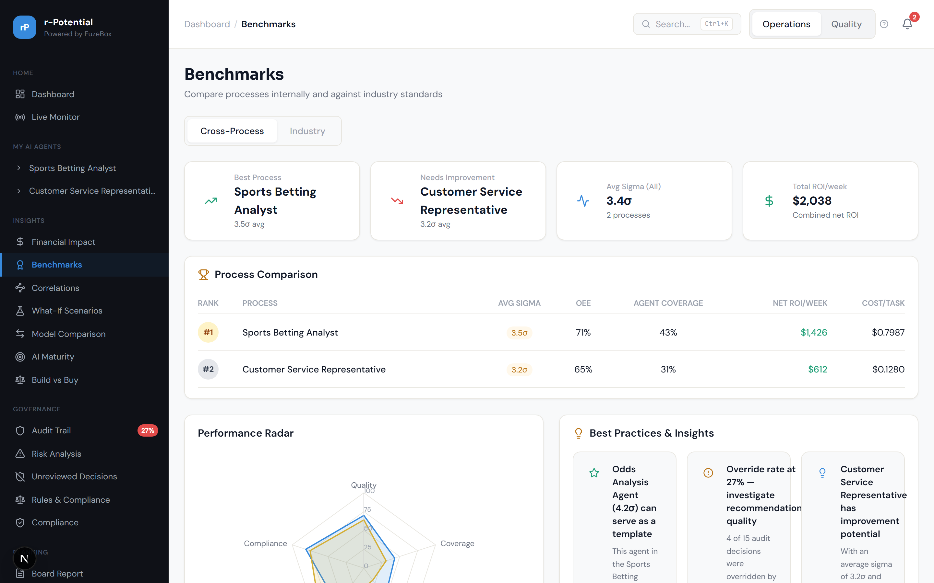
Figure 3.5 -- Cross-process benchmark comparison


Figure 3.6 -- Industry benchmark comparison

3.1.3 Correlations Engine
The Correlations page uses scatter plots to reveal relationships between metrics. For example: does higher agent cost correlate with better quality? Does override frequency correlate with agent sigma score? These insights help identify where investment has the most impact.
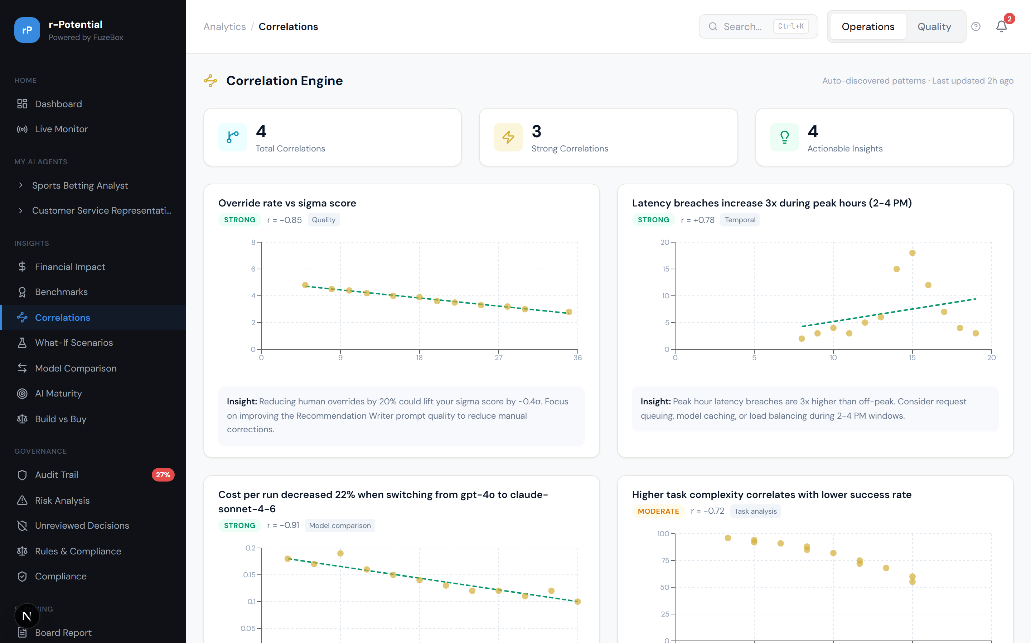
Figure 3.7 -- Correlation engine with scatter plots

3.2 Process Views (Symmetry Dashboard)
Each process (job role) has a dedicated Symmetry Dashboard showing the agent/human work split. The left column shows agents handling their tasks, the right shows human tasks, and the center shows the combined quality equation (OEE or SERVQUAL framework, togglable). Sub-pages provide deeper views into labor, quality, coverage, roadmap, training, and workforce planning.

3.2.1 Symmetry Dashboard
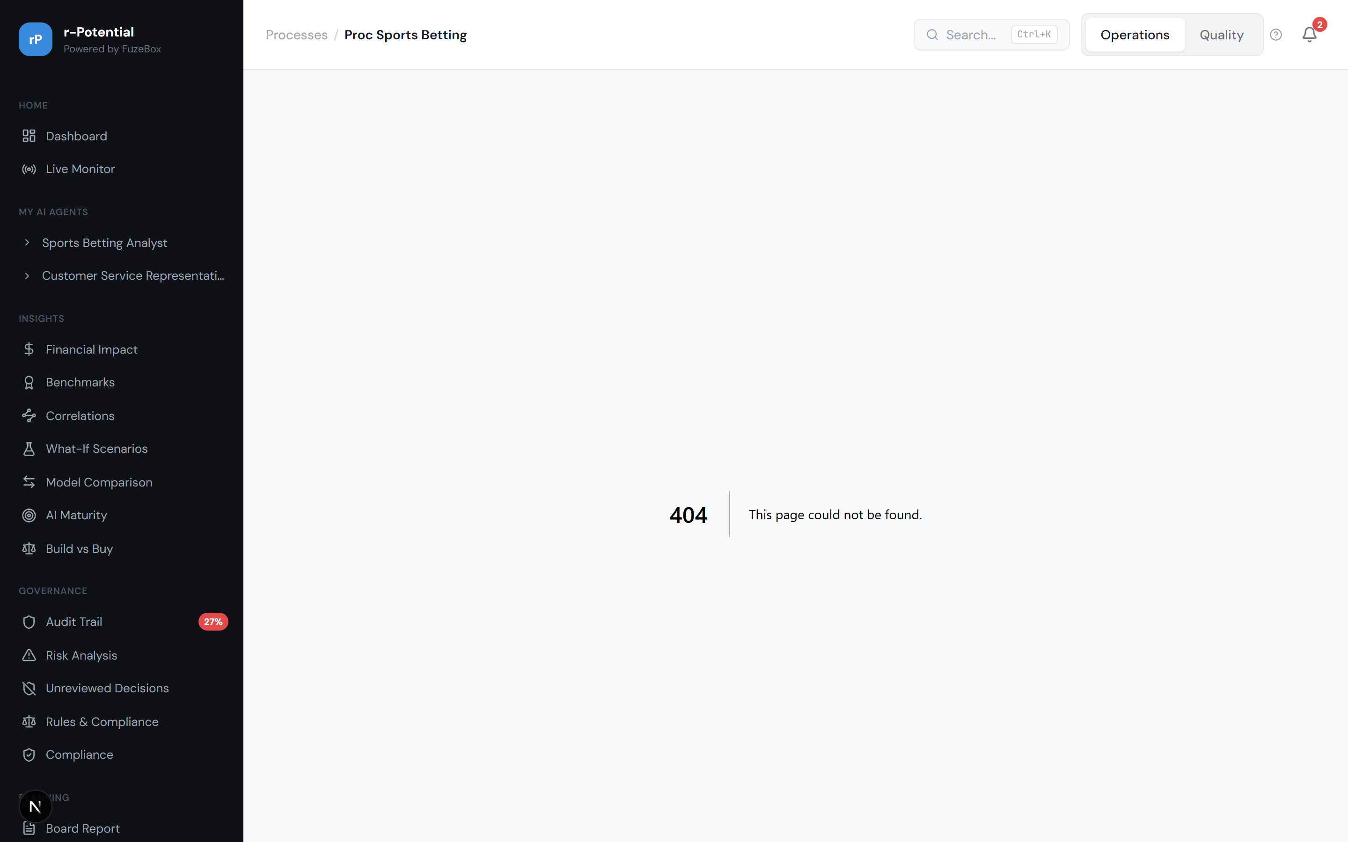
Figure 3.8 -- Symmetry Dashboard for Sports Betting Analyst

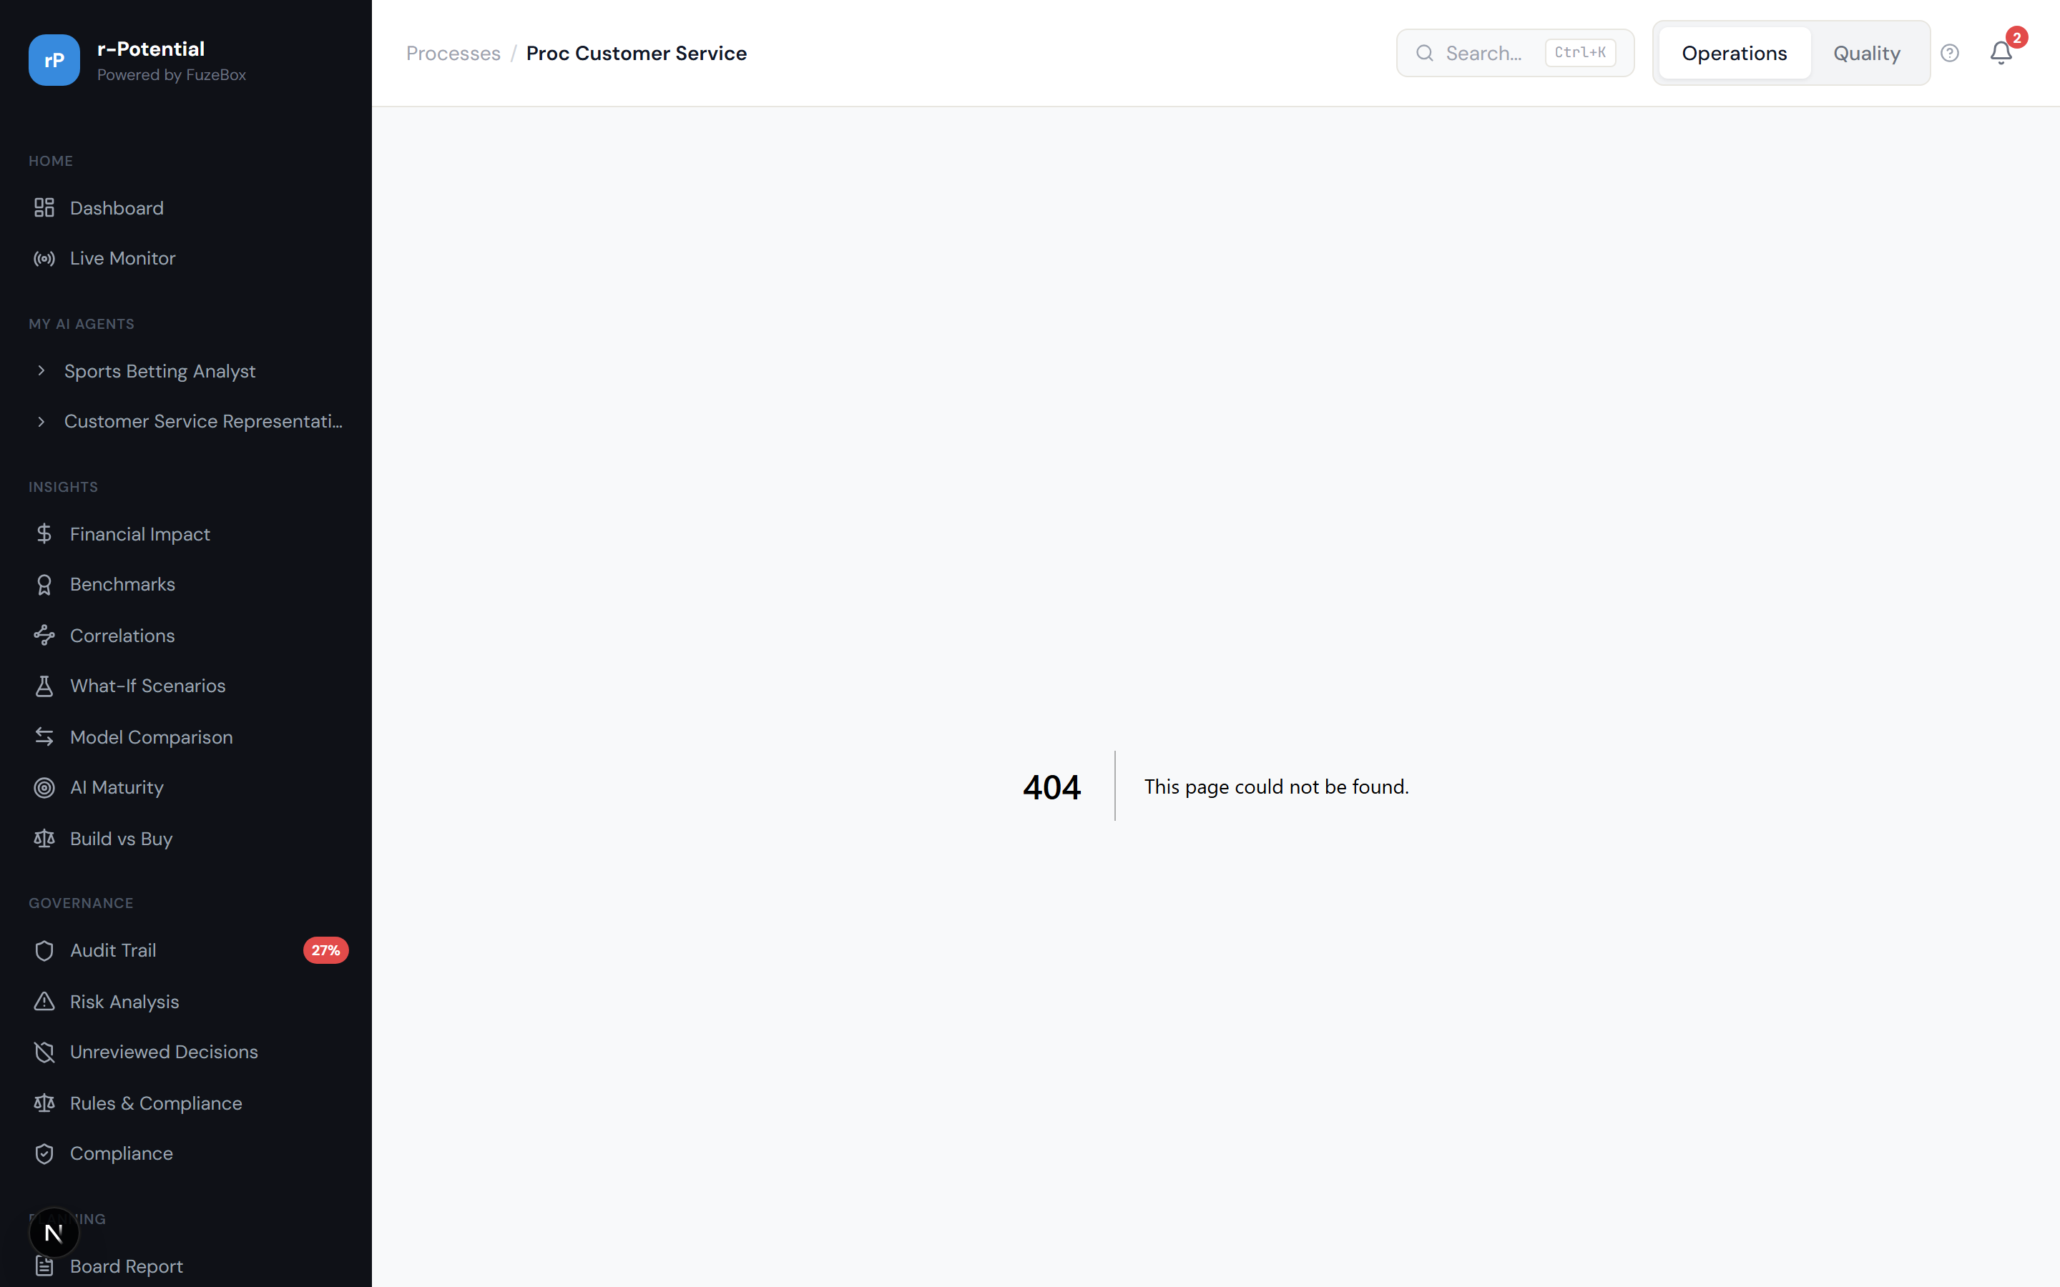
Figure 3.9 -- Symmetry Dashboard for Customer Service Representative

3.2.2 Task Ownership (Coverage Map)
The Task Ownership page shows which O*NET tasks are handled by agents vs humans. Each task card shows the automation status, the assigned agent (if any), and quality metrics. This answers: 'What exactly are my agents doing?' and 'What should we automate next?'
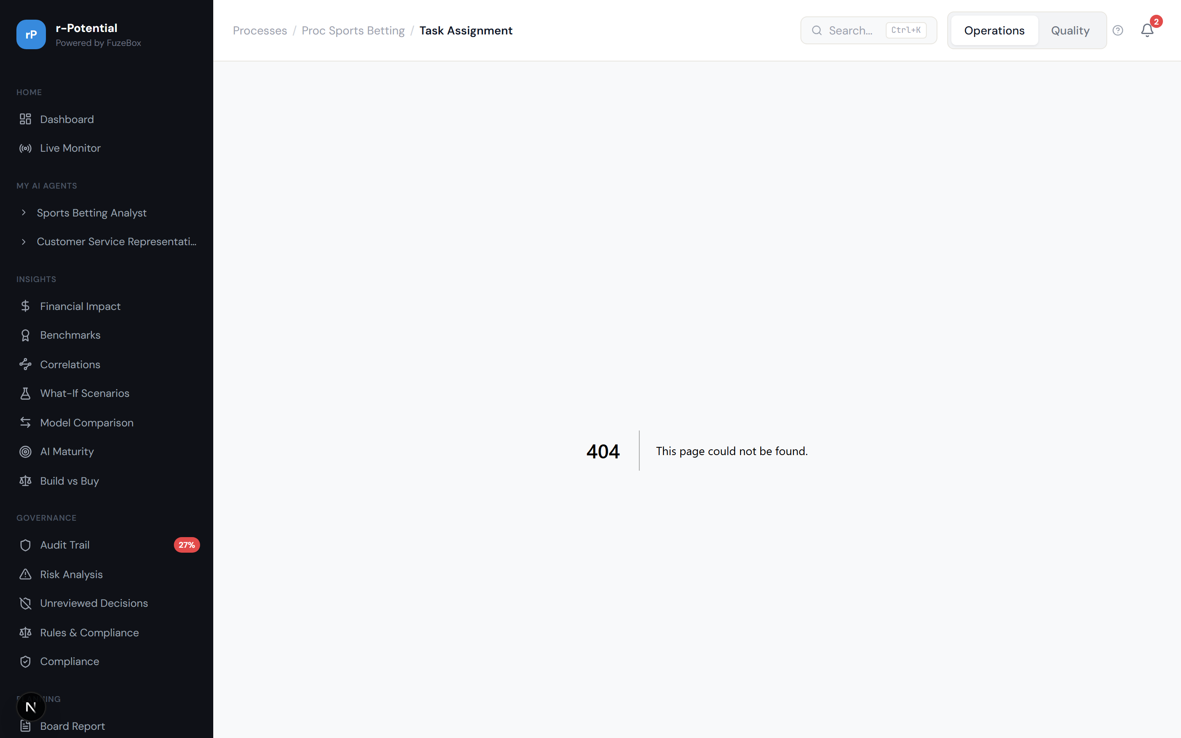
Figure 3.10 -- Task Ownership / Coverage Map

3.2.3 Labor Graph
The Labor Graph shows the human effort distribution across tasks, helping identify where humans spend the most time and where automation could have the biggest impact.

Figure 3.11 -- Labor Graph

3.2.4 Sigma Scorecard
The Sigma Scorecard shows quality scores for each agent using the Six Sigma scale (1-6 sigma). Every sigma score has a tooltip translating it to plain English (e.g., '3.4 sigma = 99.97% accuracy, world-class'). The Improvement Tracker shows sigma trends over time with projections.
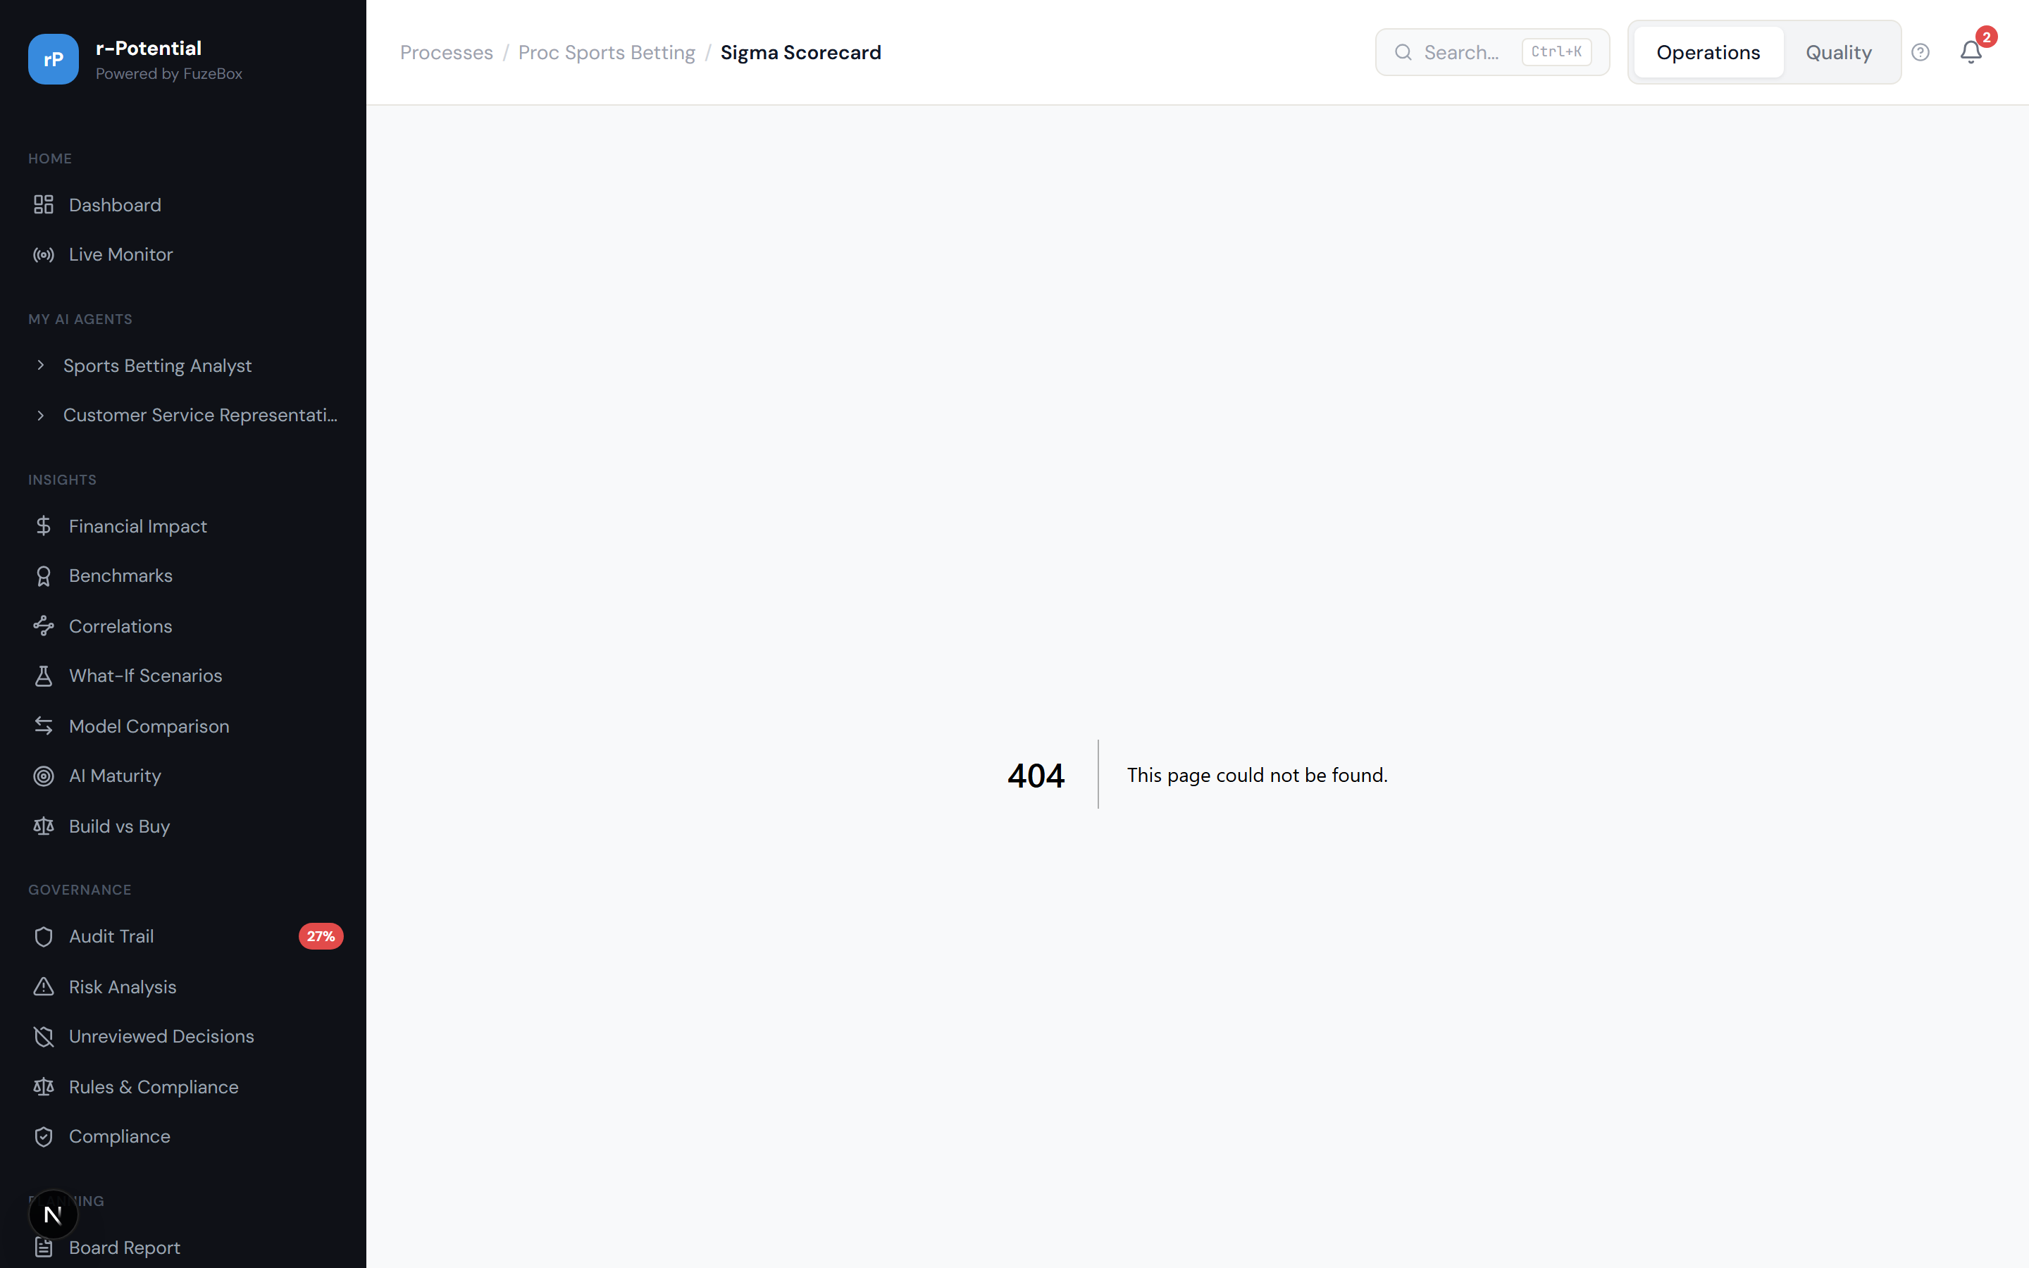
Figure 3.12 -- Sigma Scorecard with quality scores and trends

3.2.5 Transformation Roadmap
The Transformation Roadmap shows the journey from current state to target state, with stages, timelines, and ROI projections for each phase of automation.
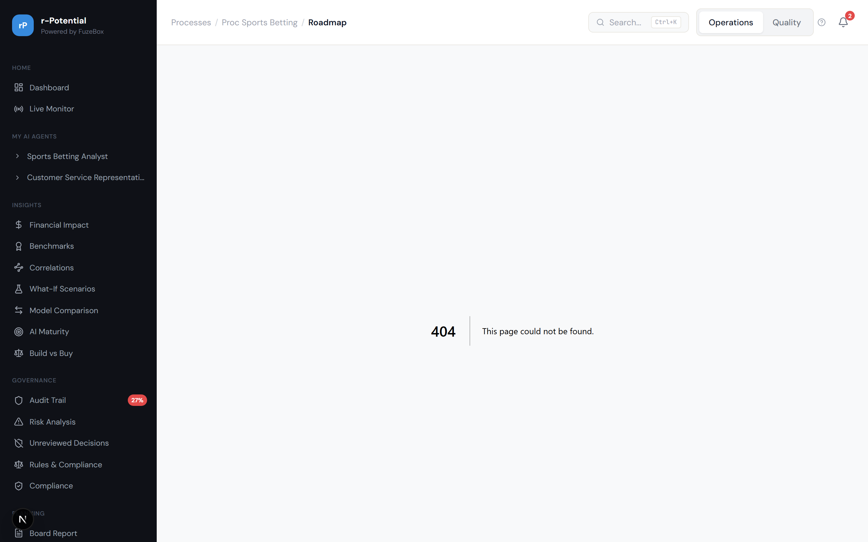
Figure 3.13 -- Transformation Roadmap with stage timeline

3.2.6 Training Plan
The Training Plan identifies skills gaps created by automation and recommends training programs to help team members transition to oversight, exception-handling, and strategic roles.
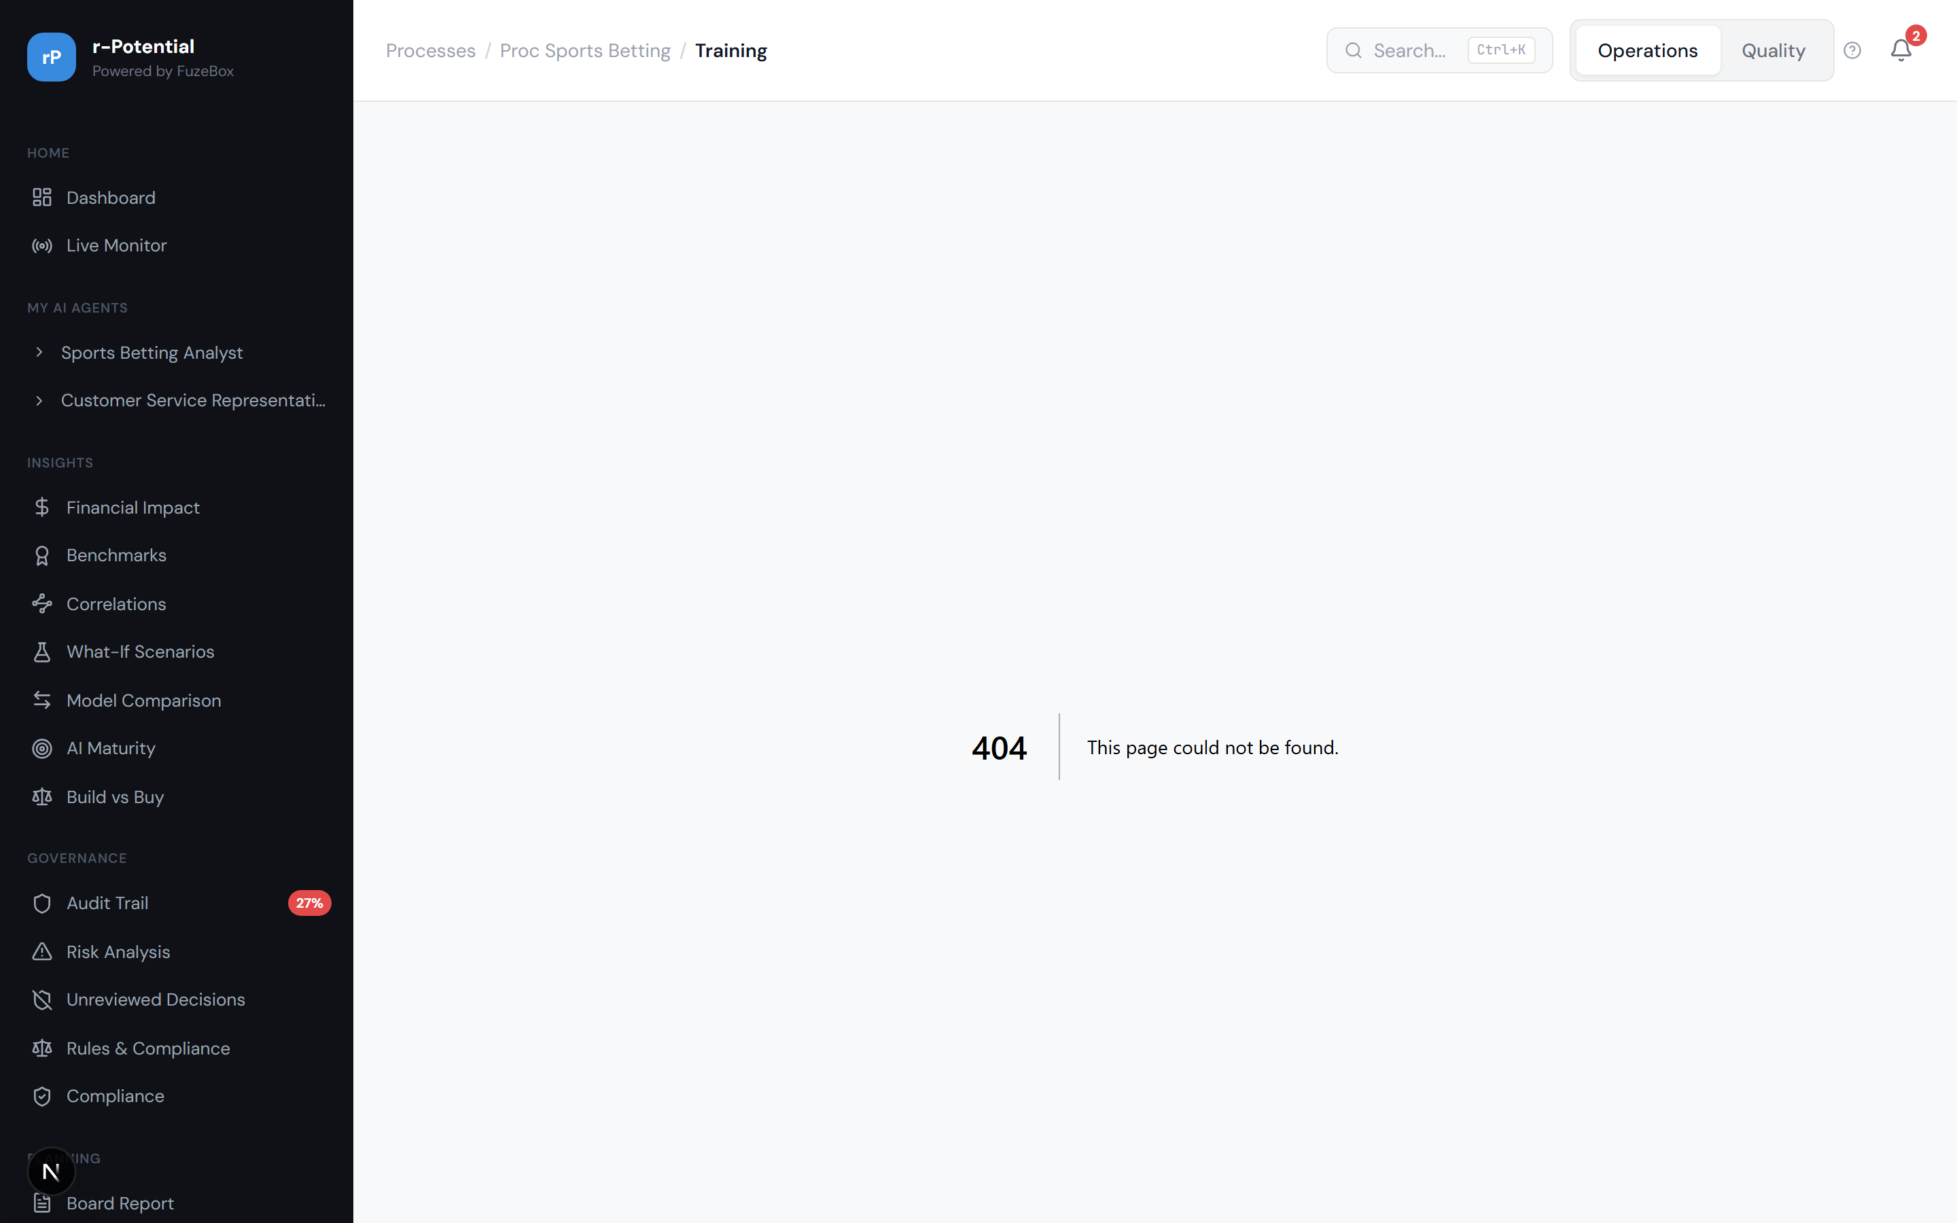
Figure 3.14 -- Skills Gap & Training Plan

3.2.7 Workforce Planning
12-month workforce projections under three scenarios (conservative, moderate, aggressive automation). Shows headcount trajectory, role transitions, and cost impact over time.
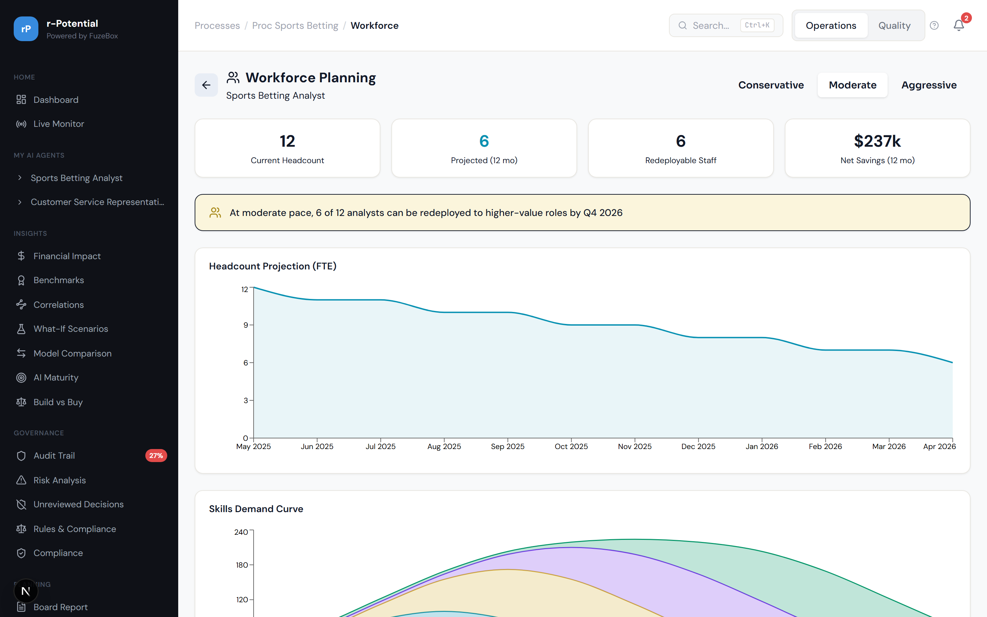
Figure 3.15 -- Workforce Planning: 12-month projections

3.3 Agent Telemetry & Management

3.3.1 Agent Detail Page
Each agent has a dedicated telemetry page showing: metrics bar (sigma, latency, cost, runs), run history, defect analysis, cost of inaction calculator, version timeline, and ROI breakdown. The Cost of Inaction shows projected financial impact if a declining agent is not addressed.
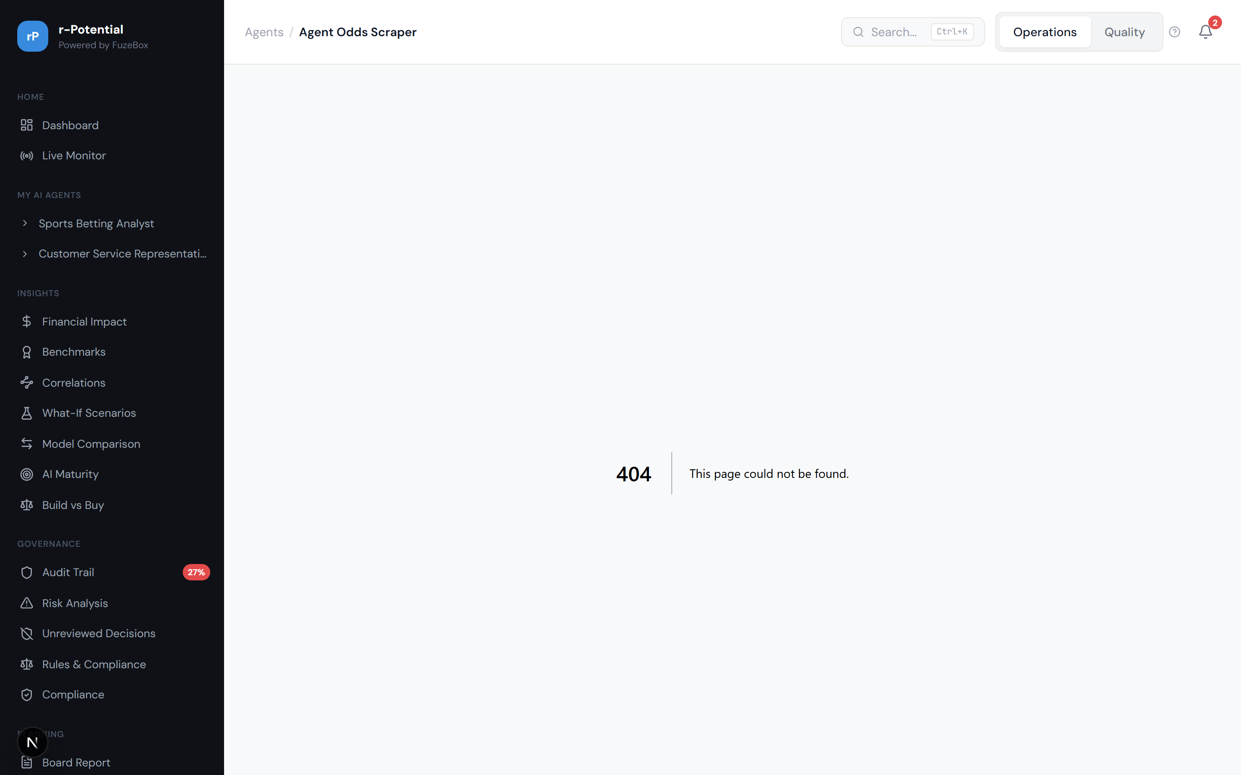
Figure 3.16 -- Odds Scraper Agent: telemetry and metrics

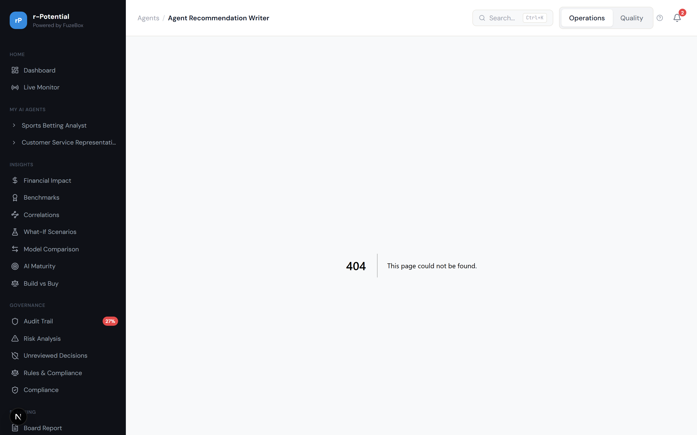
Figure 3.17 -- Recommendation Writer Agent (declining, shows cost of inaction)

3.3.2 Agent Lifecycle Management
The Manage page provides controls to pause, decommission, or swap an agent. Each action shows an impact preview before confirmation. The decommission flow shows which tasks would lose automation and the estimated manual workload increase.
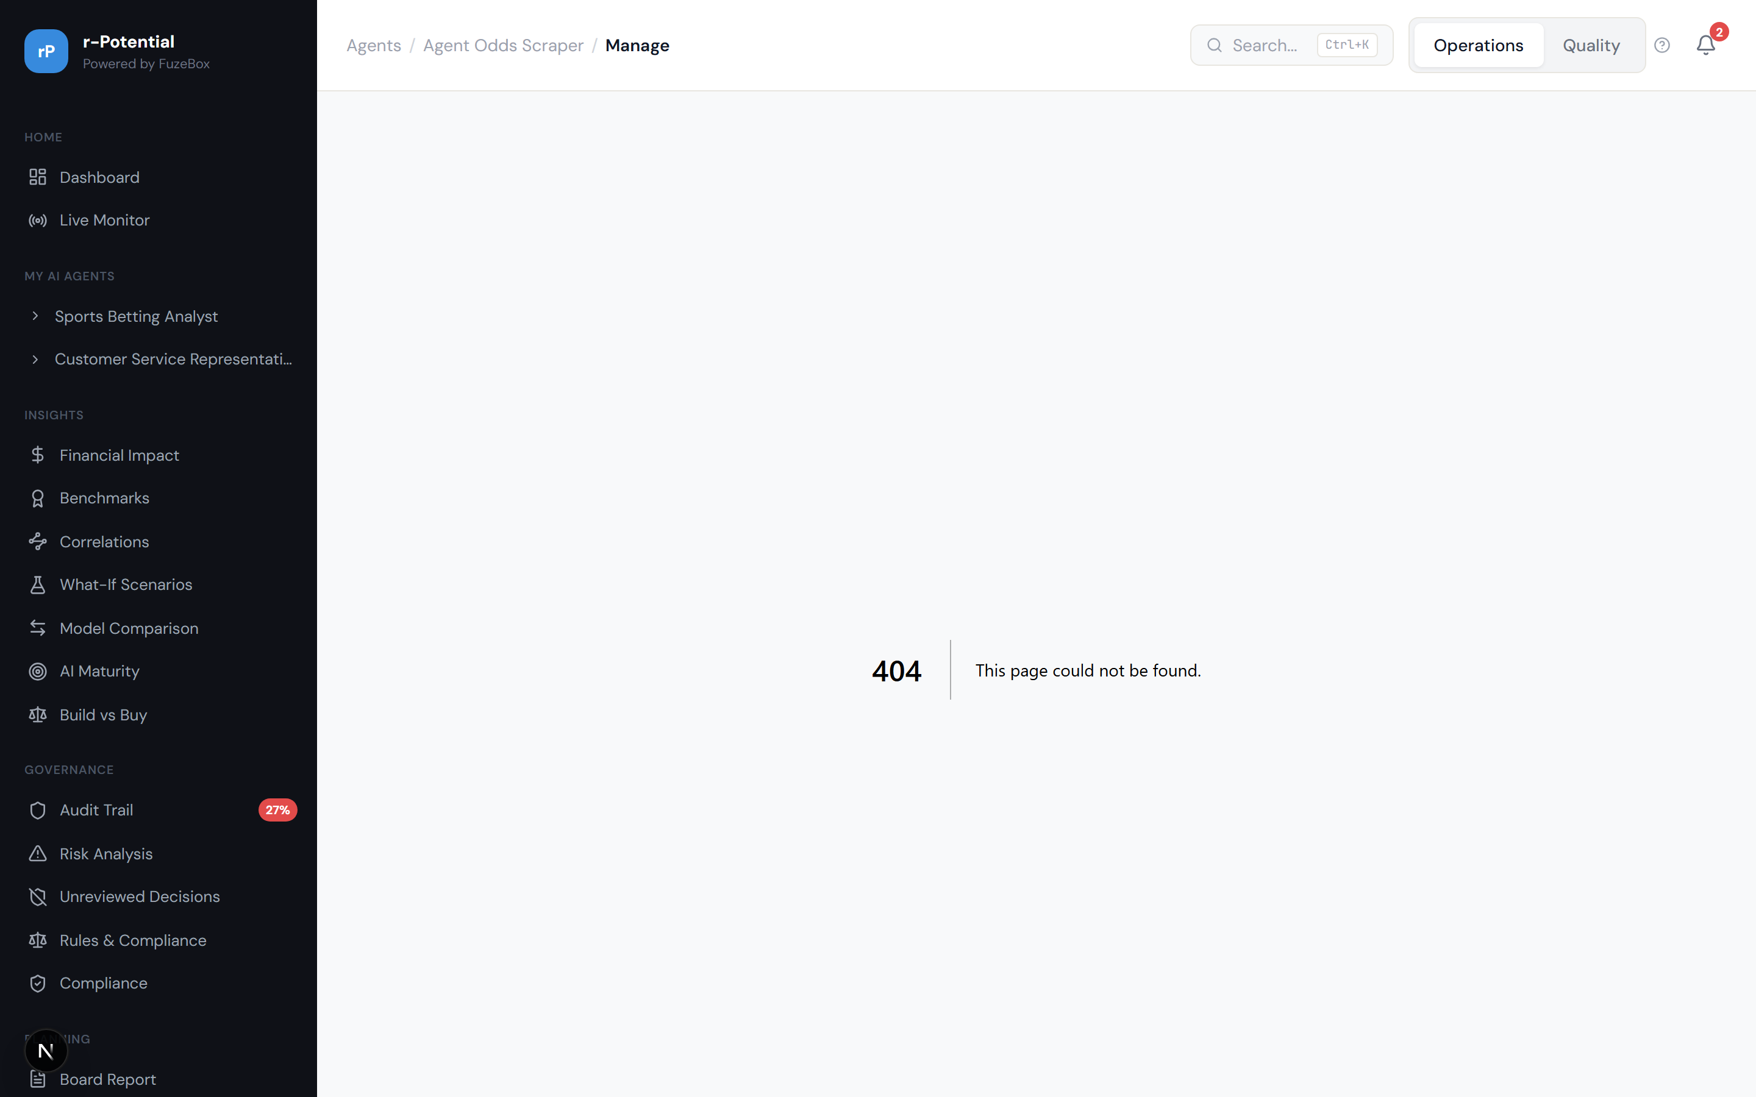
Figure 3.18 -- Agent Manage: lifecycle controls (pause, decommission, swap)

3.3.3 Agent A/B Comparison
Side-by-side agent comparison with radar chart overlay showing quality, speed, cost, reliability, and coverage dimensions. Helps answer: 'Which agent should I keep?'
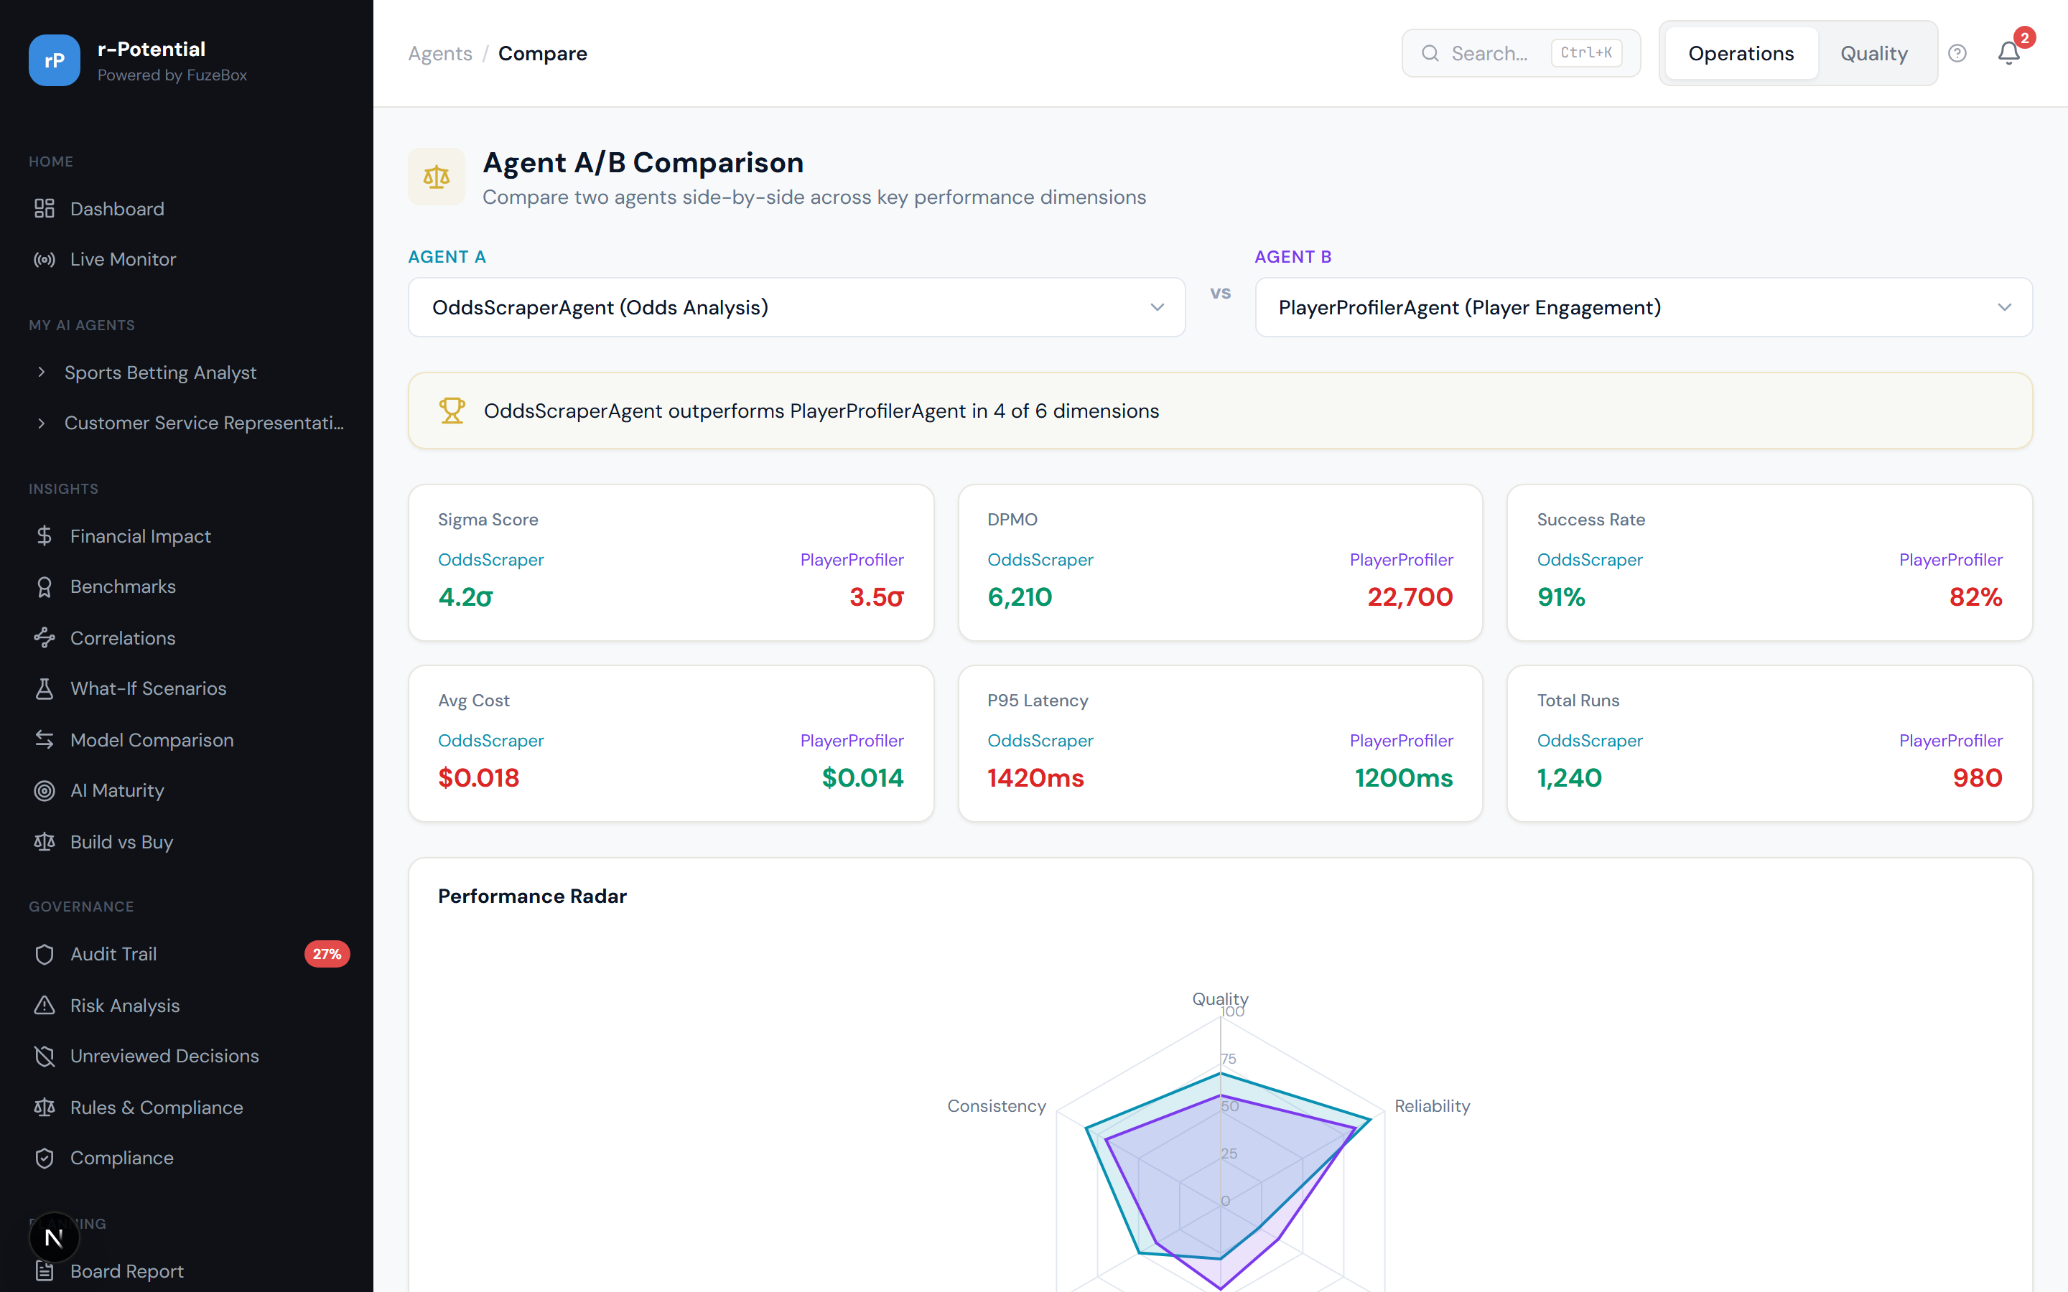
Figure 3.19 -- Agent A/B Comparison with radar chart

3.3.4 Staging / Canary View
Before promoting a new agent version to production, the staging view shows a traffic split (e.g., 80% production / 20% canary) with side-by-side metrics comparison. Promote or rollback with a single click.
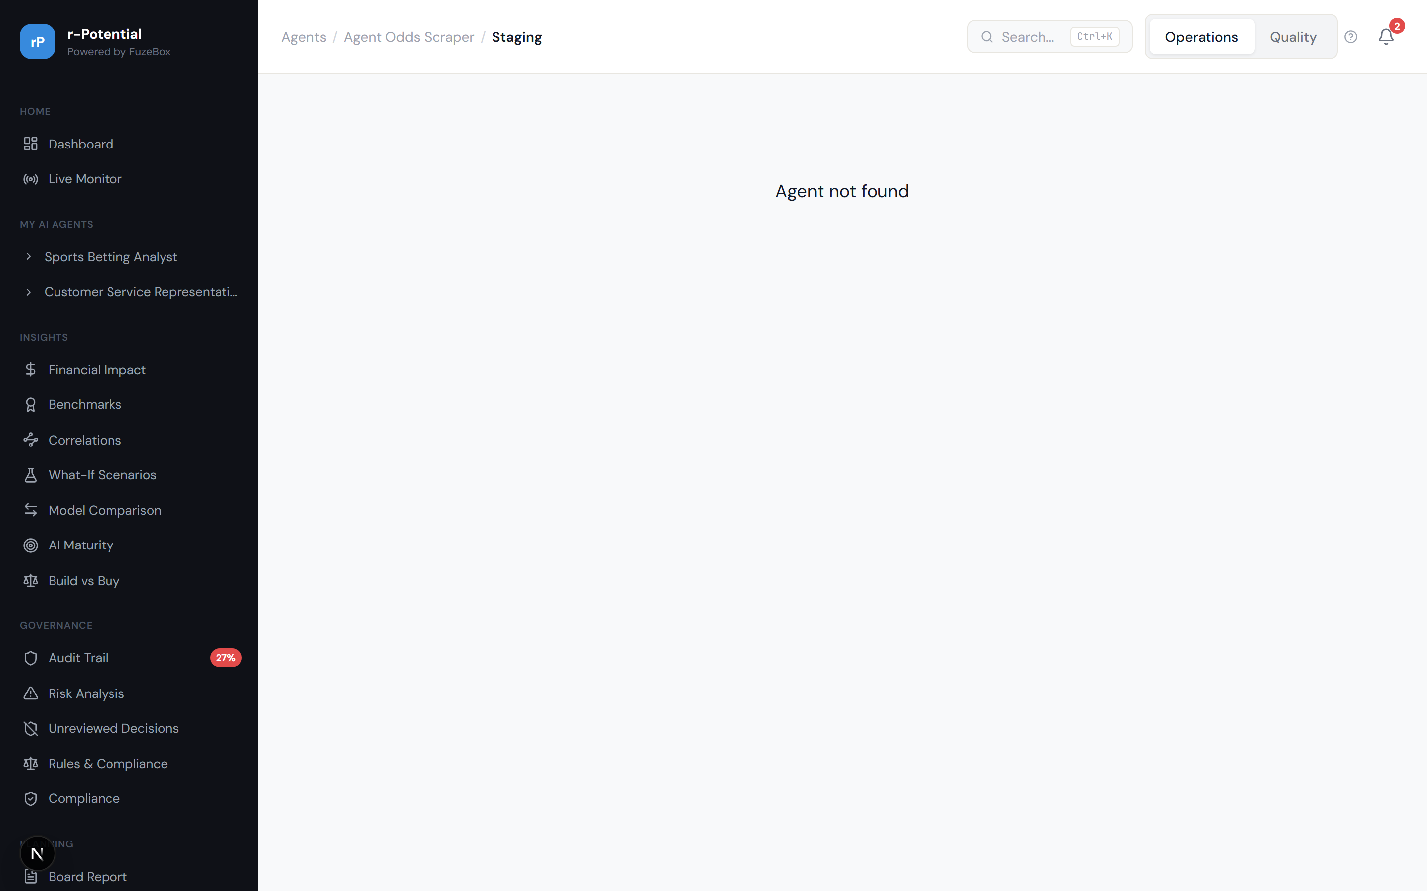
Figure 3.20 -- Agent Staging: canary deployment with traffic split

3.4 Governance & Compliance

3.4.1 Audit Trail
Complete audit log of every agent decision, human override, and system event. Filterable by agent, date, type, and reviewer. Includes override trend analysis showing weekly patterns and whether overrides are increasing or decreasing.
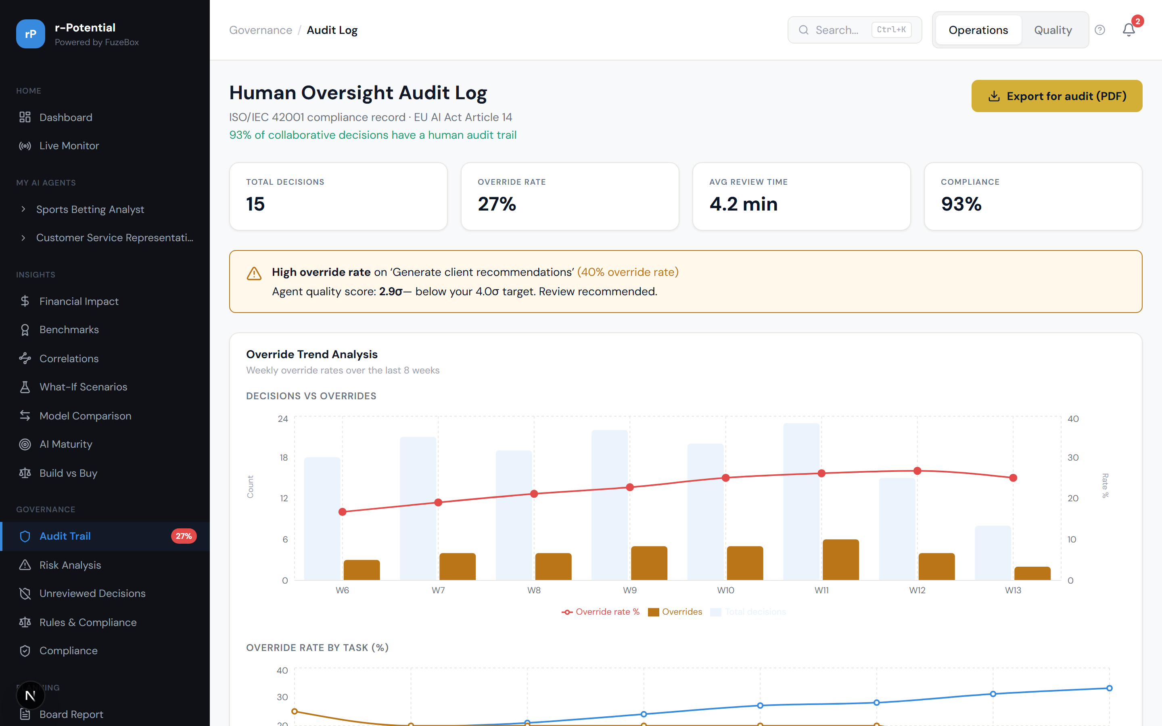
Figure 3.21 -- Audit Trail with override trend analysis

3.4.2 Risk Analysis (FMEA)
Failure Mode and Effects Analysis board ranking all identified risks by RPN (Risk Priority Number = Severity x Occurrence x Detection). The highest-RPN item is auto-selected for immediate attention. Each entry shows mitigation steps.
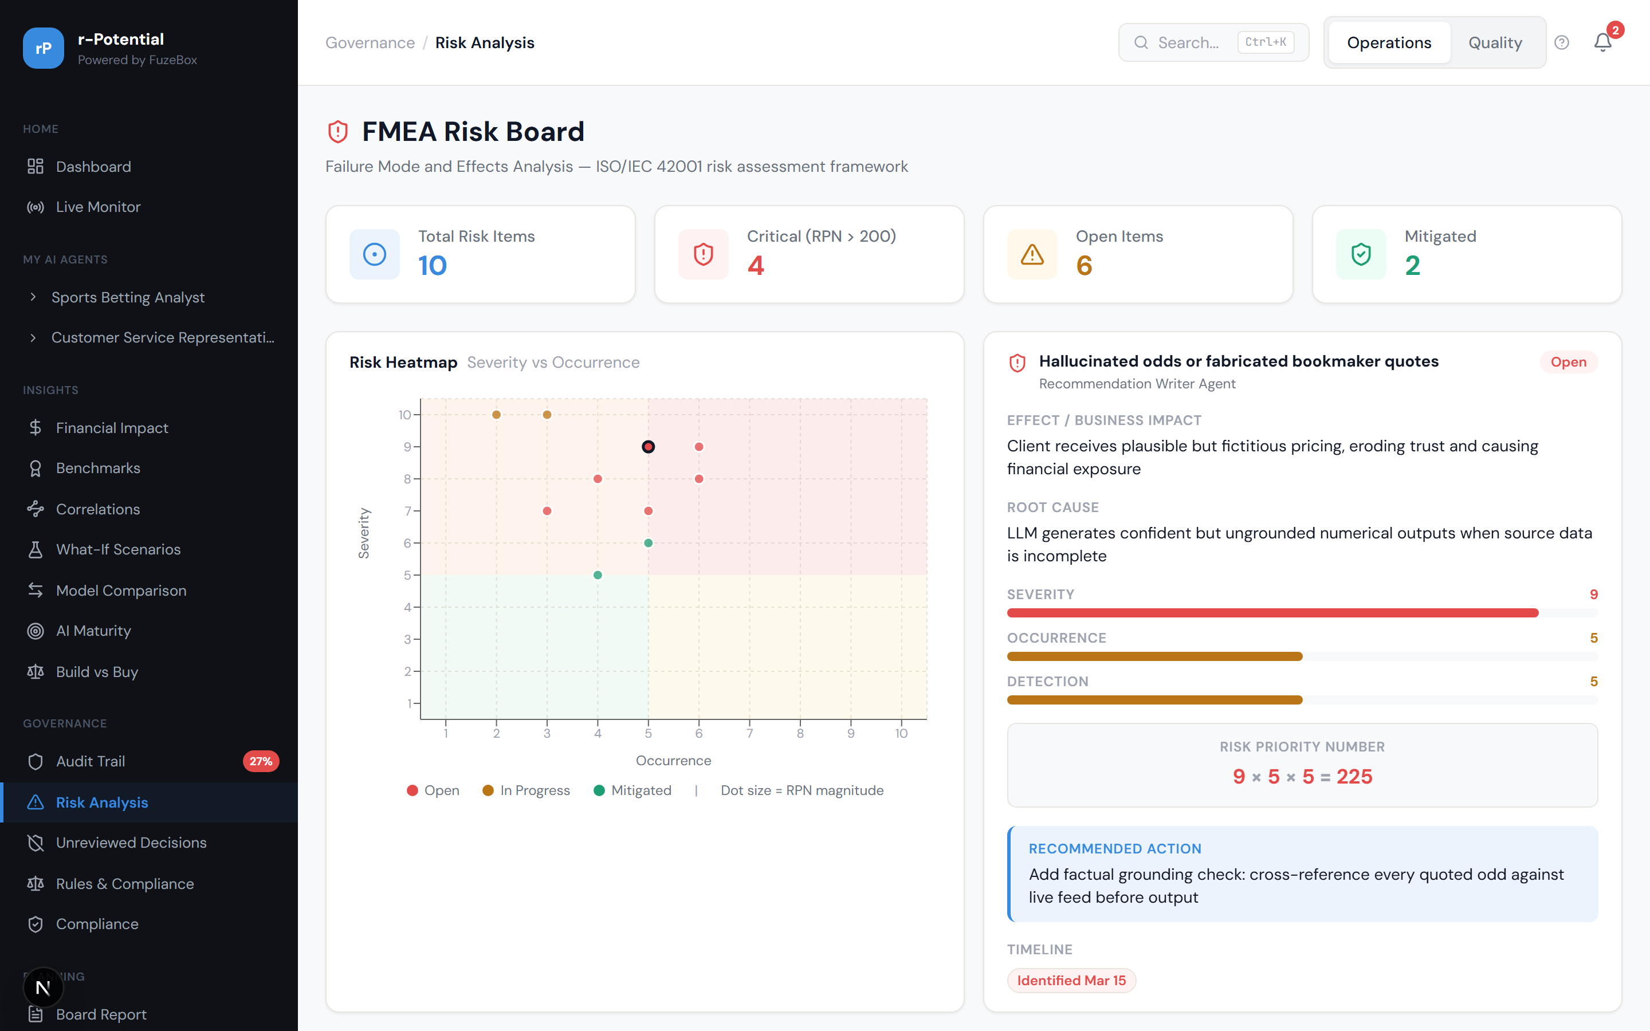
Figure 3.22 -- Risk Analysis (FMEA) board

3.4.3 Unreviewed Decisions
The Oversight Gap report shows decisions made by agents that had no human review. Critical for EU AI Act compliance and demonstrating human-in-the-loop governance.
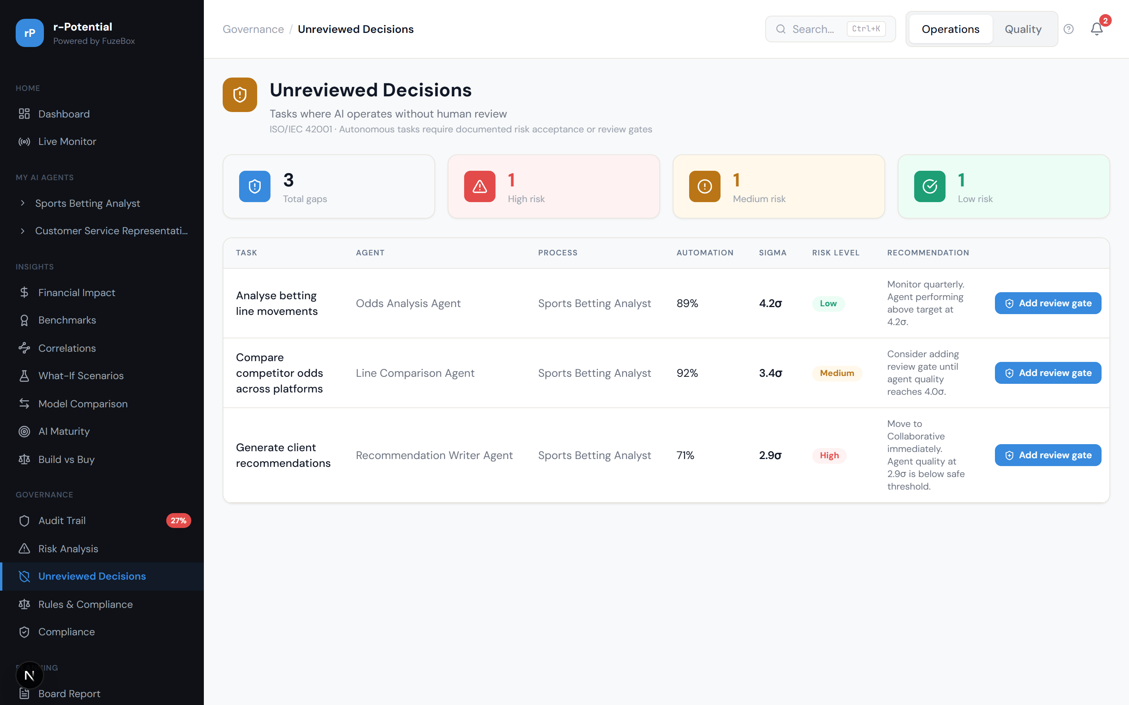
Figure 3.23 -- Unreviewed Decisions / Oversight Gap report

3.4.4 Governance Rules Engine
Configurable rules engine with 10 governance rules, compliance gauge showing overall compliance percentage, and violation tracking. Rules cover mandatory review thresholds, escalation triggers, and automated safeguards.
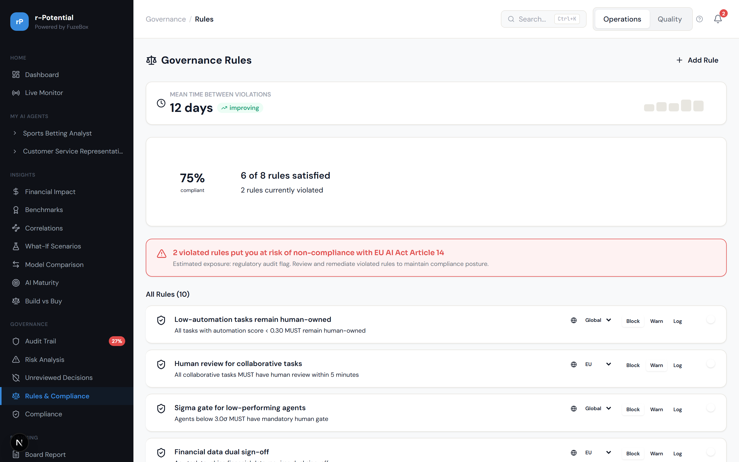
Figure 3.24 -- Governance Rules Engine with compliance gauge

3.5 Insights & Analytics

3.5.1 What-If Scenarios
Interactive scenario builder: 'What happens if I add one more agent?', 'What if I hire 2 more analysts?', 'What if I scale to 200 runs/day?'. Sliders adjust variables and results update in real-time.
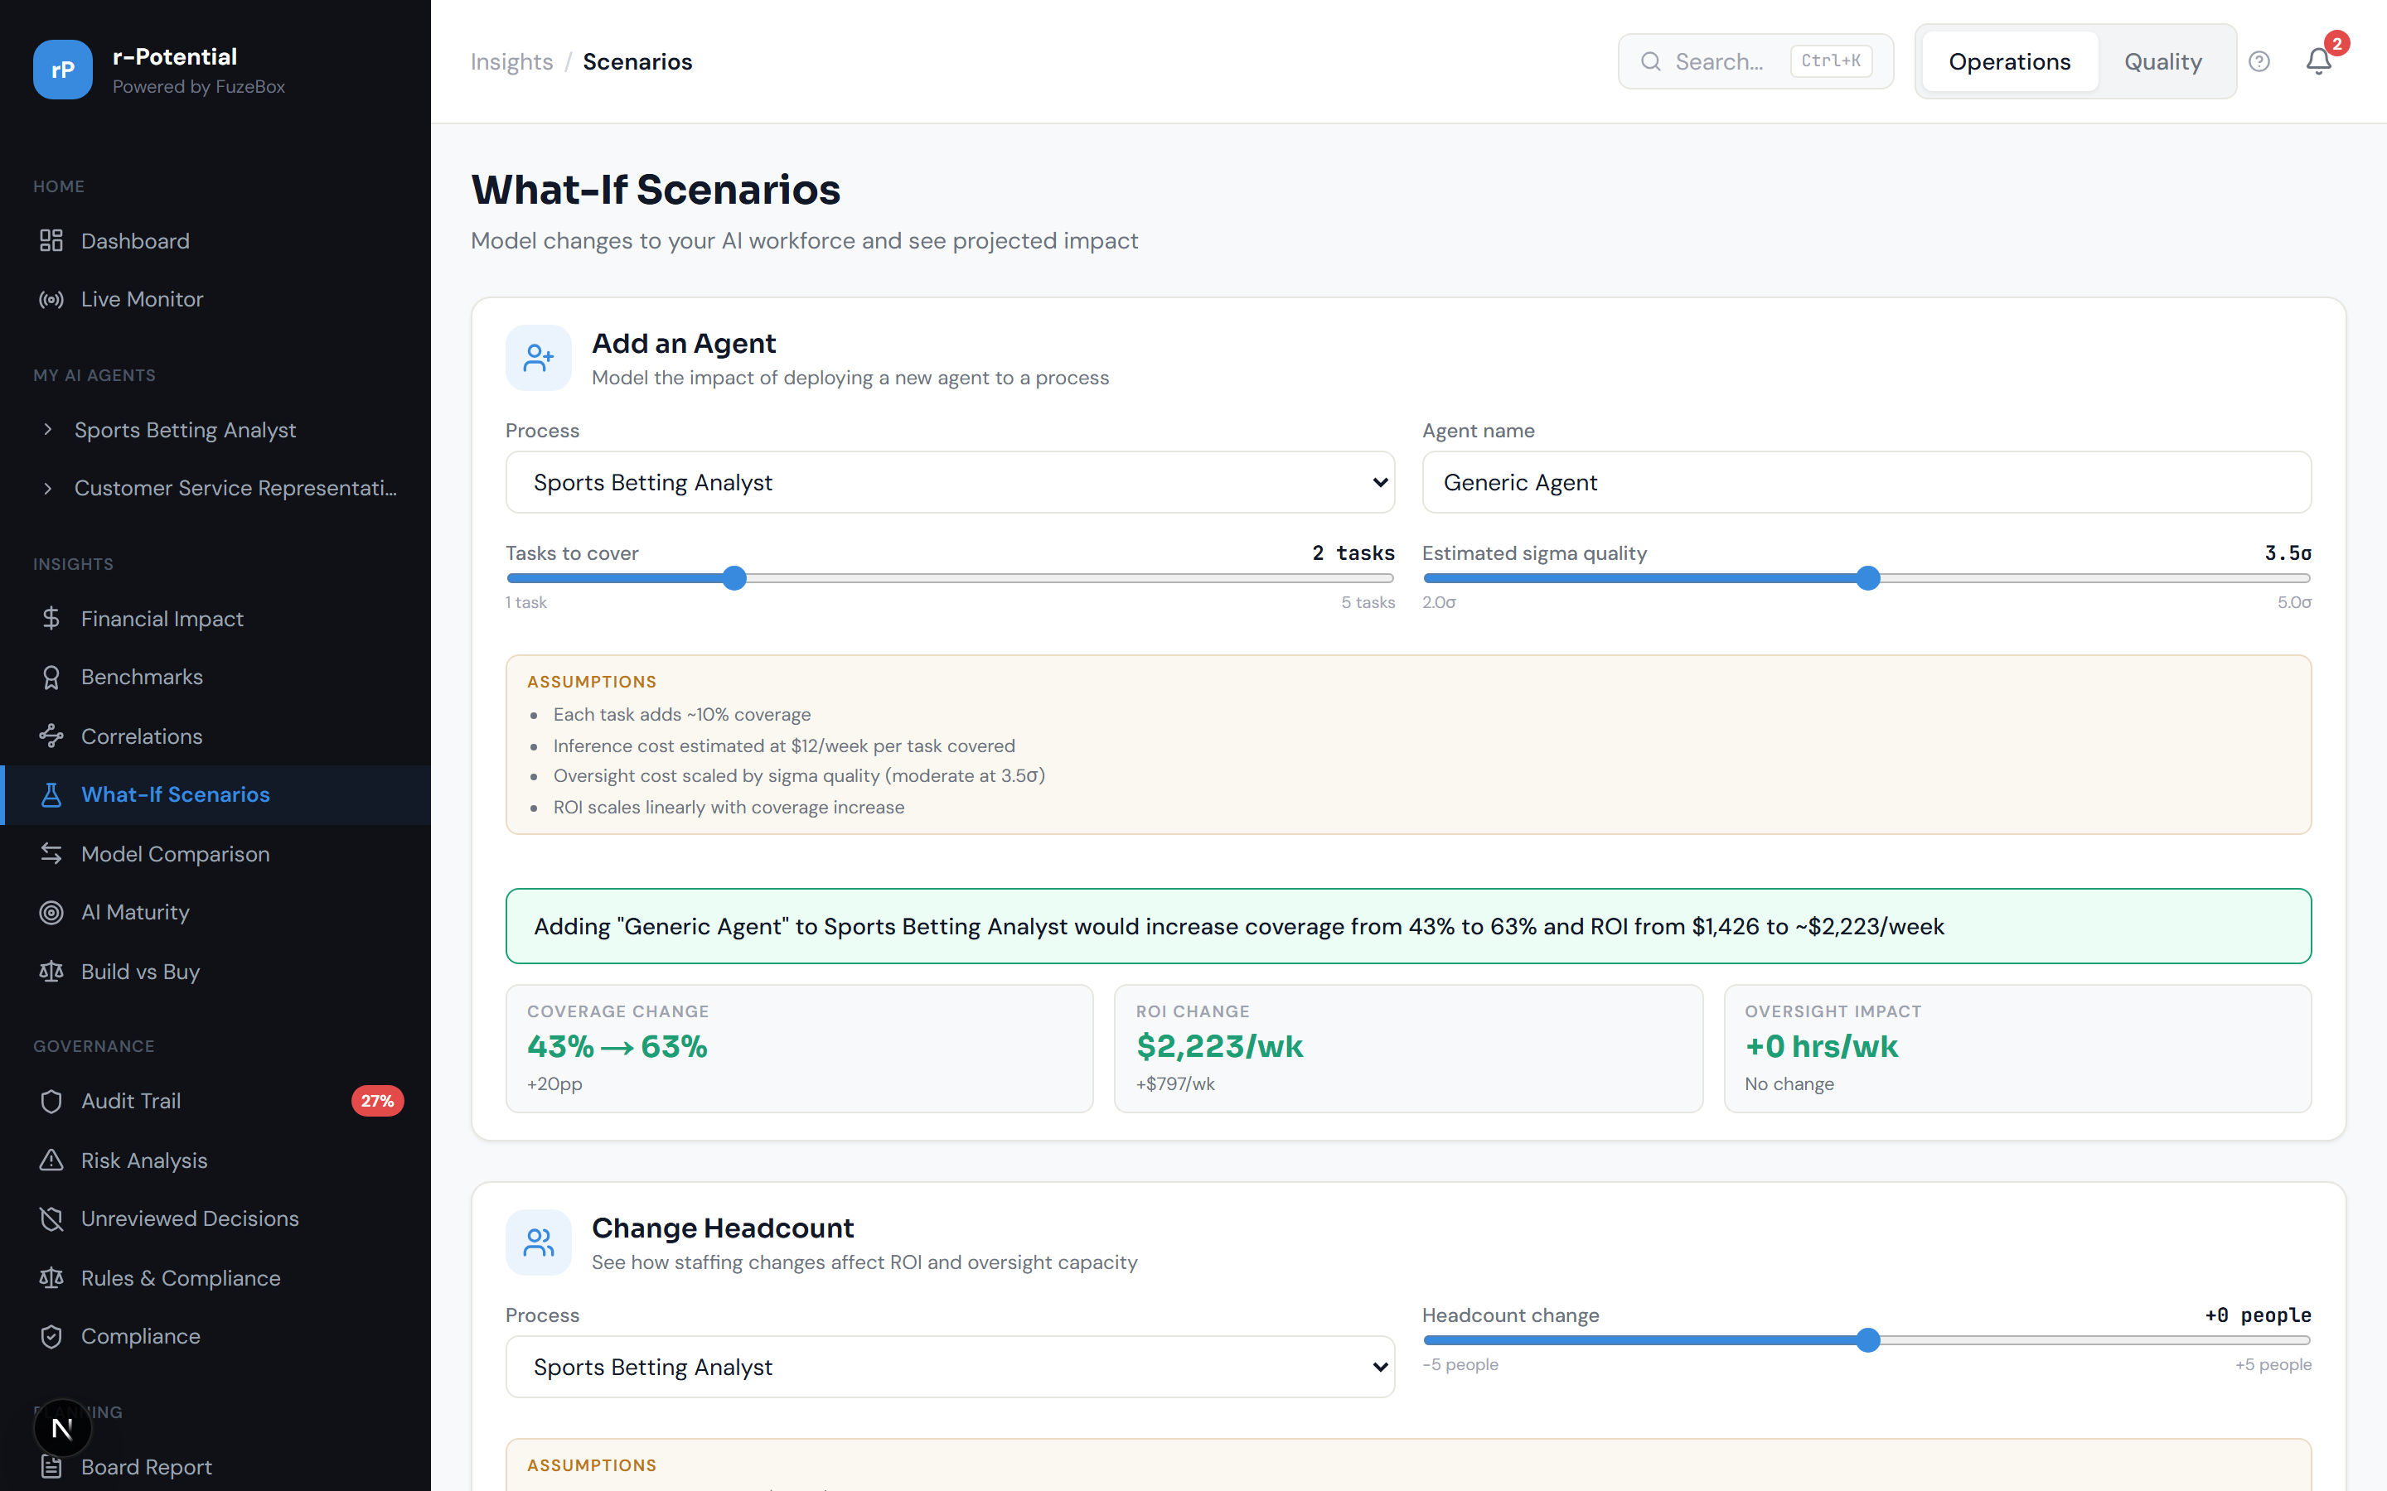
Figure 3.25 -- What-If Scenario Builder

3.5.2 AI Maturity Score
Assessment across 5 dimensions: Coverage, Quality, ROI, Governance, and Workforce Readiness. Radar chart visualization with actionable recommendations to reach the next maturity level.
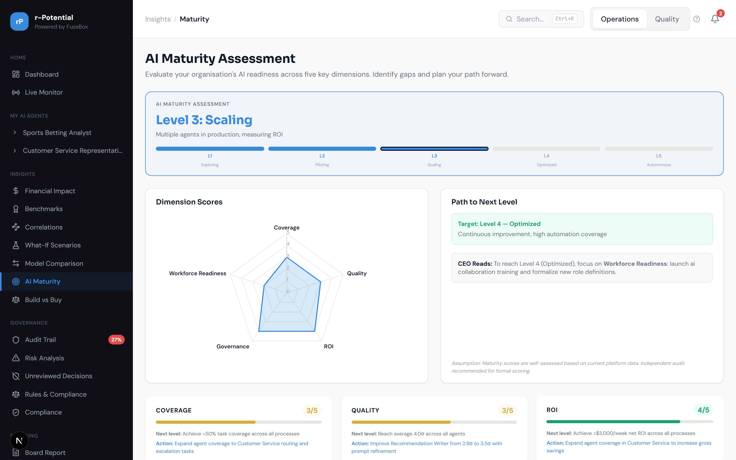
Figure 3.26 -- AI Maturity Score with radar chart

3.6 Planning & Setup

3.6.1 Board Report Export
One-click board-ready report generation. Configurable sections, PDF export, scheduled delivery (weekly/monthly) to specified recipients.
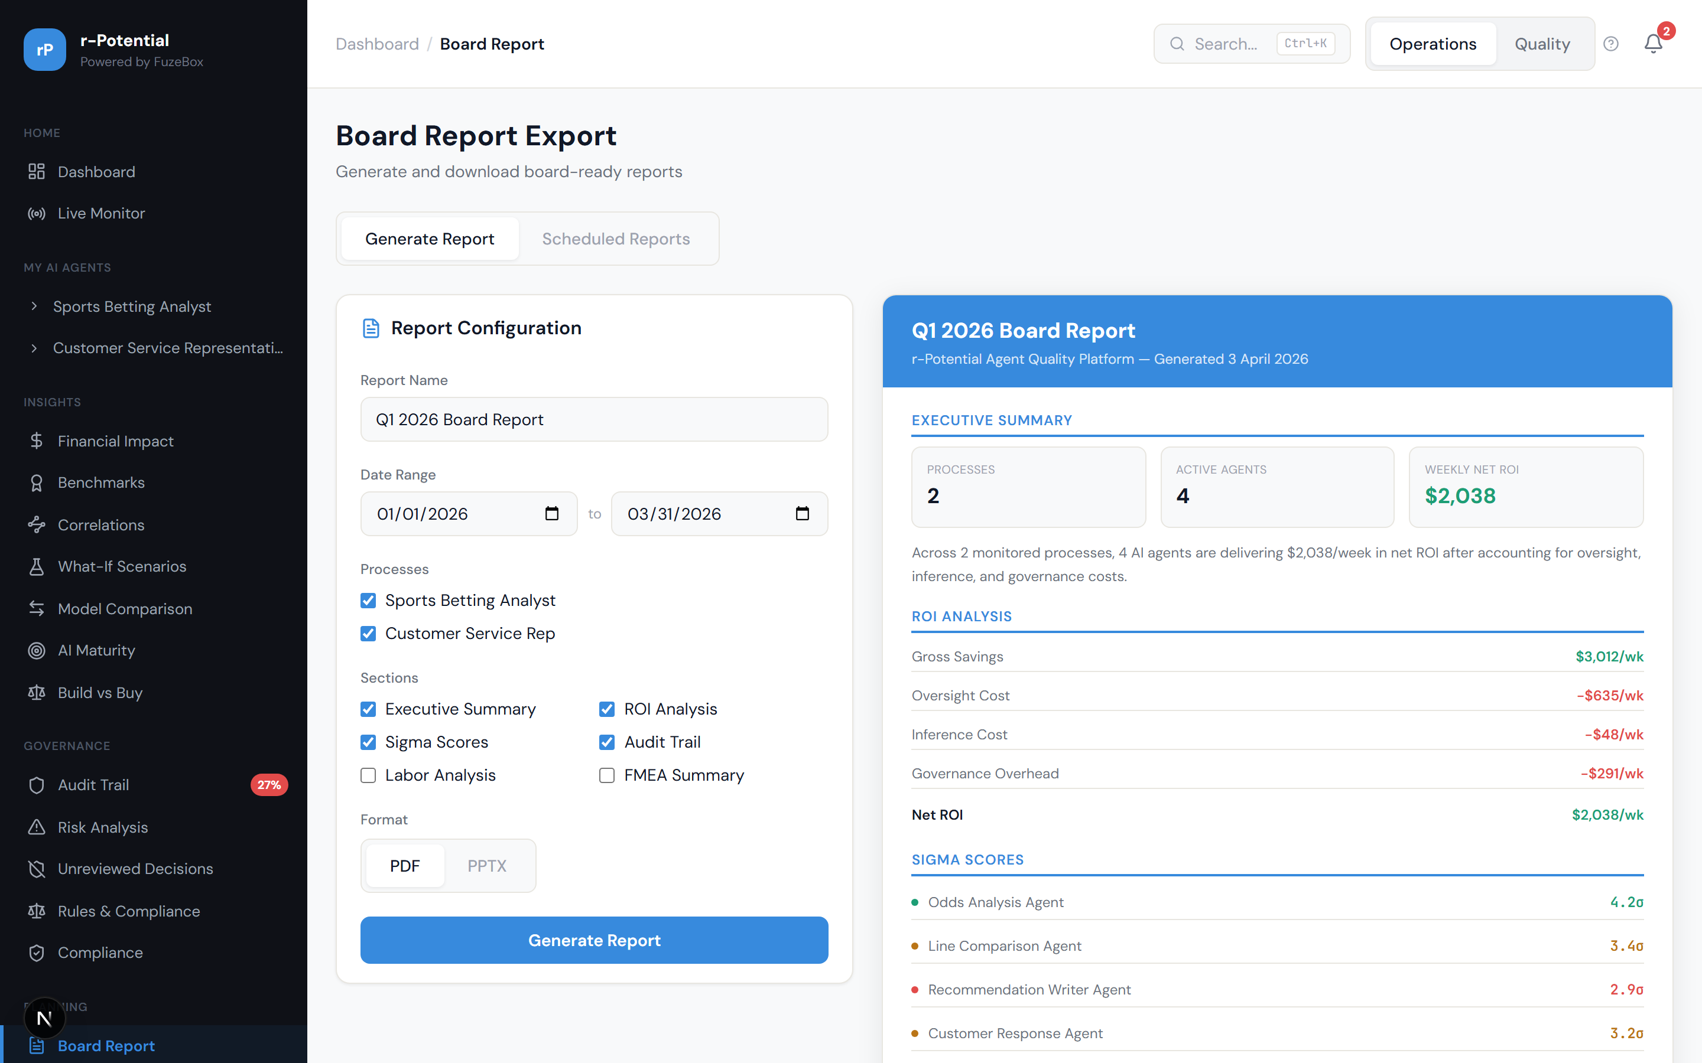
Figure 3.27 -- Board Report export with scheduling

3.6.2 Setup Wizard: Occupation Selector
O*NET occupation search to select the job role being automated. This anchors the entire analysis to a real occupation taxonomy.
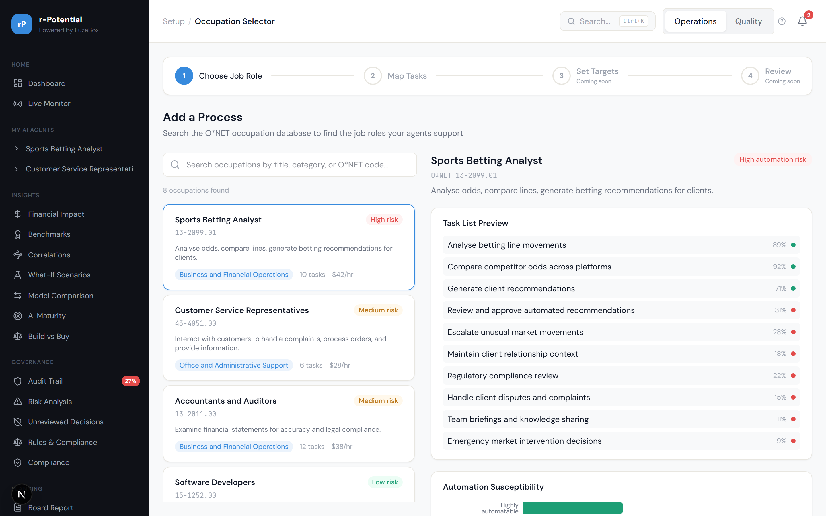
Figure 3.28 -- Occupation Selector (O*NET search)

3.6.3 Setup Wizard: Agent-to-Task Mapper
Map AI agents to specific O*NET tasks within the selected occupation. This creates the foundation for coverage analysis and ROI calculation.
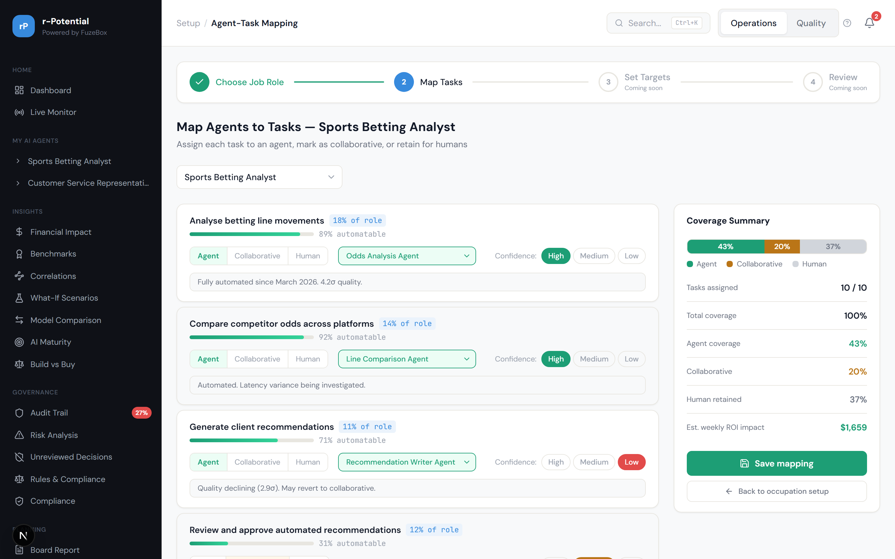
Figure 3.29 -- Agent-to-Task Mapper

3.7 Configuration & Settings

3.7.1 Settings
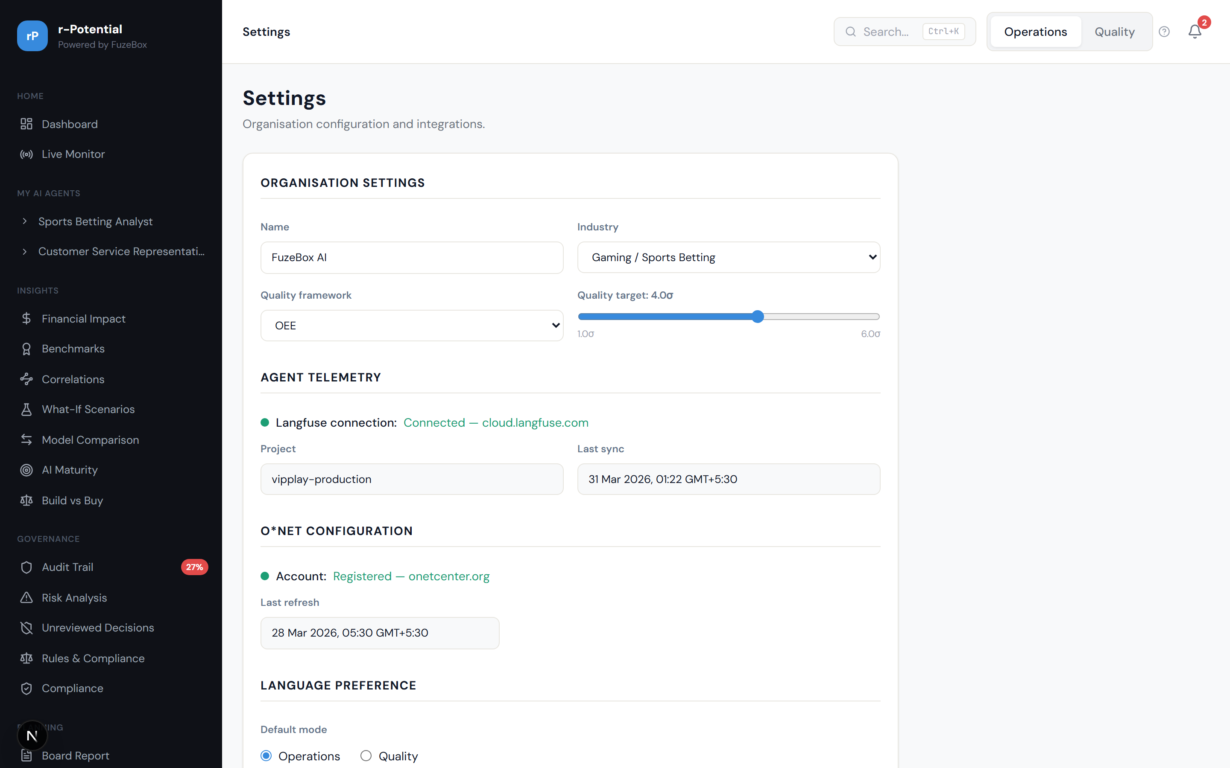
Figure 3.30 -- Settings page with shared links

3.7.2 SLA & Alert Rules
Configure per-agent SLA targets (sigma threshold, latency limit, cost cap) and alert rules that trigger notifications when thresholds are breached.
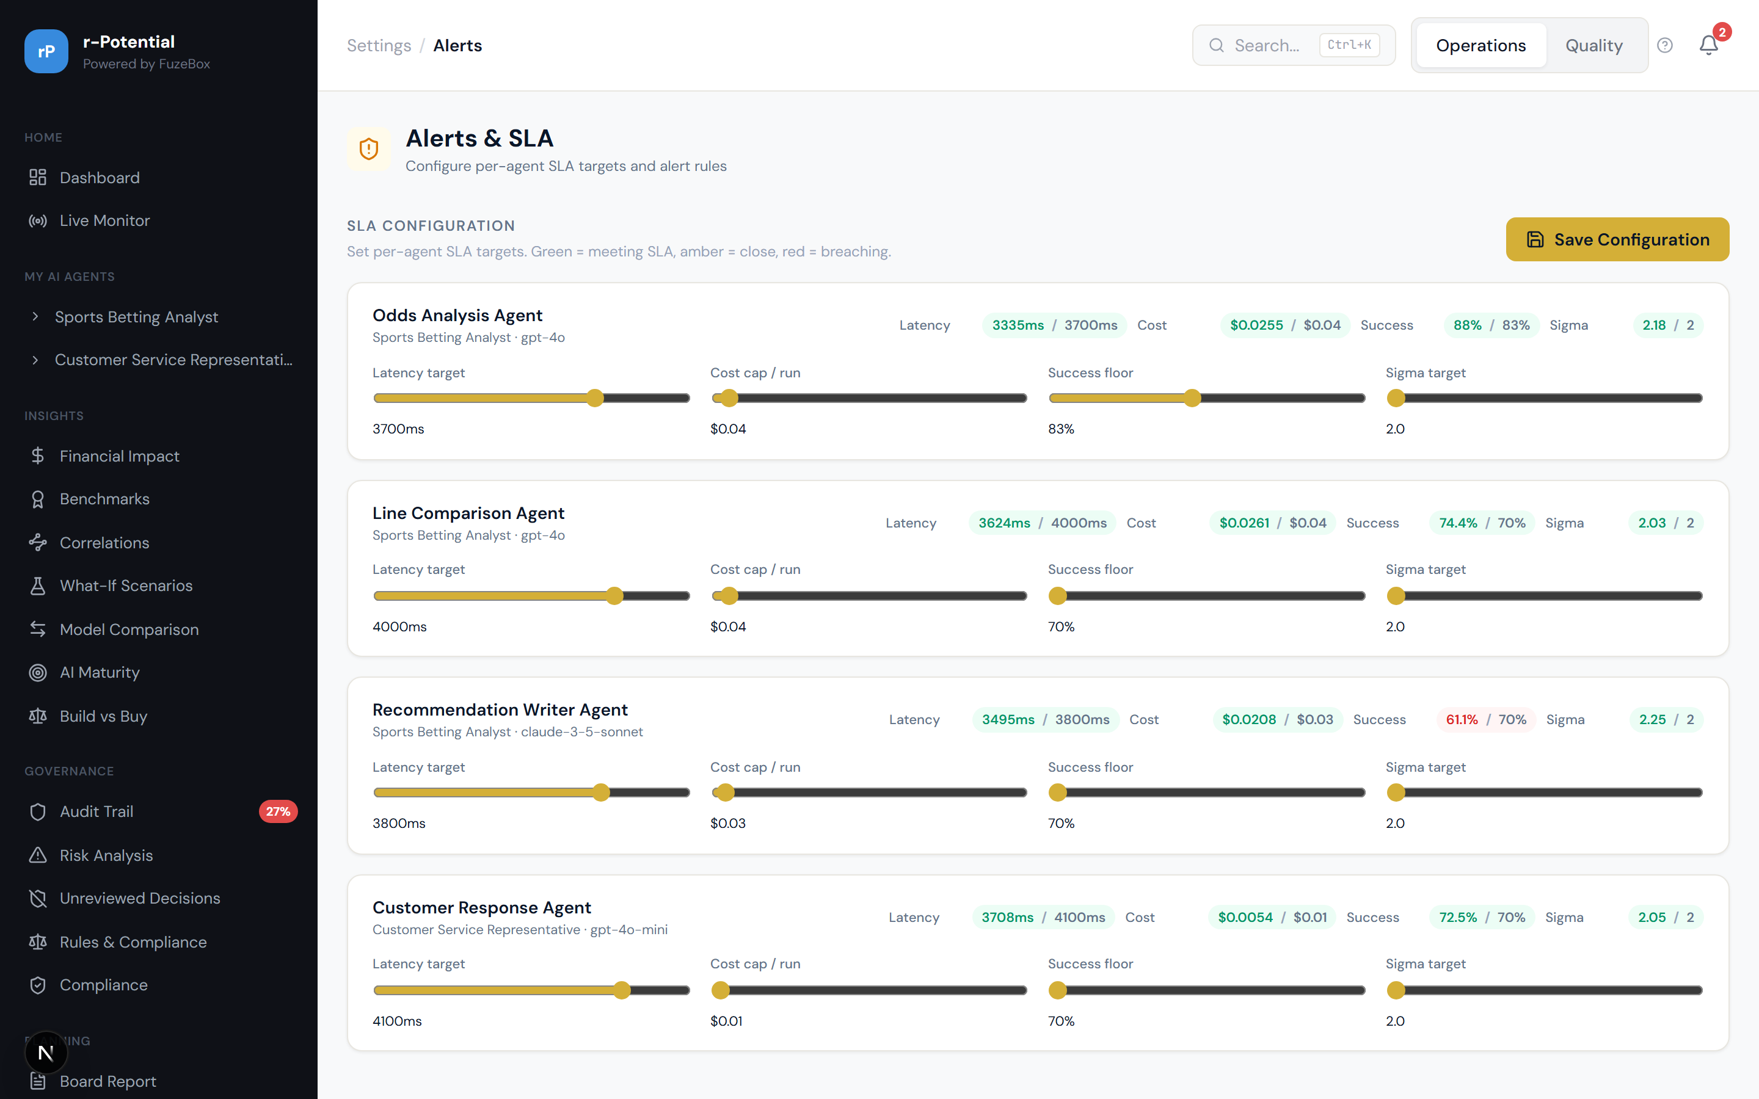
Figure 3.31 -- SLA Configuration & Alert Rules Engine

3.7.3 Budget Caps
Per-agent monthly budget caps with visual gauges showing utilization. Alerts fire when an agent approaches or exceeds its budget.
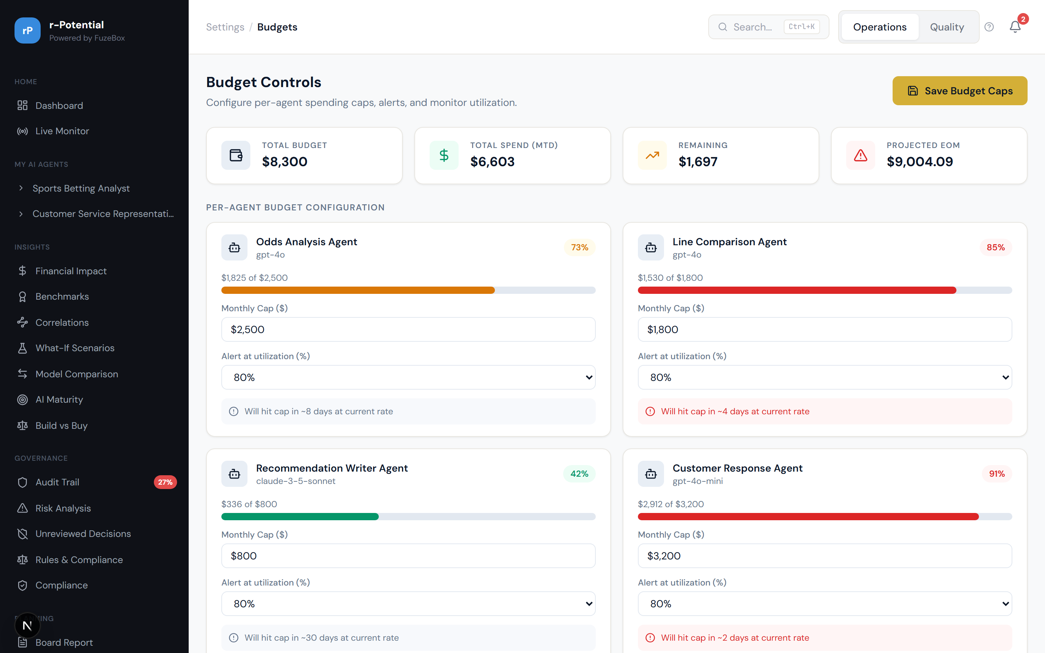
Figure 3.32 -- Per-agent Budget Caps & Utilization

3.7.4 Notification Channels
Configure notification delivery: email, Slack, Microsoft Teams. Each channel can be enabled/disabled per alert category.
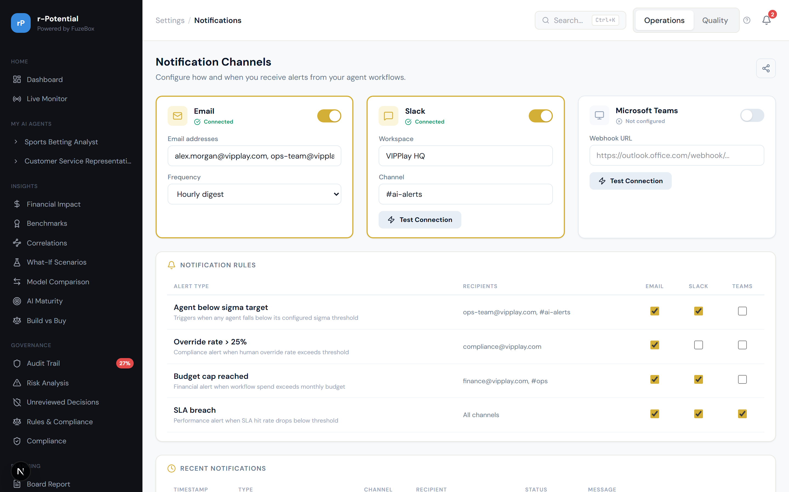
Figure 3.33 -- Notification Channel Configuration

3.7.5 Integrations
API keys management, webhook configuration, and BI tool connections (Tableau, Power BI, Looker). Enables the platform to feed data into existing enterprise toolchains.
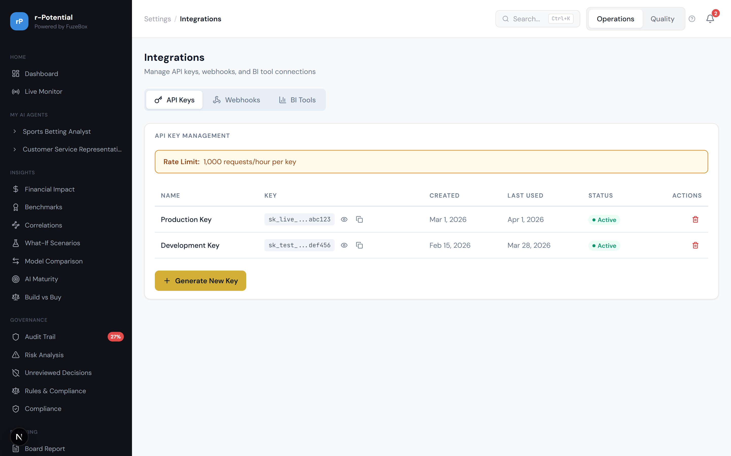
Figure 3.34 -- Integrations: API Keys, Webhooks, BI Tools

3.7.6 White-Label Branding
Customize the platform's appearance: logo, colors, product name. Live preview shows changes in real-time before saving.
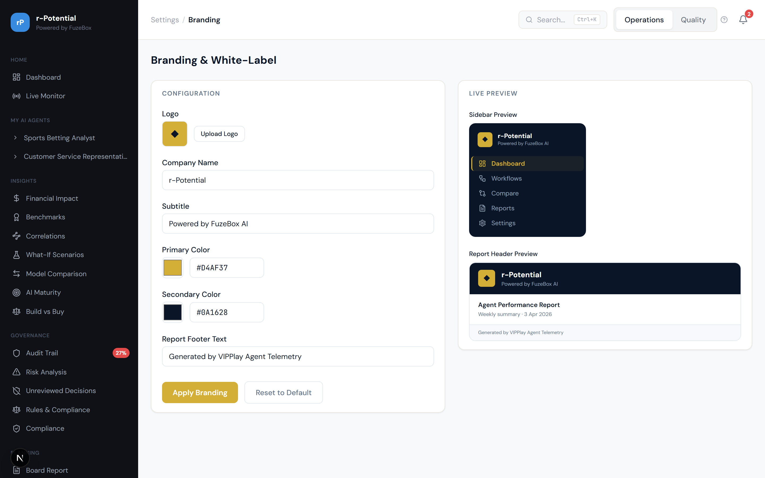
Figure 3.35 -- White-Label Branding Configuration

3.7.7 Multi-Tenant Organisations
Manage multiple organisations with separate workspaces, users, and data isolation. Enterprise-grade multi-tenancy support.
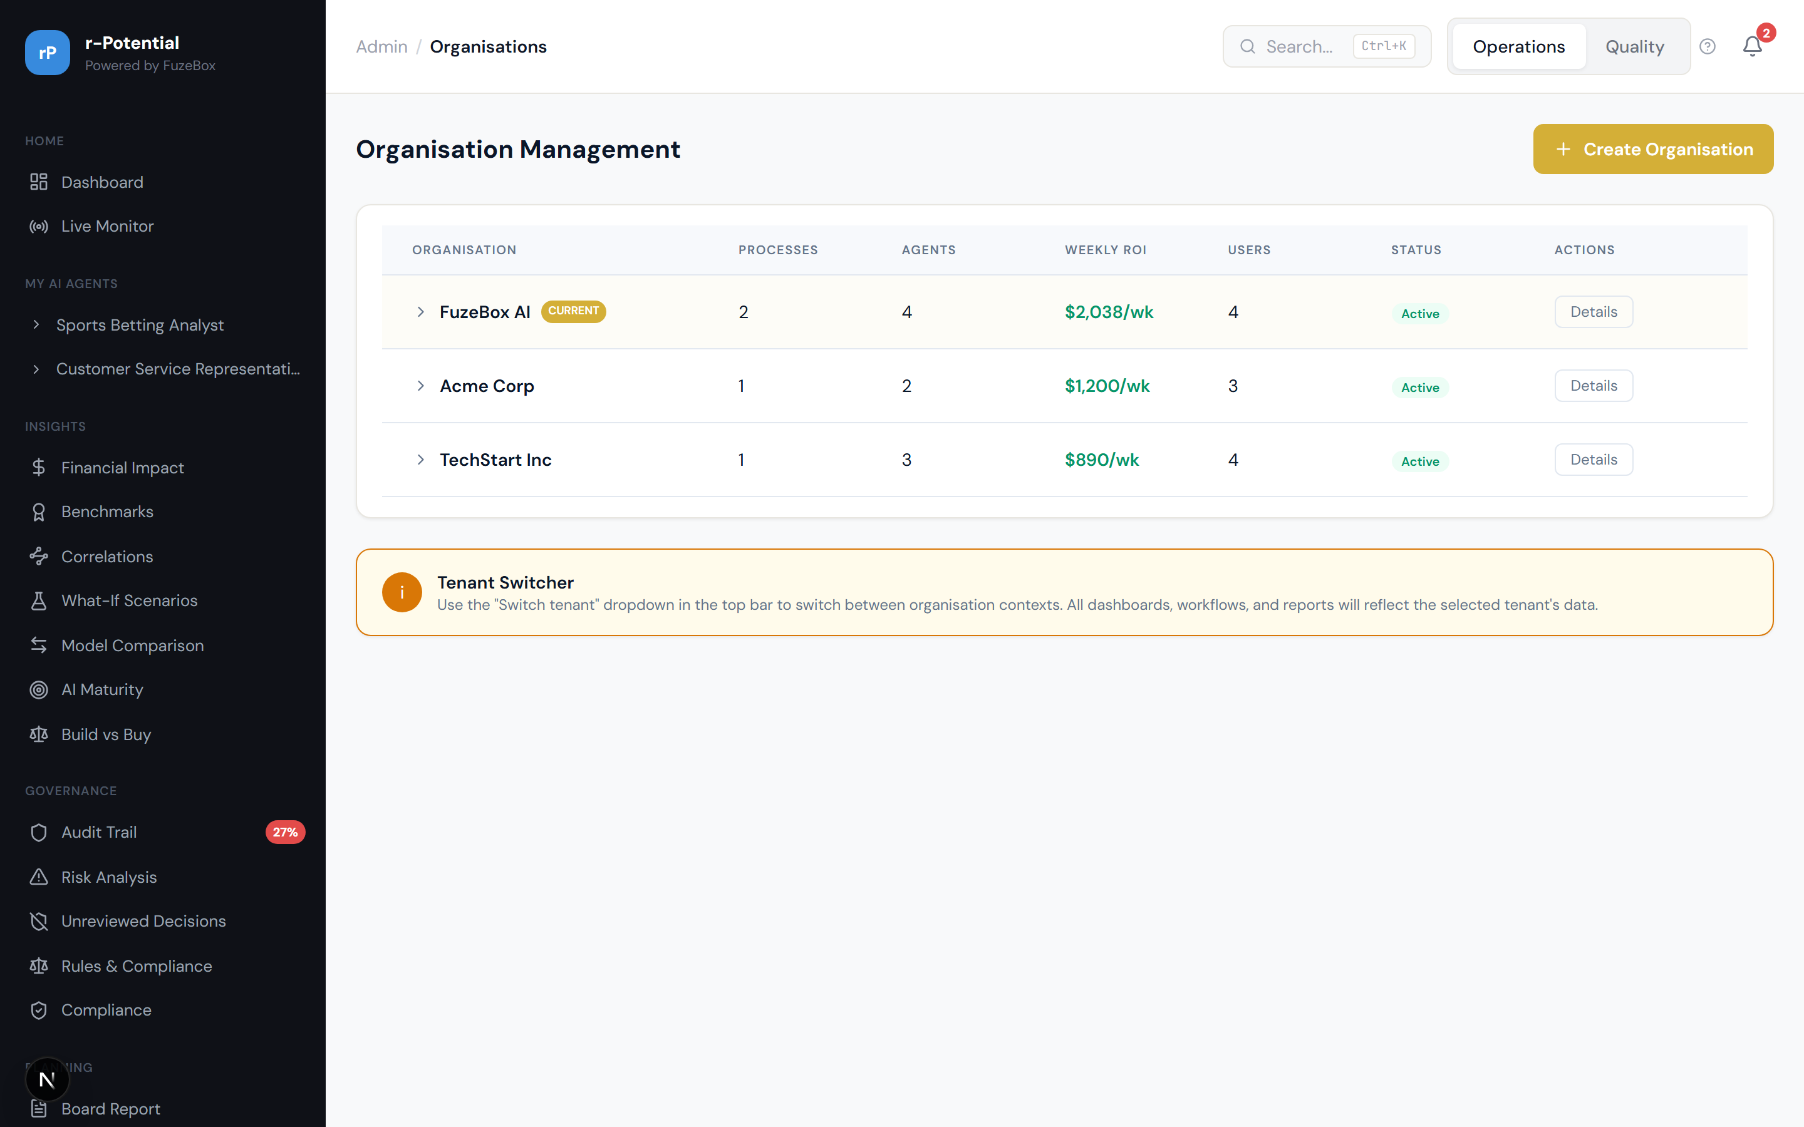
Figure 3.36 -- Multi-Tenant Organisation Management

3.8 Live Monitoring
The Live Monitor is a NOC-style dark-themed screen designed for always-on display. Shows real-time agent status grid, live event feed, active alerts, and system health. Designed for operations teams monitoring AI agent infrastructure.
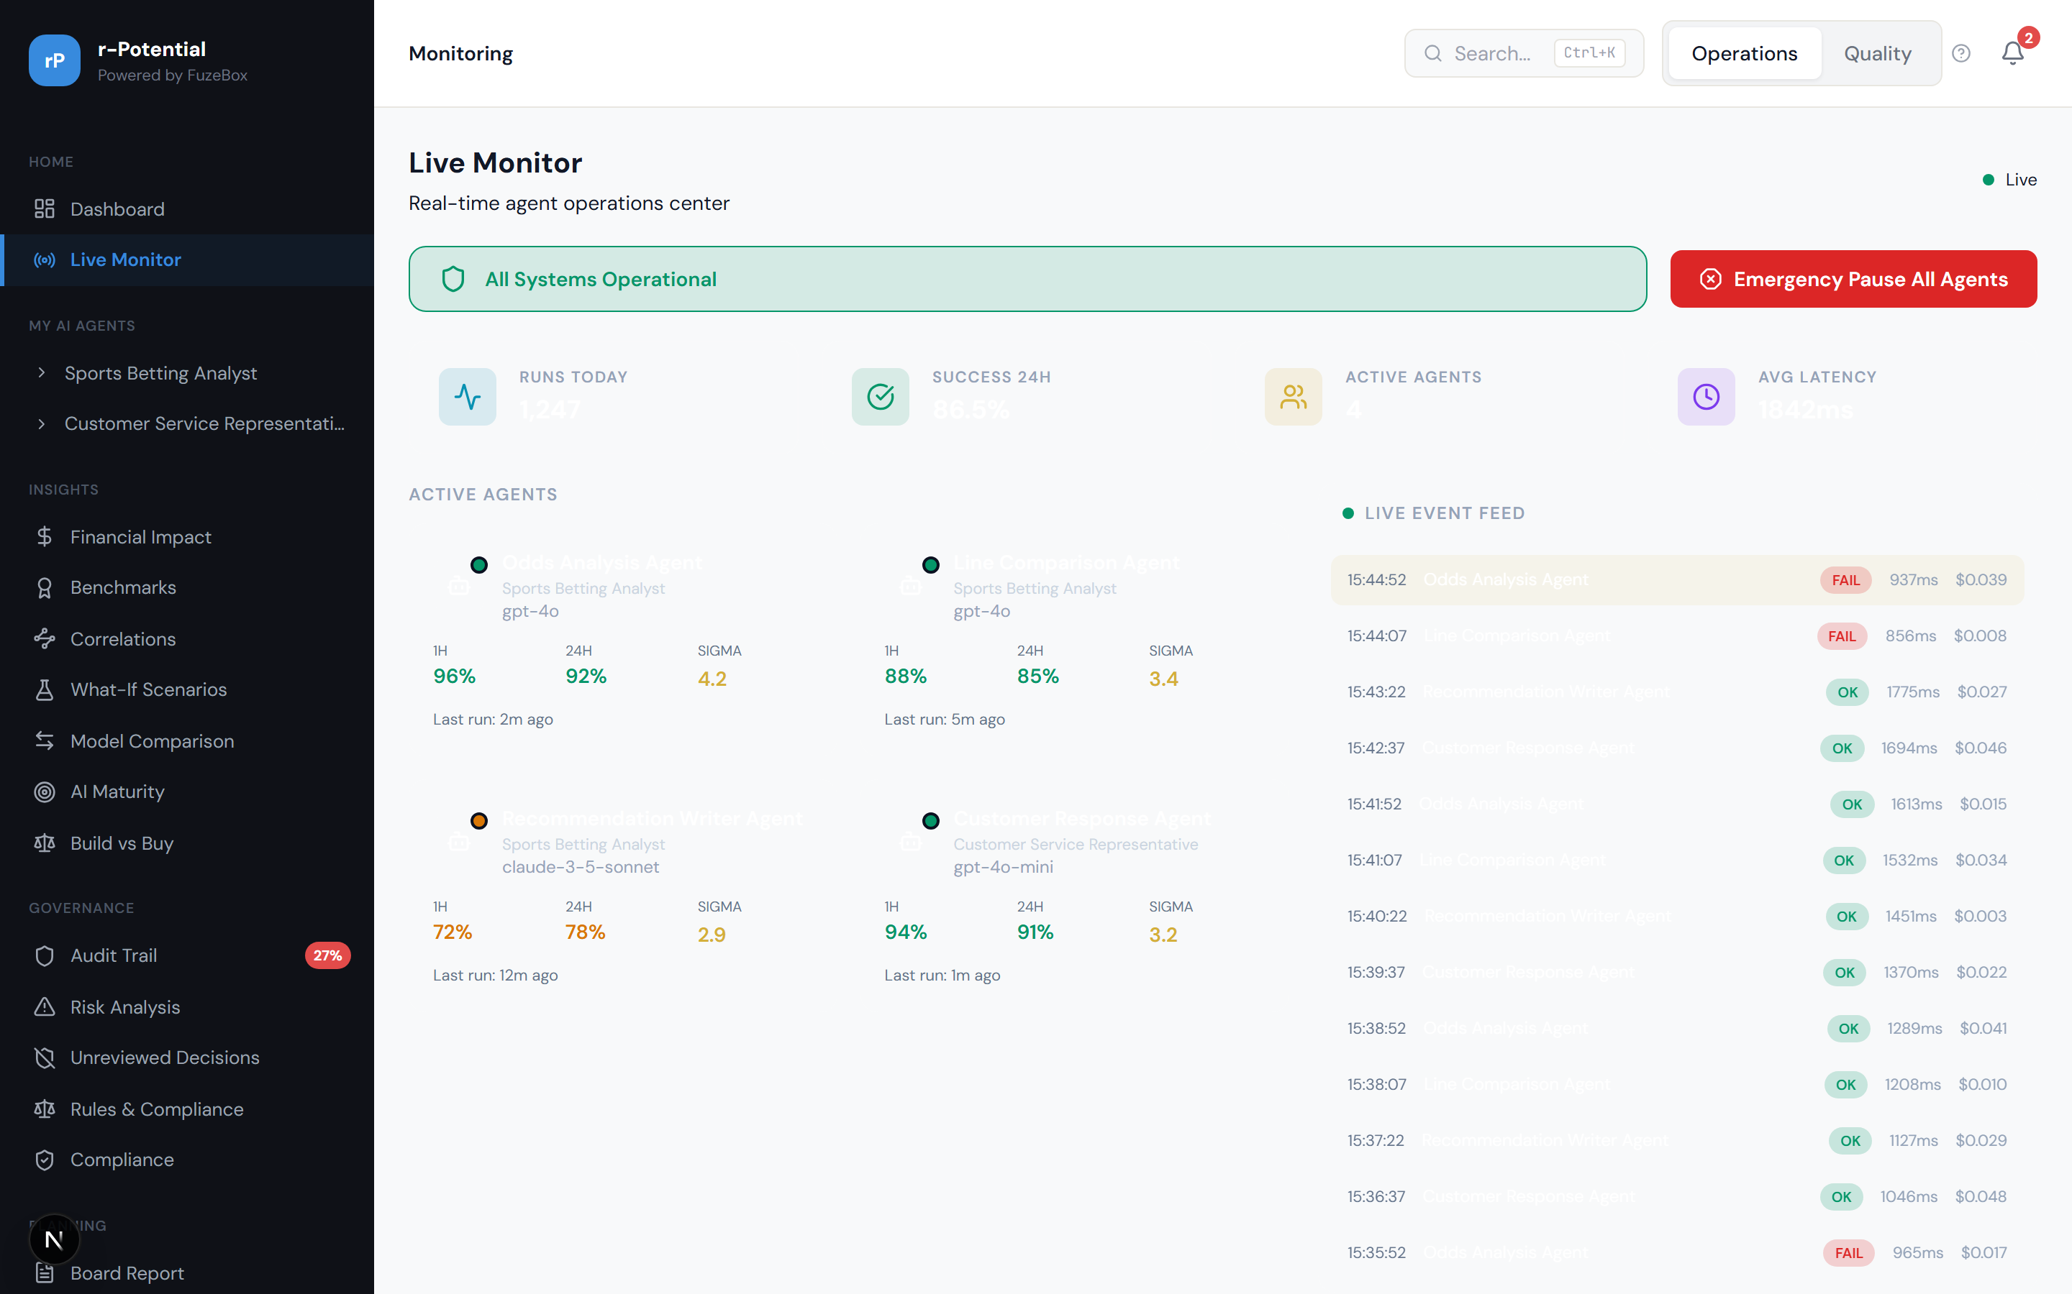
Figure 3.37 -- Live Monitoring (NOC screen, dark theme)

4. The 100 CEO Questions -- Complete Reference
This section maps every question a CEO, CTO, or VP is likely to ask about their AI agent workforce to the exact screen and feature in the platform that answers it. Questions Q1-Q40 are fully implemented. Questions Q41-Q100 show current coverage and planned enhancements.

4.1 Agent Lifecycle Management (Q1-Q6)
These questions cover the full agent lifecycle: adding, removing, replacing, testing, comparing, and tracking versions of AI agents.

Q1: How do I add a new agent?
Navigate to Planning > Setup Wizard. The Occupation Selector (step 1) lets you pick the job role from the O*NET taxonomy. The Agent-to-Task Mapper (step 2) assigns agents to specific tasks.

Q1 -- See highlighted area above

Q1 -- See highlighted area above

Q2: How do I remove/decommission a bad agent?
Go to the agent's detail page > Manage tab. The Decommission action shows impact preview: which tasks lose automation, estimated manual workload increase. Requires confirmation.

Q2 -- See highlighted area above

Q3: How do I replace one agent with another?
On the Manage page, the Swap action lets you select a replacement agent. Shows side-by-side metrics comparison before confirming the swap.

Q3 -- See highlighted area above

Q4: How do I test before promoting to production?
The Staging/Canary view shows a traffic split (e.g., 80/20) between production and canary versions. Metrics are compared in real-time. Promote or rollback with one click.

Q4 -- See highlighted area above

Q5: How do I compare two agents?
Insights > Agent Comparison provides a side-by-side view with radar chart overlay across quality, speed, cost, reliability, and coverage dimensions.

Q5 -- See highlighted area above

Q6: How do I see agent version history?
Each agent's detail page includes a Version Timeline showing the last 3 versions with sigma score changes, deployment dates, and rollback options.

Q6 -- See highlighted area above

4.2 ROI & Financial (Q7-Q13)

Q7: What is the total ROI across all processes?
The Dashboard hero banner shows total weekly savings after all costs (e.g., '$2,038/week'). The Finance pill shows net ROI. The Financial Impact page breaks this down by process in a waterfall chart.

Q7 -- See highlighted area above

Q7 -- See highlighted area above

Q8: What is the ROI per individual agent?
Each agent's detail page includes an AgentRoiCard showing that agent's specific ROI contribution: gross value generated, inference costs, overhead costs, and net ROI.

Q8 -- See highlighted area above

Q9: What is the cost of NOT fixing a bad agent?
The Cost of Inaction calculator on declining agents shows projected additional cost over 90 days if the agent continues on its current trajectory without intervention.

Q9 -- See highlighted area above

Q10: What is the monthly inference spend?
The Cost Trend Dashboard (Insights > Financial Impact) shows monthly spend breakdown across inference, overhead, and training costs with trend lines.

Q10 -- See highlighted area above

Q11: What is the ROI projection for next quarter?
The Transformation Roadmap shows projected ROI for each phase of automation, including next-quarter projections based on the current roadmap.

Q11 -- See highlighted area above

Q12: Can I set a budget cap per agent?
Configure > Budgets lets you set monthly budget caps per agent with visual utilization gauges. Alerts fire when approaching or exceeding the cap.

Q12 -- See highlighted area above

Q13: How do we benchmark against industry?
Insights > Benchmarks shows your metrics against industry averages and top-10% performers across sigma scores, automation rates, ROI, and governance.

Q13 -- See highlighted area above

4.3 Performance & Quality (Q14-Q21)

Q14: Which is the best performing agent?
The Sigma Scorecard ranks all agents by sigma score. The highest-sigma agent is clearly identified. Dashboard attention cards also highlight top and bottom performers.

Q14 -- See highlighted area above

Q15: Which agent is underperforming?
Dashboard Attention Required section shows agents with declining sigma scores in red-bordered cards with projected cost impact. The Sigma Scorecard provides the detailed breakdown.

Q15 -- See highlighted area above

Q16: What insights can improve an agent?
Each agent's detail page includes a defect analysis section showing the most common failure types, their frequency, and recommended remediation steps.

Q16 -- See highlighted area above

Q17: What is the root cause of failures?
The Risk Analysis (FMEA) board ranks all failure modes by RPN. Each entry identifies the root cause, current controls, and recommended mitigation actions.

Q17 -- See highlighted area above

Q18: Can I track improvement over time?
The Sigma Scorecard includes an Improvement Tracker showing sigma history with trend lines and projections. See whether quality is improving, stable, or declining.

Q18 -- See highlighted area above

Q19: Can I set SLA targets per agent?
Configure > Alerts lets you define per-agent SLA rules: minimum sigma threshold, maximum latency, maximum cost per run. Violations trigger configured notifications.

Q19 -- See highlighted area above

Q20: Will I be alerted when quality drops?
The Alert Rules Engine monitors all SLA thresholds continuously. When a rule is violated, notifications are sent via configured channels (email, Slack, Teams).

Q20 -- See highlighted area above

Q20 -- See highlighted area above

Q21: Can I see real-time agent performance?
The Live Monitor shows real-time status of all agents: active/idle/error state, current run metrics, and a live event feed of recent actions.

Q21 -- See highlighted area above

4.4 Reporting & Communication (Q22-Q26)

Q22: Can I download a report?
Planning > Board Report provides configurable report export. Select sections to include, preview the report, and download as PDF using the browser's print dialog.

Q22 -- See highlighted area above

Q23: Can I schedule weekly reports?
The Board Report page has a Schedule tab where you can set up recurring report delivery: daily, weekly, or monthly, sent to specified email recipients.

Q23 -- See highlighted area above

Q24: Can I share a dashboard link?
Key pages have a Share button that generates a shareable link. Shared links are managed from Settings > Shared Links, where you can revoke access.

Q24 -- See highlighted area above

Q25: Can I get Slack/Teams notifications?
Configure > Notifications supports email, Slack, and Microsoft Teams. Each channel can be enabled per alert category (quality, cost, governance, system).

Q25 -- See highlighted area above

Q26: Can I export to BI tools?
Configure > Integrations has a BI Tools tab supporting Tableau, Power BI, and Looker with connection wizards and API endpoint documentation.

Q26 -- See highlighted area above

4.5 Team & Workforce (Q27-Q30)

Q27: What skills does my team need now?
The Labor Graph shows current human task distribution. The Training Plan identifies specific skills gaps and recommends training programs for each affected role.

Q27 -- See highlighted area above

Q27 -- See highlighted area above

Q28: How do I plan training for the team?
The Training Plan page provides a structured skills gap analysis with recommended courses, timelines, and priority levels for each team member or role.

Q28 -- See highlighted area above

Q29: What is my team's role as agents improve?
The Transformation Roadmap shows how roles evolve at each stage: from manual execution to oversight, exception handling, and strategic decision-making.

Q29 -- See highlighted area above

Q30: What is the headcount impact over 12 months?
Workforce Planning shows 12-month projections under three scenarios (conservative, moderate, aggressive). Charts show headcount trajectory, role transitions, and cost curves.

Q30 -- See highlighted area above

4.6 Governance & Compliance (Q31-Q35)

Q31: Are we EU AI Act compliant?
The Audit Trail provides the compliance evidence chain. The governance rules engine enforces mandatory human review for high-risk decisions, and the audit log captures every decision for regulatory export.

Q31 -- See highlighted area above

Q32: What is the override rate trend?
The Audit Trail page includes override trend analysis charts showing weekly override frequency, whether overrides are increasing or decreasing, and correlation with agent quality scores.

Q32 -- See highlighted area above

Q33: Can I export data for auditors?
The Board Report export supports audit-specific sections. The Audit Trail itself supports filtered export by date range, agent, and event type -- suitable for regulatory submission.

Q33 -- See highlighted area above

Q33 -- See highlighted area above

Q34: Which decisions had no human oversight?
Governance > Unreviewed Decisions shows a dedicated report of all agent decisions that proceeded without human review, categorized by risk level and agent.

Q34 -- See highlighted area above

Q35: Can I require human review for high-risk decisions?
Governance > Rules Engine lets you configure mandatory human review rules. Set conditions (e.g., 'all decisions above $1000 risk') and the system enforces review before proceeding.

Q35 -- See highlighted area above

4.7 Multi-Org & Scaling (Q36-Q40)

Q36: Can I manage multiple departments?
The sidebar nests agents under their process (job role). Multiple processes represent different departments. The dashboard shows all processes side-by-side.

Q36 -- See highlighted area above

Q37: Can I set different quality targets per team?
Configure > Alerts supports per-agent SLA configuration. Each agent (and by extension, each team/process) can have different quality thresholds.

Q37 -- See highlighted area above

Q38: Can I benchmark across departments?
Insights > Benchmarks includes cross-process comparison, showing how each department's agents perform relative to each other on key metrics.

Q38 -- See highlighted area above

Q39: Can I white-label this for clients?
Configure > Branding provides full white-label customization: logo upload, color scheme, product name, and live preview of changes before saving.

Q39 -- See highlighted area above

Q40: Can I manage multiple organisations?
Configure > Organisations provides multi-tenant workspace management with separate user directories, data isolation, and per-org configuration.

Q40 -- See highlighted area above

4.8 Extended Questions (Q41-Q100)
Questions Q41-Q100 represent deeper analytical needs. The table below shows the current status of each question: which are already answered by existing features, which are partially covered, and which are planned for future phases.

Agent Performance -- Deeper (Q41-Q50)
Q41: Which agent improved the most this month?
Status: [ANSWERED] Sigma Scorecard Improvement Tracker

Q41 -- Answered: Which agent improved the most this month?

Q42: Which agent costs the most per successful outcome?
Status: [ANSWERED] Agent Detail page -- cost/success ratio

Q42 -- Answered: Which agent costs the most per successful outcome?

Q43: Failure rate trend over the last quarter?
Status: [PARTIAL] 30-day trend available; 90-day planned (Phase 7)

Q43 -- Partial: Failure rate trend over the last quarter?

Q44: Can I see what an agent does step-by-step?
Status: [PLANNED] Run Trace Viewer -- Phase 7

Q45: What happens when an agent fails?
Status: [PARTIAL] Audit Trail shows escalations; full flow planned Phase 7

Q45 -- Partial: What happens when an agent fails?

Q46: How fast are my agents responding?
Status: [ANSWERED] Agent metrics bar shows P95 latency

Q46 -- Answered: How fast are my agents responding?

Q47: Are agents getting faster or slower?
Status: [PLANNED] Latency trend chart -- Phase 7

Q48: Which tasks are agents worst at?
Status: [PARTIAL] Per-defect-type available; per-task planned Phase 7

Q48 -- Partial: Which tasks are agents worst at?

Q49: Can I see a specific failed run?
Status: [PLANNED] Run Detail Panel -- Phase 7

Q50: What is agent uptime/availability?
Status: [PLANNED] Availability Card -- Phase 7

Financial -- Deeper (Q51-Q60)
Q51: Total cost of AI ownership (TCO)?
Status: [PARTIAL] Cost trends available; full TCO breakdown planned Phase 8

Q51 -- Partial: Total cost of AI ownership (TCO)?

Q52: ROI if I add one more agent?
Status: [PLANNED] What-If Scenario Builder -- Phase 8

Q53: Payback period per agent?
Status: [PLANNED] Payback Calculator -- Phase 8

Q54: Cost per department?
Status: [PLANNED] Department-level cost view -- Phase 8

Q55: Cost trend by model (GPT vs Claude)?
Status: [PARTIAL] Inference costs shown; model breakdown planned Phase 8

Q55 -- Partial: Cost trend by model (GPT vs Claude)?

Q56: Savings from switching models?
Status: [PLANNED] Model Comparison tool -- Phase 8

Q57: Marginal cost of scaling?
Status: [PLANNED] Scenario Builder scaling slider -- Phase 8

Q58: Over-spending on oversight?
Status: [PARTIAL] Oversight costs in ROI waterfall; efficiency analysis Phase 8

Q58 -- Partial: Over-spending on oversight?

Q59: Inference cost per token?
Status: [PLANNED] Token-level TCO breakdown -- Phase 8

Q60: % of AI spend wasted on failures?
Status: [PARTIAL] Failure costs visible; waste ratio planned Phase 8

Q60 -- Partial: % of AI spend wasted on failures?

Workforce -- Deeper (Q61-Q68)
Q61: Which team members most affected?
Status: [PLANNED] Team Impact Cards -- Phase 9

Q62: New roles to create?
Status: [PARTIAL] Roadmap shows role evolution; explicit role creation Phase 9

Q62 -- Partial: New roles to create?

Q63: Humans overriding good decisions?
Status: [PARTIAL] Override rate visible; quality analysis planned Phase 7

Q63 -- Partial: Humans overriding good decisions?

Q64: Time spent reviewing AI output?
Status: [PARTIAL] Oversight hours in workforce plan; detailed view Phase 9

Q64 -- Partial: Time spent reviewing AI output?

Q65: Employee satisfaction impact?
Status: [PLANNED] Survey integration -- Phase 9

Q66: What if we hire 2 more people?
Status: [PLANNED] Scenario Builder hiring slider -- Phase 8

Q67: What tasks should we automate next?
Status: [PARTIAL] Coverage map shows gaps; recommendation engine Phase 7

Q67 -- Partial: What tasks should we automate next?

Q68: Human error vs agent error rate?
Status: [PLANNED] Human vs Agent Comparison -- Phase 9

Q69: ISO 42001 compliant?
Status: [PARTIAL] Audit trail + rules; compliance checklist planned Phase 9

Q69 -- Partial: ISO 42001 compliant?

Q70: Generate compliance certificate?
Status: [PLANNED] Compliance Dashboard -- Phase 9

Q71: Audit readiness score?
Status: [PARTIAL] Governance rules compliance gauge; full score Phase 9

Q71 -- Partial: Audit readiness score?

Q72: Who approved most overrides?
Status: [PARTIAL] Audit log filterable; per-reviewer breakdown Phase 7

Q72 -- Partial: Who approved most overrides?

Q73: Overrides correlated with time?
Status: [PLANNED] Temporal pattern chart -- Phase 7

Q74: Different rules per geography?
Status: [PLANNED] Geo-scoped rules -- Phase 9

Q75: All March decisions for a regulator?
Status: [ANSWERED] Audit Trail with date filter + export

Q75 -- Answered: All March decisions for a regulator?

Q76: Prove human-in-the-loop?
Status: [PARTIAL] Override events in audit; evidence chain Phase 9

Q76 -- Partial: Prove human-in-the-loop?

Q77: Mean time between violations?
Status: [PLANNED] MTBV metric -- Phase 9

Q78: Alert when compliance drops?
Status: [ANSWERED] Alert Rules Engine supports compliance thresholds

Q78 -- Answered: Alert when compliance drops?

Q79: Pause all agents (kill switch)?
Status: [PLANNED] Emergency Pause -- Phase 9

Q80: Blast radius if agent goes rogue?
Status: [PARTIAL] Manage page impact preview; full analysis Phase 9

Q80 -- Partial: Blast radius if agent goes rogue?

Q81: Roll back to previous version?
Status: [PARTIAL] Version Timeline; full rollback Phase 9

Q81 -- Partial: Roll back to previous version?

Q82: Dependency map between agents?
Status: [PLANNED] Dependency Map -- Phase 9

Q83: Which agents share data sources?
Status: [PLANNED] Data source mapping -- Phase 9

Q84: Peak hour performance?
Status: [PARTIAL] Monitoring shows current; heatmap planned Phase 7

Q84 -- Partial: Peak hour performance?

Q85: Set maintenance windows?
Status: [PLANNED] Maintenance Scheduler -- Phase 9

Q86: Recovery time on failure?
Status: [PLANNED] MTTR metric -- Phase 7

Q87: Where on AI maturity curve?
Status: [PARTIAL] AI Maturity Score available; full assessment Phase 8

Q87 -- Partial: Where on AI maturity curve?

Q88: Compare to competitors?
Status: [ANSWERED] Industry Benchmarks page

Q88 -- Answered: Compare to competitors?

Q89: AI strategy readiness?
Status: [PLANNED] Readiness assessment -- Phase 8

Q90: Board presentation in 5 minutes?
Status: [ANSWERED] Board Report one-click export

Q90 -- Answered: Board presentation in 5 minutes?

Q91: 3-year projection?
Status: [PLANNED] Long-Range Projection -- Phase 8

Q92: Build or buy more agents?
Status: [PLANNED] Build vs Buy Analysis -- Phase 8

Q93: AI risk exposure summary?
Status: [PARTIAL] FMEA + governance; unified risk view Phase 9

Q93 -- Partial: AI risk exposure summary?

Q94: See this on my phone?
Status: [PLANNED] Mobile responsive pass -- Phase 9

Q95: Show to investors?
Status: [PARTIAL] Board Report + Branding; investor mode Phase 8

Q95 -- Partial: Show to investors?

Q96: Competitive moat from AI?
Status: [PLANNED] Strategic assessment -- Phase 8

Q97: Connect to HR system?
Status: [PARTIAL] Integration stubs; HR connector planned Phase 9

Q97 -- Partial: Connect to HR system?

Q98: Agents trigger other system actions?
Status: [PLANNED] Outbound webhooks -- Phase 9

Q99: Import from Langfuse/LangSmith?
Status: [PLANNED] Observability import connector -- Phase 9

Q100: Set up SSO for my team?
Status: [PLANNED] SSO configuration -- Phase 9

5. Route Map & Screen Index
Complete index of all 35+ routes in the application with their purpose and phase.
Route | Screen Name | Phase | Purpose
/dashboard | Executive Dashboard | 1 | AI workforce overview, attention items, process health
/dashboard/roi | Financial Impact | 1 | ROI waterfall, cost breakdown
/dashboard/costs | Cost Trends | 3 | Monthly spend analysis
/dashboard/benchmark | Cross-Process Benchmark | 3 | Compare processes within org
/dashboard/benchmarks | Industry Benchmarks | 5 | Compare against industry averages
/dashboard/export | Board Report | 2 | Configurable report export + scheduling
/process/[id] | Symmetry Dashboard | 1 | Agent/human split, quality equation
/process/[id]/labor | Labor Graph | 1 | Human effort distribution
/process/[id]/sigma | Sigma Scorecard | 1 | Quality scores + improvement tracker
/process/[id]/coverage | Task Ownership | 2 | Coverage map: which tasks are automated
/process/[id]/roadmap | Transformation Roadmap | 2 | Stage timeline + ROI projections
/process/[id]/training | Training Plan | 3 | Skills gap analysis + course recommendations
/process/[id]/workforce | Workforce Planning | 4 | 12-month headcount projections
/agents/[id] | Agent Telemetry | 1 | Per-agent metrics, runs, defects, ROI
/agents/[id]/manage | Agent Manage | 3 | Pause, decommission, swap controls
/agents/[id]/staging | Agent Staging | 4 | Canary deployment + traffic split
/agents/compare | Agent Comparison | 3 | Side-by-side radar chart comparison
/monitoring | Live Monitor | 4 | NOC screen, real-time status + events
/governance/audit | Audit Trail | 1 | Complete decision log + override trends
/governance/fmea | Risk Analysis | 2 | FMEA board ranked by RPN
/governance/oversight | Unreviewed Decisions | 3 | Oversight gap report
/governance/rules | Rules Engine | 4 | Configurable governance rules
/analytics/correlations | Correlations | 5 | Metric correlation scatter plots
/insights/scenarios | What-If Scenarios | 7-8 | Interactive scenario modeler
/insights/maturity | AI Maturity | 7-8 | Maturity assessment radar chart
/setup/occupation | Occupation Selector | 2 | O*NET job role picker
/setup/mapping | Task Mapper | 2 | Assign agents to tasks
/settings | Settings | 1 | General config + shared links
/settings/alerts | SLA & Alerts | 3 | Per-agent SLA rules
/settings/budgets | Budgets | 4 | Per-agent budget caps
/settings/notifications | Notifications | 4 | Email, Slack, Teams channels
/settings/integrations | Integrations | 5 | API keys, webhooks, BI tools
/settings/branding | Branding | 5 | White-label customization
/admin/organisations | Organisations | 5 | Multi-tenant workspace management
/login | Login | 1 | Authentication page

Document Information
This document was generated from the live application running at localhost during development. All screenshots are captured directly from the application interface. All data shown is deterministic mock data for demonstration purposes -- no live backend is connected.

Field | Value
Product | VIPPlay Agent Telemetry Platform
Version | Phases 1-6 Complete (35 routes, 60+ components)
Built by | r-Potential / FuzeBox AI
Tech Stack | Next.js 16.2, React 19, TypeScript, Tailwind CSS 4, Recharts
Date | April 2026

