*** This does not apply anymore. To play locally open in different browsers and make sure that the settings are set to localhost. For LAN, set to the IP address of the host machine running with the Node.js prompt. This can be found around line 100 in public\js\HyperBout.js

|  |  |  |  |  |  |  |
| --- | --- | --- | --- | --- | --- | --- |
| |  | | --- | | + | | + // Change to proper IP address for LAN configuration | | + // socket = io.connect("http://192.168.0.103", {port: 8000, transports: ["websocket"]}); | | + | | + // Uncomment this for local machine testing | | + socket = io.connect("http://localhost", {port: 8000, transports: ["websocket"]}); | |

1. Open up Node.js Command Prompt and change to directory of game

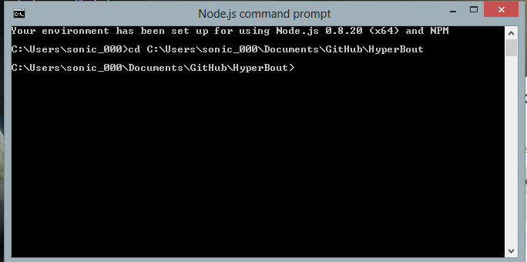

1. Start the HyperBout server by typing in “node HyperBout.js”

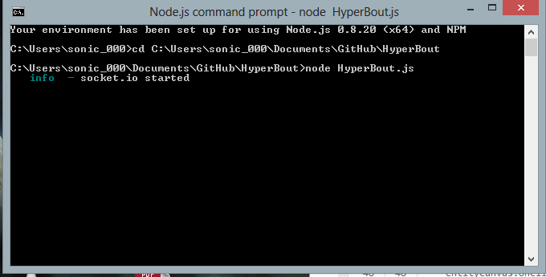

3.) Go into the public folder and open up the index.html file in both firefox and chrome

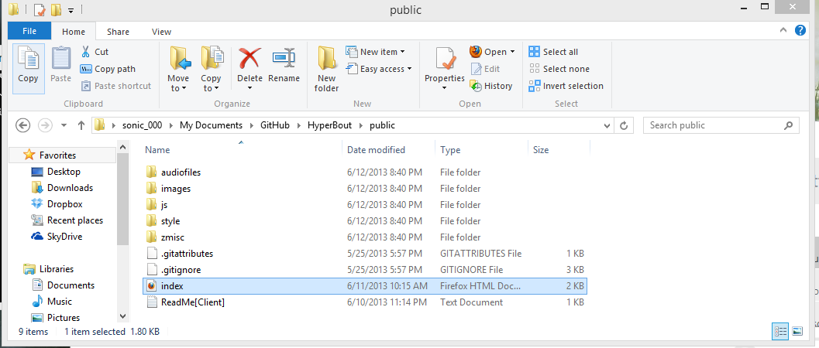

4.) Players can see both each other’s movements (however only box2d draw on the local player, not remote players)

