R EPORT ON

WEB DEVELOPMENT (CSY-1018)

**Submitted by : Prabin Maharjan**

**UNIVERSITY : Northampton University**

**College : NAMI College**

**Module Code : CSY-1018**

**UN ID : 15444349**

* **Contains:**
* Introduction
* Project Development
* Wireframe
* Good Practice
* Conclusion
* References

**Introduction**

Making a web page was a difficult task for a person like me as I had no idea and background of this subject. But with the help of YouTube and w3schools I was hopefully able to progress on with my work as they gave me basic concept of the project. And finally with a little help of my colleague I was able to work on this project. My Web page contains of four page home, CV, BIO and contact. HTML 5 and css were used to make this page.

**Project Development**

The first week of my project went by studying and researching about the project brief provided by the university. Then I started the development of the project by making HTML files using Atom. After certain development of my project I realized that it needed to be uploaded to GIT so I started to push my files in the GIT. (Link to my file <https://github.com/Triggered647/csy1018triggered> )

There was not much idea of design in me so my first design for the page was a worst one which is like a bad memory for me now. After that I got guide line from YouTube and w3schools with the help of these sites I made my page noticeable and better. Furthermore, I also used material design.

At last, I finalized my project, went through some rechecking in case to find some mistakes or spelling errors and finally submitted the project. The total time taken to finish the project is approximately 48 hours.

**Wireframe**

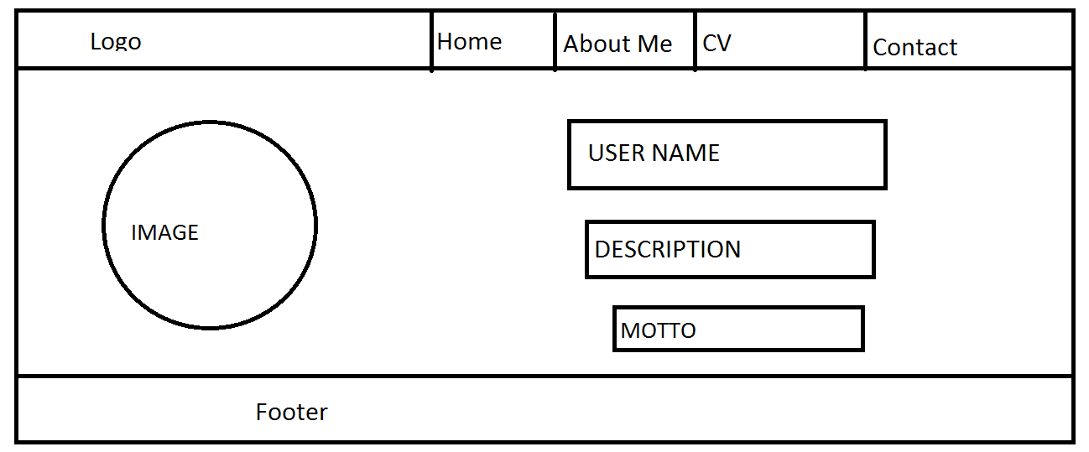

There are 3 parts in the above web page. First part which the upper most part is going to be logo and navigation part. Second part which is the middle part that consist of image and details. Third part is the lower part containing the footer. This is the wireframe of the home page.

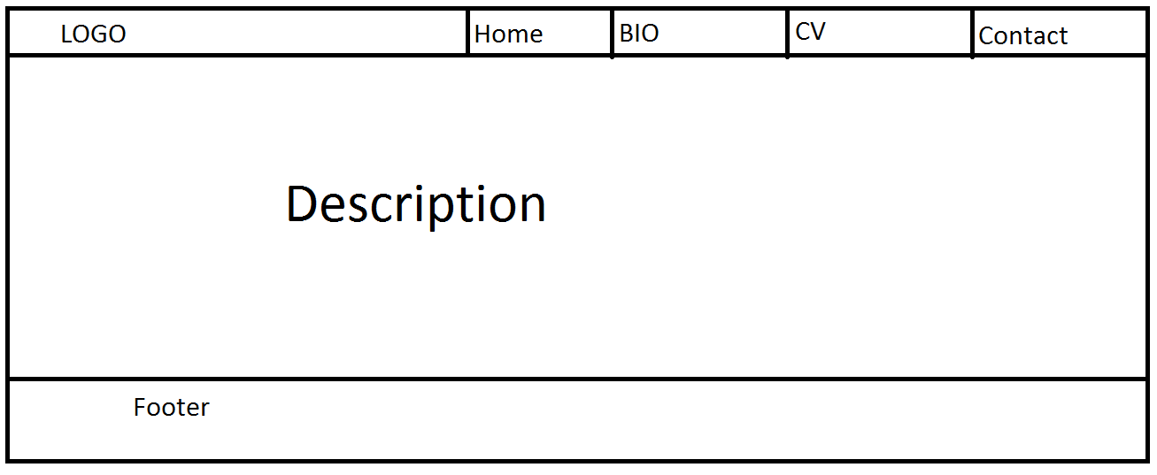

In this page I will be talking about my BIO. This page also contains 3 parts. First part is the same as the previous one. Middle part or the second part is where information about the user can be found and again the third part is also again the same as before.

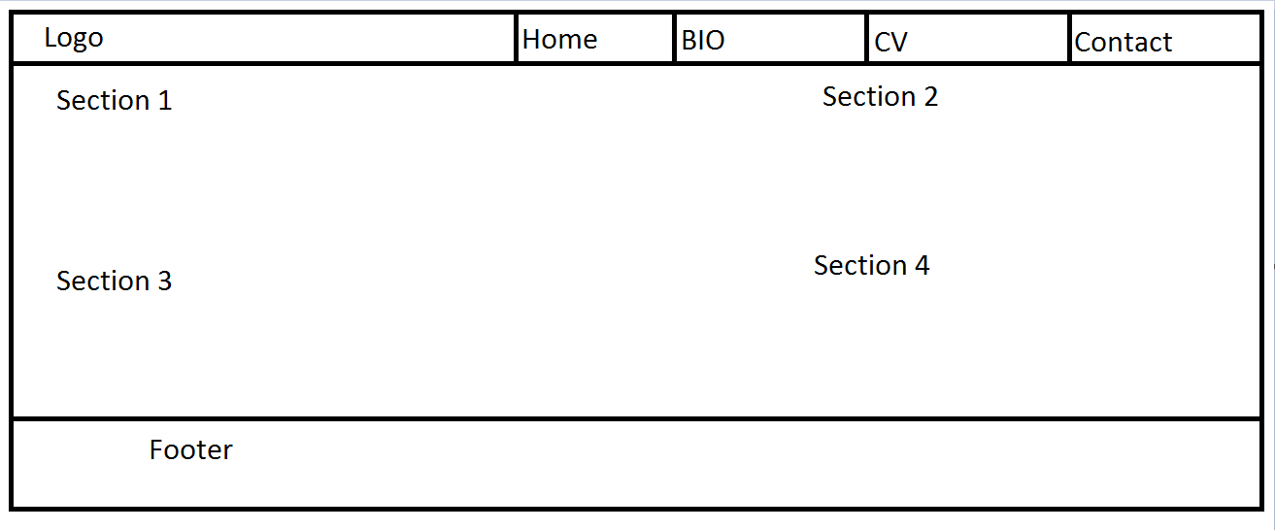

In this part of wire framing I am going to write my CV in the section part which is divided into 4 sections. But the first and last part of the page is same as the other part.

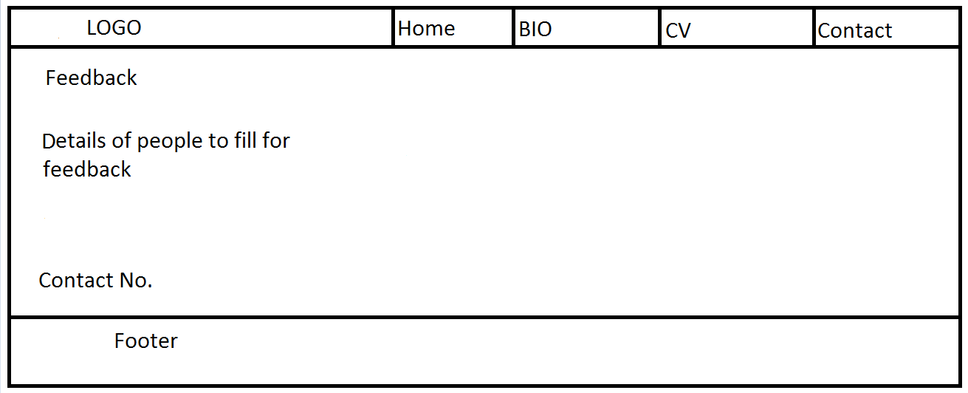

This is the last wire framing of my web page in this part the visitors of my web page can fill up the form giving me feedbacks about my web page and their information.

**Good Practice**

* Speed Test

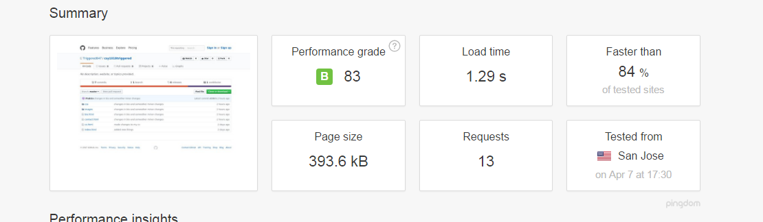

From the above image as we can see that the performance grade is 83 with grade ‘B’. The time taken to load is 1.29s and 84% faster than the other tested site.

* Social links

In this present time the trend of keeping links of social sites are every popular so I have also kept some social sites like Facebook, twitter, YouTube.

**Conclusion**

My report is made as per the requirement of the university. All the information provided in the brief is fulfilled by my web pages.

**References**

* Pingdom. 2017. Website Speed Test. [ONLINE] Available at:

https://tools.pingdom.com/. [Accessed 7th April 2017].

* W3schools.com. 2014. CSS3 Images. [ONLINE] Available at:

<https://www.w3schools.com/css/css3_images.asp> [Accessed 3rd April 2017].

* GT Coding.2017.[ONLINE]Available at: <https://www.youtube.com/channel/UCqXs3o7aLdnJfXEN3OVgafw>