OUTPUT

Problem 1: Omitted Variable Bias

--- Running simulation with N=100 (Small Sample) ---
True coefficient for X (b_true): 2
Estimated coefficient for X (Full Model, N=100): 2.1192
Estimated coefficient for X (Omitted Model, N=100): 3.3990

--- Running simulation with N=10000 (Large Sample) ---
True coefficient for X (b_true): 2
Estimated coefficient for X (Full Model, N=10000): 2.0014
Estimated coefficient for X (Omitted Model, N=10000): 3.5061

Problem 2: Sensitivity to Outliers

--- Baseline Model (No Outliers) ---
True Intercept (Beta0): 10, True Slope (Beta1): 0.5
Estimated Intercept: 10.7298, Estimated Slope: 0.4824
R-squared: 0.8794

--- Model with Outlier ---
Estimated Intercept: 4.9951, Estimated Slope: 0.6370
R-squared: 0.3088

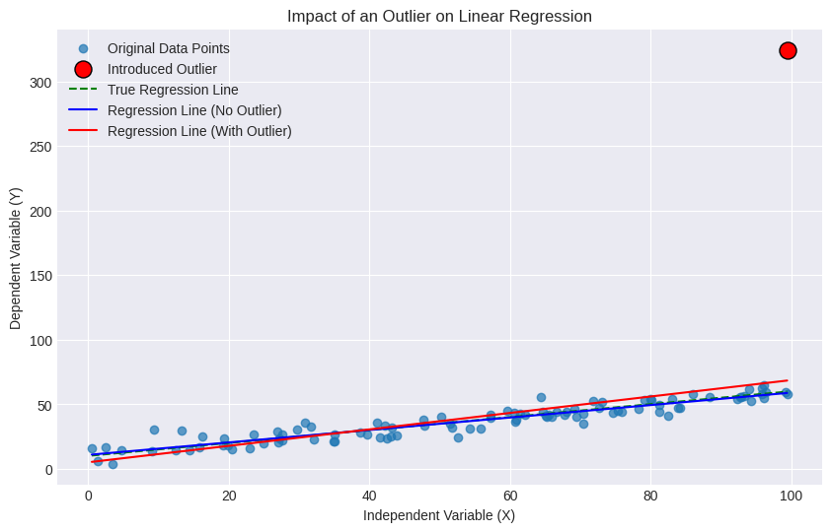
Problem 3: Model Selection
Loaded data (hardcoded) for Problem 3:
Y Z1 Z2 Z3 Z4 Z5
0 2.172296 0.121634 -0.051562 0.570616 1.279931 0.075233
1 0.502380 0.025446 -0.093062 0.304875 -0.582292 0.377388
2 0.711362 -0.136716 -0.082229 -0.191680 -0.647970 1.230986
3 -0.557168 -0.284459 -0.170922 -0.853670 -1.256146 -0.991686
4 1.500199 0.105205 -0.169141 0.826558 0.640945 1.099873

Dataset columns after renaming: ['y', 'x1', 'x2', 'x3', 'x4', 'x5']

--- Model Selection: Backward Elimination (Optimizing Adjusted R-squared) ---
Initial Full Model: Predictors ['x1', 'x2', 'x3', 'x4', 'x5'], Adjusted R-squared: 0.9936
No further improvement in Adjusted R-squared by removing any predictor.

Final Best Model by Backward Elimination (Adjusted R-squared): ['x1', 'x2', 'x3', 'x4', 'x5']

--- Model Selection: Forward Selection (Minimizing AIC) ---
Initial Null Model: Predictors [], AIC: 334.0103
Added 'x4'. New AIC: 141.1442. Current Predictors: ['x4']
Added 'x3'. New AIC: 24.4665. Current Predictors: ['x4', 'x3']
Added 'x5'. New AIC: -69.4350. Current Predictors: ['x4', 'x3', 'x5']
Added 'x2'. New AIC: -118.1856. Current Predictors: ['x4', 'x3', 'x5', 'x2']
Added 'x1'. New AIC: -165.9022. Current Predictors: ['x4', 'x3', 'x5', 'x2', 'x1']

Final Best Model by Forward Selection (AIC): ['x4', 'x3', 'x5', 'x2', 'x1']

Problem 4: Elasticity Calculations

--- Problem 4a) Elasticity Formulas and Calculations ---

--- Example Calculations for Problem 4a (using x=5 as an example where applicable) ---
For x = 5:
(a) y = 2 + 0.8x: Elasticity = 0.6667 (depends on x)
(b) ln(y) = 0.1 + 0.4x: Elasticity = 2.0000 (depends on x)
(c) ln(y) = 0.1 + 0.25ln(x): Elasticity = 0.2500 (constant)
(d) y = 0.15 + 1.2ln(x): Elasticity = 0.5766 (depends on y, which depends on x)

--- Problem 4b) Identifying the Correct Regression for Constant Elasticity ---
The question asks: 'What is the elasticity of y with respect to x in this case? Hint.. You must identify the correct regression to use for the purpose among the 4 given in the problem.'

**Analysis:**
We are looking for the model where the elasticity of y with respect to x is constant, implying it doesn't change with the values of x or y.
Let's re-examine the elasticity formulas derived for each model:
- (a) E_a = 0.8 * (x / (2 + 0.8x)): NOT constant, depends on x.
- (b) E_b = 0.4x: NOT constant, depends on x.
- (c) E_c = 0.25: CONSTANT. The elasticity is simply the coefficient of ln(x).
- (d) E_d = 1.2/y: NOT constant, depends on y.

**Conclusion for Problem 4b:**
The only regression model among the four that yields a constant elasticity of y with respect to x is **model (c): ln(y) = 0.1 + 0.25ln(x)**.
In this specific case, the elasticity of y with respect to x is **0.25**.
This type of model (log-log) is often used in economics precisely because the coefficient of the logged independent variable directly represents a constant elasticity.

Problem 5: Time Series Analysis and Forecasting
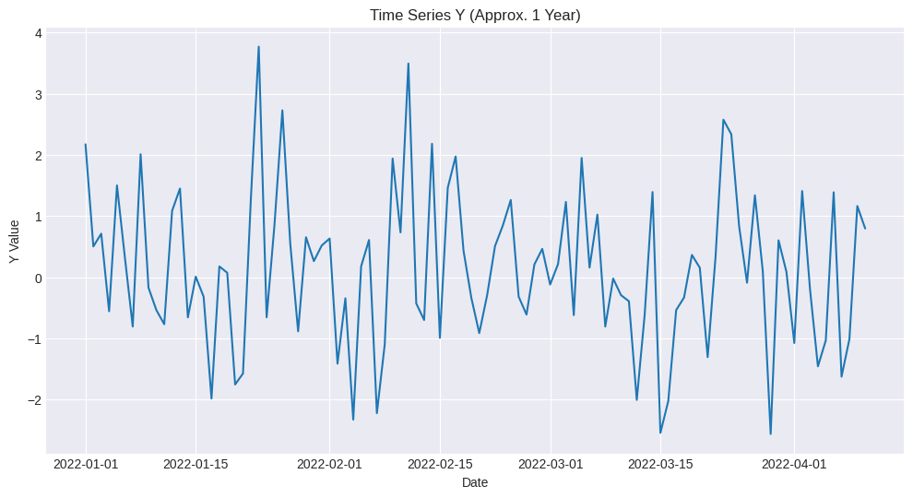
--- ADF Test for Stationarity ---
ADF Statistic: -4.961
p-value: 0.000
Critical Values:
1%: -3.500
5%: -2.892
10%: -2.583
Result: The series is stationary (reject H0)
Series is already stationary (or became stationary with d=0).

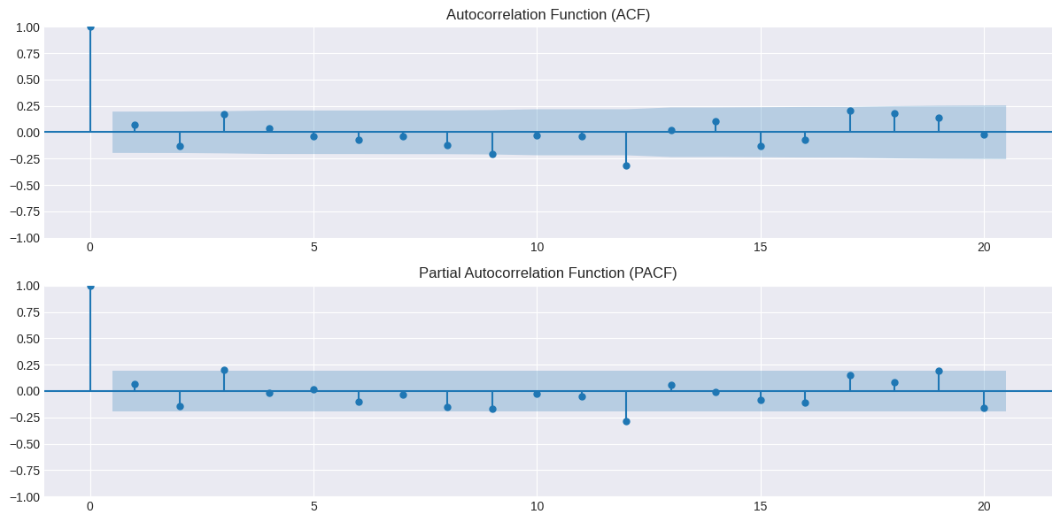
--- Manually Chosen ARIMA Order (p,d,q): (1, 0, 0) ---
Note: p and q are chosen manually. Inspect the ACF/PACF plots above to refine these values if necessary.
Given the problem description and lack of auto_arima, (1, d, 0) is a reasonable default for many financial series.

--- Fitting ARIMA Model with order (1, 0, 0) ---
SARIMAX Results
==============================================================================
Dep. Variable: y_values No. Observations: 80
Model: ARIMA(1, 0, 0) Log Likelihood -131.872
Date: Mon, 09 Jun 2025 AIC 269.744
Time: 13:36:33 BIC 276.891
Sample: 01-01-2022 HQIC 272.609
- 03-21-2022
Covariance Type: opg
==============================================================================
coef std err z P>|z| [0.025 0.975]
------------------------------------------------------------------------------
const 0.1222 0.154 0.793 0.428 -0.180 0.424
ar.L1 0.0616 0.131 0.471 0.638 -0.195 0.318
sigma2 1.5823 0.248 6.375 0.000 1.096 2.069
===================================================================================
Ljung-Box (L1) (Q): 0.00 Jarque-Bera (JB): 2.02
Prob(Q): 0.97 Prob(JB): 0.36
Heteroskedasticity (H): 0.62 Skew: 0.36
Prob(H) (two-sided): 0.22 Kurtosis: 3.27
===================================================================================

Warnings:
[1] Covariance matrix calculated using the outer product of gradients (complex-step).
/usr/local/lib/python3.11/dist-packages/statsmodels/tsa/base/tsa_model.py:473: ValueWarning: No frequency information was provided, so inferred frequency D will be used.
self._init_dates(dates, freq)
/usr/local/lib/python3.11/dist-packages/statsmodels/tsa/base/tsa_model.py:473: ValueWarning: No frequency information was provided, so inferred frequency D will be used.
self._init_dates(dates, freq)
/usr/local/lib/python3.11/dist-packages/statsmodels/tsa/base/tsa_model.py:473: ValueWarning: No frequency information was provided, so inferred frequency D will be used.
self._init_dates(dates, freq)

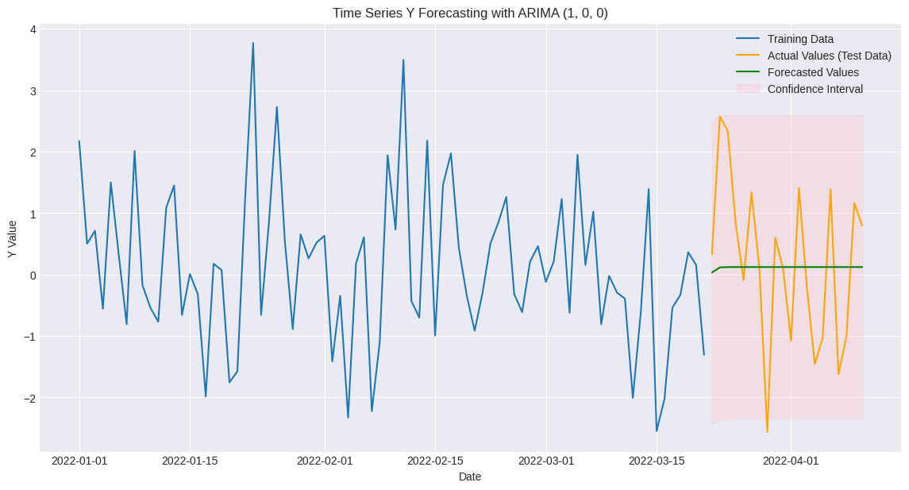
RMSE (Root Mean Squared Error) on Test Data: 1.323

Problem 6: Structural Break
--- Hardcoded Data for Problem 6 (20 periods with simulated structural break) ---
t Y X D X_D
0 1 11.962363 10.993428 0 0.000000
1 2 9.635959 9.723471 0 0.000000
2 3 10.715217 11.295377 0 0.000000
3 4 10.098282 13.046060 0 0.000000
4 5 9.221464 9.531693 0 0.000000
5 6 9.876786 9.531726 0 0.000000
6 7 10.428219 13.158426 0 0.000000
7 8 11.143133 11.534869 0 0.000000
8 9 8.929887 9.061051 0 0.000000
9 10 10.250866 11.085120 0 0.000000
10 11 18.008040 9.073165 1 9.073165
11 12 20.455089 9.068540 1 9.068540
12 13 20.712390 10.483925 1 10.483925
13 14 13.202448 6.173440 1 6.173440
14 15 15.647791 6.550164 1 6.550164
15 16 17.092294 8.875425 1 8.875425
16 17 17.170370 7.974338 1 7.974338
17 18 18.983072 10.628495 1 10.628495
18 19 15.947742 8.183952 1 8.183952
19 20 15.959950 7.175393 1 7.175393

======================================================================

--- Regression Analysis for Problem 6a) ---
Model Formulated: Y(t) = α + β1*X(t) + γ*D(t) + δ*(X(t)*D(t)) + η(t)
Equivalent Statsmodels Formula: Y ~ X + D + X_D
OLS Regression Results
==============================================================================
Dep. Variable: Y R-squared: 0.946
Model: OLS Adj. R-squared: 0.936
Method: Least Squares F-statistic: 93.04
Date: Mon, 09 Jun 2025 Prob (F-statistic): 2.43e-10
Time: 13:36:33 Log-Likelihood: -26.539
No. Observations: 20 AIC: 61.08
Df Residuals: 16 BIC: 65.06
Df Model: 3
Covariance Type: nonrobust
==============================================================================
coef std err t P>|t| [0.025 0.975]
------------------------------------------------------------------------------
Intercept 6.7203 2.582 2.603 0.019 1.247 12.193
X 0.3218 0.235 1.369 0.190 -0.177 0.820
D -0.6802 3.218 -0.211 0.835 -7.503 6.142
X_D 1.0179 0.325 3.128 0.006 0.328 1.708
==============================================================================
Omnibus: 3.082 Durbin-Watson: 2.113
Prob(Omnibus): 0.214 Jarque-Bera (JB): 1.890
Skew: 0.752 Prob(JB): 0.389
Kurtosis: 3.087 Cond. No. 186.
==============================================================================

Notes:
[1] Standard Errors assume that the covariance matrix of the errors is correctly specified.

--- Explanation of Testing for Structural Break (Problem 6a) ---
The approach involves using a single regression model with an added dummy variable and an interaction term to capture potential shifts in both the intercept and the slope.

**1. Design of the Regression Model:**
The model estimated is: Y ~ X + D + X_D
- `Y`: The dependent variable.
- `X`: The independent variable.
- `D`: A dummy variable (0 for periods before/at the breakpoint, 1 for periods after).
- `X_D`: An interaction term, calculated as `X * D`.

**2. Interpretation of Coefficients:**
- The coefficient of `X` (named `X` in the summary) represents `β1`, the slope for the initial period (t=1 to t=10).
- The coefficient of `D` (named `D` in the summary) represents `γ`, the change in the intercept after the breakpoint.
- The coefficient of `X_D` (named `X_D` in the summary) represents `δ`, the *change* in the slope (`β`) after the breakpoint.
- The `Intercept` coefficient represents `α`, the intercept for the initial period.

**3. Testing for Structural Break in β:**
To test if the slope (`β`) changes at the breakpoint (t=10), we look at the statistical significance of the `X_D` coefficient (δ).
- **Null Hypothesis (H0):** The change in slope (δ) is zero, meaning `β1 = β2` (no structural break in the slope).
- **Alternative Hypothesis (H1):** The change in slope (δ) is not zero, meaning `β1 ≠ β2` (a structural break in the slope exists).

In our simulated data, the true initial slope (β1) was 0.5 and the true post-break slope (β2) was 1.5.
Therefore, the true change in slope (δ) was 1.00.
From the regression summary, the estimated coefficient for 'X_D' (δ_hat) is 1.0179 with a p-value of 0.0065.

**Conclusion:** Since the p-value for 'X_D' is less than 0.05, we **reject the null hypothesis (H0)**.
This indicates statistically significant evidence that the β parameter (slope) *did* undergo a structural break at t=10 in this simulated dataset.

**Estimated Parameters based on the single regression model:**
- Intercept (first regime): 6.7203 (True: 5.0)
- Slope (first regime, β1): 0.3218 (True: 0.5)
- Change in Intercept (γ): -0.6802
- Change in Slope (δ): 1.0179 (True: 1.00)

**Inferred parameters for the second regime (t > 10):**
- Inferred Intercept (second regime): 6.0401
- Inferred Slope (second regime, β2): 1.3396 (True: 1.5)

