Output:
--- STEP 1: Data Preparation and Exploration ---
1.1. Downloading Data...
/tmp/ipython-input-913944317.py:40: FutureWarning: YF.download() has changed argument auto_adjust default to True
data = yf.download(TICKERS, start=START_DATE, end=END_DATE)
[*********************100%***********************] 4 of 4 completed
1.2. Computing Returns...
1.3. Aligning and Cleaning Data...
Sample Period: 2007-01-04 to 2025-11-03
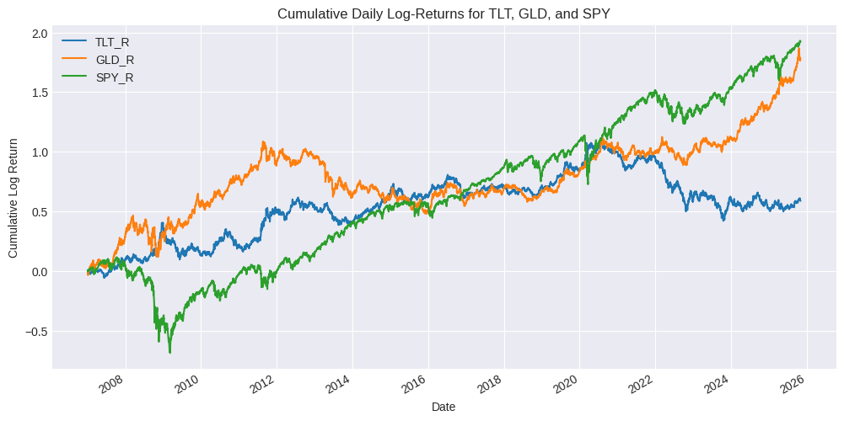
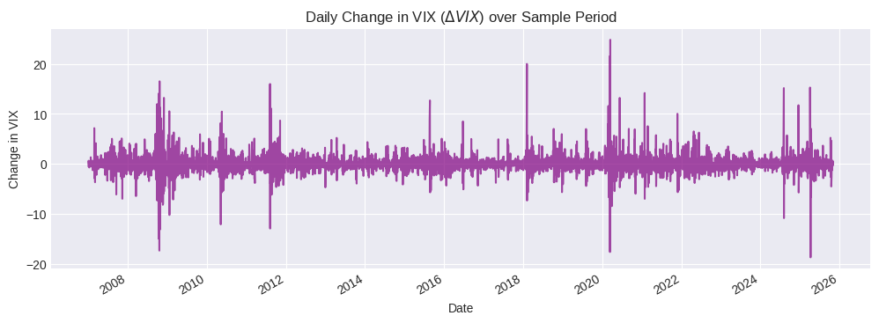

--- STEP 2 & 3: Modeling, Selection, and Interpretation ---
Fitting 2-State HMM...
Fitting 3-State HMM...

3.1. HMM Comparison Metrics:
Log-Likelihood N_Parameters AIC BIC
2 -8353.2886 7 16720.5772 16765.8223
3 -8066.7911 14 16161.5822 16252.0723

3.2. Selected Model: 3-State HMM
Transition Probability Matrix (P):
To R1 To R2 To R3
From R1 0.8741 0.1259 0.0000
From R2 0.0153 0.9039 0.0808
From R3 0.0019 0.0604 0.9377
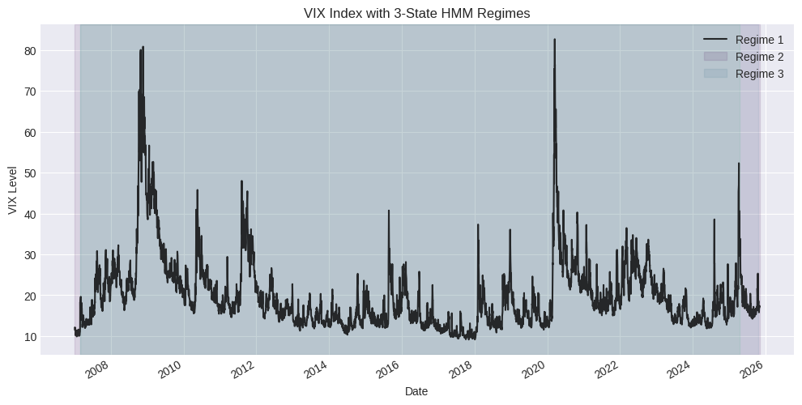

3.3. State-Conditional ETF Return Statistics:
TLT_R_mean TLT_R_std GLD_R_mean GLD_R_std SPY_R_mean SPY_R_std
Regime 1 -0.0002 0.0080 0.0003 0.0092 0.0015 0.0062
Regime 2 0.0003 0.0100 0.0004 0.0116 -0.0002 0.0130
Regime 3 0.0017 0.0187 0.0003 0.0211 -0.0065 0.0362
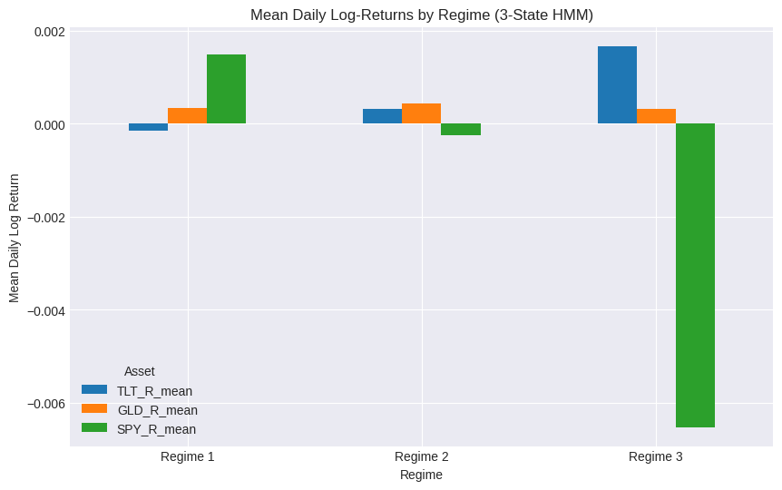

--- STEP 4: Designing the Rotation Strategy ---

4.2. State -> Allocation Mapping (1-Day Lag):
Chosen Asset (100% Allocation) Highest Mean (mu)
Regime
Regime 1 SPY_R 0.0015
Regime 2 GLD_R 0.0004
Regime 3 TLT_R 0.0017

--- STEP 5: Backtesting and Evaluation ---

5.4. Cumulative Performance Plot:
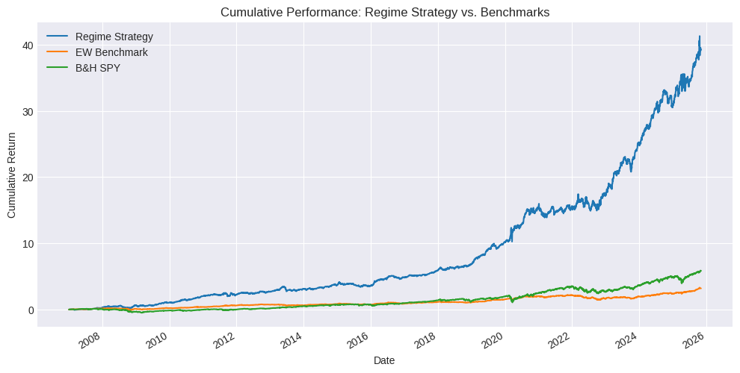

5.5. Discussion on Sensitivity is required based on the final metrics.

