Workbook of Advanced Statistics

Author: Tri Le
Matriculation Number: 9216985
Course Name: Advanced Statistics
Course of Study: Master of Artificial Intelligence
Tutor’s Name: Prof. Dr. Paul Libbrecht Gourdet
Parameters generated on https://advstats-pg.iu.de/
with signature be0d3dd0c94d10b12483ee2738eabba8161994ab

September 29, 2024
Ho Chi Minh City, Vietnam

TABLE OF CONTENT
Table of Figure II
Table of Code Snippet II
Task 1: Basic Probabilities and Visualizations (1): 3
Stage 1: Determine the probability distribution of the meteorites number falling 3
Stage 2: Test the number of trials to ensure that the probability is less than 0.005. 3
Task 2: Basic Probabilities and Visualizations (2): 5
Stage 1: Determine the probability in waiting times 5
Stage 2: Visualize Probability density function and Histogram respectively 5
Stage 3: Compute and visualize the mean, variance and quantiles: 7
Task 3: Transformed Random Variables: 8
Stage 1: Express $T$ in terms of $S1$ and $S2$: 8
Stage 2: Assumptions about the random variables: 8
Stage 3: Calculate the likelihood function for θ 9
Stage 4: Calculate the maximization of the log-likelihood: 10
Stage 5: Compute the bandwidth expectation until the dual-router system fails 10
Task 4: Hypothesis Test: 11
Stage 1: Define the distribution of hammer production 11
Stage 2: Key Assumption: 11
Stage 3: State the null and alternative hypothesis 12
Stage 4: Perform a statistical test 12
Task 5: Regularized Regression: 14
Stage 1: Explore the parameters of polynomial function by matrix algebra: 14
Stage 2: Calculate the parameter by Notebook: 15
Stage 3: Apply Ordinary Least Square with Ridge-regularized estimates 17
Stage 4: Compare the result between the normal OLS and the Ridge Regularization 18
We will evaluate the performance using Mean Squared Error (MSE), which calculates the average of the squared differences between the predicted and actual values. Our goal is to minimize this error in the regression function 18
Task 6: Bayesian Estimates 20
Stage 1: Determine the objectives 20
Stage 2: Calculate the prior and Likelihood 20
Stage 3: Determine the posterior distribution of $θ$ 21
Stage 4: Bayes Point Estimates 21
LIST OF REFERENCES 22

Table of Figure
Figure 1: Geometric Distribution of n Meteorites Falling 4
Figure 2: Probability density function graph 5
Figure 3:Histogram of Owl Hearing Time (per minute) 6
Figure 4: Polynomial Regression Plot 16
Figure 5: Compare Normal OLS to Ridge OLS 18

Table of Code Snippet
Code 1: Code snippet for geometric distribution 4
Code 3: How to execute the PDF graph 6
Code 4: How to create Histogram 6
Code 5: Define X, Y 15
Code 6:Estimate parameter in OLS 16
Code 7: Ridge parameters 17

Task 1: Basic Probabilities and Visualizations (1):
The number of meteorites falling into an ocean in a given year can be modeled by one of the following distributions. Provide a graphic showing the probability of one, two, three, etc., meteorites falling (until the probability remains less than 0.5% for any higher number of meteorites; you should also prove it). Calculate the expectation and median and present them in this graphic:
A geometric distribution counting the number of Bernoulli trials with p = 0.96 until it succeeds.

Stage 1: Determine the probability distribution of the meteorites number falling
Let a random variable X describes a Bernoulli trial where:
- Success is defined as a meteorite falling into the ocean on a given trial.
$$P\left(A\right)=p=0.96$$
- Failure is defined as a meteorite not falling into the ocean.
$$P\left(B\right)=q=1-0.96=0.04$$
According to that, we can determine a discreate probability distribution that models the number of Bernoulli trials required to get the first success. The binomial distribution describes the probability of observing first time “success” in n trials:
$$X\sim B\left(n,p\right)=P\left(X=1\right)=\frac{n!}{1!*\left(n-1\right)!}{*p*q}^{n-1}\left(1.1\right)$$

Stage 2: Test the number of trials to ensure that the probability is less than 0.005.
Based on equation (1.1), we can determine the n trials for purpose of the probability remaining less than 0.005.
With n =1: $X\sim B\left(1,0.96\right)=P\left(X=1\right)=\frac{1!}{1!*0!}{*0.96*0.04}^{0}=0.96$
With n =2: $X\sim B\left(2,0.96\right)=P\left(X=1\right)=\frac{2!}{1!*1!}{*0.96*0.04}^{1}=0.768$
With n =3: $X\sim B\left(3,0.96\right)=P\left(X=1\right)=\frac{3!}{1!*2!}{*0.96*0.04}^{2}=0.0046$
After 3 times trials, we can determine the probability less than 0.5% for any meteorite
The expected value $E\left[X\right]$ for a geometric distribution is calculated as follows:
$$E\left[X\right]=\frac{1}{p}=\frac{1}{0.96}≈1.0416$$
By the definition of median: $P\left(X≤m\right)≥\frac{1}{2} and P\left(X≥m\right)≥\frac{1}{2}$
It has $median=\left[0 if p<\frac{1}{2} ;\left[0,1\right] if p=\frac{1}{2};1 if p>\frac{1}{2}\right]$
Due to $p=0.96>0.5$. Hence, $median = 1$
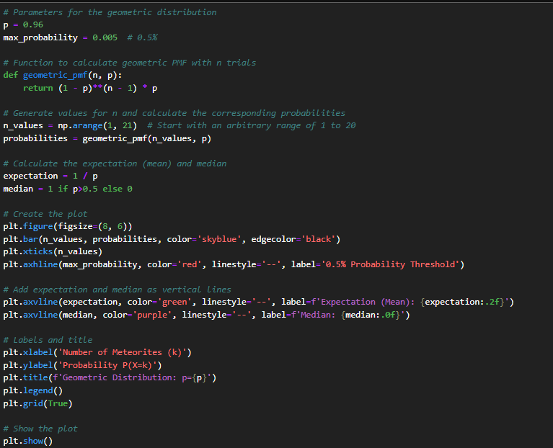
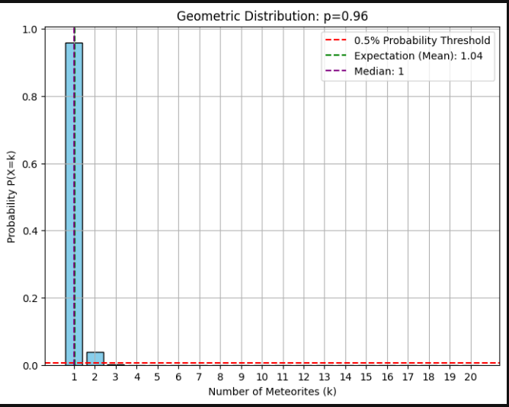
Code 1: Code snippet for geometric distribution
Figure 1: Geometric Distribution of n Meteorites Falling

Task 2: Basic Probabilities and Visualizations (2):
Let 𝑌 be the random variable with the time it takes to hear an owl from your room’s open window (in hours). Assume that the probability that you still need to wait to hear the owl after 𝑦 hours is one of the following functions:
- the probability is given by $0.4e^{-3y^{2}}+0.59e^{-8y^{8}}$
Find the probability that you need to wait between two and four hours to hear the owl, and compute and display the probability density function graph, as well as a histogram where each bar represents the probability of the hearing the owl at any minute. Compute and display in the graphics the mean, variance, and quartiles of the waiting times

Stage 1: Determine the probability in waiting times
According to that, the function describes the probability for waiting to hear the owl voice from the room:
$$f\left(y\right)= 0.4e^{-3y^{2}}+0.59e^{-8y^{8}}$$
To calculate the probability of waiting between two and four hours, we need to integrate the given probability density function, $f\left(x\right)$ over the interval $\left[2,4\right]$:
$$\int_{2}^{4}{f\left(y\right)dy=}\int_{2}^{4}{\left(0.4e^{-3y^{2}}+0.59e^{-8y^{8}}\right)dy} \\ =0.4\int_{2}^{4}{e^{-3y^{2}}dy}+0.59\int_{2}^{4}{e^{-8y^{8}}}dy≈1.18299*{10}^{-5}$$

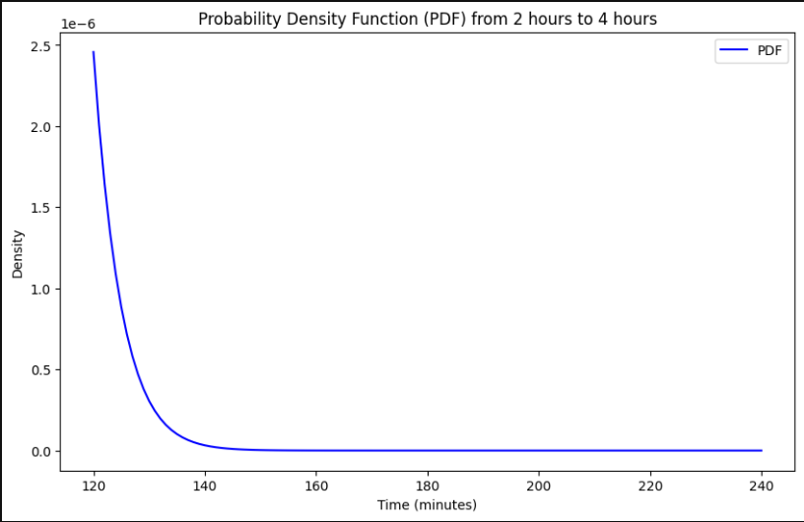
Stage 2: Visualize Probability density function and Histogram respectively
Figure 2: Probability density function graph
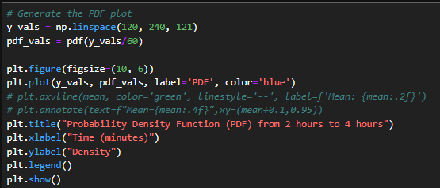
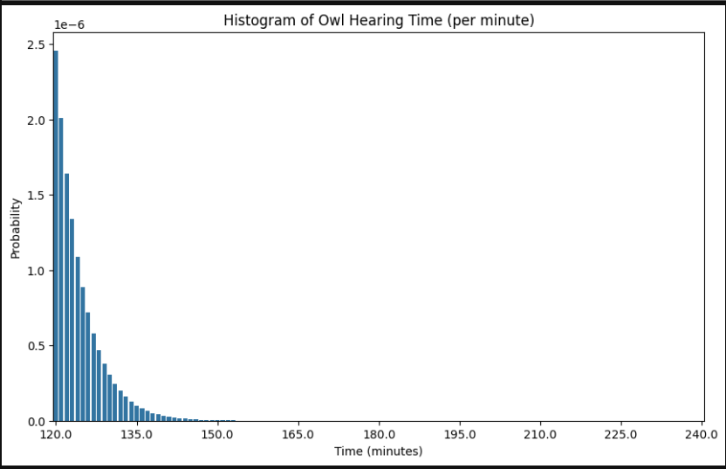
Code 2: How to execute the PDF graph
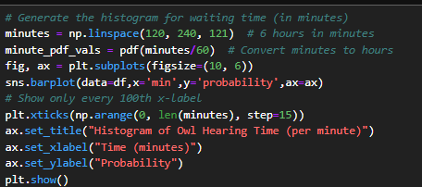
Figure 3:Histogram of Owl Hearing Time (per minute)
Code 3: How to create Histogram

Stage 3: Compute and visualize the mean, variance and quantiles:
The mean and variance of probability function are expressed as follows, respectively:
$$E\left[Y\right]=\int_{0}^{∞}{y*f\left(y\right)dy}$$
$$Var\left[Y\right]=E\left[Y^{2}\right]-{\left(E\left[Y\right]\right)}^{2}$$
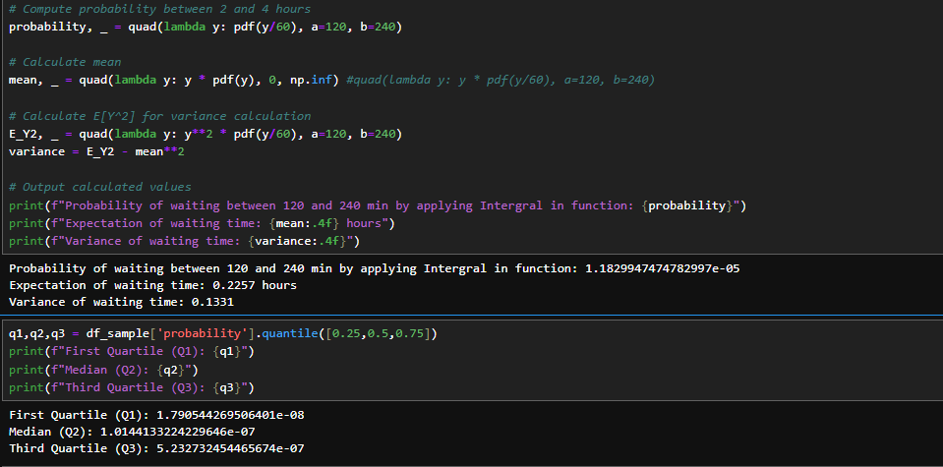
Since these integrals may not have closed-form solutions, using the python code and related libraries prefers to calculate accurately.
Code 4: Expectation, Variance and Quantiles
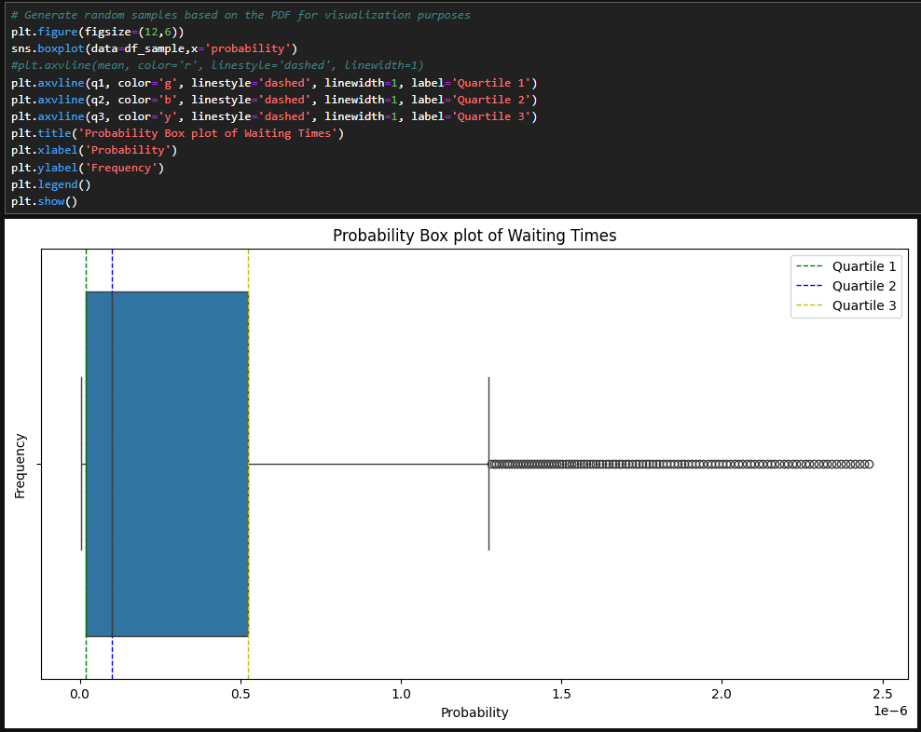
Drawing the Box Plot to visualize quantile values.
Figure 4: Box plot of waiting times

Task 3: Transformed Random Variables:
A type of network router has a bandwidth total to first hardware failure called 𝑆 expressed in terabytes. The random variable 𝑆 is modeled by an exponential distribution whose density is given by one of the following functions:
$$f_{s}\left(s\right)=\frac{1}{120θ^{7}}s^{6}e^{-\frac{s}{θ}}$$
with a single parameter 𝜃. Consider the bandwidth total to failure T of the sequence of the two routers of the same type (one being brought up automatically when the first is broken).
Express 𝑇 in terms of the bandwidth total to failure of single routers $S_{1}$ and $S_{2}$. Formulate realistic assumptions about these random variables. Calculate the density function of the variable T.
Given an experiment with the dual-router-system yielding a sample $T_{1},T_{2}, …, T_{n}$ calculate the likelihood function for 𝜃. Propose a transformation of this likelihood function whose maximum is the same and can be computed easily.
An actual experiment is performed, and the infrastructure team has obtained the bandwidth totals to failure given by the sequence $\left(114,35,29,56,501\right)$of numbers. Estimate the model-parameter with the maximum likelihood and compute the expectation of the bandwidth total to failure of the dual-router-system.

Stage 1: Express $T$ in terms of $S_{1}$ and $S_{2}$:
Assuming that both routers are of the same type, $S_{1}$ and $S_{2}$ represent the bandwidth total to failure for each router, modeled by the same exponential distribution.
Since the second router starts working only after the first one fails, the total bandwidth until failure $T$ is the sum of the bandwidths to failure of both routers:
$$T={ S}_{1}+{ S}_{12}$$

Stage 2: Assumptions about the random variables:
- $S_{1}$ and $S_{2}$ are independent and identically distributed (i.i.d.), since both routers are the same type.
- We can prove that $S_{1}$ and $S_{2}$ follow the probability density function (PDF) of a Gamma distribution.
  - Router Function:
$$f_{s}\left(s\right)=\frac{1}{720θ^{7}}s^{6}e^{-\frac{s}{θ}} \left(3.1\right)$$
  - Gamma function with shape $k=7$ and scale parameter 𝜃:
$$f_{k=7,θ}\left(s\right)=\frac{s^{k-1}e^{\frac{-s}{θ}}}{θ^{k}*Γ\left(k\right)}=\frac{s^{7-1}e^{\frac{-s}{θ}}}{θ^{7}\left(7-1\right)!}=\frac{s^{6}e^{\frac{-s}{θ}}}{θ^{7}*6!}=\frac{1}{720}\frac{s^{6}e^{\frac{-s}{θ}}}{θ^{7}} \left(3.2\right)$$
From the functions (3.1) and (3.2), we can determine that router $S_{1}$ and $S_{2}$follow the Gamma function.
To find out the density of T, we need to calculate the convolution of probability function S1 and S2. In other words, PDF of T is the total of two independent random variables.
$$f_{T}\left(t\right)=\int_{0}^{t}{f_{s}\left(S_{1}\right)*f_{s}\left({T-S}_{1}\right)}ds \\ f_{T}\left(t\right)=\int_{0}^{t}{\left(\frac{1}{720θ^{7}}s_{1}^{6}e^{-\frac{s_{1}}{θ}}\right)\left(\frac{1}{720θ^{7}}{\left(t-s_{1}\right)}^{6}e^{-\frac{\left(t-s_{1}\right)}{θ}}\right)}ds \\ f_{T}\left(t\right)=\int_{0}^{t}{\frac{1}{{720}^{2}{ θ}^{14}}s_{1}^{6}{\left(t-s_{1}\right)}^{6} e^{-\frac{t}{θ}}ds=\frac{1}{{720}^{2}{ θ}^{14}}\int_{0}^{t}{s_{1}^{6}{\left(t-s_{1}\right)}^{6} e^{-\frac{t}{θ}}ds}}$$

However, we can use a Gamma distribution to express the density function of T with shape parameter $k_{T}= k_{s_{1}}+k_{s_{2}}=7+7=14$ and scale parameter θ.
- Shape $k_{T}=14$ can be interpreted as total event of independent variables as $S_{1}$ and $S_{2}$
Their sum follows a Gamma distribution where $Γ\left(k\right)$ is the gamma function. For all positive integers, $Γ\left(k\right)=\left(k-1\right)!$
$$f_{k_{T},θ}\left(t\right)=\frac{t^{k-1}e^{\frac{-t}{θ}}}{θ^{k}*Γ\left(k\right)}for t≥0=\frac{t^{\left(14-1\right)}e^{\frac{-t}{θ}}}{θ^{2}*\left(14-1\right)!}=\frac{t^{13}e^{\frac{-t}{θ}}}{θ^{2}13!} Γ\left(α\right)$$

Stage 3: Calculate the likelihood function for θ
We can express the maximum likelihood function of θ with the dual system of yielding a sample $T_{1},T_{2}, …, T_{n}$:
$$L\left(θ\right)=\prod_{i=1}^{n}{f_{T}\left(t_{i};θ​\right)}=\prod_{i=1}^{n}{\frac{t_{i}^{13}e^{\frac{-t}{θ}}}{θ^{2}*13!}=\frac{1}{{θ^{2n}\left(13!\right)}^{n}}\prod_{i=1}^{n}{t_{i}^{13}e^{\frac{-1}{θ} \sum_{i=1}^{n}{t_{i}}}}}$$

To simplify the likelihood function, we will apply the log-likelihood function:
$$l\left(θ\right)=\log{L\left(θ\right)=}-2n\log\left(θ\right)-n\log{13!} +13\sum_{i=1}^{n}{\log{t_{i} }}-\frac{1}{θ}\sum_{i=1}^{n}{t_{i}}$$
Stage 4: Calculate the maximization of the log-likelihood:
To determine the maximum likelihood estimate (MLE) of $θ$, we take the derivative of $l\left(θ\right)$ with respect to θ, set it equal to zero, and solve for 𝜃
The derivative of the log-likelihood function is:
$$\frac{dl}{dθ}=-\frac{2n}{θ}-\frac{1}{θ^{2}}\sum_{i=1}^{n}{t_{i}}\left(3.3\right)$$Then set this derivative (3.3) equal zero to solve $θ$
$$-\frac{2n}{θ}-\frac{1}{θ^{2}}\sum_{i=1}^{n}{t_{i}}=0 \\ -2nθ-\sum_{i=1}^{n}{t_{i}}=0 \\ θ=\frac{\sum_{i=1}^{n}{t_{i}}}{2n}$$Thus, the Maximum likelihood estimate for $θ$ is
$$\hat{θ}=\frac{\sum_{i=1}^{n}{t_{i}}}{2n} \left(3.4\right)$$
Given that the sequence $\left(114,35,29,56,501\right)$of numbers, the total number of data points is $n=5$.
- Calculate the sum of numbers:
$$\sum_{i=1}^{n}{t_{i}}=114+35+29+56+501=735$$
- Compute the MLE of $θ$ from equation (3.4):
$$θ=\frac{735}{2*5}=73.5$$

Stage 5: Compute the bandwidth expectation until the dual-router system fails
For a gamma distribution with shape parameter $k_{T}=14$ and scale parameter θ.
$$E\left[T\right]=k*θ=14*73.5=1029$$
Finally, the maximum estimated likelihood of $θ$ is 73.5 and expectation or mean to failure of the dual-router system is 1029 unit of time.

Task 4: Hypothesis Test:
Over a long period of time, the production of 1,000 high-quality hammers in a factory seems to have reached a weight with an average of 877 (in g) and standard deviation of 13.8 (in 𝑔). Propose a model for the weight of the hammers including a probability distribution for the weight. Provide all the assumptions needed for this model to hold (even the uncertain ones). What parameters does this model have?
One aims to answer one of the following questions about a new production system:
- Does the new system make more constant weights?
To answer this question, a random sample of newly produced hammers is evaluated yielding the weights in $\left(890,894,901,882,864,907,916,909,881,868\right)$.
- What hypotheses can you propose to test the question?
- What test and decision rule can you make to estimate whether the new system answers the given question? Express the decision rules as logical statements involving critical values.
- What error probabilities can you suggest and calculate? Perform the test and draw the conclusion to answer the question.

Stage 1: Define the distribution of hammer production
Beginning by considering the weight of a hammer produced by the system, let W represent a random variable denoting the weight of a hammer.
There are a sample of 1000 high-quality hammers in old system, we can denote a sample normal distribution $W\sim N\left(\overline{x}=877,s^{2}={13.8}^{2}=190.44\right)$, where:
- $\overline{x}=877g$ (sample mean),
- $s^{2}=190.44$ (sample variance).

Stage 2: Key Assumption:
- Independence: The weights of the hammers are independent of each other.
- Normality: The weight of hammers produced by the factory follows a normal distribution.
- Stationarity: The mean and standard deviation of the weight remain constant over time.
- Constant Variance: The variance in hammer weight does not change over time.
These assumptions are critical for the model, though some, such as independence, may not hold perfectly due to potential batch effects in production. If the assumptions are reasonably satisfied, the model can reliably describe the distribution of hammer weights in the system.

Stage 3: State the null and alternative hypothesis
To respond to the assignment question whether the new system can produce more consistent hammer weights, it means the variance of producing hammer under new system is smaller than under the old ones. Let generate two variances in two cases:
- $s_{new}^{2}$ is the sample variance of the hammer weights produced by the new system.
- $s_{old}^{2}=190.44$is the sample variance of the hammer weights produced by the old system.
We will state the following hypotheses for this assumption:
- $H_{0}$: Variability of new system is greater than or equal to that of old system
($s_{new}^{2}≥ s_{old}^{2}$).
- $H_{1}$: Variability of new system is lower than that of old system ($s_{new}^{2}< s_{old}^{2}$).

Stage 4: Perform a statistical test
The appropriate test to compare the variances between two different sample groups is the one-tailed F-test for the hypothesis that the volatility of the new system is lower than that of the old system. This test is applied to determine if the variances of two independent groups are significantly different from each other.

Step 1: Calculate the variance of the new system
According to the sample provided, let $X_{1},X_{2},X_{3},…,X_{10}$ ​ represent the individual hammer weights in the sample. The sample can be written as:
$$X=\left\{890,894,901,882,864,907,916,909,881,868\right\}$$
Where:
- $X$ is the sample of hammer weights,
- Each $X_{i}$ is an individual observation (weight) in the sample, for $i=1,2,3,…,10$
Let ${\overline{x}}_{new}$ is the sample mean of new system which calculated as:
$${\overline{x}}_{new}=\frac{1}{n}\sum_{i=1}^{10}{x_{i}}=\frac{890+894+901+882+864+907+916+909+881+868}{10} \\ =\frac{8912}{10}=891.2 \left(4.1\right)$$
Based on equation (4.1), the sample variance of the new system $s_{new}^{2}$ is calculated as:
$$s_{new}^{2}=\frac{1}{n-1}\sum_{i=1}^{10}{{\left(x_{i}-{\overline{x}}_{new}\right)}^{2} }=\frac{1}{9}\sum_{i=1}^{10}{{\left(x_{i}-891.2\right)}^{2}} \\ =\frac{1}{9}\left(1.44+7.84+96.04+84.64+739.84+249.64+615.04+316.84+104+538.24\right) \\ =\frac{1}{9}*2753≈305.95$$
Step 2: Apply the F-Test to Evaluate the Stated Hypotheses
To compute F-test, we need to assume the data we use following the standard below:
- Normality: the data in 2 production systems should be approximately normally distributed.
- Independence: Independence: The samples from different groups should not influence each other.
The F-test statistic is calculated as the ratio between two sample variances with the larger variance as a numerator, ensuring that the F-statistic is always greater than or equal to 1
$$F=\frac{s_{new}^{2}}{s_{old}^{2}}=\frac{305.95}{190.44}=1.606 \left(4.2\right)$$
Step 3: Compute the critical value.
Based on the F-distribution table, we can obtain the critical value for the F-test:
- Degree of freedom for the numerator $df_{1}=n_{new}-1=10-1=9$
- Degree of freedom for the denominator $df_{2}=n_{old}-1=1000-1=999$
- Regards to rejection region, we set significant level $α=0.05$
$$F_{α=0.05,df_{1}=9,df_{2}=∞}=1.8799 \left(4.3\right)$$
Step 4: Decide which system yields better results in the production process.
Regards to (4.2) and (4.3), because $F< F_{α=0.05,df_{1}=9,df_{2}=∞} \left(1.606<1.8799\right)$, we fail to reject the null hypothesis $H_{0}$.
In other words, there is not enough evidence to conclude that the new system has lower volatility than the old system.

Task 5: Regularized Regression:
Given the values of an unknown function $f: R → R$at some selected points, we try to calculate the parameters of a model function using OLS as a distance and a ridge regularization:
A polynomial model function of twelve $a_{i}$ parameters: $f\left(x\right)= a_{0}+ α_{1}x+α_{2}x^{2}+…+α_{12}x^{12}$
Calculate the OLS estimate, and the OLS ridge-regularized estimates for the parameters given the sample points of the graph of 𝑓 given that the values are (𝑥, 𝑦) each of the elements of 𝜉16. What weight do you give to the penalties? What are the qualities of each of the solutions?
With 𝜉16:
(-13, 225385895364052.3), (-17, 5811657633972780), (-1, -5.87), (5, 2811916306.29),
(0, 6.05), (12, 90358534424396.1), (2, 46415.15), (-18, 11204577014257644),
(3, 6275139), (8, 746649238196.51), (4, 198487333.83), (11, 33394345046782.03),
(-4, 128365817.85), (10, 10919032274044.46),
(20, 43052965121871700), (-19, 21245591652845230),
(9, 2964922794244.08), (-9, 2489601369724.04),
(6, 24878001005.47), (-11, 29488329293502.94),
(15, 1423615000457769.8), (17, 6305655164612032),
(16, 3080695685933265.5), (-5, 1984368050.78),
(18, 12606606059284856), (-3, 3463549.53)

Stage 1: Explore the parameters of polynomial function by matrix algebra:
According to the assignment, we know that this polynomial function has twelve parameters:
$$f\left(x\right)= a_{0}+ α_{1}x+α_{2}x^{2}+…+α_{12}x^{12}$$
To find the OLS estimates, we need to set up a linear system. Given data points $\left(x_{i},y_{i}\right)$, the polynomial model can be written like that by using the matrix dot product:
$$\left[\begin{matrix}1 & x_{1} & x^{2} & … & x^{12} \\ 1 & x_{2} & x_{2}^{2} & … & x_{2}^{12} \\ ⋮ & ⋮ & ⋮ & ⋱ & ⋮ \\ 1 & x_{n} & x_{n}^{2} & … & x_{n}^{12}\end{matrix} \right].\left[\begin{matrix}a_{0} \\ a_{1} \\ ⋮ \\ a_{12}\end{matrix}\right]=\left[\begin{matrix}y_{1} \\ y_{2} \\ ⋮ \\ y_{n}\end{matrix}\right] \left(5.1\right)$$
Or we can writer shorter from the formula (5.1):
$$X_{n×12}.a_{12×1}=y_{n×1}$$

To find the parameter, we need to minimize the residual sum of squares (RSS):
$$RSS\left(a\right)={\left\|y-Xa\right\|}_{2}^{2}$$
$$RSS\left(a\right)={\left(y-Xa\right)}^{T}\left(y-Xa\right)=\left(y^{T}-X^{T}a^{T}\right)\left(y-Xa\right) \\ RSS\left(a\right)=y^{T}y-y^{T}Xa-a^{T}X^{T}y+a^{T}X^{T}Xa \left(5.2\right)$$
Note that $y^{T}Xa$ and $a^{T}X^{T}y$ are transposes of each other (scalar quantities), so from the calculation (5.2), it equals:
$$RSS\left(a\right)=y^{T}y-2a^{T}X^{T}y+a^{T} X^{T}Xa$$
Our goal is to minimize this expression with respect to a. Hence, we derivative this function and set it to zero:
$$\frac{∂}{∂_{a}}RSS\left(a\right)=-2X^{T}y+2X^{T}Xa=0$$
Then we can rewrite to this form:
$$X^{T}Xa=X^{T}y \left(5.3\right)$$
To solve the parameter, we multiply both sides in equation (5.3) by a matrix inverse, denoted ${\left(X^{T}X\right)}^{-1}$ to vanish the part of $X^{T}X$ (becoming the identity matrix)
$$a={\left(X^{T}X\right)}^{-1}X^{T}y (5.4)$$
Where X is the matrix of powers of x, and y is the vector of corresponding y-values

Stage 2: Calculate the parameter by Notebook:
Due to the complexity of the mathematical statement, we will apply notebook to solve this problem according to the equation we proved before.
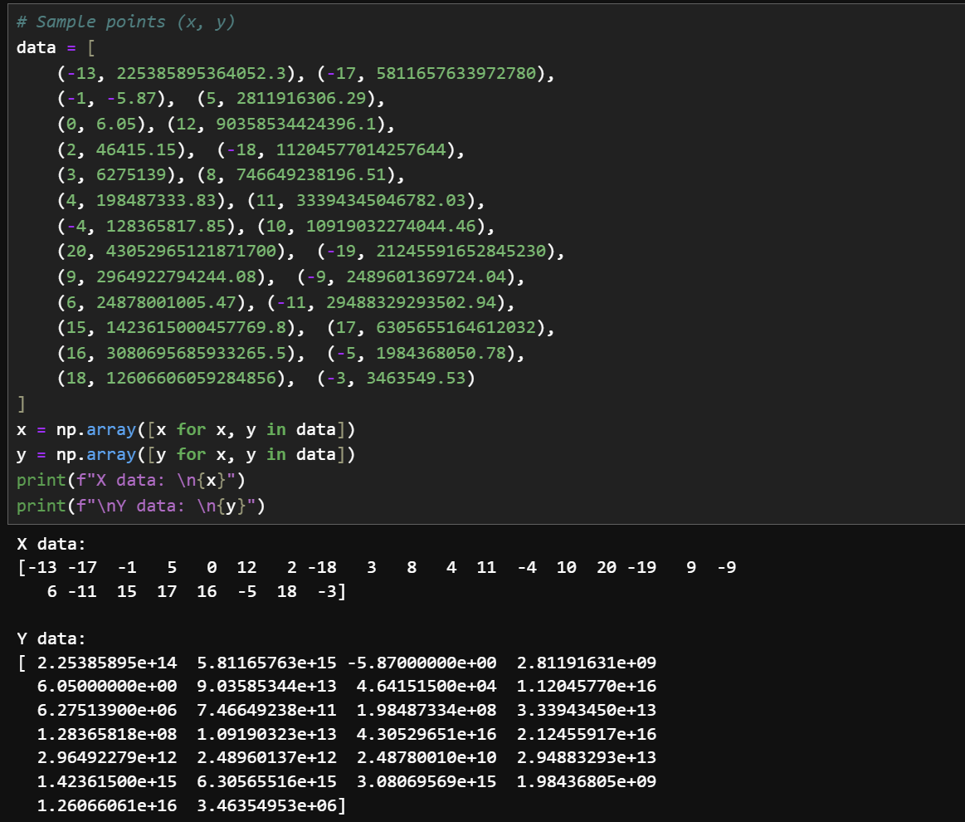
Step 1: Define X and Y
Code 5: Define X, Y

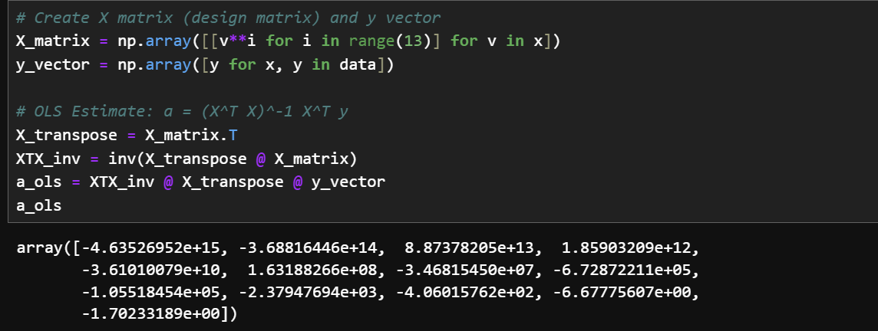
Step 2: Estimate the Ordinary Least Square basing on the equation before
Code 6: Estimate parameter in OLS
In summary, we can express the polynomial regression function by OLS:
$$\hat{Y}= -4.635*{10}^{15}-3.688*{10}^{15}x+8.874*{10}^{13}x^{2}+…-6.678x^{11}-1.702x^{12}$$
Step 3: Visualize this polynomial regression function:
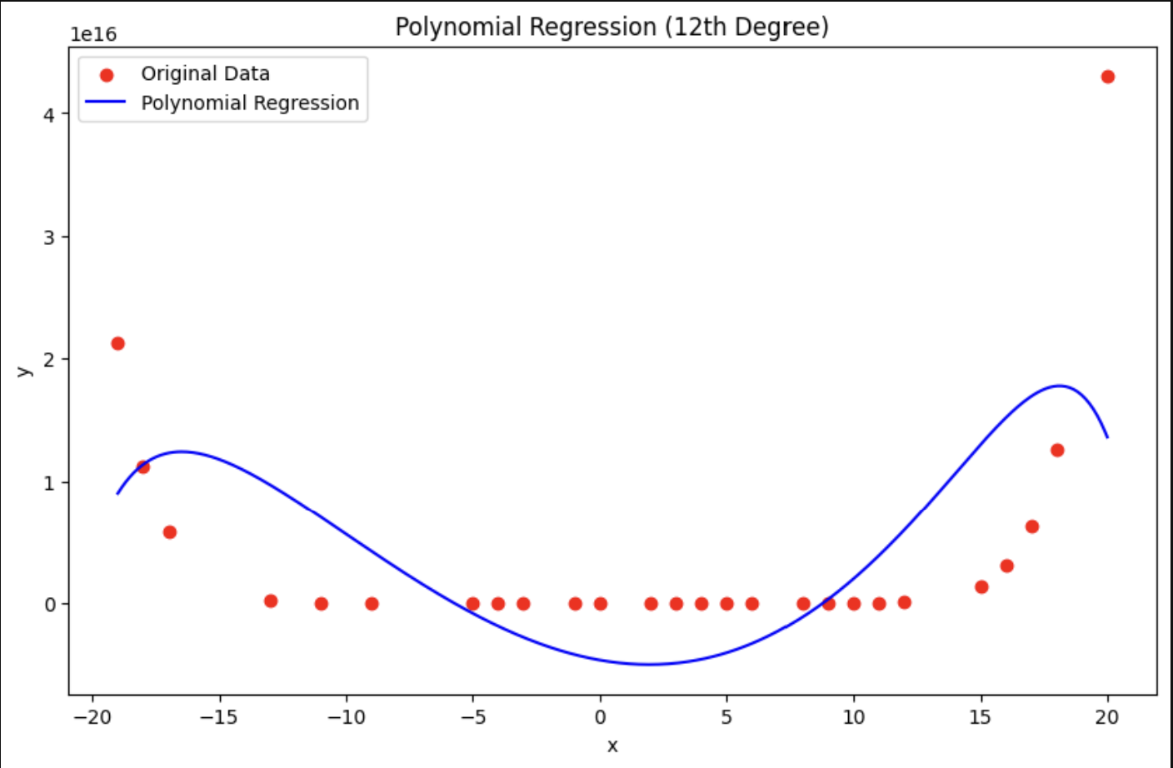
Figure 5: Polynomial Regression Plot
Regarding our regression plot, the polynomial trend line reasonably captures the overall pattern of the data, particularly in the middle range. However, there is still some difference in the beginning and ending of data, specifically the outliers.
According to that, we can experiment on the ordinary least square with the ridge-regularization to handle large variations better.

Stage 3: Apply Ordinary Least Square with Ridge-regularized estimates
Based on the previous OLS equation (5.4), ridge regularization modifies OLS by adding a penalty term to the squared magnitude of the coefficients. It estimates parameter $a_{ridge}$ as follows.
$$a_{ridge}={\left(X^{T}X+λI \right)}^{-1}X^{T}y (5.5)$$
With $λI$ being the ridge penalty, where:
- $λ$ represents the regularization amount and
- $I$ is the identity matrix of size $13×13$.
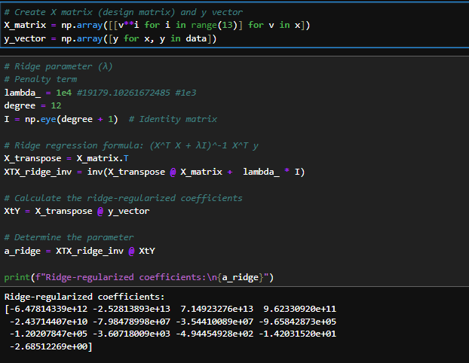
Set weight of penalty $λ$ with ${10}^{4}$, Then we calculate the parameters according to equation (5.5):
Code 7: Ridge parameters

Stage 4: Compare the result between the normal OLS and the Ridge Regularization
Step 1: Apply Cost function:

We will evaluate the performance using Mean Squared Error (MSE), which calculates the average of the squared differences between the predicted and actual values. Our goal is to minimize this error in the regression function
$$MSE=\frac{1}{N}\sum_{i=1}^{N}{{\left(y_{i}-\hat{y_{i}}\right)}^{2}}$$
Where:
- $y_{i}$​: Actual value (from data).
- ${\hat{y}}_{i}$: Predicted value (from the model).
- $N:$Number of data points.
According to the cost function before, we can find the MSE of Ridge regression and MSE of Normal Polynomial function.
$$MSE_{normal}=\frac{1}{N}\sum_{i=1}^{N=26}{{\left(y_{i}-\hat{y_{i}}\right)}^{2}}≈{7.0724*10}^{31}$$
$$MSE_{ridge}=\frac{1}{N}\sum_{i=1}^{N=26}{{\left(y_{i}-\hat{y_{i}}\right)}^{2}}≈{1.0572*10}^{32}$$
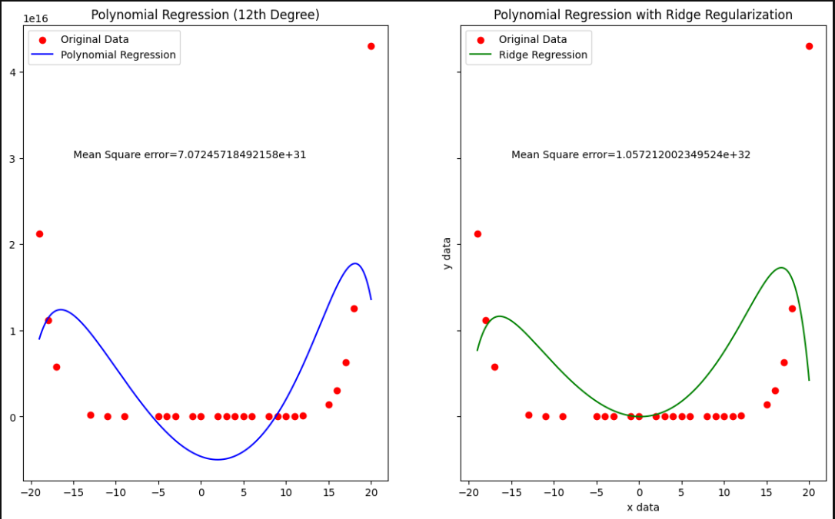
Step 2: Visualize the Normal OLS and OLS with penalty term $λ={10}^{4}$:
Figure 6: Compare Normal OLS to Ridge OLS
Stage 3: Review
- Normal OLS (Left Plot):
  - Fit: The 12th-degree polynomial curve (blue) overfits the data, trying to pass through most points.
  - MSE: ${7.0724*10}^{31}$, high due to overfitting.
  - Conclusion: While the model captures the variance in the data, it is likely to perform poorly on new data due to overfitting and sensitivity to noise.
- Ridge Regularization (Right Plot):
  - Fit: The green curve is smoother and less prone to overfitting.
  - MSE: ${1.0572*10}^{32}$, slightly higher but indicates less overfitting.
  - Conclusion: Regularization reduces overfitting by controlling the complexity, potentially improving generalization. The higher MSE might be due to underfitting but fine-tuning the regularization parameter could optimize results.
- Summary:
  - Normal OLS overfits with a lower MSE but risks poor generalization.
  - Ridge Regularization balances bias and variance, producing a smoother fit that can generalize better with fine-tuning $λ$.

Task 6: Bayesian Estimates
Following Hogg et al. (2020), exercise 11.2.2:
Let $x_{1}, x_{2}, …, x_{10}$ be a random sample from a gamma distribution with $α=3$ and $β=\frac{1}{θ}$. Suppose we believe that 𝜃 follows a gamma-distribution with $α = 34$ and $β = 38$ and suppose we have a trial $\left(x_{1},…,x_{n}\right)$ with an observed $\overline{x}=23.05$.
- Find the posterior distribution of 𝜃.
- What is the Bayes point estimate of 𝜃 associated with the square-error loss function?
- What is the Bayes point estimate of 𝜃 using the mode of the posterior distribution?

Stage 1: Determine the objectives
To find the posterior distribution of 𝜃, we consider the following information:
- Give a random sample $x_{1},x_{2},…,x_{10}$ from a gamma distribution with shape parameter $α=3$ and rate parameter $β=\frac{1}{θ}$.
$$X_{i}|θ\sim Γ\left(α=3,β=\frac{1}{θ} \right) (5.1)$$
- Parameter $θ$ follows a gamma distribution with parameters $α=34$ and $β=38$.
$$θ\sim Γ\left(α=34,β=38 \right) (5.2)$$
- The observed sample mean is $\overline{x}=23.05$.
By using Bayes' theorem, we can find the posterior distribution $k\left(θ ∣ x\right)$ because it is proportional to the product of the prior $h\left(θ\right)$ and the likelihood function $L\left(x ∣ θ\right)$, which is the probability of observing the data x given that $θ$ is true. It can be express the give form:
$$k\left(θ ∣ x\right)∝L\left(x ∣ θ\right)h\left(θ\right) \left(5.3\right)$$

Stage 2: Calculate the prior and Likelihood
According to formula (5.1), we can express the likelihood of a single observation $x_{i}$ following the Gamma distribution:
$$f_{α=3,β=\frac{1}{θ} }\left(x ∣ θ\right)=\frac{β^{α}}{Γ\left(α\right)}x^{α-1}e^{-βx}=\frac{1}{θ^{3}Γ\left(3\right)}x^{2}e^{-\frac{x}{θ}} for x>0$$
Since we have $n=10$ independent observations, the likelihood of the sample $x_{1},x_{2},…,x_{10}$ given $θ$ is:
$$L\left(x ∣ θ\right)=\prod_{i=1}^{10}{f\left(x_{i} ∣ θ\right)}=\prod_{1}^{10}{\left(\frac{1}{θ^{3}Γ\left(3\right)}x_{i}^{2}e^{-\frac{x}{θ}} \right)} \\ L\left(x ∣ θ\right)=\frac{1}{Γ{\left(3\right)}^{10}}{*\frac{1}{θ^{30}}*e}^{-\frac{\sum_{i=1}^{10}{x_{i}}}{θ}}*\prod_{i=1}^{10}{x_{i}^{2}}$$
Based on the prerequisite of distribution denotation (5.2), we can determine the prior distribution of parameter $θ$:
$$h_{α=34,β=38 }\left(θ\right)=\frac{β^{α}}{Γ\left(α\right)}θ^{α-1}e^{-βθ}=\frac{{38}^{34}}{Γ\left(34\right)}θ^{33}e^{-38θ}$$

Stage 3: Determine the posterior distribution of $θ$
Multiplying the likelihood and the prior, the posterior distribution is given by:
$$k\left(θ ∣ x\right)∝L\left(x ∣ θ\right)h\left(θ\right)$$
$$k\left(θ ∣ x\right)∝θ^{30}e^{-\frac{\sum_{i=1}^{10}{x_{i}}}{θ}}*θ^{33}e^{-38θ}$$
Given $\sum_{i=1}^{10}{x_{i}}=10⋅\overline{x}=10⋅23.05=230.5$, the posterior distribution becomes:
$$k\left(θ ∣ x\right)∝θ^{30+33}e^{-θ\left(230.5+38\right)} \\ k\left(θ ∣ x\right)∝θ^{(64-1)}e^{-268.5θ}$$
Thus, the posterior distribution of $θ$ is:
$$k\left(θ ∣ x\right)∼Gamma(a_{post}​=64,β_{post}​=268.5)$$

Stage 4: Bayes Point Estimates

Part 1: Finding the bayes point estimate of $θ$ associated with the square-error loss function
Under the squared-error loss function, the bayes estimator is the mean of the posterior distribution, The mean is given by:
$$E\left[θ|x\right]=\frac{α_{post}}{β_{post}}=\frac{64}{268.5}≈0.238$$

Part 2: Finding the bayes point estimate of $θ$ by using the mode of the posterior distribution:
For the distribution we calculated before, the mode is computed as follows:
$$Mode\left(θ ∣ x\right)=\frac{(α_{post}-1)}{β_{post}}=\frac{64-1}{268.5}=0.234 for α_{post}=64>1$$

LIST OF REFERENCES
Hint: If willing to help click ability you can insert a bookmark before each literature entry and link references to this.
- Task 1: The binomial distribution:
Admin. (2021, December 17). Binomial Distribution Formula in Probability with Examples. BYJUS. https://byjus.com/binomial-distribution-formula/
- Task 2: Integral the probability on a time interval:
Integration and probability. (n.d.). https://www2.math.upenn.edu/~ancoop/103/ss-prob.html
- Task 3: Apply Gamma Distribution:
Wikipedia contributors. (2024, October 10). Gamma distribution. Wikipedia. https://en.wikipedia.org/wiki/Gamma_distribution
Gamma Distribution Definition, Formula & Examples - Lesson | Study.com. (n.d.). study.com. https://study.com/academy/lesson/gamma-distribution-definition-equations-examples.html
- Task 4: Hypothesis Testing:
  - F table:
Ivo Dinov: www.SOCR.ucla.edu. (n.d.). F-Distribution tables. http://www.socr.ucla.edu/Applets.dir/F_Table.html
  - Central Limit Theorem:
Frost, J. (2024, August 1). Central limit theorem explained. Statistics by Jim. https://statisticsbyjim.com/basics/central-limit-theorem/
- Taks 5:
  - OLS:
Pflueger, N. & Amherst College. (2018). Matrix formulation: Least-squares. Math 272, Spring 2018. https://npflueger.github.io/teaching/272-19spring/handouts/LeastSquares.pdf
  - Ridge estimator:
Wikipedia contributors. (2024, October 20). Ordinary least squares. Wikipedia. https://en.wikipedia.org/wiki/Ordinary_least_squares
Wikipedia contributors. (2024a, September 21). Ridge regression. Wikipedia. https://en.wikipedia.org/wiki/Ridge_regression

- Task 6: Introduction to Mathematical Statistics:
Aa, N., Hogg, R. V., & Craig, A. T. (1996). Introduction to Mathematical Statistics. Journal of the American Statistical Association, 91(433), 441. https://minerva.it.manchester.ac.uk/~saralees/statbook2.pdf

