Written Assignment of Programming with Python

Author: Tri Le
Matriculation Number: 9216985
Course Name: Programming with Python
Course of Study: Master of Artificial Intelligence
Tutor’s Name: Dr. Cosmina Croitoru

March 22, 2025
Ho Chi Minh City, Vietnam

TABLE OF CONTENT
Table of Figure II
Table of Code Snippet II
Section 1: Applying Python in the Sporting Field 3
A. Introduction: 3
B. Package and Module for Implementation: 3
C. Data Requirements: 5
D. Application of Python in the Sporting Field: 6
E. Deployment Plan: 8
F. Conclusion & Future Trends: 9
Section 2: Practical Assignment 11
A. Determine the probability in waiting times 11
B. Visualize Probability density function and Histogram respectively 11
C. Compute and visualize the meaning, variance and quantiles: 11
LIST OF REFERENCES 12
References 13

Table of Figure
Figure 1: Pandas and NumPy in processing and featuring data 3
Figure 2: Visualize Next Goal Probability by Plotly 4
Figure 3: Package for building ML models 4
Figure 4: Use CV2 and YOLO in object detection 5
Figure 5:Apply FastAPI to deploy models 5

Table of Code Snippet
Code 1: Code snippet for geometric distribution 4
Code 3: How to execute the PDF graph 6
Code 4: How to create Histogram 6
Code 5: Define X, Y 15
Code 6:Estimate parameter in OLS 16
Code 7: Ridge parameters 17

Section 1: Applying Python in the Sporting Field

Introduction:
Python has become an essential tool in the sporting field due to its versatility, extensive libraries, and ease of use. The increasing availability of sports data has enabled analysts, coaches, and broadcasters to leverage Python for performance analysis, sports forecasting, wearable technology, and real-time game insights. This assignment explores the application of Python in sports with real-world case studies and technical implementations.

Package and Module for Implementation:
Python provides several powerful libraries for sports analytics, each serving a unique purpose in data processing, visualization, modeling, and deployment.

Data Processing and Feature Engineering:
Pandas – Used for handling structured data, cleaning datasets, and performing feature engineering.
NumPy – Provides efficient numerical operations, array manipulations, and matrix calculations for sports data.
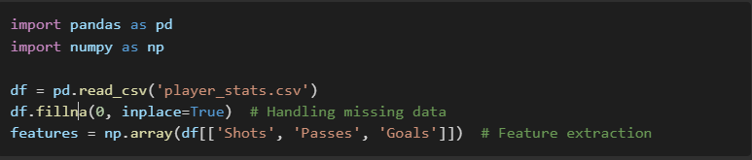
Example Usage:
Figure 1: Pandas and NumPy in processing and featuring data

Data Visualization and Performance Trend Analysis:
Matplotlib – Enables static, animated, and interactive visualizations for sports data.
Seaborn – Provides advanced statistical visualizations, useful for performance analysis.
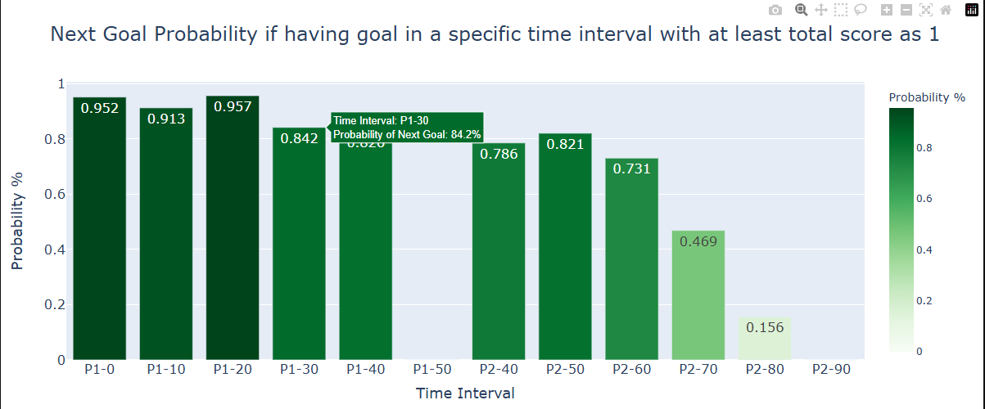
Plotly – Enable the interactive plot for sporting field help visualize more lively
Figure 2: Visualize Next Goal Probability by Plotly

Machine Learning and Model Building:
Scikit-learn – Supports predictive analytics, classification, and clustering models for sports forecasting.
SciPy – Provides scientific computations such as statistical analysis and optimizations.
Imbalanced-learn – Useful for handling imbalanced datasets, particularly in injury prediction or rare event detection.
XGBoost – A state of Art package used for advanced player or team performance predictions.
Example Usage:
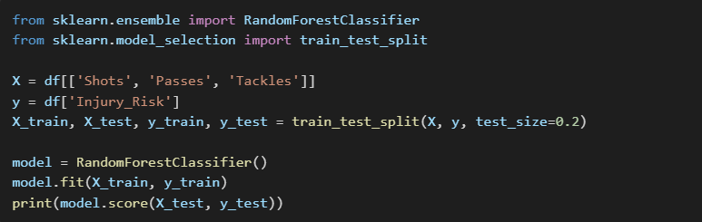
Figure 3: Package for building ML models

Computer Vision for Sports Broadcasting:
OpenCV – Processes video frames or images for player and ball tracking.
YOLO (You Only Look Once) – A deep learning-based object detection framework for real-time sports broadcasting. (detects ball and players)
PyTorch – Supports custom deep learning models for tracking and event detection.
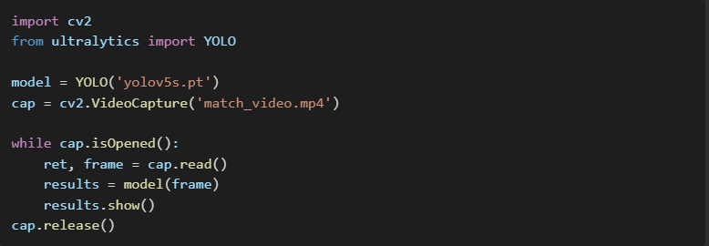
Example Usage:
Figure 4: Use CV2 and YOLO in object detection

API Development and Deployment:
FastAPI – A modern framework for building and deploying sports analytics APIs.
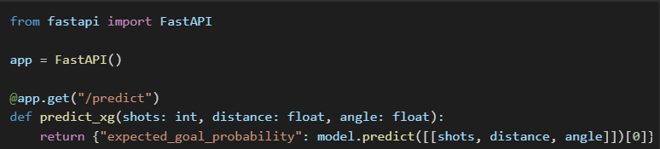
Example Usage:
Figure 5:Apply FastAPI to deploy models

Data Requirements:
Accurate and well-structured data is crucial for effective sports analytics. The quality of insights drawn from sports data depends on the reliability of the data sources, preprocessing techniques, and feature engineering applied.

Types of Sports Data:
Sports data can be categorized into various types, including:
- Match and Player Statistics: player ratings, player statistics: Shot, Cross, Pass,..
- Tracking Data: Player movements, speed, and positioning through sensors and GPS trackers.
- Biometric Data: Heart rate, oxygen levels, fatigue metrics from wearable devices.
- Video and Image Data: Game footage used for object detection and tracking.
- Betting and Odds Data: Used for calculate win loss reports

Sources of Sports Data:
Sports data can be collected from multiple sources, such as:
- APIs: Opta, StatsBomb, FIFA datasets, and Sportradar provide structured sports data.
- CSV and Database Records: Historical match records from open-source platforms and sports organizations.
- Wearable Devices: Smart fitness trackers like Garmin, Fitbit, and WHOOP.
- Live-Streaming Feeds: Capturing real-time video for analysis using computer vision.
- Web Scraping: Extracting sports-related statistics from websites using Python libraries like BeautifulSoup and Scrapy.

Data Preprocessing and Feature Engineering
Before using sports data in analytics and machine learning models, preprocessing is essential. The steps include:
- Cleaning and Handling Missing Data
- Normalization and Scaling: Standardizing numeric data to improve model performance.
- Feature Engineering: Creating new features, such as expected goals (xG), player efficiency scores, or fatigue indexes.
- Data Augmentation for Computer Vision: Applying transformations like cropping, rotation, and contrast adjustment to video and image data.

Application of Python in the Sporting Field:

Performance Analysis
Performance analysis involves dissecting player and team metrics to identify strengths and weaknesses. Python is used to analyze data such as points scored, assists, rebounding efficiency, and shooting percentages. By leveraging libraries like SciPy and Statsmodels, analysts can perform advanced statistical analysis and visualize data using Matplotlib and Seaborn. This helps coaches tailor training programs to improve player skills and overall team performance.
Real-world Case Study: Many professional sports teams use Python to analyze player performance. There are many use cases:
- The NBA uses advanced statistical models to evaluate player efficiency and optimize team strategies.

- Calculate Player and Team Performance in 4 big soccer leagues:
  - England Premiere League
  - Germany Bundesliga
  - France Ligue 1
  - Italy Serie A
  - Spain LaLiga

Sport Broadcasting: Computer Vision
Python's OpenCV library is used in sports broadcasting to apply computer vision techniques. This involves detecting players and the ball in real-time, enhancing the viewer’s experience with automated analysis and commentary. Especially, it supports track object detection of ball or players in camera video.
Real-world Case Study:
- The use of AI-powered video analysis in the NHL and NFL helps coaches identify pivotal moments in games and develop winning strategies.
- Real-Time Ball and Player Tracking with data from Live sports broadcast footage by implementing YOLO-based object detection. (Kagne, 2023)

Sport Forecasting: Predicting Expected Goals or Final winner.
Sport forecasting involves analyzing player statistics to predict game outcomes, such as expected goals. These models analyze historical data to forecast future performance, helping teams make informed decisions.
Besides we can use these models to run Monte Carlo stimulation to predict the final winner in a specific tournament.
Real-world Case Study:
- According to the team and player statistics, The English Premier League uses predictive models to forecast match outcomes and providing insights for strategic planning. (Premier League First Team Club statistics, Team & Player stats., n.d.)
- Based on the Monte Carlo and Machine Learning model, predict the final winner in World Cup 2018 (Kenton, 2024)

Wearable Technology:
Wearable devices collect data on player health and performance, such as heart rate and movement patterns. Python is used to analyze this data, helping teams prevent injuries and optimize training regimes.
Real-world Case Study: NFL teams use AI-powered wearables to monitor player fatigue and adjust training plans accordingly, reducing injury risks and improving player health. (Langton, 2024)

Deployment Plan:
Deploying a machine learning model for sports analytics requires a structured approach to ensure efficiency, scalability, and real-time performance.

General Deployment Process
Model Training: The machine learning or deep learning model is trained using historical data.
Model Serialization: The trained model is saved in formats such as .pkl, .pt, or .onnx.
API Development: The model is integrated into a FastAPI or Flask-based API.
Containerization: Using Docker to package dependencies and models for easy deployment.
Cloud Deployment: Hosting on cloud platforms such as AWS, Azure, or GCP.

Traditional vs. Deep Learning Model Deployment
Traditional Models: Lightweight, faster inference can run on CPUs.
Deep Learning Models: Require GPUs, optimized using TensorRT, ONNX, or the other techniques.

Key Considerations in Model Deployment
Scalability: Using Kubernetes for dynamic scaling.
Monitoring: Logging with ElasticSearch, monitoring with Prometheus.
MLOps Integration: Using MLflow for tracking experiments.
CI/CD Pipelines: Automating deployment with Jenkins or GitHub Actions.

Architecture Diagram for deploying a machine learning model.
Deploying sports analytics applications requires a robust technical stack to ensure scalability, reliability, and real-time performance.
- Redis for real-time caching to enhance query speed.
- Azure for scalable cloud storage and computer resources.
- Kafka as a streaming pipeline for real-time data ingestion.
- FastAPI for serving machine learning models as REST APIs.
- Docker & Kubernetes for containerization and orchestration of microservices.
- ElasticSearch for logging predictions and monitoring system performance.
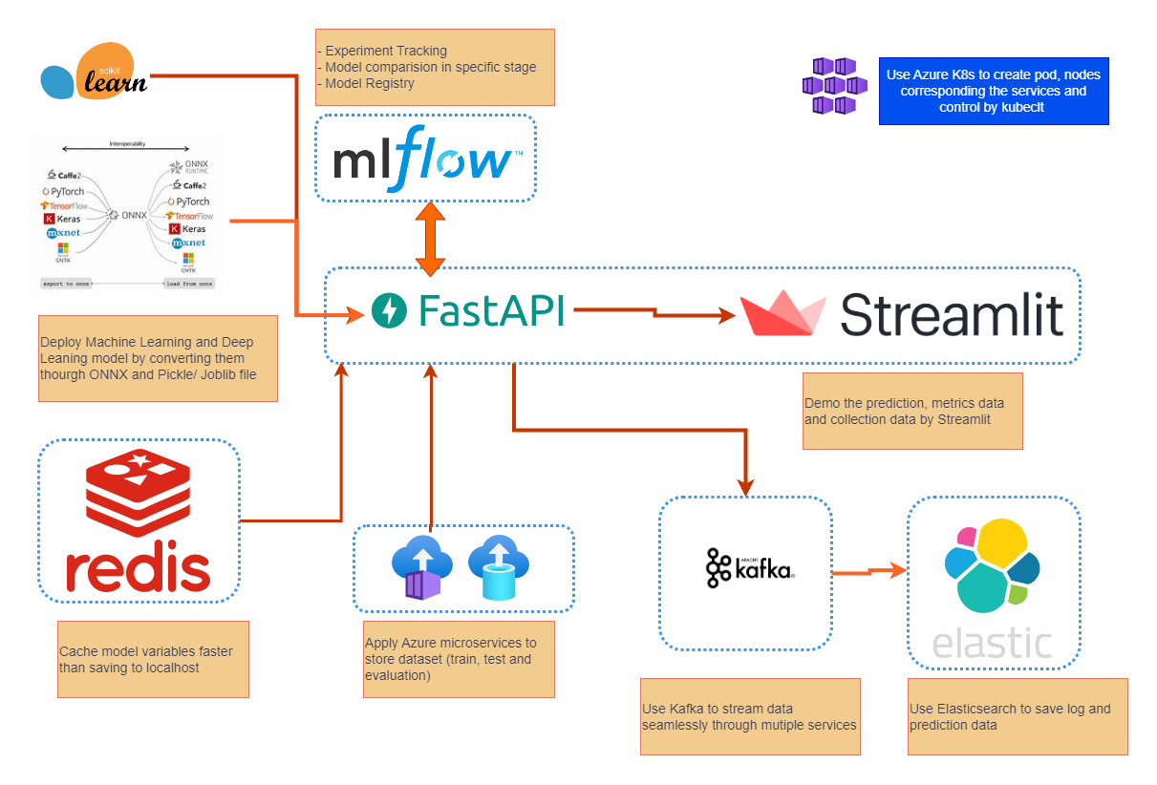
Please refer to the image below:
Figure 6: Architecture diagram

Conclusion & Future Trends:
Python’s influence in the sporting field is undeniable, with its applications spanning across multiple areas such as sports broadcasting, forecasting, performance analysis, and wearable technology. As technology continues to evolve, Python’s role in sports analytics is expected to grow, paving the way for new innovations and deeper insights into athletic performance.

Python’s Growing Role in Sports
Python's flexibility, combined with its vast ecosystem of libraries, makes it an ideal choice for handling complex sports-related tasks. From real-time player tracking to advanced predictive modeling, Python simplifies the implementation of powerful machine learning and AI-based solutions. The ability to integrate Python with cloud platforms, IoT devices, and scalable architectures further enhances its relevance in sports analytics.

Real-World Implementations of Future Trends
Several emerging trends highlight how Python will shape the future of sports technology:
- AI-Driven Coaching Systems: Machine learning models powered by Python are increasingly used to analyze in-game decisions, suggest tactical adjustments, and improve player training programs based on historical data. AI-driven coaching assistants are expected to play a bigger role in real-time strategic decision-making.
- Automated Referee Decision-Making: Technologies like computer vision and deep learning enhancing referee accuracy in critical match situations. Python-based models, integrated with tools such as OpenCV and YOLO, are improving the detection of fouls, offside calls, and goal-line decisions, reducing human error in officiating.
- Player Injury Prediction & Load Management: By analyzing biometric and performance data, Python-based predictive models can help teams prevent injuries by identifying early warning signs of fatigue or overexertion. This approach is particularly useful in high-intensity sports where injury prevention can extend careers and improve player availability.
- Enhanced Sports Broadcasting & Fan Engagement: Broadcasters are using Python-driven AI models to generate real-time game insights, provide player comparisons, and even produce automated commentary. This allows fans to experience more interactive and data-rich sports coverage.

Short-Term and Current Developments
In the next 1–3 years, Python’s application in sports analytics will likely see rapid advancements in:
- Real-time player tracking and movement analysis, powered by IoT and AI.
- Personalized fan experiences, using AI-generated insights and automated content creation.
- Integration of edge computing for wearable technology, enabling faster and more localized data processing.
As sports organizations continue to embrace data-driven decision-making, Python will remain at the forefront of these innovations, ensuring that teams, athletes, and fans benefit from cutting-edge analytics and AI-driven insights.

Section 2: Practical Assignment

Determine the probability in waiting times
Least square error: (deviations squared)
PPT - Simple Linear Regression PowerPoint Presentation, free download - ID:3148735

Visualize Probability density function and Histogram respectively

Compute and visualize the meaning, variance and quantiles:

LIST OF REFERENCES
Section 1: Applying Python in the Sporting Field
- Python in Sports Analytics: Leveraging Data for Performance Insights | MoldStud. (2024, February 6). https://moldstud.com/articles/p-python-in-sports-analytics-leveraging-data-for-performance-insights
- IJPREMS. (2023). Computer Vision-Based Sports Performance Analytics Systems.https://www.ijprems.com/uploadedfiles/paper/issue_5_may_2023/31381/final/fin_ijprems1685070526.pdf
- Balantekin, B. (2023, December 20). Wearable Device Data 101—Introduction to Sports Analytics with Python. Medium. https://blog.stackademic.com/wearable-device-data-101-introduction-to-sports-analytics-with-python-71e86f0f4e39
- Shah, H., & Shah, H. (2025, January 3). How AI is Revolutionizing the Sports Industry. Prismetric. https://www.prismetric.com/ai-in-sports/
- Writer, C. (2025, February 4). Top 5 Computer Vision Python Packages [2025]. Roboflow Blog. https://blog.roboflow.com/computer-vision-python-packages/
- Akdogan, E. (2023, January 22). Oxford AI predicts World Cup winner - Predict - Medium. Medium. https://medium.com/predict/oxford-ai-predicts-world-cup-winner-6bd005f3a882

References
Akdogan, E. (2023, January 22). Oxford AI predicts World Cup winner. Retrieved from Medium: https://medium.com/predict/oxford-ai-predicts-world-cup-winner-6bd005f3a882
Balantekin, B. (2023, December 20). Wearable Device Data 101—Introduction to Sports Analytics with Python. Retrieved from blog.stackademic.com: https://blog.stackademic.com/wearable-device-data-101-introduction-to-sports-analytics-with-python-71e86f0f4e39
Kagne, S. (2023). COMPUTER VISION-BASED SPORTS PERFORMANCE ANALYTICS. Pune, Maharashtra, India.
Kenton, W. (2024, June 27). Monte Carlo Simulation: What it is, how it works, history, 4 key steps. Retrieved from investopedia: https://www.investopedia.com/terms/m/montecarlosimulation.asp
Langton, J. (2024, February 1). Building a digital athlete: Using AI to rewrite the playbook on NFL player safety. Retrieved from NFL: https://www.nfl.com/playerhealthandsafety/equipment-and-innovation/aws-partnership/building-a-digital-athlete-using-ai-to-rewrite-the-playbook-on-nfl-player-safety
MoldStud. (2024, February 6). Python in Sports Analytics: Leveraging Data for Performance Insights. Retrieved from moldstud.com: https://moldstud.com/articles/p-python-in-sports-analytics-leveraging-data-for-performance-insights
Premier League First Team Club statistics, Team & Player stats. (n.d.). Retrieved from premierleague: https://www.premierleague.com/stats
Shah, H. &. (2025, January 3). How AI is Revolutionizing the Sports Industry. Prismetric. Retrieved from https://www.prismetric.com/ai-in-sports/
Writer, C. (2025, February 4). Top 5 Computer Vision Python Packages. Retrieved from Roboflow Blog: https://blog.roboflow.com/computer-vision-python-packages/

