**Tryton**

Tryton adalah sebuah aplikasi hasil dari pengembangan proyek opensource komersial OpenERP ditahun 2009. Aplikasi ini merupakan kerangka kerja three-tiers tingkat tinggi yang dapat dikembangkan kembali untuk macam-macam kegunaan, berlisensi GNU General Public License(GPLv3) dan dibuat dengan bahasa pemrograman python dan menggunakan postgresql sebagai basisdata utama. Aplikasi ini meyediakan modularitas.

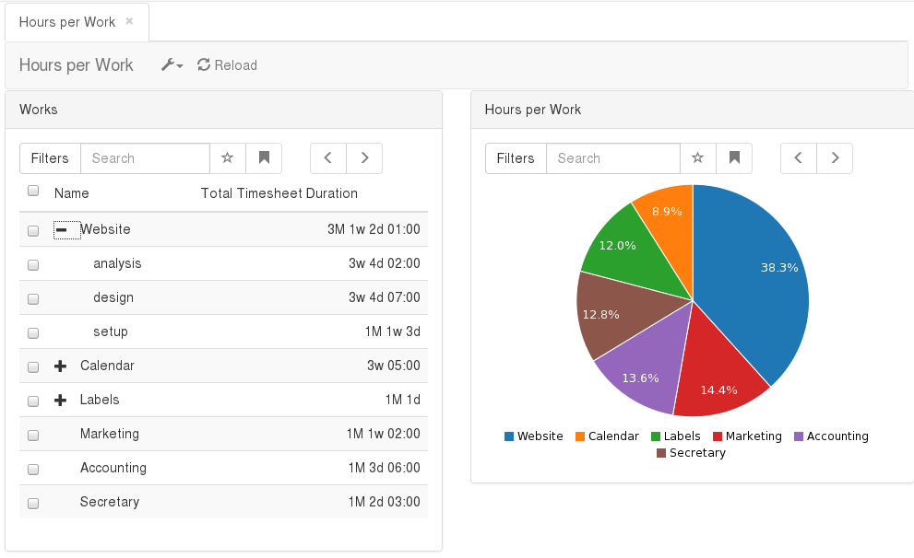

Aplikasi ini terdiri dari 3 bagian yaitu aplikasi server atau disebut trytond, paket-paket modul aplikasi kernel tryron, dan aplikasi kliennya. Berikut ii adalah penjelasan dari masing-masing bagiannya:

Aplikasi Inti Tryton(trytond).

Aplikasi inti tryton merupakan aplikasi server yang melayani semua fungsi yang diperlukan. Seperti: data yang persisten, modul-modul yang dapat diperluas, managemen pengguna, alurkerja. Dapat bekerja secara online maupun lokal.

Modul-modul tryton.

Modul-modul tryton ini dibuat dan dapat diintegrasikan ke dalam aplikasi inti tryton yang mana berfungsi sebagai pengembangan fungsional dari aplikasi inti tryton agar sesuai dengan keinginan dan kebutuhan dari pemakai. Modul-modul tryton dikeluarkan secara resmi oleh tryton foundation maupun olem komunitas tryton. Berikut ini adalah modul-modul dokumentasi yang tersedia dalam situ resminya:

[Account Module](http://doc.tryton.org/4.6/modules/account/doc/index.html)

[Account Asset Module](http://doc.tryton.org/4.6/modules/account_asset/doc/index.html)

[Account Credit Limit](http://doc.tryton.org/4.6/modules/account_credit_limit/doc/index.html)

[Account Deposit Module](http://doc.tryton.org/4.6/modules/account_deposit/doc/index.html)

[Account Dunning Module](http://doc.tryton.org/4.6/modules/account_dunning/doc/index.html)

[Account Dunning Email Module](http://doc.tryton.org/4.6/modules/account_dunning_email/doc/index.html)

[Account Dunning Fee Module](http://doc.tryton.org/4.6/modules/account_dunning_fee/doc/index.html)

[Account Dunning Letter Module](http://doc.tryton.org/4.6/modules/account_dunning_letter/doc/index.html)

[Spanish Account Module](http://doc.tryton.org/4.6/modules/account_es/doc/index.html)

[Account Europe Module](http://doc.tryton.org/4.6/modules/account_eu/doc/index.html)

[Account Invoice Module](http://doc.tryton.org/4.6/modules/account_invoice/doc/index.html)

[Account Invoice Correction Module](http://doc.tryton.org/4.6/modules/account_invoice_correction/doc/index.html)

[Account Payment Module](http://doc.tryton.org/4.6/modules/account_payment/doc/index.html)

[Account Payment Clearing Module](http://doc.tryton.org/4.6/modules/account_payment_clearing/doc/index.html)

[Account Payment SEPA Module](http://doc.tryton.org/4.6/modules/account_payment_sepa/doc/index.html)

[Account Payment SEPA CFONB Module](http://doc.tryton.org/4.6/modules/account_payment_sepa_cfonb/doc/index.html)

[Account Payment Stripe Module](http://doc.tryton.org/4.6/modules/account_payment_stripe/doc/index.html)

[Account Statement Module](http://doc.tryton.org/4.6/modules/account_statement/doc/index.html)

[Account Statement Coda Module](http://doc.tryton.org/4.6/modules/account_statement_coda/doc/index.html)

[Account Stock Anglo-Saxon Module](http://doc.tryton.org/4.6/modules/account_stock_anglo_saxon/doc/index.html)

[Account Stock Continental Module](http://doc.tryton.org/4.6/modules/account_stock_continental/doc/index.html)

[Account Stock Landed Cost Module](http://doc.tryton.org/4.6/modules/account_stock_landed_cost/doc/index.html)

[Account Stock Landed Cost Weight Module](http://doc.tryton.org/4.6/modules/account_stock_landed_cost_weight/doc/index.html)

[Account Tax Rule Country](http://doc.tryton.org/4.6/modules/account_tax_rule_country/doc/index.html)

[Authentication SMS Module](http://doc.tryton.org/4.6/modules/authentication_sms/doc/index.html)

[Bank Module](http://doc.tryton.org/4.6/modules/bank/doc/index.html)

[Carrier Module](http://doc.tryton.org/4.6/modules/carrier/doc/index.html)

[Carrier Percentage Module](http://doc.tryton.org/4.6/modules/carrier_percentage/doc/index.html)

[Carrier Weight Module](http://doc.tryton.org/4.6/modules/carrier_weight/doc/index.html)

[Commission Module](http://doc.tryton.org/4.6/modules/commission/doc/index.html)

[Commission Waiting](http://doc.tryton.org/4.6/modules/commission_waiting/doc/index.html)

[Company Module](http://doc.tryton.org/4.6/modules/company/doc/index.html)

[Company Work Time Module](http://doc.tryton.org/4.6/modules/company_work_time/doc/index.html)

[Country Module](http://doc.tryton.org/4.6/modules/country/doc/index.html)

[Currency Module](http://doc.tryton.org/4.6/modules/currency/doc/index.html)

[Customs Module](http://doc.tryton.org/4.6/modules/customs/doc/index.html)

[Google Maps Module](http://doc.tryton.org/4.6/modules/google_maps/doc/index.html)

[LDAP Authentication Module](http://doc.tryton.org/4.6/modules/ldap_authentication/doc/index.html)

[Notification Email Module](http://doc.tryton.org/4.6/modules/notification_email/doc/index.html)

[Party Module](http://doc.tryton.org/4.6/modules/party/doc/index.html)

[Party Relationship Module](http://doc.tryton.org/4.6/modules/party_relationship/doc/index.html)

[Product Module](http://doc.tryton.org/4.6/modules/product/doc/index.html)

[Product Attribute Module](http://doc.tryton.org/4.6/modules/product_attribute/doc/index.html)

[Product Classification Module](http://doc.tryton.org/4.6/modules/product_classification/doc/index.html)

[Product Classification Taxonomic Module](http://doc.tryton.org/4.6/modules/product_classification_taxonomic/doc/index.html)

[Product Cost FIFO Module](http://doc.tryton.org/4.6/modules/product_cost_fifo/doc/index.html)

[Product Cost History Module](http://doc.tryton.org/4.6/modules/product_cost_history/doc/index.html)

[Product Measurements](http://doc.tryton.org/4.6/modules/product_measurements/doc/index.html)

[Product Price List Dates Module](http://doc.tryton.org/4.6/modules/product_price_list_dates/doc/index.html)

[Production Module](http://doc.tryton.org/4.6/modules/production/doc/index.html)

[Production Routing Module](http://doc.tryton.org/4.6/modules/production_routing/doc/index.html)

[Production Split Module](http://doc.tryton.org/4.6/modules/production_split/doc/index.html)

[Production Work Module](http://doc.tryton.org/4.6/modules/production_work/doc/index.html)

[Production Work Timesheet Module](http://doc.tryton.org/4.6/modules/production_work_timesheet/doc/index.html)

[Project Module](http://doc.tryton.org/4.6/modules/project/doc/index.html)

[Project Invoice Module](http://doc.tryton.org/4.6/modules/project_invoice/doc/index.html)

[Project Plan Module](http://doc.tryton.org/4.6/modules/project_plan/doc/index.html)

[Purchase Module](http://doc.tryton.org/4.6/modules/purchase/doc/index.html)

[Purchase Request Module](http://doc.tryton.org/4.6/modules/purchase_request/doc/index.html)

[Purchase Requisition Module](http://doc.tryton.org/4.6/modules/purchase_requisition/doc/index.html)

[Purchase Shipment Cost Module](http://doc.tryton.org/4.6/modules/purchase_shipment_cost/doc/index.html)

[Sale Module](http://doc.tryton.org/4.6/modules/sale/doc/index.html)

[Sale Advance Payment Module](http://doc.tryton.org/4.6/modules/sale_advance_payment/doc/index.html)

[Sale Complaint Module](http://doc.tryton.org/4.6/modules/sale_complaint/doc/index.html)

[Sale Credit Limit](http://doc.tryton.org/4.6/modules/sale_credit_limit/doc/index.html)

[Sale Extra](http://doc.tryton.org/4.6/modules/sale_extra/doc/index.html)

[Sale Invoice Grouping Module](http://doc.tryton.org/4.6/modules/sale_invoice_grouping/doc/index.html)

[Sale Opportunity Module](http://doc.tryton.org/4.6/modules/sale_opportunity/doc/index.html)

[Sale Payment Module](http://doc.tryton.org/4.6/modules/sale_payment/doc/index.html)

[Sale Promotion](http://doc.tryton.org/4.6/modules/sale_promotion/doc/index.html)

[Sale Shipment Cost Module](http://doc.tryton.org/4.6/modules/sale_shipment_cost/doc/index.html)

[Sale Shipment Grouping Module](http://doc.tryton.org/4.6/modules/sale_shipment_grouping/doc/index.html)

[Sale Shipment Tolerance Module](http://doc.tryton.org/4.6/modules/sale_shipment_tolerance/doc/index.html)

[Sale Stock Quantity](http://doc.tryton.org/4.6/modules/sale_stock_quantity/doc/index.html)

[Sale Subscription Module](http://doc.tryton.org/4.6/modules/sale_subscription/doc/index.html)

[Sale Supply Module](http://doc.tryton.org/4.6/modules/sale_supply/doc/index.html)

[Sale Supply Drop Shipment Model](http://doc.tryton.org/4.6/modules/sale_supply_drop_shipment/doc/index.html)

[Stock Module](http://doc.tryton.org/4.6/modules/stock/doc/index.html)

[Stock Consignment Module](http://doc.tryton.org/4.6/modules/stock_consignment/doc/index.html)

[Stock Forecast Module](http://doc.tryton.org/4.6/modules/stock_forecast/doc/index.html)

[Stock Inventory Location Module](http://doc.tryton.org/4.6/modules/stock_inventory_location/doc/index.html)

[Stock Location Move Module](http://doc.tryton.org/4.6/modules/stock_location_move/doc/index.html)

[Stock Lot Module](http://doc.tryton.org/4.6/modules/stock_lot/doc/index.html)

[Stock Lot Shelf Life Expiration Date](http://doc.tryton.org/4.6/modules/stock_lot_sled/doc/index.html)

[Stock Package Module](http://doc.tryton.org/4.6/modules/stock_package/doc/index.html)

[Stock Package Shipping Module](http://doc.tryton.org/4.6/modules/stock_package_shipping/doc/index.html)

[Stock Package Shipping DPD Module](http://doc.tryton.org/4.6/modules/stock_package_shipping_dpd/doc/index.html)

[Stock Package Shipping UPS Module](http://doc.tryton.org/4.6/modules/stock_package_shipping_ups/doc/index.html)

[Stock Product Location Module](http://doc.tryton.org/4.6/modules/stock_product_location/doc/index.html)

[Stock Shipment Measurements Module](http://doc.tryton.org/4.6/modules/stock_shipment_measurements/doc/index.html)

[Stock Split Module](http://doc.tryton.org/4.6/modules/stock_split/doc/index.html)

[Stock Supply Module](http://doc.tryton.org/4.6/modules/stock_supply/doc/index.html)

[Stock Supply Day Module](http://doc.tryton.org/4.6/modules/stock_supply_day/doc/index.html)

[Stock Supply Production Module](http://doc.tryton.org/4.6/modules/stock_supply_production/doc/index.html)

[Timesheet Module](http://doc.tryton.org/4.6/modules/timesheet/doc/index.html)

[Web User Module](http://doc.tryton.org/4.6/modules/web_user/doc/index.html)

Aplikasi Klien tryton

Aplikasi klien digunakan oleh pengguna untuk mengakses aplikasi tryton baik secara jaringan internet atau pun lokal, aplikasi ini multi-plaform dan juga dapat bekerja pada container seperti docker.