VoxLoop System Documentation
In-Flight Multi-Agent Critique & Self-Correction Voice Engine for Support QA

📌 PROJECT LINKS & REPOSITORY URLS
🔗 GitHub Repository URL: https://github.com/TrijalLuhariwala/voxloop
🌐 Live Deployment URL: https://voxloop.duckdns.org

1. Executive Summary
VoxLoop is a state-of-the-art real-time voice assistant platform engineered around an in-flight multi-agent critique and self-correction feedback loop. Built using FastAPI, WebSockets, LangGraph, LangChain, and Mistral AI, VoxLoop captures raw microphone speech from a browser interface, transcribes it locally using faster-whisper, drafts an initial response, critiques that response against a secondary evaluation LLM across 6 compliance dimensions, rewrites the phrasing using structured critique feedback, and streams synthesized speech back to the client.
2. Target Role & Problem Statement
The Target Role
The primary user role for VoxLoop is Sarah Jenkins, a Quality Assurance (QA) Lead at a FinTech Call Center overseeing 50 support agents.
The Specific Problem
In high-stakes phone customer service (e.g., banking, technical support, insurance), support reps frequently give answers that are technically correct but fail on critical soft skills: empathy, clarity, or strict regulatory policy compliance. QA leads currently spend 20+ hours every week listening to past call recordings post-mortem to fill out evaluation forms manually. Because this evaluation happens hours or days after the call, agents miss out on real-time coaching.
How VoxLoop Solves It
VoxLoop operates as an in-flight live critique & training copilot. It automatically scores support responses across 6 key metrics (Accuracy, Relevance, Empathy, Clarity, Policy Compliance, and Overall Quality), provides immediate actionable suggestions, and demonstrates the exact improved phrasing that should have been spoken.
3. System Architecture & Workflow Diagram
The system separates concerns into a clean 4-stage pipeline: Client Interaction, Speech & Storage, LangGraph Multi-Agent Engine, and LLM Provider.
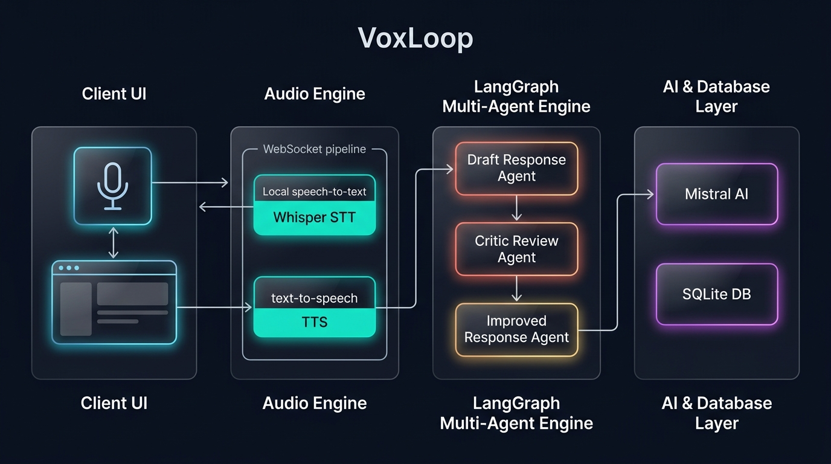
4. Technology Stack & Component Specifications
Layer / Module | Technology Used | Role in Architecture
Frontend Interface | Next.js 15, React 19, CSS Glassmorphism | Dual-column layout, live microphone capture, score progress bars, chat bubbles.
Backend Framework | FastAPI, Uvicorn, WebSockets | Async event loop, real-time WebSocket protocol (`/ws/voice-turn`), REST API routes.
Agent Orchestration | LangGraph, LangChain | State-graph execution chaining draft_response -> critique_response -> improve_response.
LLM Engine | Mistral AI (mistral-small-latest) | Primary response generation and structured JSON output evaluation.
Speech-to-Text (STT) | faster-whisper | Local CTranslate2 Whisper model with Voice Activity Detection (VAD) running on CPU/INT8.
Text-to-Speech (TTS) | pyttsx3 | Offline cross-platform SAPI / espeak voice synthesis engine saving .wav files.
Database Layer | SQLite + SQLAlchemy ORM | Persistent store for conversation runs, session history, and scorecards (`voxloop.db`).
Containerization | Docker & Docker Compose | Multi-stage builds packaging backend and frontend into isolated containers.
Reverse Proxy & SSL | Nginx + Let's Encrypt (Certbot) | Production HTTPS/WSS proxying with automated SSL certificate renewal.

5. Python Backend File Structure & Detailed Explanation
File: backend/app/config.py
Manages application settings, model defaults, and environment variables loaded from backend/.env using Pydantic BaseSettings.
File: backend/app/models.py
Defines Pydantic data transfer objects (DTOs) for VoiceTurnRequest, GradingScorecard (0-100 bounds), CritiqueResult, and VoiceTurnResponse.
File: backend/app/db.py
Defines the SQLAlchemy ConversationRun ORM table, engine creation with directory safety, and session lifecycle helper functions.
File: backend/app/audio.py
Handles asynchronous speech-to-text (transcribe_audio using faster-whisper) and text-to-speech (synthesize_speech using pyttsx3 with Linux exception safety).
File: backend/app/workflow.py
Constructs the LangGraph state machine (build_workflow) chaining draft_response, critique_response, and improve_response nodes.
File: backend/app/main.py
The central FastAPI application providing /health, /api/reset-session, /api/voice-turn, and the real-time WebSocket connection handler (/ws/voice-turn).

6. Technical & Architectural Deep Dives
01. Why could no one have made this project in 2023?
In early 2023, LLM interactions were restricted to single-pass prompt chains. LangGraph (released in late 2023/2024) introduced stateful cyclic graphs allowing state to flow through discrete node functions with explicit branch controls. Additionally, deterministic JSON schema enforcement via Pydantic output parsing and fast edge local STT (faster-whisper) made real-time feedback loops viable without high API latency or regex output parsing bugs.
02. What is the non-obvious hard part?
Managing Multi-Turn Context Consistency Across a Cyclic Multi-Agent Graph Without Hallucination or Feedback Loops. If you naive-append the raw Critique object into subsequent turns as conversation history, the LLM starts hallucinating about its own meta-critique in future turns ('As a critic agent, I scored myself 85...') rather than speaking naturally. To solve this, VoxLoop enforces strict memory isolation: only the Human Utterance and the Final Improved Response are saved to long-term SQLite history, while critique scores remain isolated strictly to the active turn evaluation graph.
03. What did you build versus what did the API give you?
The APIs provided raw text completions (Mistral API), audio bytes to text (Faster-Whisper), and string to audio file (pyttsx3). WE built the entire custom software engine: the real-time WebSocket state machine, non-blocking asyncio thread pools, the 3-node LangGraph orchestration graph, SQLite multi-turn context formatting (_history_text), session reset handlers, and the dual-column Next.js glassmorphism frontend.
04. Why does this break if you remove the AI?
VoxLoop is fundamentally an AI-driven evaluation system. Without the Critic Agent LLM, you cannot calculate dynamic scores for subjective human soft skills like Empathy, Relevance, or Clarity. Static rule matchers can only look for rigid keywords. Without the Primary Agent LLM, the system cannot take unstructured critique recommendations and automatically synthesize a rewritten response. Without AI, the app collapses into a simple audio file recorder.
05. What breaks at ten thousand concurrent users?
1. CPU Bottleneck: Local faster-whisper STT and pyttsx3 CPU inference on the FastAPI host will saturate CPU cores. Solution: Offload STT/TTS to a distributed Ray/Celery GPU worker cluster.
2. SQLite Write Locks: Simultaneous writes will throw 'database is locked' errors. Solution: Migrate SQLite to PostgreSQL / AWS Aurora with Redis session caching.
3. WebSocket File Descriptors: A single FastAPI instance will exhaust file descriptors. Solution: Load balance multiple FastAPI instances behind Nginx with a Redis Pub/Sub backplane.

7. Production Deployment Architecture
VoxLoop is deployed on an Oracle Cloud Infrastructure (OCI) Always-Free ARM Ampere instance (Ubuntu 22.04 LTS) containerized using Docker Compose, reverse-proxied via Nginx, and secured with Let's Encrypt SSL (DuckDNS).

