**GROUP MEMBERS:**

**AYESIGA NOBERT 20/U/2063/EVE**

**ASIIMWE ELIZABETH 20/U/2025/EVE**

**NUWAGABA PATRICIA 20/U/2032/EVE**

**BWIRE EMMANUEL OLAKA 20/U/2040/EVE**

**MANUAL FOR THE COMPLAINT PROJECT**

The student needs do registration before accessing the home page!

The username must be unique. The email and password and password confirmation fields must be filled

* 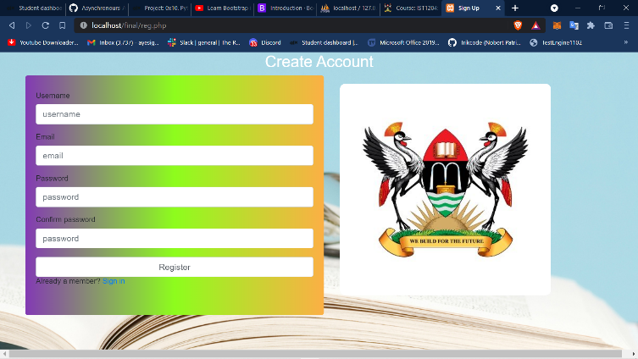The code is in. (reg.php) file

If user already has an account, he/she can go to to sign in page.(login.php)

He can login as AR or student and will redirected to the corresponding page

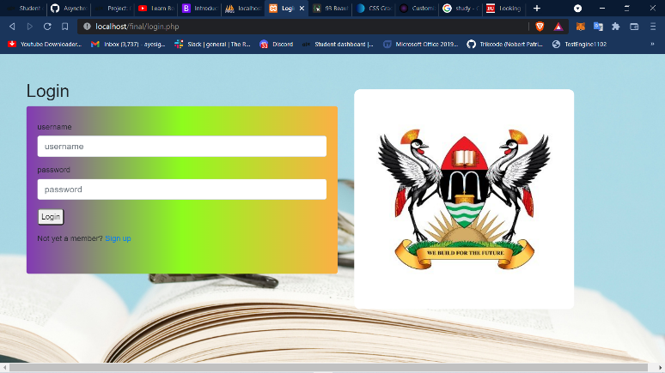

**STUDENT**

If the student logins he will be redirected to this page(index.php)

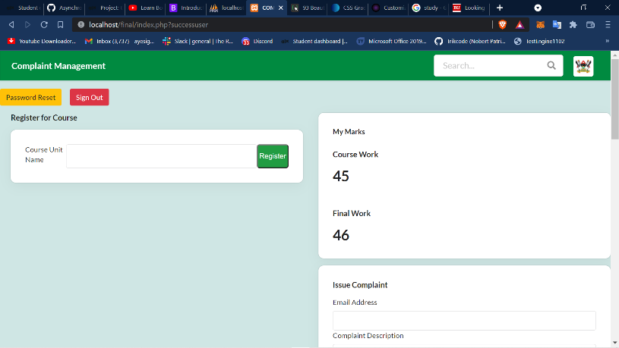

Here the user can register for the course unit!

**ADMIN(home.php)**

And also complain about the results

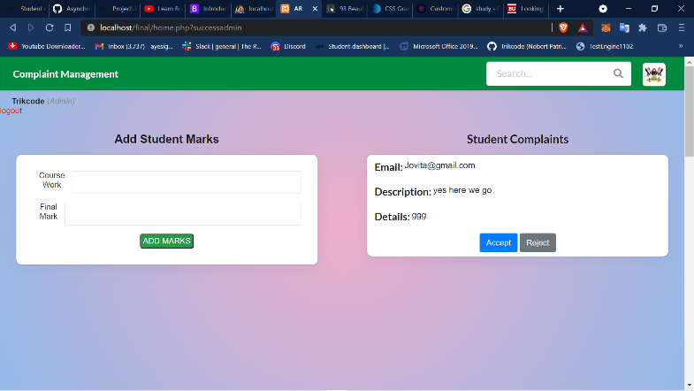And If the AR logs in, he will be redirected here

The Complaints are received here by the AR who can accept and forward them to the HOD or reject them and they appear on the student’s dashboard.

The lecturer can also add marks of the student

They are all able log out and will be redirected to logout page.