**NAÏVE BAYES CLASSIFIER**

Naive Bayes is an algorithm that uses Baye’s theorem. Baye’s theorem is a formula that calculates a probability by counting the frequency of given values or combinations of values in a data set.

Naive Bayes Model works particularly well with text classification and spam filtering.

**Advantages** of working with NB algorithm are:

* Requires a small amount of training data to learn the parameters
* Can be trained relatively fast compared to sophisticated models

**The main disadvantage** of NB Algorithm is:

* It’s a decent classifier but a bad estimator
* It works well with discrete values but won’t work with continuous values (can’t be used in a regression)

Let’s take a toy example of movie text and review and it’s sentiment polarity (0->negative, 1->positive).

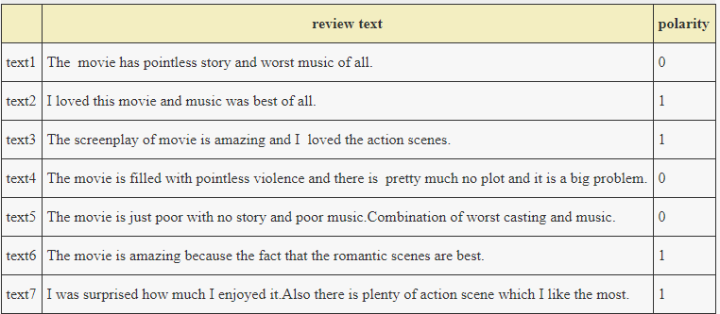

**Step1**: Text Preprocessing

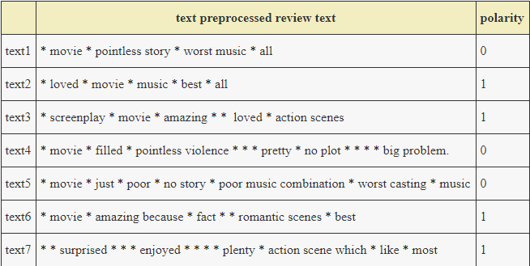

**Step2**: **Bag of Words Representation**

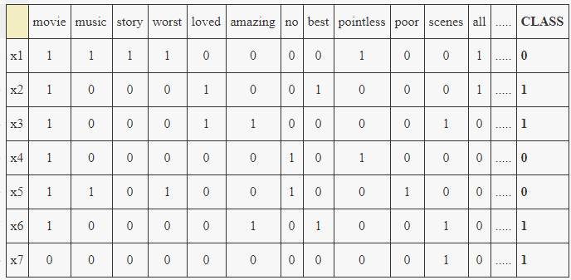

**Step 3: Apply Laplace Smoothing**

**Step 4:** Apply Multinomial Naive Bayes

**Step 5**:  Predict the output using Multinomial Naive Bayes classifier

**Step 6**: Find test accuracy and train accuracy

**Step 7**: Plot a confusion matrix and heatmap - A confusion matrix is a table that allows us to visualize the performance of a classification algorithm.

Finding the most frequent words used in both positive and negative reviews. We have taken a sample of positive and negative words and found out the frequency of most frequent words used.

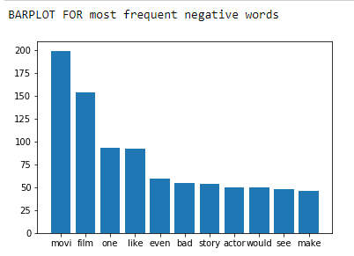

Here we observe that words like “bad” are frequently used which depicts negative reviews.

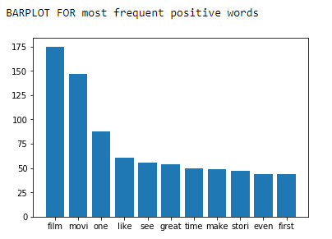

Here we observe that words like “great” are frequently used which depicts positive reviews.