H1:How Agencies Help You Rank for “Near Me” Searches
H2:Understanding “Near Me” Searches and Their Impact on Local Businesses.
H2:How Google Decides Which Businesses Show Up
H2:Why Local SEO Is Essential for Chennai Businesses
H2:How Local SEO Turns Google Searches Into Real Customers
H2:How Long Does It Take to See Results?
H2:Why Local SEO Has One of the Best Returns
H2:Final Call to Action
H3:Google Business Profile Optimization
H3:Local Keyword Research
H3:Location-Based Website Pages
H3:Local Business Listings and Citations
H3:Review and Reputation Management
H3:Mobile Optimization
H3:Local Content Creation

How Agencies Help You Rank for “Near Me” Searches
When someone in Chennai opens Google and types "digital marketing company near me," they're not just scrolling for information. They're looking for a business they can trust, contact, and hire right now.
Think about that for a moment.
Your potential client is already searching. Their phone is in their hand. Their need is urgent. The only question is: does your business appear in front of them, or does your competitor?
If you're not showing up in those results, you're silently losing high-value customers every single day to businesses that have invested in smart local SEO.
That's why working with a professional digital marketing agency in Chennai is no longer just about marketing. It's about being visible where real buying decisions are made. It's about showing up at the exact moment someone is ready to choose. And if you're not there, someone else will be
and they'll take the business that should have been yours.

Understanding “Near Me” Searches and Their Impact on Local Businesses.
“Near me” searches are location-based searches where people are looking for something close to them right now.
Examples include:
- digital marketing company near me
- SEO agency near me
- website development company near me
- digital marketing agency in Chennai

These searches are powerful because they come from users who already know what they want. They are not researching. They are choosing.
How Google Decides Which Businesses Show Up
Google does not randomly display results for “near me” searches. It uses three main signals:
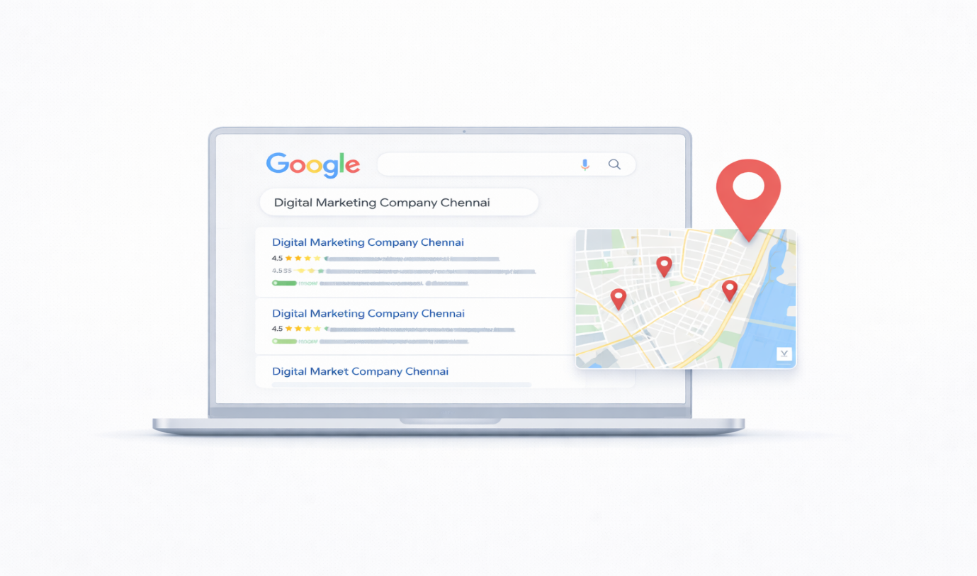
1. Location
Google checks how close your business is to the person searching.
2. Relevance
It analyses whether your business actually offers what the user is looking for.
3. Trust
It evaluates how reliable your business is based on reviews, website quality, and online presence.
A skilled digital marketing agency in Chennai optimizes all three so your business ranks higher than your competitors.
Why Local SEO Is Essential for Chennai Businesses
Chennai is one of India’s fastest-growing business hubs. Every area from Velachery to Anna Nagar has dozens of companies offering similar services.
Local SEO allows your business to:
- Stand out in a crowded market
- Reach customers in your service area
- Get leads without paying for ads
- Build long-term online visibility
Without local SEO, even the best digital marketing company can remain invisible.
Google Business Profile Optimization
Your Google Business Profile is the backbone of your local search visibility.
- Choosing the correct business category
- Adding service areas across Chennai
- Writing keyword-rich descriptions
- Uploading real photos and branding images
- Adding phone numbers, directions, and website links
This profile is what appears in Google Maps and local search results.
Without optimization, you simply will not rank for “digital marketing agency in Chennai” searches.
Local Keyword Research
Ranking for local searches requires knowing what Chennai users actually type.
A good agency finds keywords such as:
- digital marketing agency in Chennai
- digital marketing company near me
- SEO services in Chennai
- social media marketing Chennai
These keywords are then placed naturally across your website, pages, and content.
This tells Google that your business is relevant to people searching in Chennai.
Location-Based Website Pages
Agencies don’t rely on one generic service page. They create pages that target specific locations.
Examples:
- Digital Marketing Agency in Chennai
- SEO Services in Velachery
- Social Media Marketing in Anna Nagar
This helps you rank across multiple Chennai neighbourhoods instead of just one.
Local Business Listings and Citations
Google trusts businesses that appear consistently across the internet.
A digital marketing agency in Chennai lists your business on platforms like:
- Google
- Justdial
- Facebook
Review and Reputation Management
Reviews play a huge role in “near me” searches.
Businesses with more positive Google reviews:
- Rank higher
- Get more clicks
- Get more calls
Agencies help you:
- Collect genuine customer reviews
- Respond professionally
- Improve your star rating
- Build trust with new customers
When someone sees your business with strong reviews, they are far more likely to contact you.
Mobile Optimization
Most “near me” searches happen on mobile phones.
Agencies make sure:
- Your site loads fast
- Pages display correctly on all devices
- Call buttons work
- Directions are easy to tap
Google prioritizes mobile-friendly websites in local results.
Local Content Creation
Local SEO is not just technical. Content plays a big role.
Agencies create:
- Chennai-focused blog posts
- Area-specific service pages
- Case studies from local clients
- Business updates and FAQs
This shows Google that your business is active and relevant to Chennai users.
What Makes a Digital Marketing Agency in Chennai Different?
Local agencies understand:
- Chennai search behaviour
- Local competition
- Regional customer needs
- Language and buying habits
They know what it takes to rank a business for “digital marketing company near me” within the Chennai market.
How Local SEO Turns Google Searches Into Real Customers
When your business ranks in local search, the journey looks like this:
- A customer searches for a service
- Your business appears in Google Maps
- They click to view your profile
- They call or visit your website
- You get a lead
This happens every day once your local SEO is set up correctly.
Why Businesses in Chennai Choose Trimsel for Local SEO
At Trimsel, we don’t chase rankings for the sake of rankings. We focus on getting you real, qualified Chennai customers.
As a digital marketing agency in Chennai, we help businesses grow by:
Appear in Google Maps
- Rank for high-intent keywords
- Get more calls and inquiries
- Build long-term visibility
Our local SEO strategies are designed to turn search traffic into paying clients.
How Long Does It Take to See Results?
Local SEO usually starts showing improvements in:
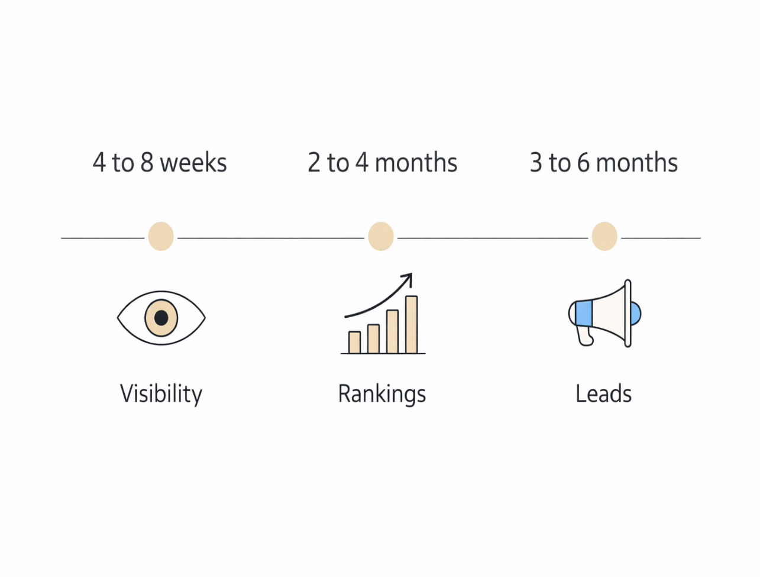
Unlike paid ads, these results continue to bring customers even when you stop spending.
Why Local SEO Has One of the Best Returns
Local SEO works because:
- People are already searching
- The competition is smaller
- The leads are high-intent
- You don’t pay per click
Ranking for “digital marketing agency in Chennai” can bring dozens of inquiries every month without ongoing ad costs.
Frequently Asked Questions
- What does “near me” mean in Google search?
It means Google is showing businesses based on the user’s current location.
- How do I rank for digital marketing company near me?
You need an optimized Google Business Profile, local keywords, reviews, and a mobile-friendly website.
- Do I need a physical office in Chennai?
Yes, a real address helps you rank better in local results.
- Is local SEO better than paid ads?
Local SEO provides long-term traffic, while ads stop when you stop paying.
- How much does local SEO cost?
Costs vary based on competition and scope, but it is usually far more affordable than running ads every month.
Final Call to Action
If you want customers in Chennai to find your business when they search “digital marketing company near me”, you need more than just a website you need a strong local SEO strategy that puts you on Google Maps and at the top of search results.
Trimsel is your trusted digital marketing agency in Chennai for turning Google searches into real leads.

