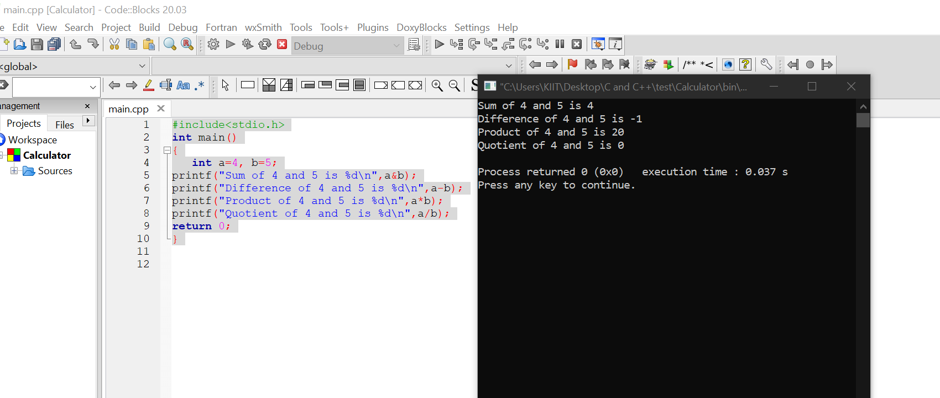

Sir, I was facing trouble while uploading the code in Github as the file uploaded (in the format .cbp) was not displaying the code. So, I have attached a screenshot of the page.

