System Architecture for Real-Time Bank Fraud Detection

1. Overview
This document describes the high-level system architecture of the SecureGuard Fraud Detection System. The system is designed to provide real-time inference on transactional data using an XGBoost-based machine learning model integrated with a robust Flask backend.

2. Architecture Flowchart
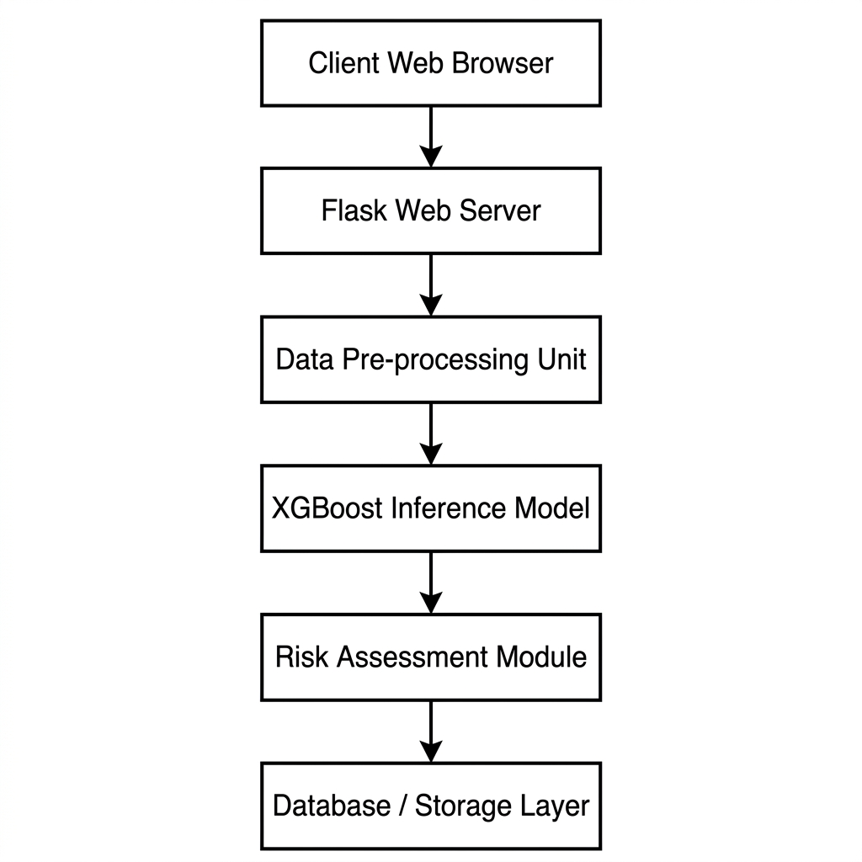
Figure 1: Vertical System Architecture Flowchart (Minimalist IEEE Style)

3. Component Breakdown
Component | Description
Client Layer | Web-based interface for transaction input and real-time monitoring.
Flask Web Server | Core backend handling routing, authentication, and session management.
Preprocessing Unit | Transforms raw transactional data into model-compatible features.
XGBoost Model | High-performance machine learning engine for fraud probability scoring.
Risk Assessment | Logic-driven module for categorizing alerts and generating recommendations.
Database Layer | Persistent storage for transactional logs and user accounts.

