Detailed System Architecture & Technology Stack

1. System Overview
The SecureGuard Fraud Detection System employs a robust, multi-layered architecture designed for high-throughput transaction processing. The architecture integrates cutting-edge machine learning libraries with a secure backend to provide real-time fraud probability scores and risk assessments.

2. System Architecture Flowchart
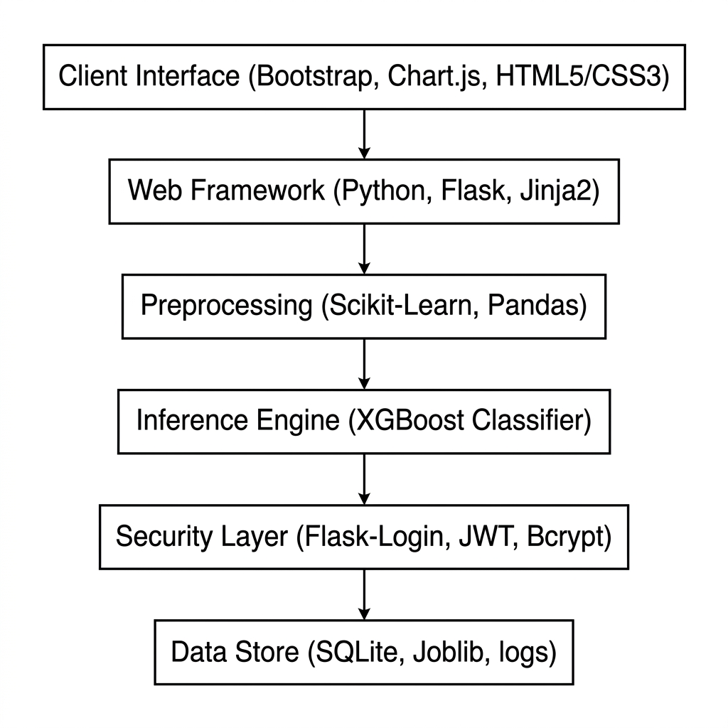
Figure 1: System Architecture

3. Technology Stack Breakdown
Layer | Technologies | Purpose
Frontend | HTML5, CSS3, JS, Chart.js, Bootstrap | Responsive analytics dashboard & real-time monitoring.
Backend | Python 3.x, Flask, Gunicorn, Jinja2 | REST API handling, core business logic, and routing.
ML Pipeline | XGBoost, Scikit-learn, Pandas | Feature engineering and high-accuracy fraud classification.
Security | Flask-Login, Bcrypt, PyJWT | Secure auth, password hashing, and session management.
Data Store | SQLite 3, Joblib, CSV | Persistent storage for user data, logs, and model artifacts.

4. Implementation Details
The system utilizes an XGBoost Classifier trained on anonymized historical banking data. Real-time requests are validated, pre-processed using scikit-learn encoders, and then passed to the inference engine. Any transaction exceeding the risk threshold triggers an immediate security alert.

