**File Operations as per the Project requirements and snapshots of the respective results:**

**Main or Menu Screen:**

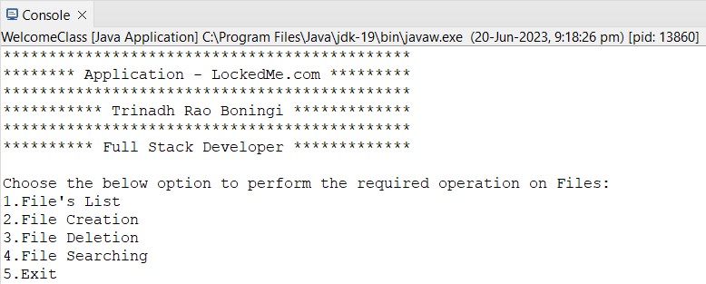

**File Operations as per the options given in the menu screen:**

**1.File’s List - Press 1 - To display list of files in ascending order**

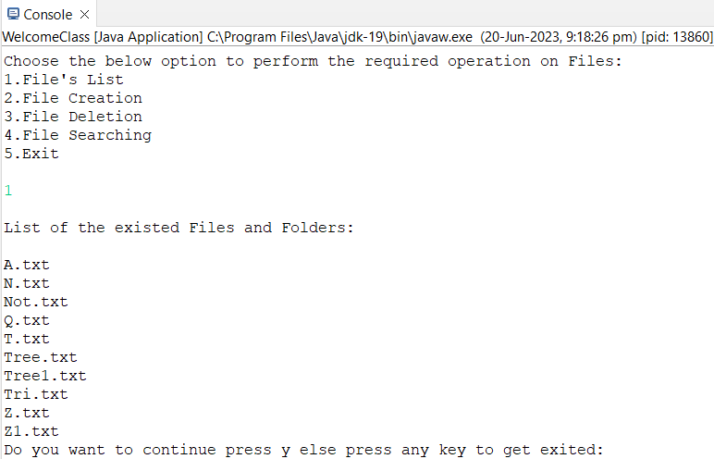

**Press y to continue to perform next operation else press any other key to exit**

**2. File Creation - Press 2 - For creating a file**

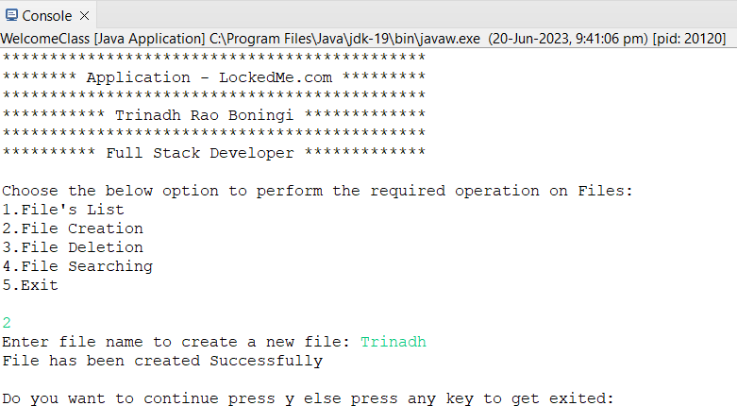

**Below is the example if we try to create an already existed file**

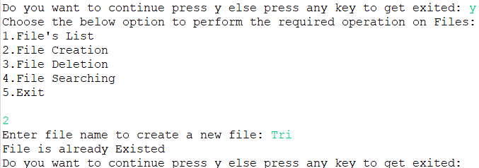

**Press y to continue to perform next operation else press any other key to exit.**

**3. File - Deletion Press 3 - To delete the file**

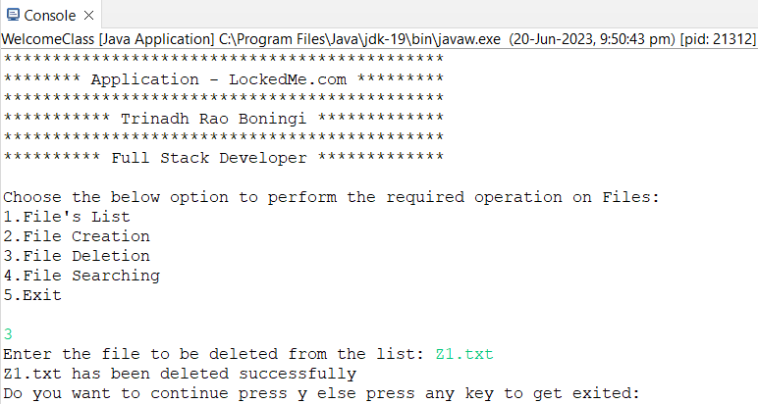

**Below is the example if we try to delete the file which is not existed**

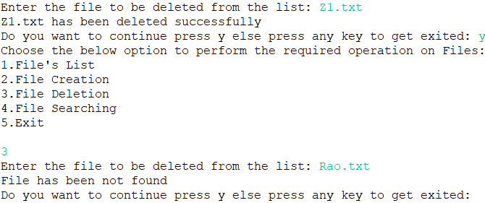

**Press y to continue to perform next operation else press any other key to exit.**

**4. File Searching - Press 4 - To search for the file**

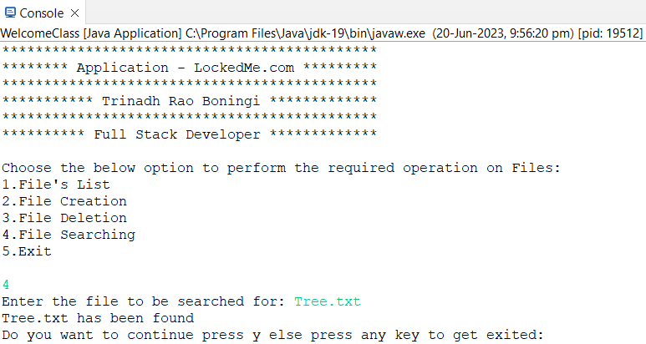

**Below is the example if we try to search for the file which is not existed**

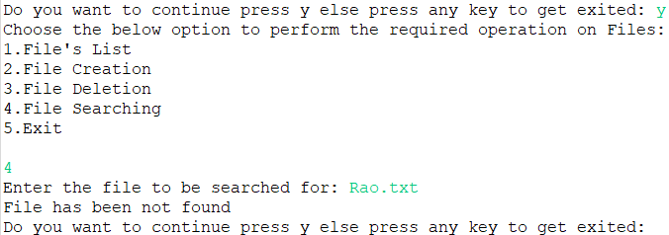

**Press y to continue to perform next operation else press any other key to exit.**

**5. Exit - Press 5 - To exit from operation screen**

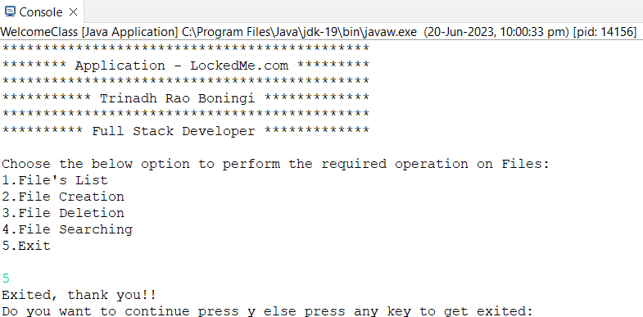

**Finally, below is just to show all the existed file’s list in descending order after all the operations**

