REAL TIME ONE-TO-ONE CHAT APPLICATION

A Project Report Submitted in partial fulfilment of the requirements for the award of the degree of
BACHELOR OF TECHNOLOGY
In
ELECTRONICS AND COMMUNICATION ENGINEERING
Submitted By
GORRELA SIVA SATYA TRINADH |  |  | 22221A0462
AKULA PAVAN VENKATA RAMA KRISHNA |  |  | 22221A0410
CHODISETTI KIRAN SAI TEJA |  |  | 22221A0439

Under the Esteemed Guidance of
Mrs. V. SANDHYA
M.Tech.(Ph.D)

Associate Professor



DEPARTMENT OF ELECTRONICS AND COMMUNICATION ENGINEERING

BONAM VENKATA CHALAMAYYA ENGINEERING COLLEGE
(AUTONOMOUS)
(Approved by A.I.C.T.E, New Delhi & Affiliated to J.N.T.U.K, Kakinada)
(Accredited by NBA &NAAC with “A‟ Grade)
ODALAREVU-533210
2022 – 2026

BONAM VENKATA CHALAMAYYA ENGINEERING COLLEGE
(AUTONOMOUS)

ODALAREVU-533210
DEPARTMENT OF ELECTRONICS AND COMMUNICATION ENGINEERING


CERTIFICATE

This is to certify that the project work entitled “REAL TIME ONE-TO-ONE CHAT APPLICATION” is being submitted for the partial fulfillment of the requirements for the award of the degree of Bachelor Of Technology in Electronics and Communication Engineering to Bonam Venkata Chalamayya Engineering College(A), Odalarevu, is a Bonafide work done by GORRELA SIVA SATYA TRINADH (22221A0462), AKULA PAVAN VENKATA RAMA KRISHNA (22221A0410), CHODISETTI SAI KIRAN TEJA (22221A0439), under my guidance during the academic year 2022-2026 and it has been found suitable for acceptance according to the requirement of the University.
The results embodied in this thesis have not been submitted to any other University or Institute for the award of any degree.

Project Guide Head of the Department
Mrs .V. SANDHYA Dr. T.SARAN KUMAR
M.Tech.,(Ph.D) M.Tech., (Ph.D),MIETE

EXTERNAL EXAMINER
ACKNOWLEDGEMENT

We profoundly grateful to express our deep sense of gratitude and respect towards our guide Mrs. V. SANDHYA, Associate Professor of ECE Department, Bonam Venkata Chalamayya Engineering College(A), Odalarevu, for his excellent guidance right from selection of the project and his valuable suggestions throughout the project work. His constant encouragement and support has been the cause of our success, in completing this thesis in the college.
We also grateful to the Project Coordinator Mr.s. S. N. V. D. L. Priyanka,
Assistant Professor of ECE Department, Bonam Venkata Chalamayya Engineering College(A), Odalarevu, for her excellent guidance right from selection of the project and her valuable suggestions throughout the project work.
We really thankful to Dr. T. SARAN KUMAR, and Head of the Department for Electronics and Communication Engineering for providing the laboratory facilities to the fullest extent as and when required and also for giving us the opportunity to carry out the project work in the college.
We also thankful to Dr. MAHESWAR DUTTA, Bonam Venkata Chalamayya Engineering College(A), Odalarevu, for his support during and till the completion of the project.
We are also thankful to our MANAGEMENT, Bonam Venkata Chalamayya
Engineering College(A), Odalarevu, for their support during and till the completion of the project.
We are thankful to all the TEACHING AND NON-TEACHING STAFF of Electronics and Communication Engineering Department, Bonam Venkata Chalamayya Engineering College(A), Odalarevu, and FRIENDS for their direct and indirect help provided to us in completing the project.
Last but not least, we own all our success to our FAMILY MEMBERS, CLASS MATES AND TEACHERS from our child hood, whose vision, love and inspiration made us to reach out for these glories.
Project Associates………

GORRELA SIVA SATYA TRINADH 22221A0462
AKULA PAVAN VENKATA RAMA KRISHNA 22221A0410
CHODISETTI SAI KIRAN TEJA 22221A0439

ABSTRACT
Real-time communication has become a fundamental requirement in modern web applications, where instant message delivery, low latency, and reliability are critical. Conventional HTTP-based request–response models are inefficient for chat systems due to increased latency and server overhead. This project focuses on the design and development of a real-time one-to-one chat application using Java Full Stack technologies to address these limitations.
The proposed system enables authenticated users to exchange messages instantly through persistent WebSocket connections. The backend is developed using Spring Boot, integrating WebSocket communication with the STOMP protocol to ensure efficient and bi-directional message transfer. User authentication and authorization are implemented using JWT-based security to provide secure, stateless access control. Chat messages are stored in a MySQL database and managed through a defined message lifecycle consisting of SENT, DELIVERED, and SEEN states, allowing accurate delivery confirmation and read receipts.
The frontend is built using HTML,CSS and JavaScript, which communicates with the backend via REST APIs for authentication and data retrieval, while real-time interactions such as messaging and typing indicators are handled through WebSocket connections. By separating REST-based services from real-time communication logic, the system achieves improved scalability, maintainability, and performance.
This project demonstrates the practical implementation of real-time messaging systems, event-driven architecture, and secure backend design using industry-relevant technologies, making it suitable for academic evaluation and entry-level industry applications

TABLE OF CONTENTS
ABSTRACT 4
TABLE OF CONTENTS 5
CHAPTER 1 9
1. INTRODUCTION 9
1.1 Overview of the project 9
1.2 Background 9
1.3 Motivation 9
1.4 Problem Statement 10
1.5 Objectives of the project 10
1.5 Scope of the project 10
1.6 Assumptions and constraints 11
1.7 Applications of the project 11
CHAPTER 2
2. LITERATURE SURVEY 12
2.1Introduction 12
2.2Traditional Web-Based Communication Systems 12
2.3 Long Polling and AJAX-Based Chat Systems………………………………………………12
2.4 WebSocket-Based Real-Time Communication……………………………………………...13
2.5 STOMP Protocol for Message Routing……………………………………………..............13
2.6 Authentication and Security in Chat Applications…………………………………………..14
2.7 Backend Frameworks for Real-Time Applications………………………………………….14
2.8 Database Systems for Message Persistence…………………………………………….14

2.9 Frontend Approaches in Chat Applications…………………………………………… 14
2.10 Research Gap and Motivation……………………………………………………15
2.11 Summary……………………………………………………………………………………………………………………
CHAPTER 3………………………………………………………………………….
3. SYSTEM ANALYSIS AND DESIGN…………………………………………..16
3.1 Introduction………………………………………………………………………………16
3.2 Requirement Analysis……………………………………………………………………16
3.3 Existing System Analysis………………………………………………………………...16
3.4 Proposed System Architecture……………………………………………………………17
3.5 Software Requirements Specification (SRS)…………………………………………..…17
3.5.1 Functional Requirements……………………………………………………………17
3.6 Performance Requirements……………………………………………………………....18
3.7 System Design Overview………………………………………………………………...18
3.8 Data Flow Design………………………………………………………………………...19
3.9 Modular Design………………………………………………………………………… 19
3.9.1 Authentication Module……………………………………………………………...19
3.9.2 Chat Module………………………………………………………………………...19
3.9.3 Friendship Module…………………………………………………………………..19
3.10 Summary……………………………………………………………………….....19
CHAPTER 4
4. SYSTEM IMPLEMENTATION………………………………………………
4.1 Introduction .................................................................................................................20
4.2 Backend Implementation …………………………………………………………………………………………….20
4.3 WebSocket Implementation ………………………………………………………………………………………..20
4.4 Security Implementation …………………………………………………………………………………………….21
4.5 Database Implementation …………………………………………………………………………………………..21
4.6 Frontend Implementation ……………………………………………………………………………………………21
4.7 Integration of Components ………………………………………………………………………………………….23

CHAPTER 5
5. QUALITY ASSURANCE AND VALIDATION ………………………………...24
5.1 Overview ………………………………………………………………………………….24
5.2 Validation Strategy ……………………………………………………………..................24
5.3 Authentication and Security Validation ……………………………………………………24
5.4 Real-Time Messaging Validation ………………………………………………………….25
5.5 Data Persistence and Consistency Checks …………………………………………………25
5.6 Frontend Interaction Validation ……………………………………………………………25
5.7 End-to-End Scenario Testing ………………………………………………………………25
5.8 Reliability and Stability Observations ……………………………………………………..26
5.9 Friendship Management Module Validation ……………………………………………….26
5.10 Notification Module Validation …………………………………………………………..28
5.11 Admin Monitoring Module Validation …………………………………………………….27
5.12 Error Handling and Exception Validation ………………………………….................27
CHAPTER 6
6. SYSTEM INTERFACE AND VISUAL REPRESENTATION ……………….....29
6.0 Introduction ………………………………………………………………………….29
6.1 Home Page ………………………………………………………………………………….29
6.2 User Registration Page ……………………………………………………………………..29
6.3 User Login Page ……………………………………………………………………………30
6.4 User Dashboard …………………………………………………………………………….31
6.5 Friend Request Interface ……………………………………………………………………31
6.6 One-to-One Chat Interface ………………………………………………………………….32
6.7 Real-Time Notification Panel ……………………………………………………………….33
6.8 Message History View ………………………………………………………………………33
CHAPTER 7
7. SYSTEM WORKFLOW USING FLOWCHARTS AND TABLES …………….38
7.1 User Login Block Diagram …………………………………………………………………38
7.2 WebSocket Connection Block Diagram ………………………………………….................38
7.3 One-to-One Message Sending Block Diagram ……………………………………………..39
7.4 Complete Login-to-Message Flow Block Diagram ………………………………………...41
7.5 Supporting Block Diagram – Module Interaction ………………………………………42
CHAPTER 8
8. DETAILED PROJECT DESCRIPTION AND ANALYSIS ……………………..44
8.1 Introduction …………………………………………………………………………………44
8.2 Core Concept of the Project ………………………………………………………………...44
8.3 Real-Time Communication Mechanism …………………………………………………....44
8.4 Authentication and Authorization Flow …………………………………………………….45
8.5 Backend Architecture and Processing ……………………………………………………...45
8.6 Database Design and Data Handling ………………………………………………............46
8.7 Frontend Architecture and Interaction Handling …………………………………………..46
8.8 User Interaction Workflow ………………………………………………………………...47
8.9 Message Lifecycle in the System ………………………………………………………….47
8.10 Performance Considerations ………………………………………………………… …..47
8.11 Modularity and Maintainability …………………………………………………………..48
8.12 Engineering Significance of the Chapter …………………………………………………48
CHAPTER 9
9. REFERENCES AND CONCLUSION

CHAPTER 1

INTRODUCTION
1.1 Overview of the Project
The Real-Time One-to-One Chat Application is a full-stack web-based communication system designed to provide secure, instant, and reliable messaging between authenticated users. The application enables real-time interaction using persistent connections, ensuring low latency and seamless user experience.
This project is developed using modern backend technologies and real-time communication protocols, closely simulating the behaviour of real-world messaging platforms used in industry today.
1.2 Background
With the rapid growth of internet-based applications, real-time communication has become a critical requirement. Traditional web applications rely on the HTTP request–response model, which is not suitable for applications that demand instant data updates, such as chat systems.
To address these limitations, technologies like WebSockets allow continuous, bidirectional communication between the client and the server. This project leverages such technologies to overcome latency issues and provide real-time message delivery.
1.3 Motivation
Many academic projects use heavy frontend frameworks or third-party services that abstract the core logic of real-time communication. While these tools simplify development, they limit understanding of the actual system behaviour.
The motivation behind this project is to build a real-time chat application from the ground up, focusing on understanding:
- The lifecycle of WebSocket connections
- Stateless authentication using JWT
- Backend-driven real-time event handling
- Manual frontend state management using Vanilla JavaScript
This approach ensures a strong foundation in real-world software engineering concepts.
1.4 Problem Statement
The HTTP protocol is inherently stateless and inefficient for real-time messaging due to frequent polling and delayed responses. Additionally, session-based authentication mechanisms introduce scalability challenges in distributed systems.
The problem addressed in this project is the design and implementation of a secure, scalable, and real-time messaging system that:
- Maintains persistent client-server connections
- Delivers messages instantly
- Eliminates server-side session dependency
- Ensures secure user authentication and authorization
1.5 Objectives of the Project
The main objectives of the Real-Time One-to-One Chat Application are:
- To implement real-time, bidirectional communication using WebSockets
- To secure the application using JWT-based stateless authentication
- To design a clean and layered backend architecture using Spring Boot
- To store and retrieve messages using a relational database
- To build the frontend using pure HTML, CSS, and JavaScript without external frameworks
1.6 Scope of the Project
The scope of this project is limited to one-to-one private communication between registered users. The application includes:
- User registration and secure login
- Friend request and relationship management
- Real-time private messaging
- Persistent storage of messages
- Real-time notifications
Advanced features such as group chats, file sharing, and end-to-end encryption are not included in the current version and are considered as future enhancements.
1.7 Assumptions and Constraints
Every software system is designed based on certain assumptions and constraints. The Real-Time One-to-One Chat Application operates under the assumption that users have stable internet connectivity and access to a modern web browser.
The key constraints of the system include:
- Dependency on active internet connection for real-time communication
- Browser compatibility limitations
- Server resource limitations during high concurrency
- Current support limited to one-to-one messaging
These constraints were considered during design to ensure stable system behaviour.
1.8 Applications of the Project
The Real-Time One-to-One Chat Application can be applied in various real-world scenarios, including:
- Private messaging platforms
- Customer support chat systems
- Internal communication tools for organizations
- Notification and alert systems

CHAPTER 2
LITERATURE SURVEY
2.1 Introduction
The literature survey provides an overview of existing research, technologies, and systems related to real-time communication and chat applications. It helps in understanding how similar systems are designed, the technologies commonly used, and the limitations present in existing solutions.
This chapter reviews various approaches to real-time messaging systems, authentication mechanisms, communication protocols, and frontend–backend interaction models that influenced the design of the Real-Time One-to-One Chat Application.
2.2 Traditional Web-Based Communication Systems
Early web-based communication systems relied primarily on the HTTP request–response model. In this approach, the client periodically sends requests to the server to check for new messages, a method commonly known as polling.
Although simple to implement, this approach has several drawbacks:
• Increased network traffic due to repeated requests
• Higher server load
• Delayed message delivery
• Poor real-time user experience
These limitations made traditional HTTP-based systems unsuitable for real-time chat applications.
2.3 Long Polling and AJAX-Based Chat Systems
To overcome basic polling limitations, long polling and AJAX-based techniques were introduced. In long polling, the server holds the request open until new data is available.
While this approach improves responsiveness compared to traditional polling, it still suffers from:
• Inefficient resource usage
• Complexity in implementation
• Scalability issues with many concurrent users
These challenges led to the adoption of more efficient real-time communication protocols.
2.4 WebSocket-Based Real-Time Communication
WebSocket technology introduced a major shift in real-time web applications by enabling persistent, bidirectional communication between client and server. Once a WebSocket connection is established, data can be exchanged instantly without repeated HTTP requests.
Studies and existing systems highlight the advantages of WebSockets:
• Low latency communication
• Reduced network overhead
• Persistent connections
• Efficient handling of real-time events
Modern chat applications widely adopt WebSockets due to these benefits, making it a suitable choice for this project.
2.5 STOMP Protocol for Message Routing
The Simple Text Oriented Messaging Protocol (STOMP) is commonly used over WebSockets to manage message routing using a publish–subscribe model. It allows clients to subscribe to specific topics and receive messages automatically.
Literature shows that STOMP:
• Simplifies real-time message handling
• Supports scalable messaging architectures
• Improves clarity in message routing
This protocol is frequently integrated with backend frameworks like Spring Boot.

2.6 Authentication and Security in Chat Applications
Security is a critical concern in messaging systems. Traditional session-based authentication stores user sessions on the server, which can limit scalability.
Recent research favors JWT (JSON Web Token) based authentication because:
Password encryption techniques such as BCrypt are widely recommended to ensure secure credential storage.
2.7 Backend Frameworks for Real-Time Applications
Backend frameworks play a crucial role in managing real-time communication and security. Spring Boot is widely used for building scalable backend systems due to its modular design and integration capabilities.
Studies highlight Spring Boot’s advantages:
• Simplified configuration
• Strong security support
• Built-in WebSocket support
• Easy database integration
These features make Spring Boot a preferred choice for real-time chat systems.
2.8 Database Systems for Message Persistence
Chat applications require reliable data storage for users and messages. Relational databases such as MySQL are commonly used due to their structured schema and consistency.
Literature emphasizes:
• Message persistence for chat history
• Proper relational mapping between users and messages
• Data integrity and reliability
Relational databases remain a strong choice for one-to-one messaging systems.

2.9 Frontend Approaches in Chat Applications
Many modern chat applications use frontend frameworks like React or Angular. However, literature also emphasizes the importance of understanding core frontend concepts such as DOM manipulation and event handling.
Using Vanilla JavaScript:
• Reduces dependency on frameworks
• Improves understanding of frontend fundamentals
• Provides lightweight and fast UI performance
This approach is suitable for learning-focused and performance-oriented applications.
2.10 Research Gap and Motivation
Although many chat applications exist, most rely heavily on frameworks or third-party services, hiding core implementation details. There is limited academic work focusing on from-scratch real-time chat systems that emphasize fundamental understanding.
This project addresses the gap by:
• Implementing real-time communication using WebSockets
• Using stateless JWT authentication
• Avoiding heavy frontend frameworks
• Demonstrating complete end-to-end system design
2.11 Summary
This chapter reviewed existing communication models, real-time technologies, security mechanisms, and system architectures related to chat applications. The insights gained from this literature survey guided the design and implementation of the Real-Time One-to-One Chat Application, ensuring the use of modern, efficient, and secure technologies.

CHAPTER 3

SYSTEM ANALYSIS AND DESIGN
3.1 Introduction
System analysis and design form the foundation of any successful software application. This phase focuses on understanding user requirements, identifying system constraints, and designing a structured solution that meets functional, performance, and security expectations.
For the Real-Time One-to-One Chat Application, this phase emphasizes real-time communication, secure authentication, efficient data handling, and scalable system design. Proper analysis ensures the system delivers instant messaging while maintaining reliability and security
3.2 Requirement Analysis

Requirement analysis involves identifying what the system must do and how well it must perform. The requirements are gathered by analysing user interaction flow and real-time communication needs.

The primary requirements identified are:

Instant delivery of private messages

Secure user authentication and authorization

Persistent storage of messages

Efficient handling of multiple concurrent users

Responsive and lightweight frontend interaction

3.3 Existing System Analysis

Traditional chat systems implemented using HTTP rely on frequent client requests to fetch new messages. This approach is inefficient for real-time applications and results in delayed communication.

Key drawbacks of the existing system include:

High latency due to polling mechanisms

Unnecessary network overhead

Increased server load

Poor real-time user experience
3.4 Proposed System Architecture
The proposed system replaces polling-based communication with WebSocket-based persistent connections, enabling real-time, bidirectional communication between clients and the server.
Key advantages of the proposed system:
- Low-latency message transmission
- Reduced network overhead
- Stateless authentication using JWT
- Scalable backend architecture
- Improved real-time user experience
3.5 Software Requirements Specification (SRS)
The Software Requirements Specification defines all system requirements in a structured manner, serving as a reference throughout development.
3.5.1 Functional Requirements
The functional requirements of the Real-Time One-to-One Chat Application include:
- User registration with secure credential storage
- User login and JWT token generation
- Real-time message sending and receiving
- Friend request management
- Chat history retrieval
- Admin-level monitoring features2.5.2 Non-Functional Requirements

The non-functional requirements define system quality attributes:

Low response time for real-time communication

High availability and fault tolerance

Secure data handling and encryption

Scalability to support growing user base

Maintainable and modular codebase

3.6 Performance Requirements

The system is designed to ensure minimal latency during message delivery. WebSocket connections maintain persistent communication, reducing response delays and improving throughput.

The system must support multiple simultaneous users without performance degradation.
3.7 System Design Overview
System design translates requirements into an implementation blueprint.
The application follows a layered architecture to promote separation of
concerns and ease of maintenance.
The layers include:
- Presentation Layer (Frontend)
- Controller Layer (REST and WebSocket Controllers)
- Service Layer (Business Logic)
- Repository Layer (Database Access)
- Database Layer (MySQL)

3.8 Data Flow Design
The data flow begins with user authentication through REST APIs. Once authenticated, the client establishes a WebSocket connection for real-time communication.
Messages sent by a user flow through:
Client → WebSocket Controller → Service Layer → Database → Recipient Client
This ensures both real-time delivery and message persistence.
3.9 Modular Design
The system is divided into independent modules for better organization and scalability.
3.9.1 Authentication Module
Handles user registration, login, JWT creation, and token validation using Spring Security.
3.9.2 Chat Module
Manages real-time messaging, message persistence, and delivery acknowledgment.
3.9.3 Friendship Module
Controls user relationships, including sending, accepting, and rejecting friend requests.
3.10 Summary
This chapter presented a detailed analysis and design of the Real-Time One-to-One Chat Application. The system addresses the limitations of traditional communication models by adopting real-time technologies and secure authentication mechanisms, ensuring a scalable and efficient messaging platform.

CHAPTER 4

SYSTEM IMPLEMENTATION
4.1 Introduction
System implementation is the phase where the analysed and designed system is converted into a working application. This chapter explains how the Real-Time One-to-One Chat Application is implemented using backend, frontend, database, and security components.
The implementation focuses on real-time communication, secure authentication, and efficient data handling to ensure smooth and reliable message exchange between users.
4.2 Backend Implementation
The backend of the application is developed using Java Spring Boot, which provides a robust and scalable framework for building enterprise-grade applications.
Key backend components include:
- REST Controllers for user authentication and data access
- WebSocket Controllers for real-time messaging
- Service layer for business logic
- Repository layer for database operations
Spring Boot simplifies configuration while maintaining clean separation of concerns.
4.3 WebSocket Implementation
Real-time communication is implemented using WebSocket with STOMP protocol. Once the user is authenticated, the client establishes a persistent WebSocket connection with the server.
The WebSocket implementation enables:
- Instant message delivery
- Bi-directional communication
- Reduced network overhead
- Real-time notifications
Messages are routed through predefined endpoints and delivered to subscribed users without delay.
4.4 Security Implementation
Security is a critical aspect of the chat application. The system uses JWT (JSON Web Tokens) for stateless authentication and BCrypt for password encryption.
Security measures include:
Token generation upon successful login
Token validation for protected API endpoints
Encrypted password storage
Role-based access control for admin features
This approach ensures high security while maintaining scalability.
4.5 Database Implementation
The application uses MySQL as the relational database to store user details, messages, and friendship relationships.
Database implementation includes:
- User table for storing account details
- Message table for storing chat history
- Friendship table for managing user relationships
Spring Data JPA is used to interact with the database, simplifying CRUD operations and maintaining data integrity.
4.6 Frontend Implementation
The frontend is built using HTML5, CSS3, and Vanilla JavaScript without any external frameworks. This approach ensures complete control over DOM manipulation and frontend logic.
Frontend responsibilities include:
- User interface rendering
- Handling user interactions
- Managing WebSocket connections
- Updating UI in real time based on incoming messages
This lightweight frontend design improves performance and clarity.
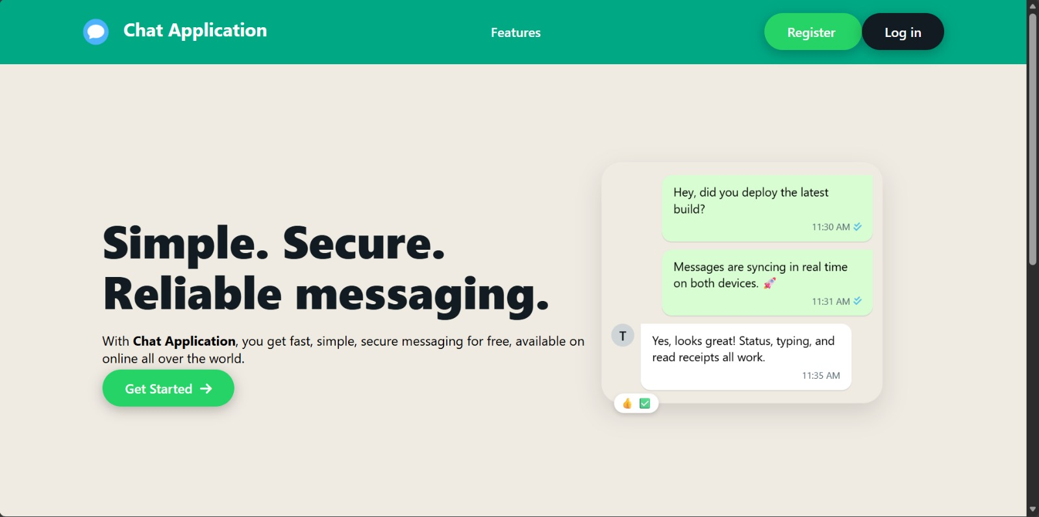
Home Page

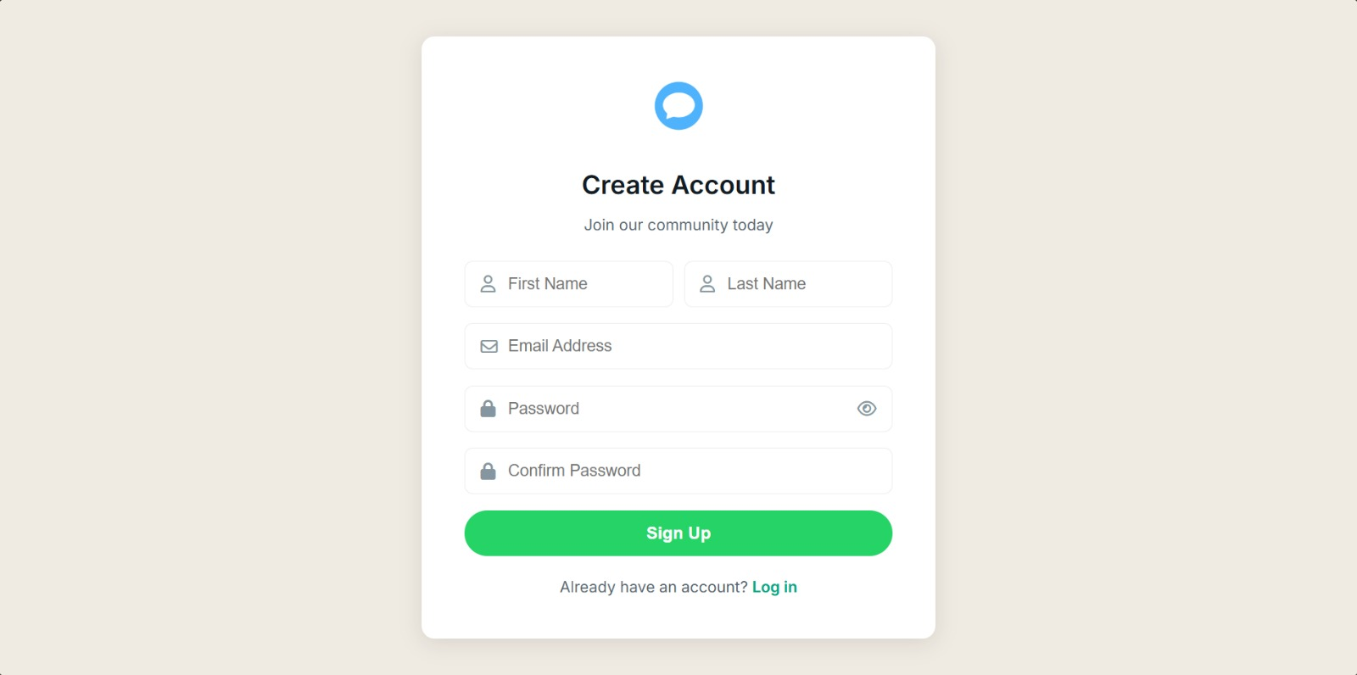
Register Page
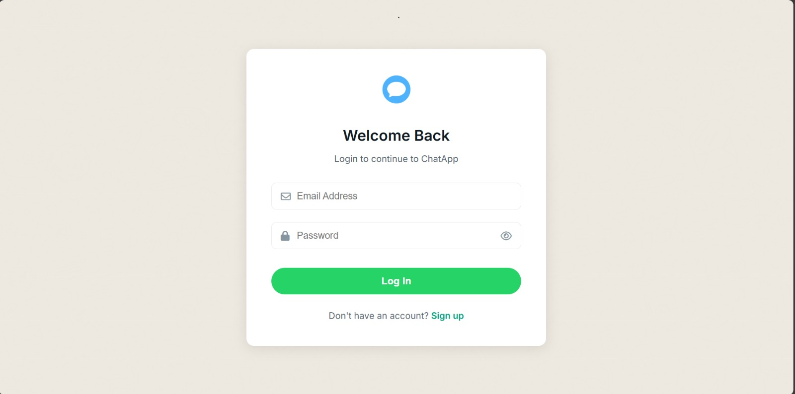
Login Page

4.7 Integration of Components
All components of the system are integrated to work seamlessly:
- REST APIs handle authentication and data retrieval
- WebSocket connections handle real-time messaging
- Database ensures message persistence
- Frontend reflects real-time updates instantly
This integration ensures a smooth and responsive chat experience.
SUMMARY
This chapter describes the implementation of the Real-Time One-to-One Chat Application, where the analysed and designed system is transformed into a fully functional application. It explains how backend, frontend, database, and security components are integrated to achieve secure and real-time communication between users.

CHAPTER 5
QUALITY ASSURANCE AND VALIDATION

5.1 Overview
Quality assurance ensures that the Real-Time One-to-One Chat Application operates reliably under real-world conditions. Unlike traditional applications, a real-time chat system must handle continuous connections, instant data delivery, and secure access simultaneously.
This chapter explains how the application was validated to ensure correctness, performance, security, and usability across all major components.
5.2 Validation Strategy
The validation strategy for this project focuses on verifying the system at multiple levels rather than testing isolated features alone. Each core functionality was validated in scenarios that closely resemble actual user behaviour.
The strategy includes:
Verifying real-time message flow
Validating authentication and authorization logic
Ensuring database consistency
Testing system behaviour under normal and edge conditions
5.3 Authentication and Security Validation
Security validation ensures that only authorized users can access the system and communicate with others.
The following checks were performed:
Verification of JWT token generation after login
Validation of token expiration and invalid token handling
Ensuring protected APIs are inaccessible without authentication
Confirming passwords are stored only in encrypted form
These validations confirm that the system follows stateless and secure authentication principles.

5.4 Real-Time Messaging Validation
Real-time messaging is the core functionality of the application. Validation focuses on message delivery speed, correctness, and reliability.
The following scenarios were tested:
Message delivery between two active users
Message reception without page refresh
Correct ordering of messages
Real-time UI updates using WebSocket events
Successful validation confirms that WebSocket-based communication works as intended.
5.5 Data Persistence and Consistency Checks
To ensure reliability, all messages exchanged between users must be stored and retrievable.
Validation steps include:
Confirming message storage in the database
Retrieving chat history after re-login
Verifying sender and receiver mapping
Ensuring no duplicate or missing messages
This guarantees data consistency across sessions.
5.6 Frontend Interaction Validation
The frontend plays a crucial role in user experience. Validation ensures that the interface responds correctly to user actions and backend events.
Frontend validation includes:
Smooth navigation between pages
Correct rendering of chat messages
Instant UI updates on message arrival
Error handling for invalid inputs
This ensures a responsive and user-friendly interface.

5.7 End-to-End Scenario Testing
End-to-end validation tests the complete flow of the application from the user’s perspective.
Example scenario:
User registers and logs in
User sends a friend request
Friend accepts the request
Users exchange real-time messages
Messages remain available after logout and re-login
This confirms that all modules work together seamlessly.
5.8 Reliability and Stability Observations
During testing, the application demonstrated stable behaviour with multiple active users. Persistent WebSocket connections remained intact, and no unexpected system failures were observed under normal usage conditions.
This indicates that the system is reliable for real-time communication.
5.9 Friendship Management Module Validation
The Friendship Management Module is responsible for handling user relationships within the chat application. This module was validated to ensure that users can securely connect with each other before initiating private conversations.
Validation scenarios include:
- Sending a friend request to another user
- Accepting or rejecting incoming friend requests
- Preventing duplicate or unauthorized friend requests
- Allowing chat functionality only between accepted friends
Successful validation of this module ensures controlled and secure user interactions within the system.
5.10 Notification Module Validation
The Notification Module provides real-time alerts for important events such as incoming friend requests and new messages. This module was validated to ensure timely and accurate delivery of notifications.
Validation checks include:
- Real-time notification delivery using WebSocket events
- Correct notification mapping to the intended user
- Immediate UI updates without page refresh
- Handling multiple notifications simultaneously
This validation confirms that the notification system enhances user experience without affecting performance.
5.11 Admin Monitoring Module Validation
The Admin Monitoring Module allows restricted access to administrative features for observing user activity and system behavior. Validation ensures that only authorized admin users can access these features.
Validation steps include:
- Verifying admin authentication and authorization
- Restricting admin endpoints from regular users
- Viewing user and message metadata securely
- Ensuring no modification of user messages by admin
This module validation confirms transparency and control without compromising user privacy.
5.12 Error Handling and Exception Validation
Proper error handling is essential for maintaining system stability. The application was tested for various error and exception scenarios to ensure graceful failure handling.
Validated scenarios include:
- Invalid login credentials
- Expired or invalid JWT tokens
- WebSocket disconnection and reconnection
- Invalid message payloads
The system responds with appropriate error messages without crashing or exposing sensitive information.

5.13 Performance and Stability Validation
Performance validation was conducted to evaluate system behavior under normal usage conditions. Multiple users were connected simultaneously to test message delivery speed and connection stability.
Observations include:
- Minimal latency in real-time message delivery
- Stable WebSocket connections
- No data loss during active communication
- Consistent performance with concurrent users
This confirms that the application is stable for real-time usage.
5.14 End-to-End Workflow Validation
End-to-end validation ensures that all modules work together seamlessly. Complete user workflows were tested from login to message exchange and logout.
A typical validated workflow includes:
- User registration and login
- Friend request and acceptance
- Real-time message exchange
- Logout and re-login
- Chat history retrieval
Successful execution of this workflow confirms system integrity.
Summary
This chapter presented a unique validation-driven approach to ensuring the quality of the Real-Time One-to-One Chat Application. By validating security, real-time communication.

CHAPTER 6
SYSTEM INTERFACE AND VISUAL REPRESENTATION
6.0 Introduction
This chapter presents the visual representation of the Real-Time One-to-One Chat Application. It highlights the user interface screens that demonstrate how users interact with the system, from authentication to real-time messaging.
The screenshots included in this chapter provide a clear understanding of the system’s functionality and user experience.
6.1 Home Page
In the home page we are have register page, login page and get started where user can register/login.

6.2 User Registration Page
The User Registration Page allows new users to create an account by providing required details such as username, email, and password. Input validations are applied to ensure correct and secure data entry.
This screen serves as the entry point for new users into the system.

User Registration Page
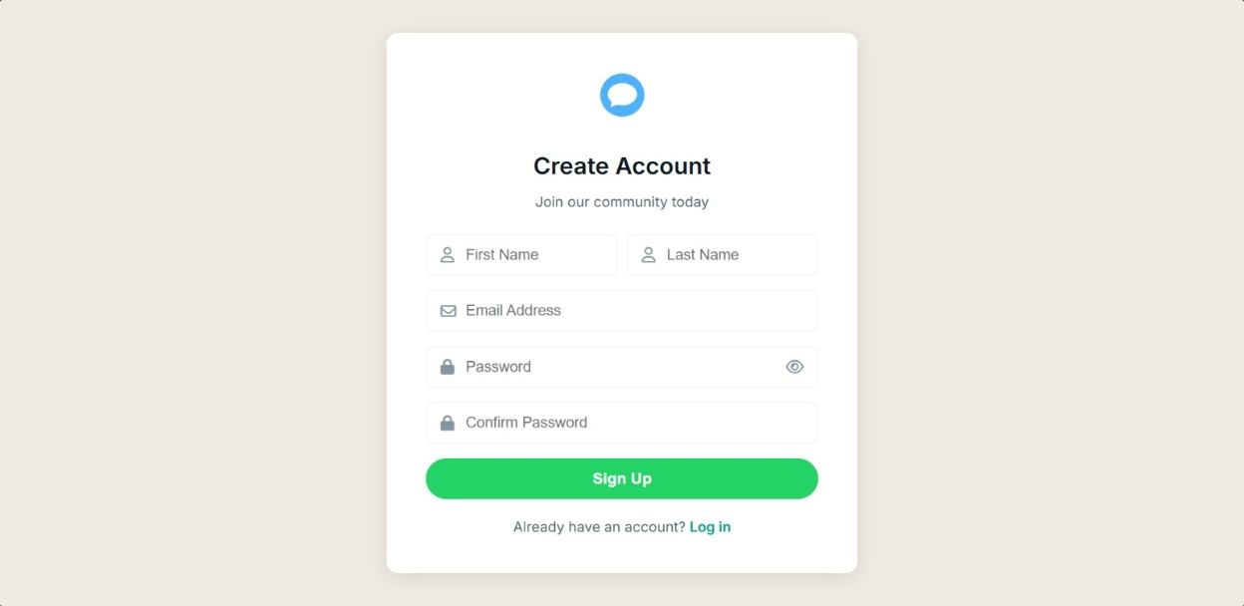
6.3 User Login Page
The User Login Page enables registered users to authenticate themselves using valid credentials. Upon successful login, a JWT token is generated and the user is granted access to protected features of the application.
This page ensures secure and controlled access to the system.
User Login Page
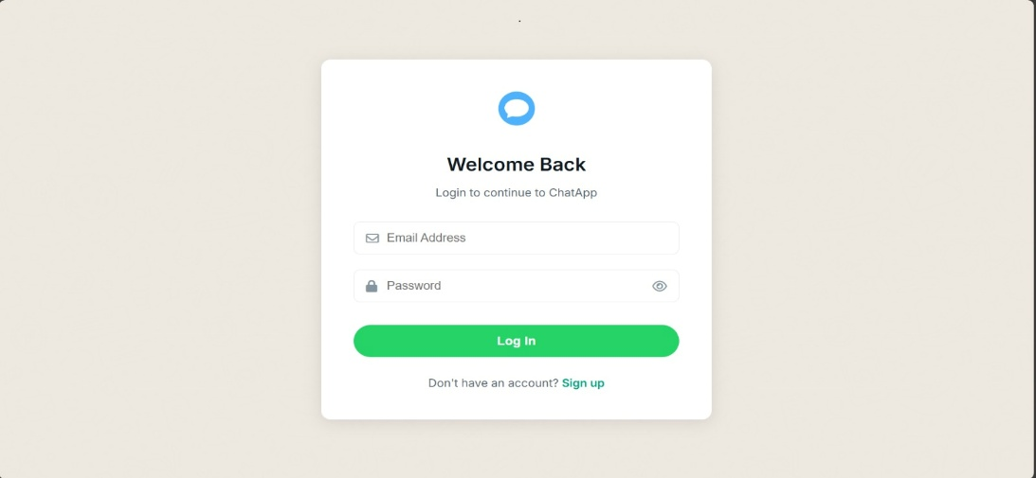
6.4 User Dashboard
The User Dashboard acts as the main interface after login. It displays user-related information and navigation options to access chat, friend requests, and notifications.
The dashboard provides a centralized view for managing all user activities.
The User Dashboard is the main control center where users can view their profile, see their active chats, and select friends to start real-time conversations.
It provides quick access to messaging features while managing the WebSocket connection securely in the background.
User Dashboard
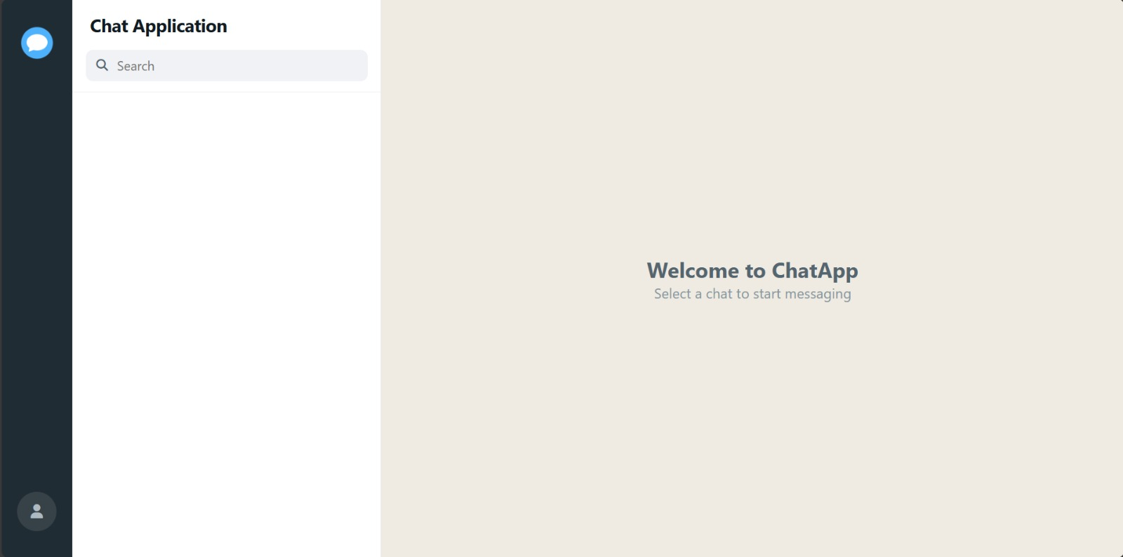
6.5 Friend Request Interface
The Friend Request Interface allows users to send, accept, or reject friend requests. Only users with an accepted friendship status are allowed to initiate private conversations.
This interface ensures controlled and secure communication between users.
The Friend Request interface in our real-time one-to-one chat application allows users to manage incoming connection requests easily. Users can view sender details and accept or reject requests with a single action. Once accepted, the users are instantly connected and allowed to start secure real-time messaging.
Friend Request Interface
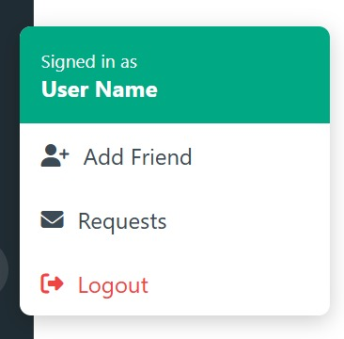
6.6 One-to-One Chat Interface
The One-to-One Chat Interface is the core component of the application. It enables real-time message exchange between two users using WebSocket connections.
Messages are displayed instantly without page refresh, and chat history is preserved for future access.
One-to-One Chat Interface
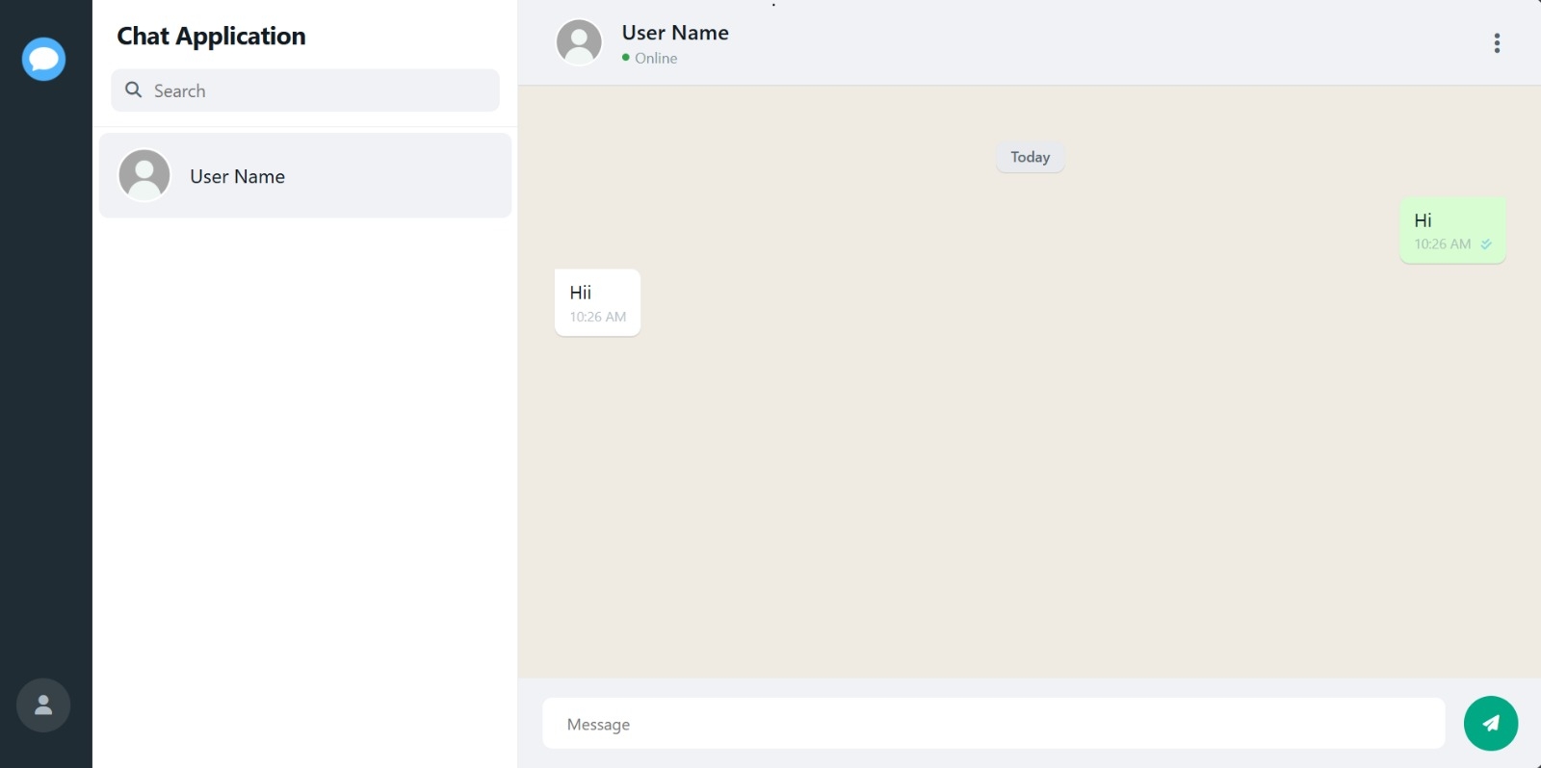
6.7 Real-Time Notification Panel
The Notification Panel displays real-time alerts for incoming messages and friend requests. Notifications are delivered instantly using WebSocket events.
This feature enhances user engagement and responsiveness.
When a new message arrives, the system instantly pushes it to the user using a real-time connection, so there’s no refresh drama.
A notification alert (sound, badge, or popup) is triggered to let the user know a new message has landed.
If the user is offline, the message is saved in the database and shown as an unread notification when they log back in.
Add Friend
The Add Friend feature allows users to search for other users and send a friend request. Once the request is sent, the system stores it with a pending status and prevents duplicate requests. This ensures users can only connect through proper approval, keeping interactions intentional and secure.
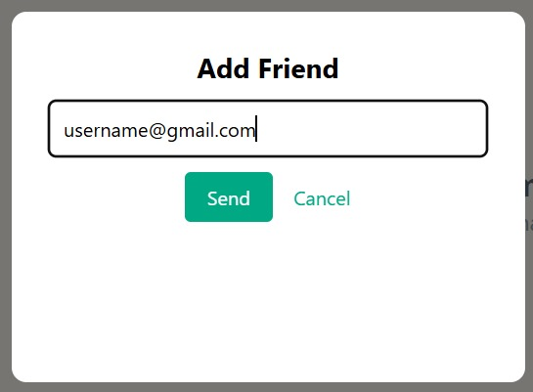

Notification Panel
Friend request sending :
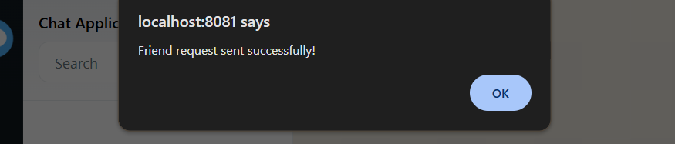
Friend Request Received
When a user receives a friend request, it appears instantly in the Friend Request interface. The user can view sender details and choose to accept or reject the request. Real-time notifications ensure the user never misses a request.

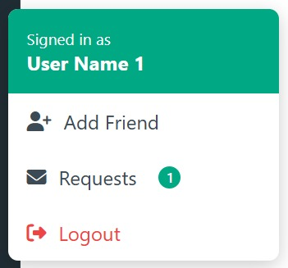
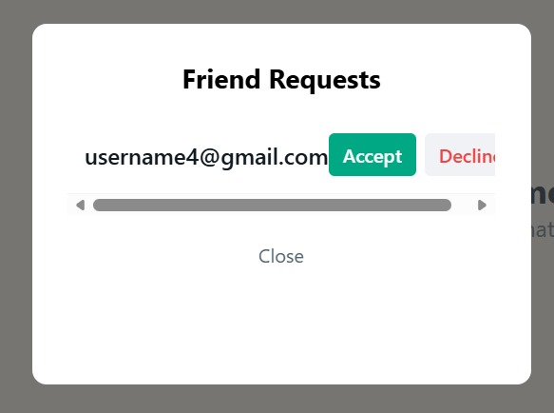

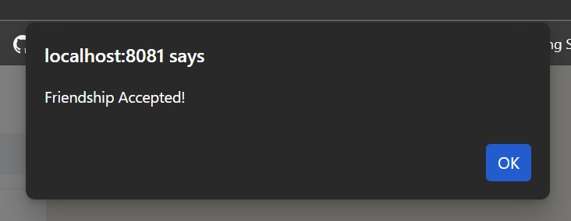

Delete / Remove Friend
The Delete Friend option allows users to remove an existing connection at any time. Once removed, the friendship link is deleted from the database and chat access is revoked. This gives users full control over their connections and privacy within the application
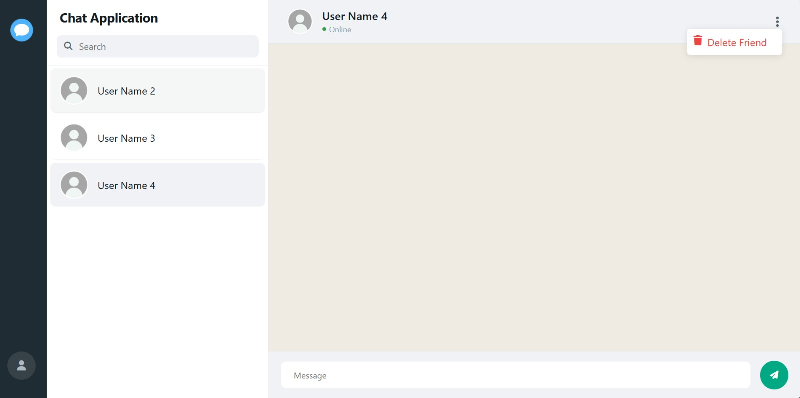

6.8 Message History View
The Message History View allows users to view previous conversations after logging in again. Messages are retrieved from the database and displayed in chronological order.
This ensures continuity of communication.

CHAPTER 7
SYSTEM WORKFLOW USING FLOWCHARTS AND TABLES
This section explains the internal workflow of the proposed Real-Time One-to-One Chat Application using block diagrams. Block diagrams are used to visually represent the flow of control and data between major system components in a simplified and easy-to-understand manner.
Each block represents a functional module, and arrows indicate the direction of data flow between modules.
This block diagram explains the complete workflow of a secure real-time chat application, starting from when a user opens the app, handling registration/login, establishing a JWT-secured WebSocket connection, enabling real-time messaging, storing messages in the database, and finally logging out.
BLOCK DIAGRAM: USER LOGIN TO MESSAGE DELIVERY
The process begins when the User enters login credentials through the Login Page (UI). The frontend sends these credentials to the backend Authentication Controller, which acts as the entry point for all authentication-related requests.
The block diagram represents the complete flow of user authentication and real-time message delivery in the chat application.
Initially, the user opens the application and logs in by providing valid credentials. The authentication module verifies the user details and generates a secure session or token. Once authenticated, the user establishes a WebSocket connection with the server.
After the connection is established, the user can send messages through the chat interface. The message is transmitted to the server via the WebSocket module, where it is processed and stored in the database. The server then delivers the message instantly to the intended receiver, ensuring real-time one-to-one communication.
This flow ensures secure login, persistent connection, and fast message delivery.
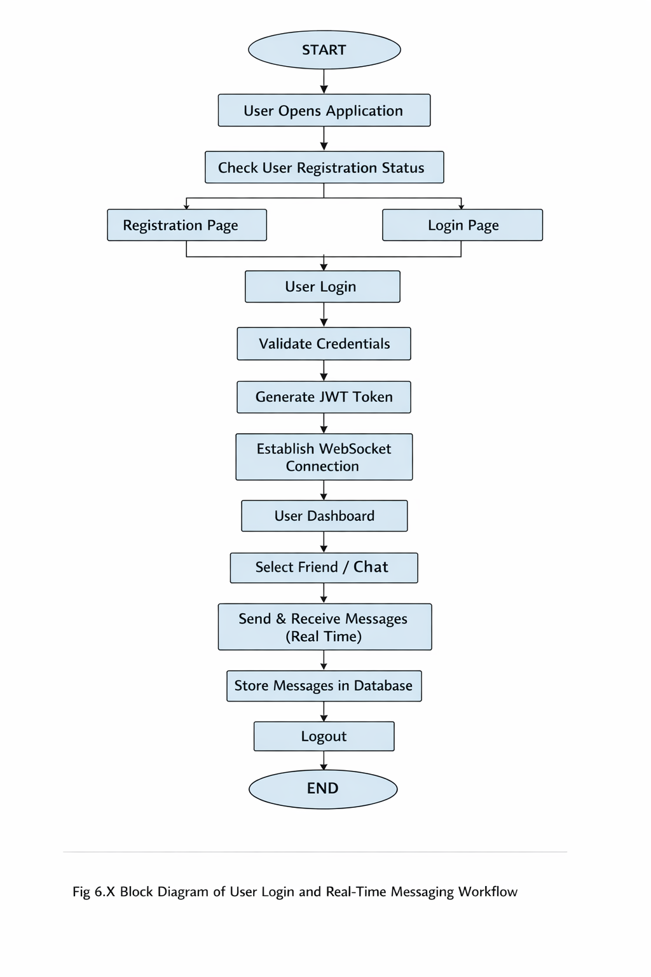
Step-Wise Explanation (Write This Below the Diagram)
Step 1: Start
The process begins when the system is initialized.
Step 2: User Opens Application
The user launches the chat application on their device.
Step 3: Check User Registration Status
The system checks whether the user is already registered in the database.
- If not registered → Redirect to Registration Page
- If registered → Redirect to Login Page
Step 4: Registration / Login Page
- New users provide details and complete registration.
- Existing users proceed directly to login.
Both paths eventually lead to authentication.
Step 5: User Login
The user enters login credentials (email/username and password).
Step 6: Validate Credentials
The backend verifies the credentials against stored records.
- If invalid → Access denied
- If valid → Authentication successful
Step 7: Generate JWT Token
After successful validation, a JWT (JSON Web Token) is generated to maintain secure, stateless authentication.
Step 8: Establish WebSocket Connection
Using the JWT token, a secure WebSocket connection is established for real-time communication.
Step 9: User Dashboard
The authenticated user is redirected to the dashboard where chat features are available.
Step 10: Select Friend / Chat
The user selects a contact or chat room to start messaging.
Step 11: Send & Receive Messages (Real Time)
Messages are exchanged instantly between users using WebSocket technology.
Step 12: Store Messages in Database
All sent and received messages are stored persistently in the database for history and reliability.
Step 13: Logout
The user logs out, and the session/token is invalidated.
Step 14: End
The workflow ends safely.
The block diagram represents the complete flow of user authentication and real-time message delivery in the chat application.
Initially, the user opens the application and logs in by providing valid credentials. The authentication module verifies the user details and generates a secure session or token. Once authenticated, the user establishes a WebSocket connection with the server.
After the connection is established, the user can send messages through the chat interface. The message is transmitted to the server via the WebSocket module, where it is processed and stored in the database. The server then delivers the message instantly to the intended receiver, ensuring real-time one-to-one communication.

7.1 User Login Block Diagram
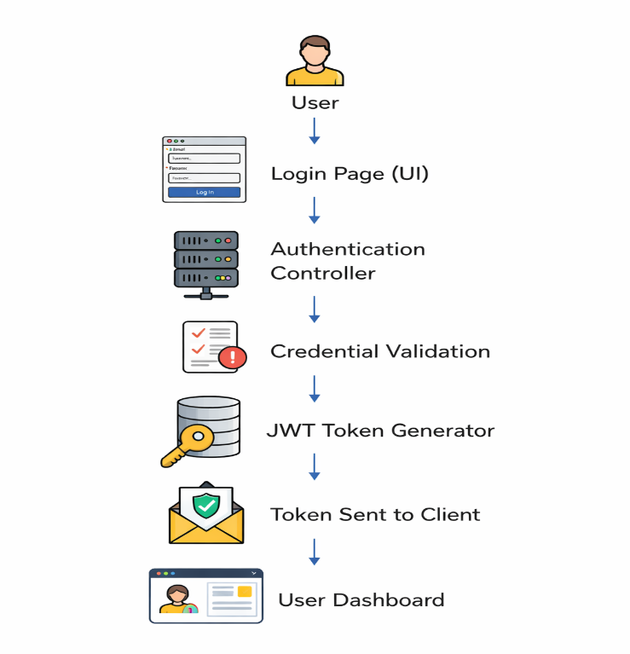

Detailed Explanation:
This block diagram illustrates the complete user authentication process.
The process begins when the user enters login credentials through the Login Page (UI). The frontend sends these credentials to the backend Authentication Controller, which acts as the entry point for all authentication-related requests.
The Credential Validation block verifies the submitted credentials by checking them against securely stored user data in the database. Passwords are never stored or compared in plain text; instead, encrypted password hashes are validated to ensure security.
Once validation is successful, the JWT Token Generator creates a signed JSON Web Token containing the user’s identity and authorization details. This token is sent back to the client and stored securely on the client side.
Finally, the authenticated user is redirected to the User Dashboard, which serves as the main interface for accessing chat functionality.

7.2 WebSocket Connection Block Diagram
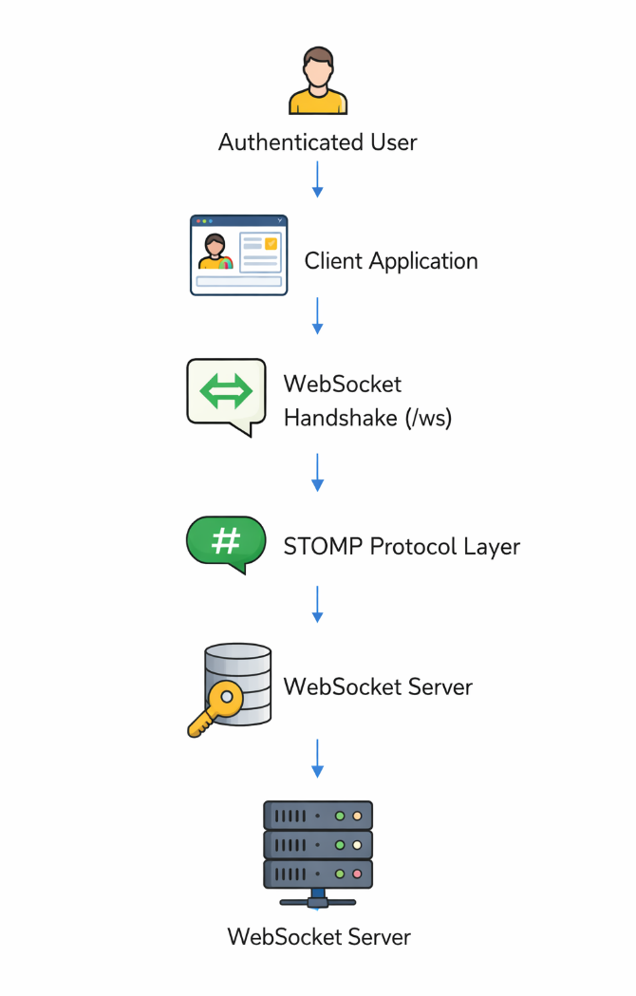
Detailed Explanation:
This block diagram represents the establishment of a real-time communication channel.
After successful authentication, the Authenticated User initiates a connection from the Client Application. The client sends a request to the backend WebSocket endpoint (/ws) to initiate a WebSocket Handshake.
Once the handshake is completed, communication is managed using the STOMP protocol layer, which provides message routing, subscription handling, and structured messaging over WebSockets.
The WebSocket Server maintains a persistent, bidirectional connection with the client, enabling instant message exchange without repeated HTTP requests. This architecture ensures low latency and efficient real-time communication.
7.3 One-to-One Message Sending Block Diagram
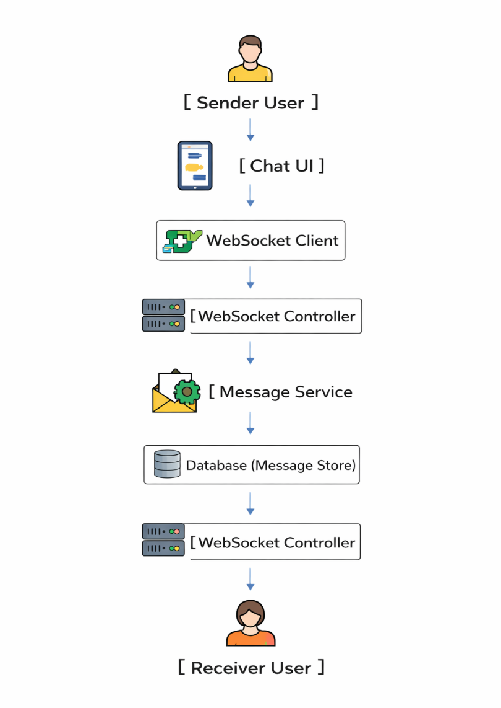

Detailed Explanation:
This block diagram explains the real-time one-to-one messaging flow.
The Sender User types a message using the Chat UI. The message is immediately sent to the backend through the WebSocket Client, ensuring real-time transmission.
The WebSocket Controller receives the message and forwards it to the Message Service, which handles business logic such as message formatting, timestamping, and sender–receiver mapping.
The message is then stored in the Database (Message Store) to ensure persistence and message history availability. After successful storage, the message is routed back through the WebSocket Controller and delivered instantly to the Receiver User.
7.4 Complete Login-to-Message Flow Block Diagram
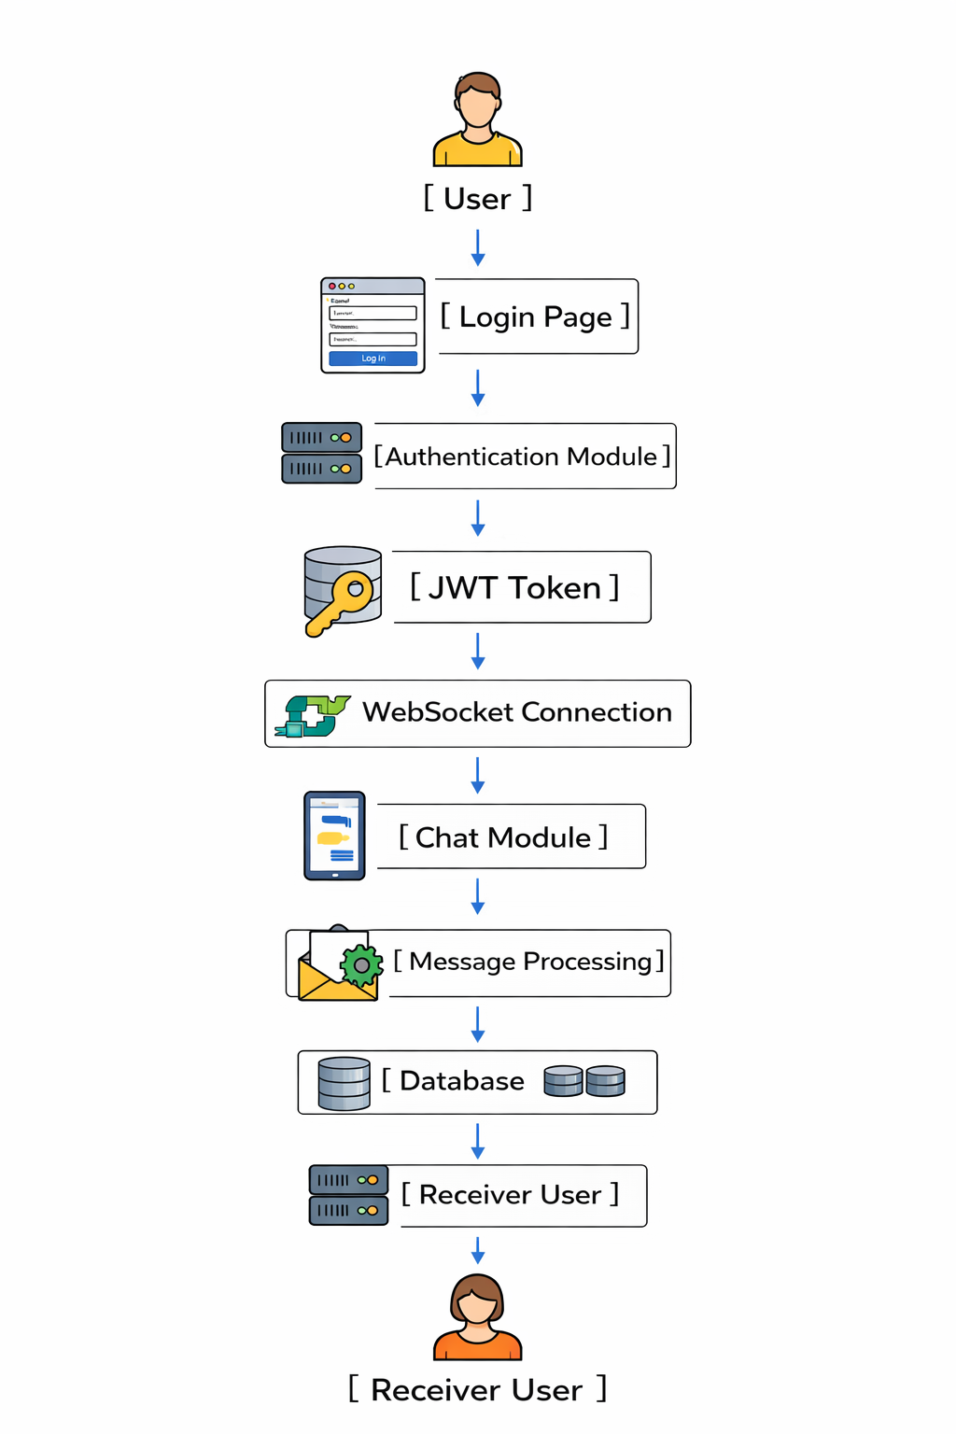
Detailed Explanation:
This block diagram provides a holistic view of the entire system workflow, starting from user authentication and ending with message delivery.
The user logs in through the Login Page, where credentials are processed by the Authentication Module. Upon successful authentication, a JWT Token is issued and used to authorize further requests.
The authenticated session establishes a WebSocket Connection, enabling real-time interaction within the Chat Module. Messages are processed, validated, and stored through the Message Processing and Database blocks.
Finally, messages are delivered instantly to the Receiver User, completing the end-to-end communication cycle.
7.5 Supporting Block Diagram – Module Interaction
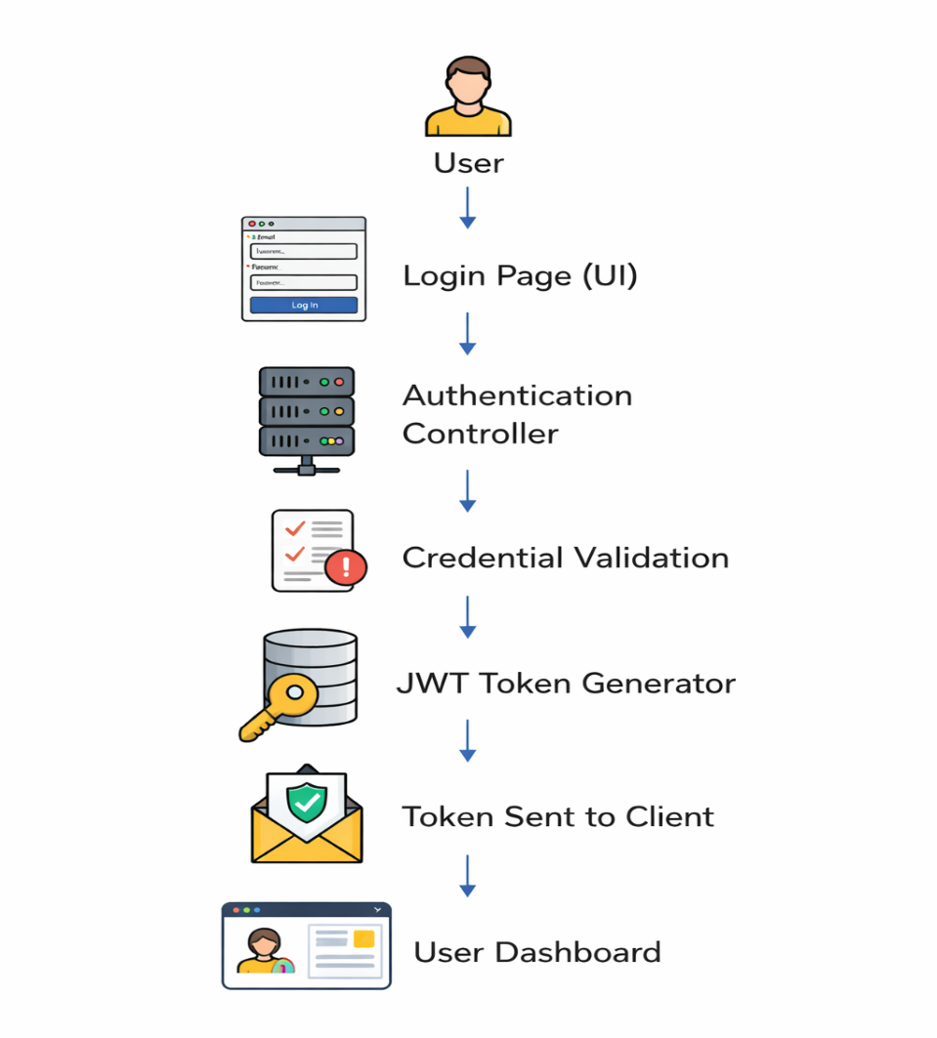

Detailed Explanation:
This supporting diagram shows the interaction between major system modules.
The Frontend communicates with the Authentication Module for secure access. Once authenticated, users interact with the Chat Module, which relies on the WebSocket Module for real-time communication.
All messages and user data are managed by the Database Module, ensuring consistency, security, and persistence across the system.
SUMMARY
The system workflow illustrates the end-to-end operation of the real-time one-to-one chat application using flowcharts and tables for better clarity. The flowcharts visually represent the sequence of actions starting from user registration and login, followed by authentication, connection establishment, message transmission, and message delivery. Each step shows how data flows between the user interface, server, and database.
Tables are used to clearly describe the inputs, processes, and outputs of each module in the system. This structured representation helps in understanding system behavior, simplifies implementation, and ensures smooth coordination between different components of the application. Overall, the workflow ensures secure access, real-time communication, and reliable message handling.

CHAPTER 8
DETAILED PROJECT DESCRIPTION AND ANALYSIS
8.1 Introduction
This chapter provides a detailed description and technical analysis of the Real-Time One-to-One Chat Application. It explains the fundamental concept of the system, the working principles behind real-time communication, and the integration of various components used to build the application.
The chapter focuses on how the project operates internally and how different technologies are combined to deliver secure and real-time messaging functionality.
8.2 Core Concept of the Project
The Real-Time One-to-One Chat Application is designed to facilitate instant private communication between two authenticated users. Unlike traditional web applications that rely on repeated HTTP requests, this system maintains persistent connections to support real-time data exchange.
The core idea of the project is based on:
Continuous client–server communication
Event-driven message handling
Stateless security mechanisms
Reliable message storage
This approach closely reflects how modern messaging platform’s function.
8.3 Real-Time Communication Mechanism
Real-time communication in the application is achieved using WebSocket technology with the STOMP protocol.
After successful authentication, the client establishes a persistent WebSocket connection with the server.

• Bidirectional data transfer
• Topic-based message routing
• Immediate message propagation
• Reduced network overhead
This mechanism ensures instant delivery of messages without the need for page refresh or polling.
8.4 Authentication and Authorization Flow
Authentication is handled using JSON Web Tokens (JWT), enabling stateless and secure access control. Upon successful login, a token is generated and sent to the client.
The authentication flow involves:
• User credential verification
• Token generation and validation
• Securing REST APIs using filters
• Restricting WebSocket access to authenticated users
Authorization rules ensure that only permitted users can access specific features such as admin functionalities.
8.5 Backend Architecture and Processing
The backend of the application is developed using Spring Boot, following a layered architecture that separates responsibilities.
The backend consists of:
• REST Controllers for authentication and data access
• WebSocket Controllers for handling real-time messages
• Service Layer for business logic
• Repository Layer for database interactions
This structure improves scalability, maintainability, and clarity of the system.
8.6 Database Design and Data Handling
The application uses a relational database to manage user information, messages, and friendship relationships. Structured data storage ensures consistency and reliability.
Data handling includes:
• Storage of user credentials and profiles
• Message persistence with sender–receiver mapping
• Friendship status tracking
• Retrieval of chat history
This design enables seamless access to historical conversations.
8.7 Frontend Architecture and Interaction Handling
The frontend is implemented using HTML, CSS, and Vanilla JavaScript, allowing direct control over user interactions and UI updates.
Frontend responsibilities include:
• Rendering user interfaces
• Handling authentication tokens
• Establishing WebSocket connections
• Updating the chat interface in real time
Manual state management ensures accurate and responsive UI behavior.
8.8 User Interaction Workflow
The application follows a structured user workflow to ensure ease of use and reliability.
The typical workflow includes:
1. User registration and login
2. Authentication token generation
3. Establishment of WebSocket connection
4. Friend request and acceptance
5. Real-time message exchange
6. Persistent storage of messages
This workflow ensures controlled and secure communication.
8.9 Message Lifecycle in the System
Each message follows a defined lifecycle within the application:
• Message creation on the client side
• Transmission through WebSocket
• Processing in the server-side controller
• Storage in the database
• Delivery to the recipient
This lifecycle guarantees both real-time delivery and long-term persistence.
8.10 Performance Considerations
The system is designed to maintain performance during active communication. Persistent WebSocket connections reduce latency and improve throughput.
Performance considerations include:
• Efficient message routing
• Reduced server load
• Stable connection handling
• Consistent response time
These considerations ensure smooth operation under normal usage conditions.
8.11 Modularity and Maintainability
The application is divided into independent modules such as authentication, chat, friendship, and admin modules. Each module performs a specific function and interacts with others through defined interfaces.
This modular approach simplifies debugging, testing, and future extension of the system.
8.12 Engineering Significance of the Chapter
This chapter demonstrates the practical implementation of real-time systems, secure authentication, and full-stack integration. It highlights the technical depth of the project and its alignment with real-world software engineering practices.
Summary
This chapter explains the design, working principles, and internal architecture of the Real-Time One-to-One Chat Application. It focuses on how real-time communication is achieved by integrating multiple technologies to provide secure, efficient, and reliable messaging.
The system is built around the concept of persistent client–server communication using WebSocket technology with the STOMP protocol, enabling instant, bidirectional message exchange without repeated HTTP requests. Event-driven processing ensures immediate message delivery with reduced network overhead.
Security is implemented using JSON Web Tokens (JWT), providing stateless authentication and authorization. Only authenticated users are allowed to access REST APIs and establish WebSocket connections, ensuring controlled and secure communication.
The backend follows a layered Spring Boot architecture, separating controllers, services, and repositories to improve scalability and maintainability. Data is stored in a relational database, supporting user management, message persistence, friendship tracking, and retrieval of chat history.
The frontend, developed using HTML, CSS, and JavaScript, manages user interactions, authentication tokens, and real-time UI updates through WebSocket connections. A structured user workflow governs registration, authentication, messaging, and data storage.
Overall, this chapter highlights the engineering significance of the project by demonstrating practical implementation of real-time systems, secure access control, and full-stack integration aligned with modern software engineering practices.

CHAPTER 9
REFERENCES AND CONCLUSION
9.1 Introduction
This chapter presents the concluding discussion of the project titled “Real-Time One-to-One Chat Application”. It summarizes the objectives, design decisions, technologies used, and outcomes achieved during the development of the system. The chapter also reflects on the learning outcomes and engineering relevance of the project while outlining potential enhancements and future scope. Finally, a detailed list of references used throughout the project is provided to acknowledge the technical sources and documentation that guided the development process.
9.2 Project Overview and Achievements
The primary objective of this project was to design and implement a real-time messaging system that allows two authenticated users to communicate instantly and securely. Unlike conventional web applications that rely on repeated HTTP request–response cycles, this system utilizes persistent communication to ensure immediate data exchange.
The project successfully achieves the following objectives:
- Implementation of real-time communication using WebSocket technology
- Secure authentication and authorization using JWT
- Reliable message delivery with database persistence
- Modular and scalable backend architecture
- Responsive and interactive frontend user interface
The application closely mirrors the behaviour of modern messaging platforms while maintaining simplicity suitable for academic evaluation.

9.3 Technical Outcomes and System Effectiveness
The system demonstrates effective integration of frontend and backend components to deliver seamless communication. Persistent WebSocket connections significantly reduce latency and server overhead, resulting in faster message delivery compared to traditional polling-based approaches.
JWT-based stateless authentication ensures secure access control without maintaining server-side session data. This approach enhances scalability and aligns with modern security practices. The layered backend architecture improves maintainability by clearly separating responsibilities across controllers, services, and repositories.
The database design enables reliable storage of user credentials, friendship relationships, and chat history. This ensures both real-time delivery and long-term availability of messages, which is a critical requirement for messaging systems.
9.4 Learning Outcomes and Engineering Skills Gained
This project provided hands-on exposure to several important software engineering concepts and technologies. Key learning outcomes include:
- Understanding real-time communication models and WebSocket protocols
- Practical implementation of stateless authentication mechanisms
- Experience with full-stack application development
- Exposure to backend architectural patterns and modular design
- Database modeling for real-world applications
The project strengthened problem-solving abilities and improved understanding of how real-time systems operate in production environments.
9.5 Practical Applications and Industry Relevance
Real-time messaging systems are widely used in applications such as customer support platforms, collaboration tools, social networking applications, and online gaming systems. The concepts implemented in this project are directly applicable to industry-level systems.
The project aligns with industry practices such as event-driven architecture, secure API design, and separation of concerns. It provides a strong foundation for understanding scalable real-time systems and prepares students for advanced development roles in backend and full-stack engineering.
9.6 Limitations of the Current System
While the project meets its intended objectives, certain limitations exist:
- The application currently supports only one-to-one messaging
- Media sharing functionality is not implemented
- End-to-end encryption is not included
- Mobile platform support is not available
- Deployment is limited to a local or basic server environment
These limitations were consciously accepted to maintain scope clarity and academic focus.
9.7 Future Scope and Enhancements
The system can be enhanced in multiple ways to increase functionality, security, and scalability:
- Group Chat Support: Allowing multiple users to participate in a single conversation
- End-to-End Encryption: Ensuring message confidentiality between users
- Media Sharing: Support for images, documents, and videos
- Push Notifications: Alerts for offline users
- Mobile Application Integration: Android and iOS clients
- Cloud Deployment: Hosting on cloud platforms for high availability
- Load Balancing: Handling high user traffic efficiently
These enhancements would transform the application into a production-ready communication platform.
9.8 Conclusion
The Real-Time One-to-One Chat Application successfully demonstrates the design and implementation of a secure, scalable, and efficient real-time messaging system. The project integrates modern technologies and follows sound software engineering principles to deliver a functional and reliable application.
Through persistent communication, stateless authentication, and structured architecture, the system achieves its goal of instant and secure user communication. The project not only fulfills academic requirements but also provides valuable industry-relevant experience.
In conclusion, this project stands as a strong example of practical full-stack development and real-time system implementation, reflecting both technical competence and engineering discipline.

REFERENCES
🔗 Online References
- HTML – W3Schools
https://www.w3schools.com/html/
- CSS – W3Schools
https://www.w3schools.com/css/
- JavaScript – W3Schools
https://www.w3schools.com/js/
- JavaScript DOM – W3Schools
https://www.w3schools.com/js/js_htmldom.asp
- SQL – W3Schools
https://www.w3schools.com/sql/
- MySQL – W3Schools
https://www.w3schools.com/mysql/
- Java – W3Schools
https://www.w3schools.com/java/
- JDBC – GeeksforGeeks
https://www.geeksforgeeks.org/java-database-connectivity-with-mysql/
- Spring Boot – GeeksforGeeks
https://www.geeksforgeeks.org/spring-boot/
- Spring Security – GeeksforGeeks
https://www.geeksforgeeks.org/spring-security/
- WebSocket – GeeksforGeeks
https://www.geeksforgeeks.org/web-socket-in-java/
- REST API Concepts – GeeksforGeeks
https://www.geeksforgeeks.org/rest-api-introduction/
- JWT Authentication – GeeksforGeeks
https://www.geeksforgeeks.org/json-web-token-jwt/
- HTTP Protocol Basics – MDN Web Docs
https://developer.mozilla.org/en-US/docs/Web/HTTP
- WebSocket Protocol – MDN Web Docs
https://developer.mozilla.org/en-US/docs/Web/API/WebSockets_API
Textbooks References
- HTML & CSS: Design and Build Websites – Jon Duckett
- JavaScript: The Definitive Guide – David Flanagan
- Eloquent JavaScript – Marijn Haverbeke
- Head First HTML and CSS – Eric Freeman, Elisabeth Robson
- Core Java Volume I – Cay S. Horstmann
- Effective Java – Joshua Bloch
- Spring in Action – Craig Walls
- Pro Spring Boot – Felipe Gutierrez
- Java Persistence with Hibernate – Christian Bauer, Gavin King
- Database System Concepts – Abraham Silberschatz, Henry Korth, S. Sudarshan
- SQL, PL/SQL: The Programming Language of Oracle – Ivan Bayross
- Fundamentals of Database Systems – Ramez Elmasri, Shamkant Navathe

