**Major Project Report**

**Submitted in partial fulfilment of the degree of**

**CSE**

**By**

**Trinankur Atarthi (11900120078)**

**Third year student of**

**Siliguri Institute of Technology**

**Under the supervision of**

**Mr. Mainak Deb**

**SikharthyInfotechPvt. Ltd.**

**Department of Computer Science & Engineering**

Date: 15/09/2022

I hereby forward the documentation prepared under my supervision **Trinankur Atarthi** entitled **Siliguri Institute of Technology**  be accepted as fulfilment of the requirement for the Degree of Bachelor of **Computer Science & Engineering**(CSE) in **Computer Application**from **Siliguri Institute of Technology** affiliated to **Maulana Abul Kalam Azad University of Technology** (**MAKAUT**) .

|  |  |
| --- | --- |
| ______________________________  **Mr.Mainak Deb**  **Project Guide**  **SikharthyInfotechPvt. Ltd.** | ____________________________________  **Trinankur Atarthi**  **Computer Science & Engineering**  **Siliguri Institute of Technology** |

**FACIMOJI**

By

**Trinankur Atarthi(11900120078)**

UNDER THE GUIDANCE OF

**Mr. Mainak Deb**

**Project Guide**

**SikharthyInfotechPvt. Ltd.**

THEIS SUBMITTED IN FULFILLMENT OFTHE REQUIREMENTS FOR THE DEGREE OF

**C.S.E**

IN

COMPUTER SCIENCE & ENGINEERING

**SILIGURI INSTITUTE OF TECHNOLOGY**

**AFFILIATED TO**

**MaulanaAbulKalam Azad University of Technology**

[**Address**](https://www.google.co.in/search?rlz=1C1GTPM_enIN734IN734&biw=1366&bih=613&q=future+institute+of+technology+address&stick=H4sIAAAAAAAAAOPgE-LVT9c3NEyrMC-JTzbO0JLNTrbSz8lPTizJzM-DM6wSU1KKUouLAYQ6jCEwAAAA&sa=X&ved=0ahUKEwi3htjS0_rbAhVLQY8KHTJnC-kQ6BMI1wEwEQ)**:**Bengal Pailan Park, Sector 1,Phase 1,Amgachia Road, Pailan, Joka, Kolkata, West Bengal-700104

[**Phone**](https://www.google.co.in/search?rlz=1C1GTPM_enIN734IN734&biw=1366&bih=613&q=future+institute+of+technology+phone&sa=X&ved=0ahUKEwi3htjS0_rbAhVLQY8KHTJnC-kQ6BMI6gEwEw)**:**(033)2453 5605/9836911117

**Email:**frontoffice@pcmt-india.net

**Website**:pcmt-india.net

**Certificate of Approval**

The foregoing project is hereby approved as a creditable study for the CSE in Computer Science & Engineering and presented in a manner of satisfactory to warrant its acceptance as a prerequisite to the degree for which it has been submitted. It is understood that by this approval the undersigned do not necessarily endorsed or approved any statement made, opinion express or conclusion therein but approve this project only for the purpose for which it is submitted.

Final Examination for

Evaluation of the Project ----------------------------------------

-----------------------------------------

------------------------------------------

Signatures of Examiners

------------------------------------------------------------------------------------------------

**ABSTRACT**

The purpose of the project entitled as “FACIMOJI” is to develop a Machine Learning Project is user friendly simple, fast, Furistic. It’s manage of users data who is interested to using this feature. The main function of the system is to make emoji using human face. Admin can add,update or remove any emoji day by day from admin panel.

**ACKNOWLEDGEMENT**

It is a great pleasure for me to acknowledge the assistance and participation of a large number of individuals to this attempt. Our project report has been structured under the valued suggestion, support and guidance of **Mr.Mainak Deb**. Under his guidance we have accomplished the challenging task in a very short time.

Finally, we express our sincere thankfulness to our family members for inspiring me all throughout and always encouraging us.

**Trinankur Atarthi**

**Computer Application**

**TABLE OF CONTENTS**

Chapter 1: Introduction

1: Introduction

Chapter 2: What We Used

2.1: Python

2.2: Keras

2.3: OpenCV

2.4: IDE

Chapter 3: Functionality of the Website

3.1: User Login Page

3.2: User Registration Page

3.3: Admin Login Page

3.4: Admin Dashboard Page

Chapter 4:FEATURES

4.1: ADMIN

4.2:USER

Chapter 5: System Analysis

5.1: Identification of the need

5.2: Preliminary Investigation

5.3: Feasibility Study

Chapter 6:Project Planning and Scheduling

Chapter 7: Functional Requirement of the System

7.1: Hardware Requirement

7.2: Software Requirement

Chapter 8: Database Design

8.1: Data Dictionary

Chapter 9: Conclusion

Chapter 10: References

**INTRODUCTION**

In daily life and especially in face-to-face (F2F) communication, humans are able to express their feelings and states by changing their emotional facial expressions. Nevertheless, these facial expressions are not only demonstrating feelings, but also other information, including mood and can be accompanied by gestures, prosody and contextual cues ([Aldunate and González-Ibáñez, 2017](https://www.frontiersin.org/articles/10.3389/fpsyg.2021.645173/full" \l "B3)). Nowadays, people are confronted with a lot of social exchange situations which are not comparable to F2F-communication, for example in computer or mobile-based communication (CMC) platforms. Via Email, Instant Messaging Chats (e.g., Facebook) or social media platforms (e.g., Instagram) the written communication has enormously grown. Within this type of communication emoji or emoticons are available to still be able to express our feelings to our chatting partners

**2. PYTHON & Keras**

**2.1 PYTHON**

We used python 3.9.0 , In this project we learned about python data-types, string methos, list, touples, function, sorting, slicing and used some of this in our program.

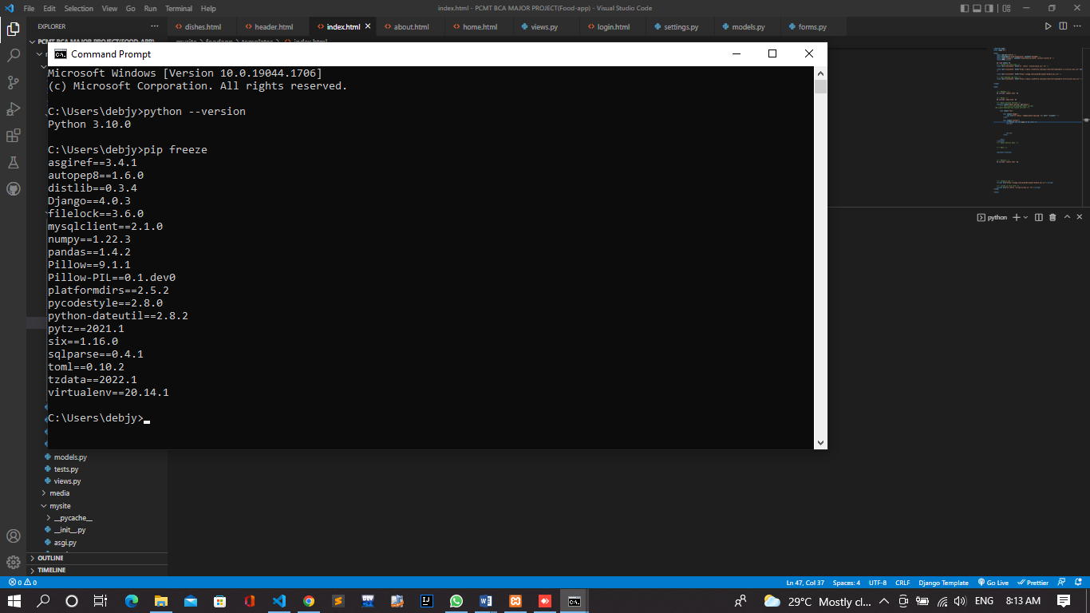

**2.2Keras**

Keras is an open-source software library that provides a Python interface for artificial neural networks. Keras acts as an interface for the TensorFlow library. Up until version 2.3, Keras supported multiple backends, including TensorFlow, Microsoft Cognitive Toolkit, Theano, and PlaidML

**2.3OpenCV**

OpenCV is a library of programming functions mainly aimed at real-time computer vision. Originally developed by Intel, it was later supported by Willow Garage then Itseez. The library is cross-platform and free for use under the open-source Apache 2 License.

**2.4IDE**

We used Microsoft Visual Studio Code(VS Code) in our project as IDE.

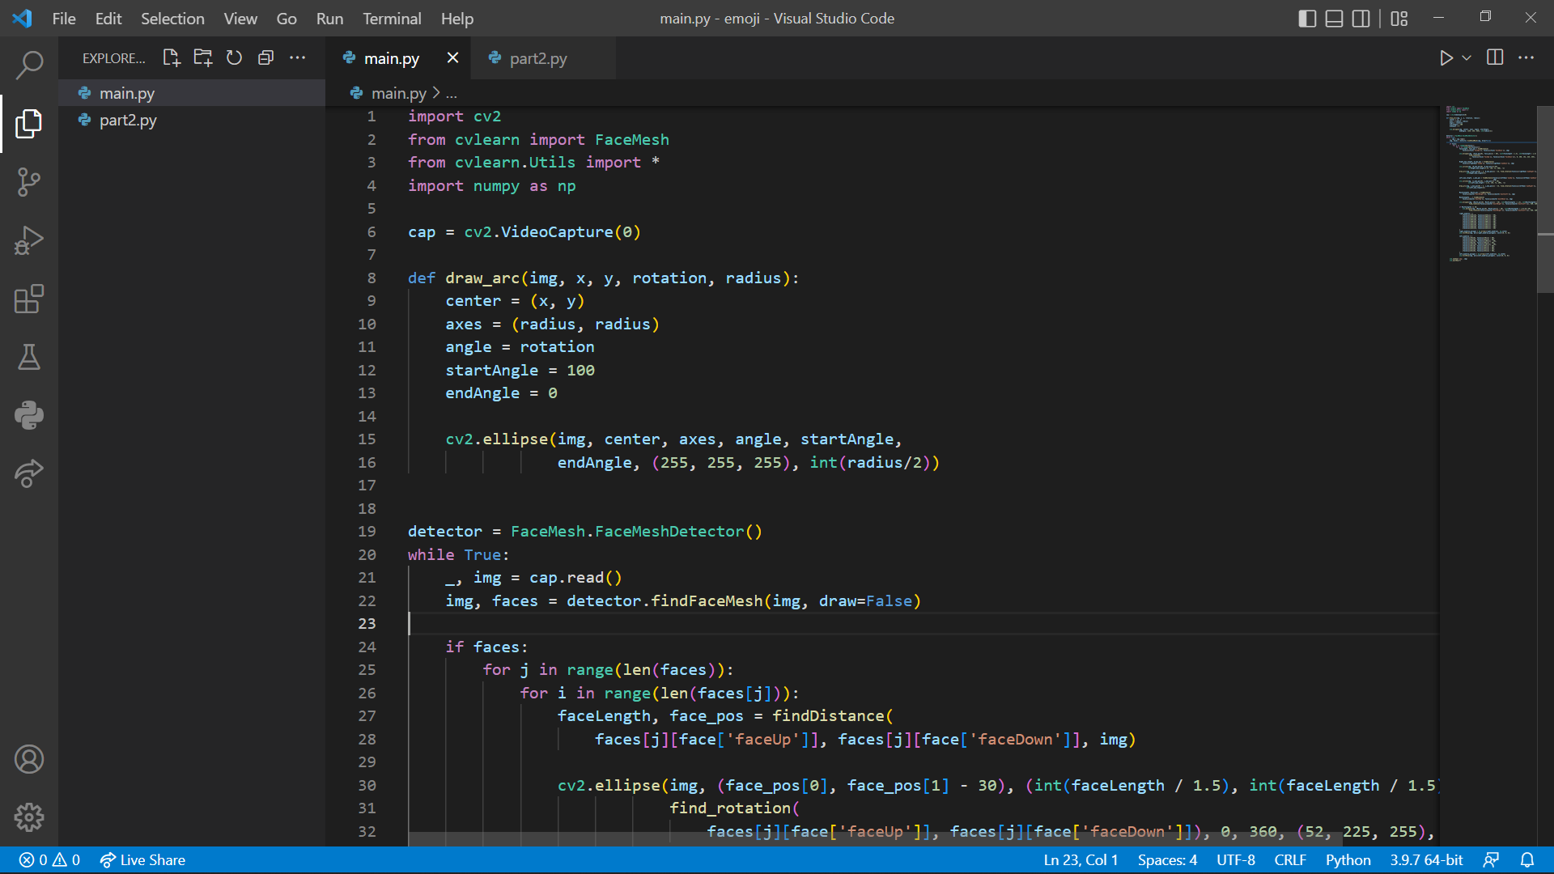

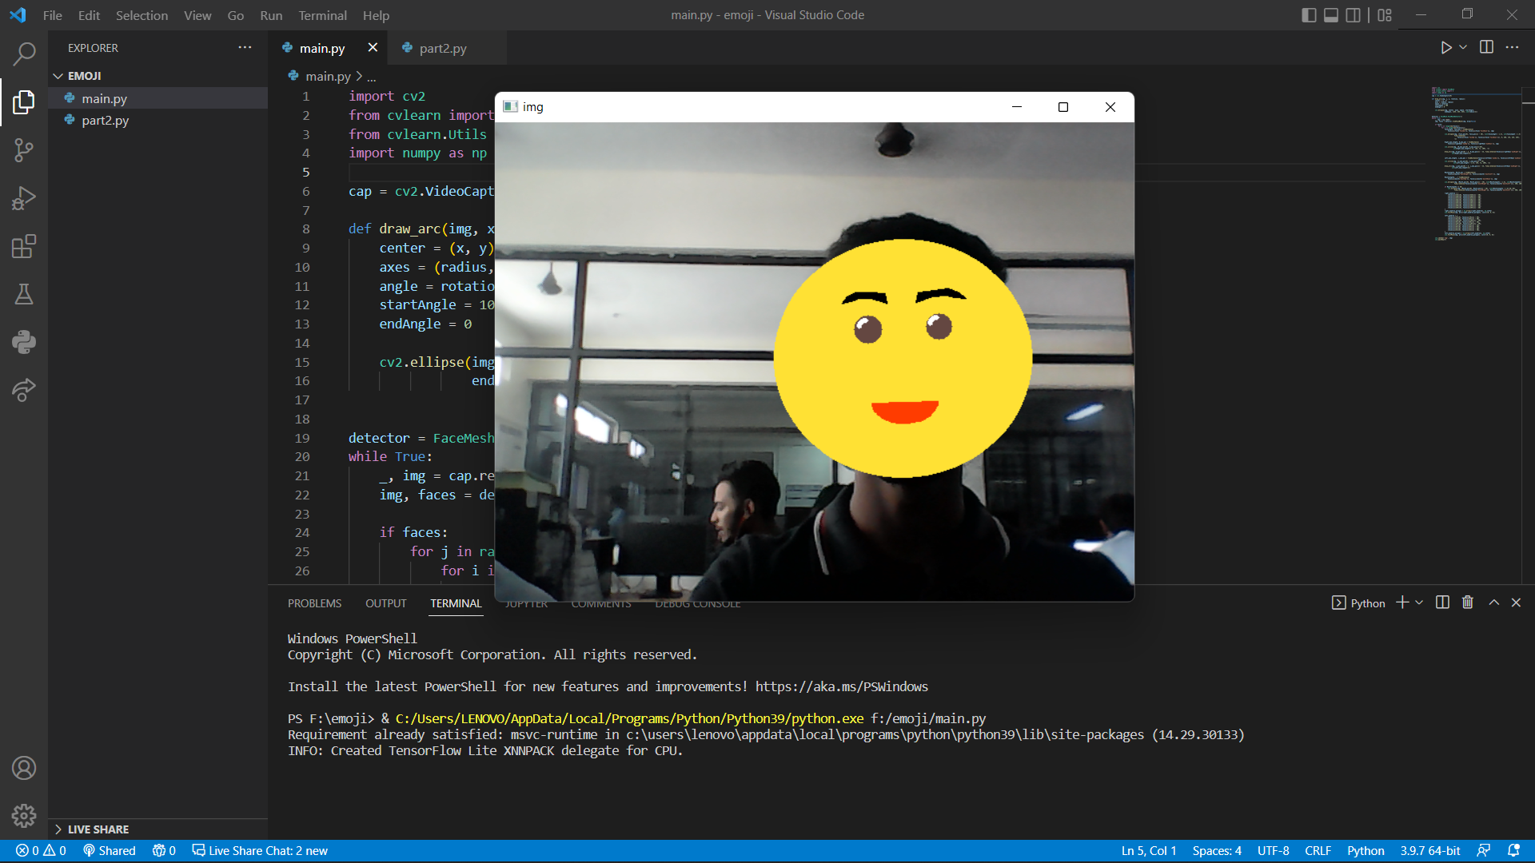

**4. FEATURES**

**4.1 ADMIN**

* Admin can add emoji.
* Admin can update/remove Emoji.
* Admin can viewUsers.
* Admin can update/removeUsers.

**4.2 USERS**

* Users can view dishes section and order.
* They can create account and login

**5. SYSTEM ANALYSIS**

Data science is a critical tool used among many customer-service sectors from technology to big brands to retail. However, only recently has there been a growing awareness that “old school” service industries – as ubiquitous as the mom-and-pop car wash – offer an unprecedented opportunity for data science to unlock tremendous value.

**5.3.2 Technical Feasibility**

The main goal of Machine Learning (ML) feasibility studies is to assess whether it is feasible to solve the problem satisfactorily using ML with the available data. We want to avoid investing too much in the solution before we have:

* Sufficient evidence that an ML solution would be the best technical solution given the business case
* Sufficient evidence that an ML solution is possible
* Some vetted direction on what an ML solution should look like

This effort ensures quality solutions backed by the appropriate, thorough amount of consideration and evidence.

**5.3.3 Operational Feasibility**

Before jumping right into your new modeling task, consider performing a feasibility study. A feasibility study of a predictive model will answer key questions that can help you and the business decide if the modeling task is likely to succeed.

**6.Project Planning and Scheduling**

Planning and project setup. Define the task and scope out requirements:

1. Data collection and labeling. Define ground truth (create labeling documentation) .
2. Model exploration. Establish baselines for model performance.
3. Model refinement.
4. Testing and evaluation.
5. Model deployment.
6. Ongoing model maintenance.

**7. Functional Requirement of the System**

Because they are non-verbal cues with rich emotional meanings, emoji are an important medium for interaction and emotional communication on the Internet.

Emoji can express or enhance emotions ([Gülşen, 2016](https://www.frontiersin.org/articles/10.3389/fpsyg.2019.02221/full" \l "B58)). [Jaeger and Ares (2017)](https://www.frontiersin.org/articles/10.3389/fpsyg.2019.02221/full" \l "B68) analyzed 33 facial emojis and found that most emoji can express one or more emotions. The rich emotional meaning of emoji makes them a key area for researchers who analyze their emotions and develop emoji emotional lexicons. By artificial annotating, [Petra et al. (2015)](https://www.frontiersin.org/articles/10.3389/fpsyg.2019.02221/full" \l "B116) divided emojis into positive, negative and neutral according to their emotional distribution, and found that most emojis were positive, but there were also some emojis which can express irony or satire ([Vanin et al., 2013](https://www.frontiersin.org/articles/10.3389/fpsyg.2019.02221/full" \l "B154)). Due to the subjectivity of human annotating, some researchers have proposed the automatic construction of emoji lexicons. [Fernandez-Gavilanes et al. (2018)](https://www.frontiersin.org/articles/10.3389/fpsyg.2019.02221/full" \l "B47) automatically constructed an emoji lexicon based on the official definitions in emojipedia

**7.1 HARDWARE REQUIREMENTS**

The minimum Hardware requirements for the application to run smoothly should have the following configuration:

|  |  |
| --- | --- |
| **Processor** | Intel Core i3 8th Gen |
| **RAM** | 4GB or more |
| **HDD** | 3GB or more |

**7.2 SOFTWARE SPECIFICATIONS**

The minimum software requirements are as follows:

|  |  |
| --- | --- |
| **Operating System** | Fedora Linux 36 (Workstation Edition) |
| **Language Used** | Python keras OpenCV Language |
| **Web Browser** | Mozilla, Google Chrome, OPERA |
| **Working IDE** | Visual Studio Code |

**8. DATABASE DESIGN**

**8.1 DATA DICTIONARY**

The logical characteristics of current system data stores including both user’s 6and admin’s name,email, username, phone number, address password 6identifies process where the data are used and where immediate access to information required, Serves as the basis for identifying database requirements during system design.

**Uses of Data Dictionary:**

* To manage the details in large systems.
* To communicate a common meaning for all system elements.
* To document the features of the system.
* To facilitate analysis of the details in order to evaluate characteristics and determine where system changes should be made.
* To locate errors and omissions in the system.

**9. CONCLUSION** **:**“The characteristics of an avatar, and especially its appearance, have the ability to modify the behavior of the person that embodies it.”

**10.REFERENCES**

1)https://youtu.be/3ya0aH6v-1M