1. Create new vserver using WFA following the NAS Provisioning Guide

CIS WFA <https://eg-cis-wfa-01.int.thomsonreuters.com/wfa/flex-client/main.html>

CPS WFA <https://eg-cps-wfa-01.int.thomsonreuters.com/wfa/flex-client/main.html>

1. Allocate IP and DNS
2. Create vserver only
3. Add snapshot space
4. Confirm SOURCE Aggregate has sufficient capacity
5. Document all capacity changes in the SMTracker document for the bundle
6. For volumes with snap reserve, check capacity and increase as needed
7. Mandatory for all volumes that don’t have snap reserve configured

* For iSCSI volumes, add space and set 50% snap reserve
* <current volume size> divided by .5 = <new size>
* ssh <source filer> vol size <source volume> <new size>
* ssh <source filer> snap reserve <volname> 50
* For NFS, CIFS, or MP volumes, add space and set 20% snap reserve
* Current volume size divided by .8 = <new size>
* ssh <source filer> vol size <source volume> <new size>
* ssh <source filer> snap reserve <volname> 20
* EXAMPLE: clnt-corp-a0077, fnr_ek_application1t_n01ora1_nosnap
* Volume is 149g NFS volume with no snap reserve
* 149g/.8 = 186g
* Set volume to 186g and apply 20% snap reserve

1. Add the target filer ICL LIF IP Address to the source vfiler snapmirror options.

ssh <target filer> network interface show -role intercluster

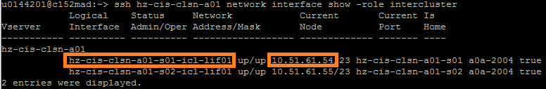

ssh <source filer> vfiler run <source vfiler> options snapmirror

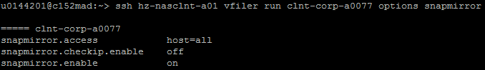

ssh <source filer> vfiler run <source vfiler> options snapmirror.access host=all,<ICL_IP>



ssh <source filer> vfiler run <source vfiler> options snapmirror

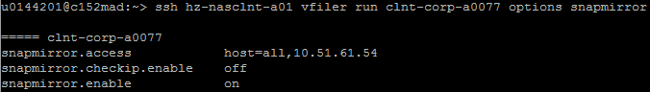

1. Enable snapmirror on the source vfiler if it is disabled.

ssh <source filer> vfiler run <source vfiler> options snapmirror

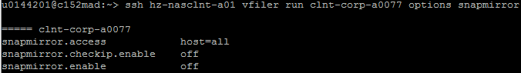

ssh <source filer> vfiler run <source vfiler> options snapmirror.enable on



ssh <source filer> vfiler run <source vfiler> options snapmirror



1. Log into 7MTT with MGMT\M-account and domain password

CIS 7MTT <https://c748stg.mgmt.tlrg.com:8443/transition/>

CPS 7MTT <https://c345bca.mgmt.tlrg.com:8443/transition/>

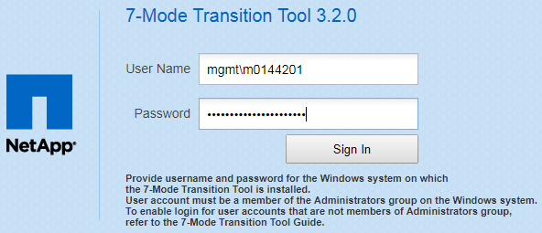

1. On the home page, select the “Copy-Based Transition” and click “Start Planning”.

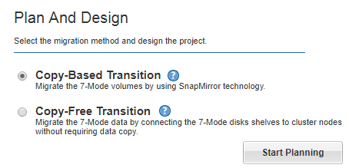

1. Look for the source and target filers in the list.

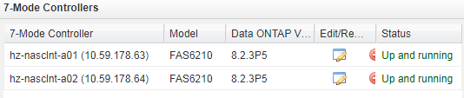

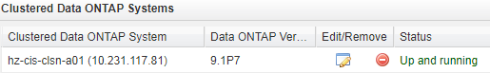

1. If the ones needed are not listed, fill in the device details and click “Add”.

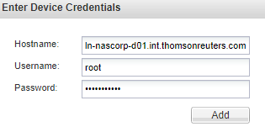

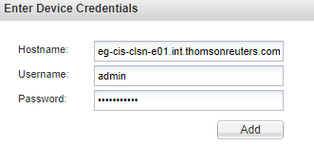

1. Once the source and target filers are listed, click “Next”.

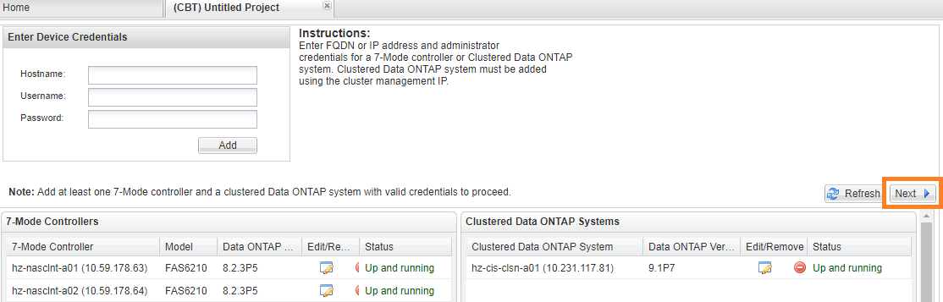

1. Select volumes for migration.
2. In the left panel, find the filer and select the vfiler that is to be migrated.
3. Review the list of volumes and “checkbox” the ones in scope (exclude root).
4. The selected volumes will appear in the bottom panel.

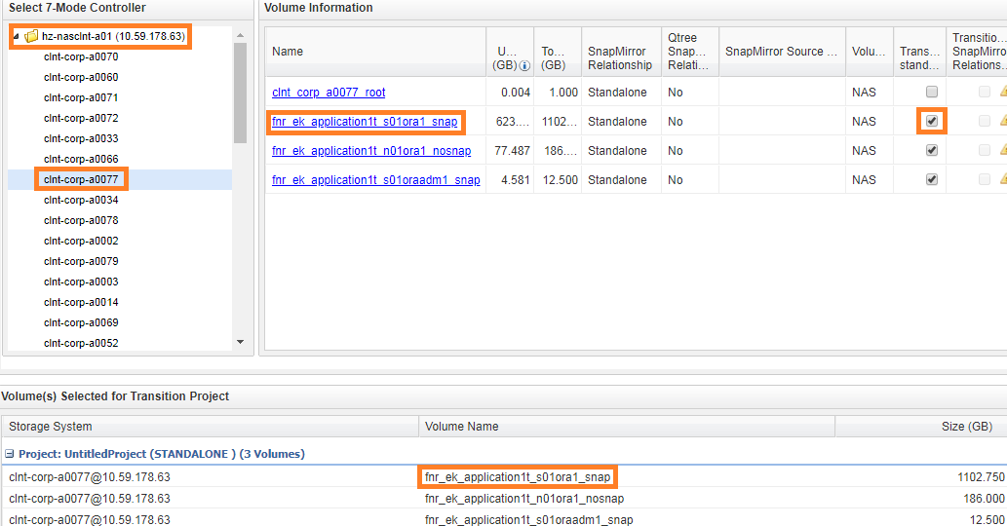

1. Once the volumes are selected, click “Create Project and Continue”.

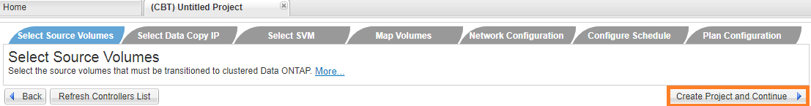

1. Fill out the Project Details.
2. Use a Project Name of <EVENTREF>_<PROTOCOL>_<VFILER>. (char limit is 40)
3. Replace any hyphens with underscores as hyphens are not allowed.
4. Protocol can be NFS, CIFS, or MP (multiprotocol).
5. Select the existing project group “2018NR” and click “Save”.

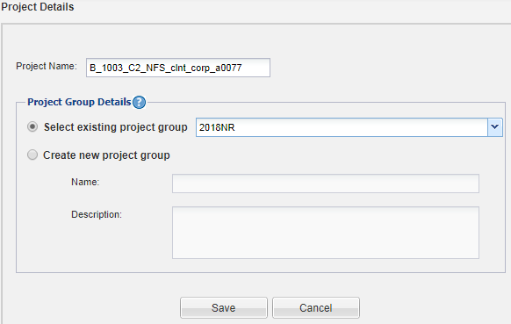

1. Update the “Data Copy IP” with the IP Address of the source 7Mode vfiler in scope.

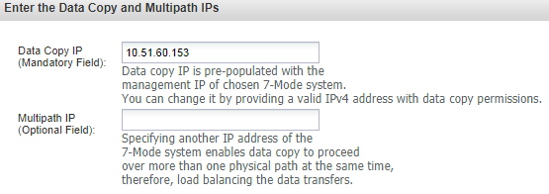

1. Once the IP is updated, click “Next”.

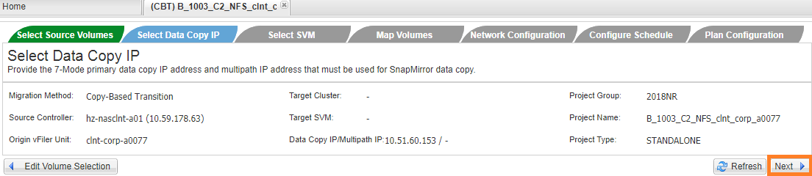

1. Select target vserver for this migration.
2. In the left panel, select the target CDOT cluster.
3. In the right panel, find the target vserver and check the box.

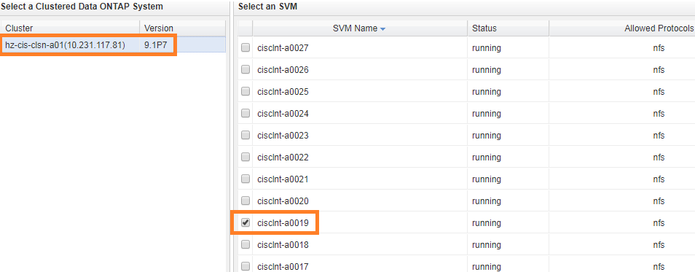

1. Once the target vserver is selected, click “Next”.

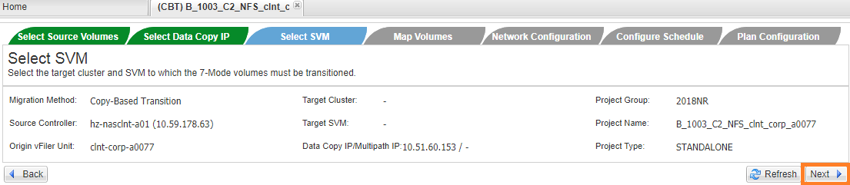

1. Fill in the new Target Volume names.

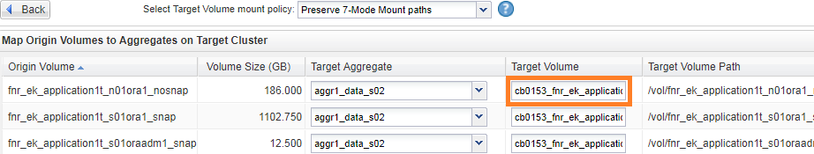

1. Once the new Target Volume names are input, select “Use clustered Data ONTAP volume names” from the dropdown. The Target Volume Path will update to reflect the new Target Volume names in the CDOT name format.

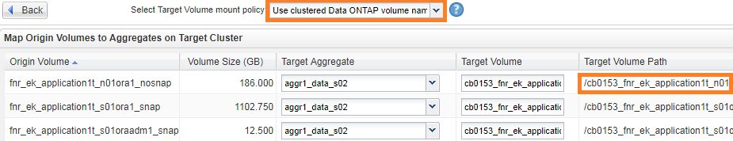

1. After the Target Volume Path has been updated to use CDOT names, select the aggregate for the destination CDOT node in scope. All volumes should be on the same aggregate.

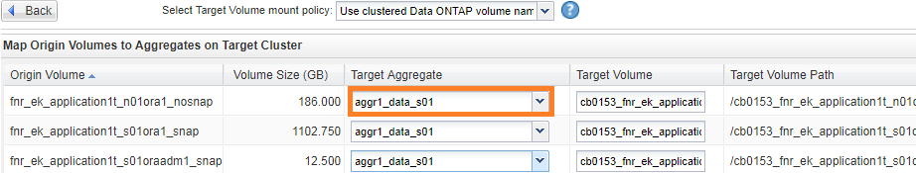

1. Double check to confirm the Target Volume names, Target Volume Path, and Target Aggregate are all correct.
2. If the volume, volume paths, and aggregates are correct, click “Next”.

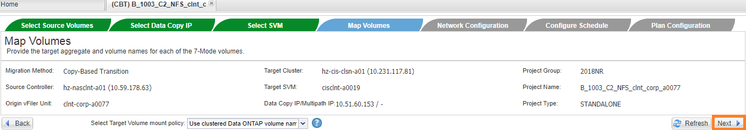

1. We do not migrate the source IP, so skip this step and click “Next”.

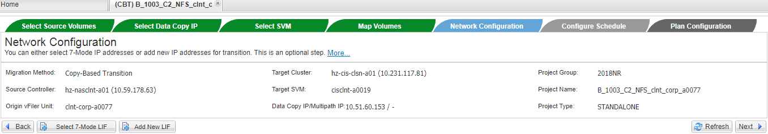

1. Click “Create Schedule”.

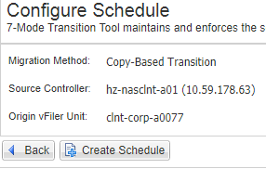

1. Set the schedule.
2. Use the project name for the schedule Name.
3. Set the Update Frequency to every 06:00 hours.
4. Click “Create”.

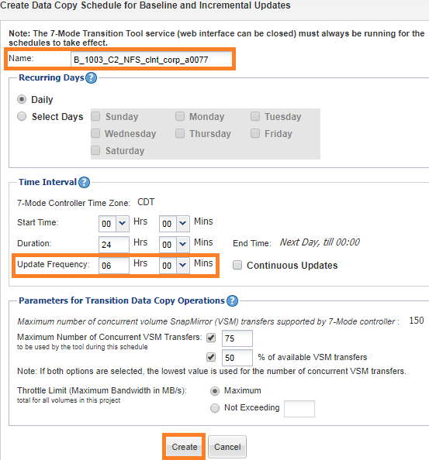

1. The newly created schedule will then be listed.



1. If the schedule looks good, click “Next”.

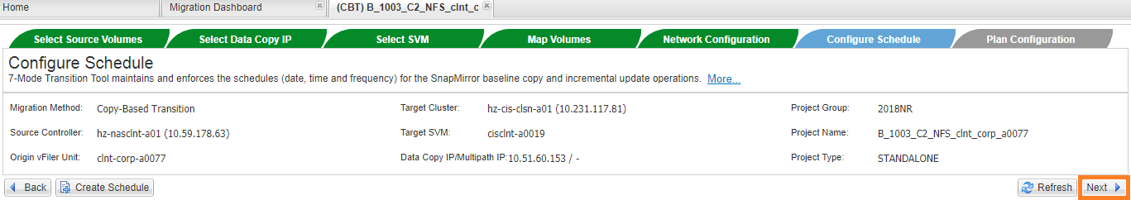

1. Fill out the Plan Configuration based on the protocol in scope.
2. For **NFS-ONLY**, select “NFS Options” and “UNIX Users and Groups” shown below.

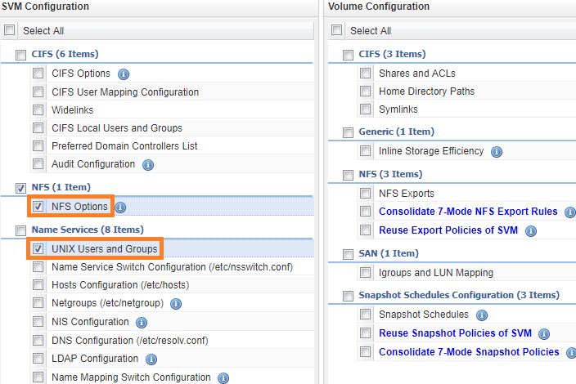

1. For **CIFS-ONLY**, checkbox all the CIFS options as shown below.

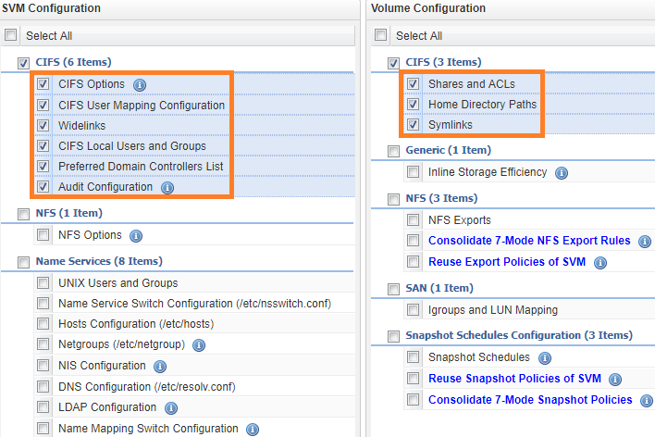

1. For **MP Multiprotocol** (CIFS+NFS), select “NFS Options”, “UNIX Users and Groups”, and all the CIFS options as shown below.

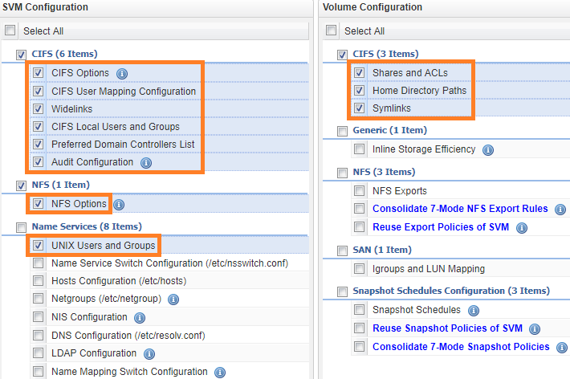

1. Once the options are selected, click “Save and go to Dashboard”.

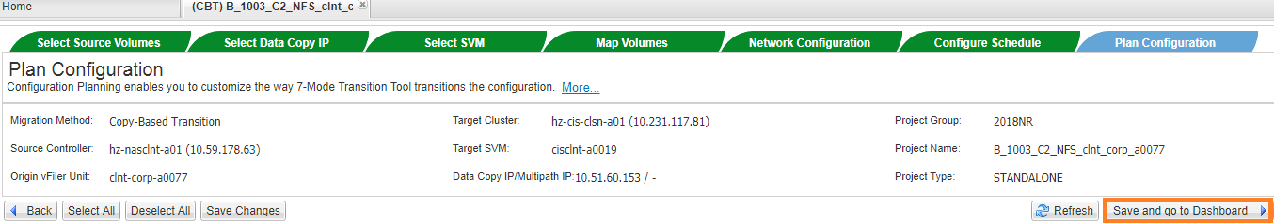

1. In the Migration Dashboard, expand the “2018NR” Project Group and select the created project.

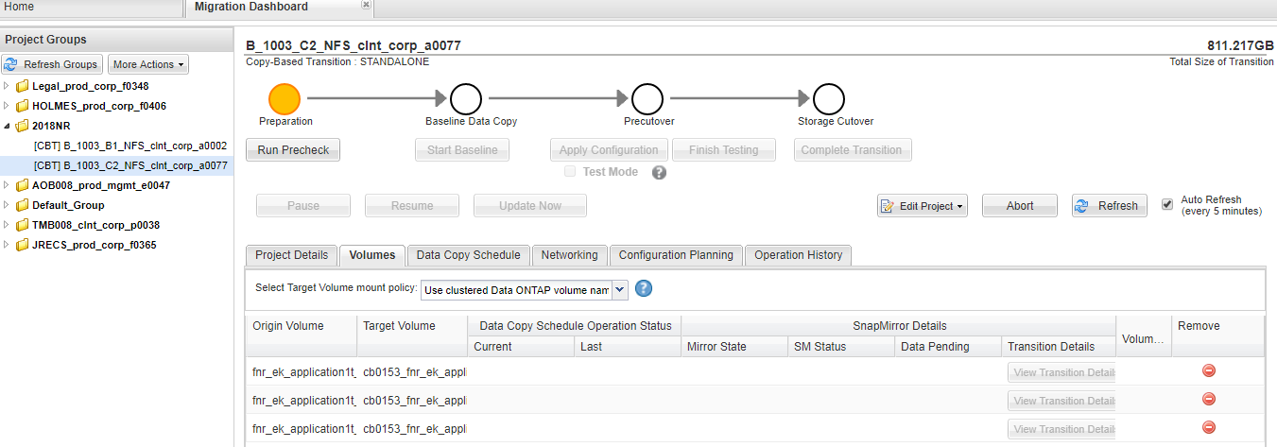

1. The status will be in the Preparation phase. Click “Run Precheck”.

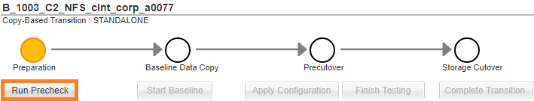

1. Once the prechecks complete, remove “Informational” from the Filter and then review all the Errors and Warnings. All Errors must be cleared to proceed to the next phase. Fix the Errors and re-run the “Run Precheck” until it is successful.

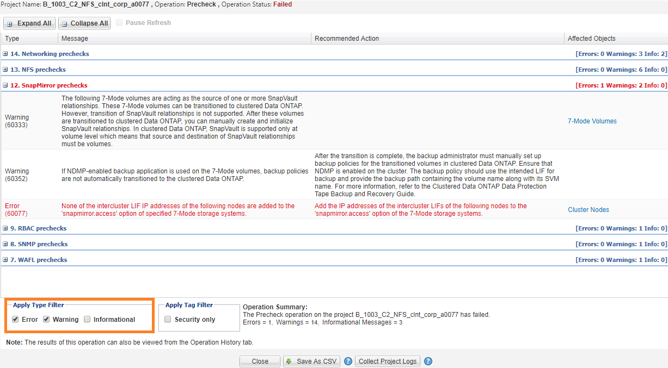

1. Even if successful, review all Warnings and address any which will cause issues.

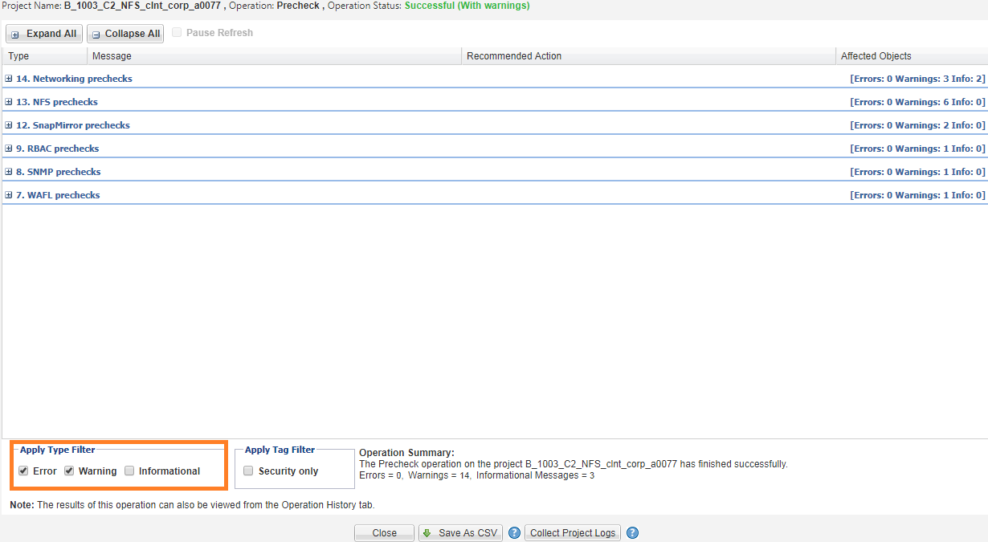

1. Once the Preparation phase is successful, click “Start Baseline” to initialize the snapmirror data copy.

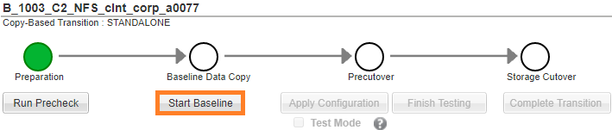

1. Click “Yes” to proceed with starting the baseline.

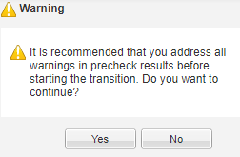

1. It will re-run some prechecks and then proceed with creating the target CDOT volumes and set up the transition snapmirrors. Review any Errors or Warnings.

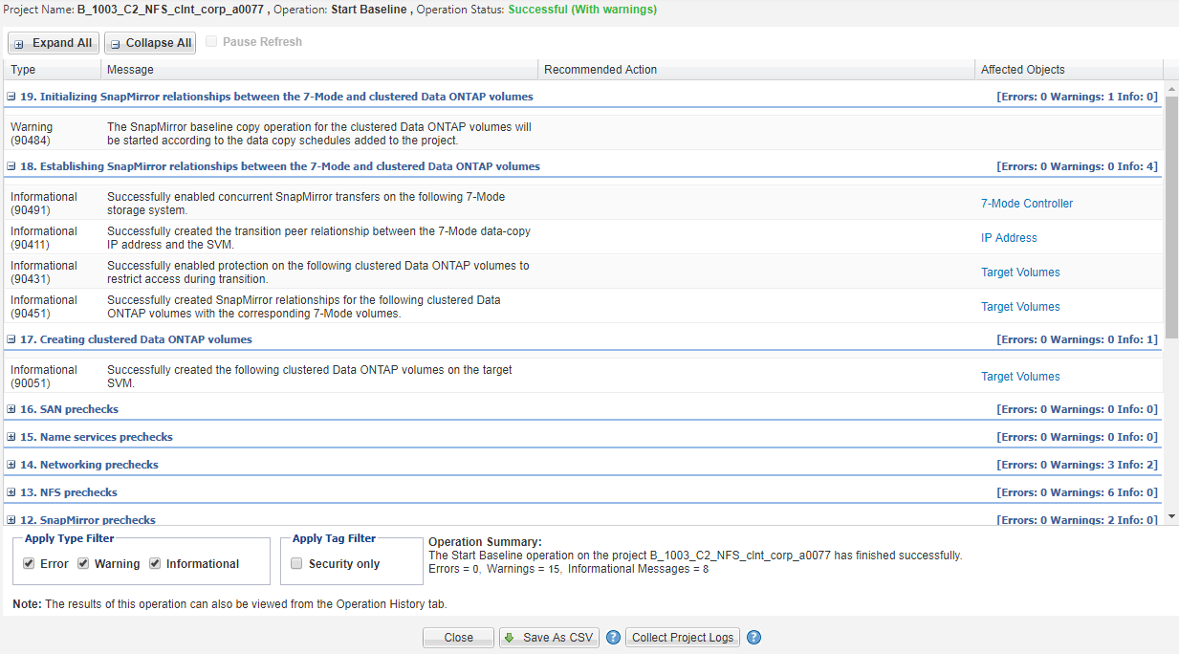

1. The project screen will show the status of the data copies. Once the baseline copy completes, the snapmirrors will update per the set schedule (every 6 hours).

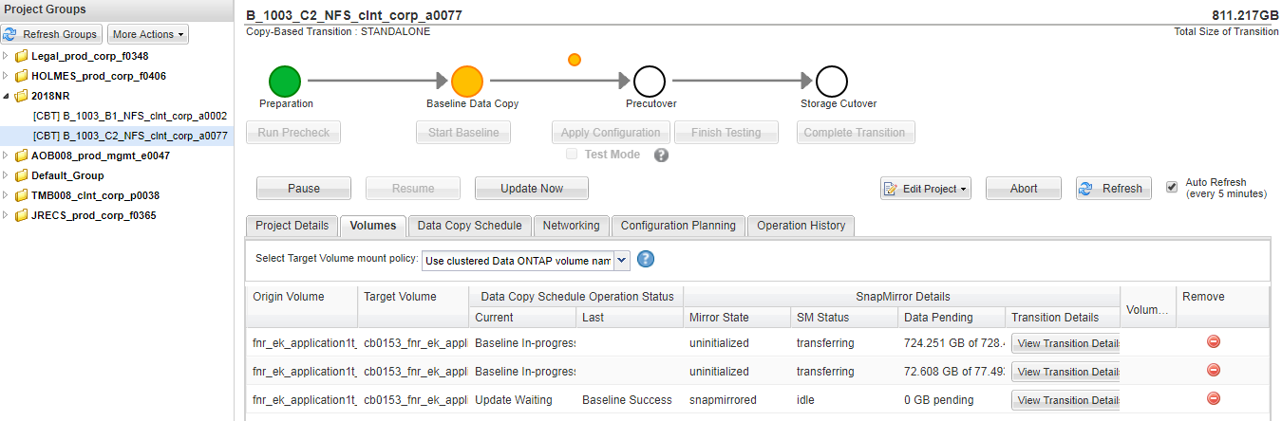

1. The snapmirrors can be monitored in the CLI.

ssh <source_filer> vfiler run <source_vfiler> snapmirror status



ssh <target_filer> snapmirror show -vserver <target_vserver>

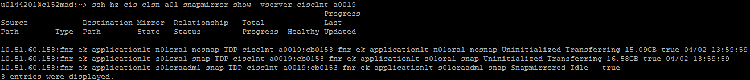

1. The Baseline Data Copy phase will be pending until all baselines are completed.

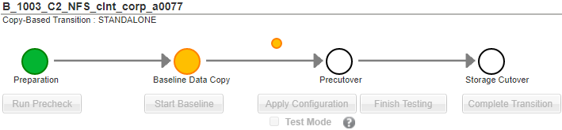

1. If there are a lot of data pending, click “Update Now” to force a snapmirror update.

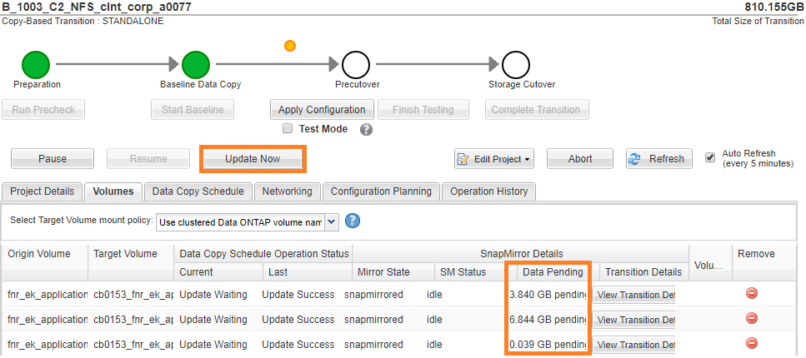

1. Click “Continue” to accept the default.

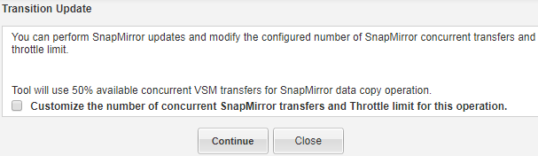

1. The transfer status can be seen on the main project page. It displays. The page is set to update every 5 minutes, but a refresh can be forced by clicking the “Refresh” button.

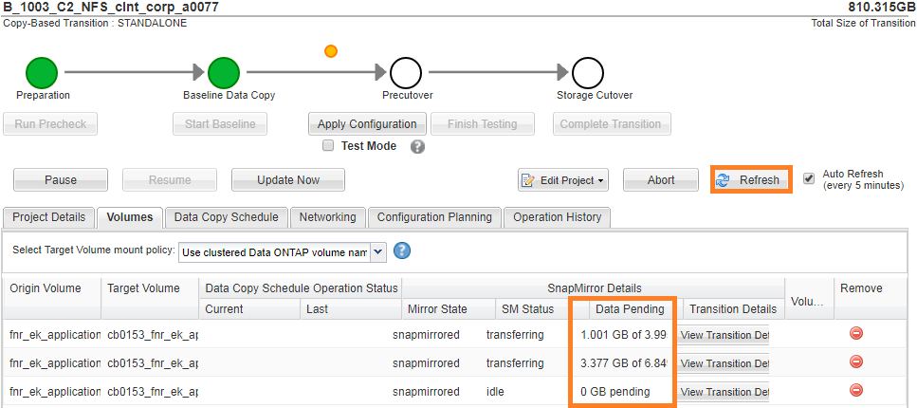

1. Before applying the configuration, check the volume space to ensure the snapshot reserve is OK. If it is highly utilized or in an overflow state, temporarily disable snapshot autodelete for the impacted volume.

ssh <source filer> vfiler run <source vfiler> df -h

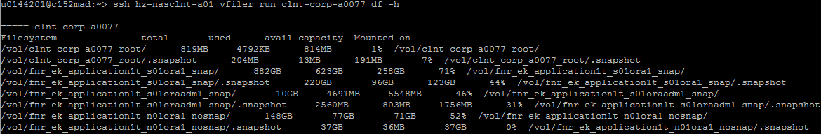

ssh <source filer> vfiler run <source vfiler> snap autodelete <source volume>

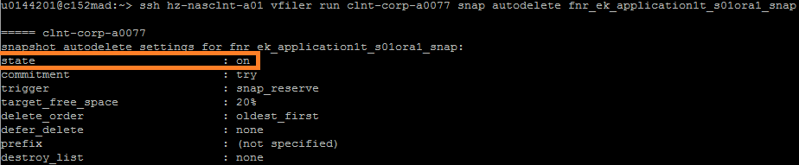

ssh <source filer> vfiler run <source vfiler> snap autodelete <source volume> off



ssh <source filer> vfiler run <source vfiler> snap autodelete <source volume>

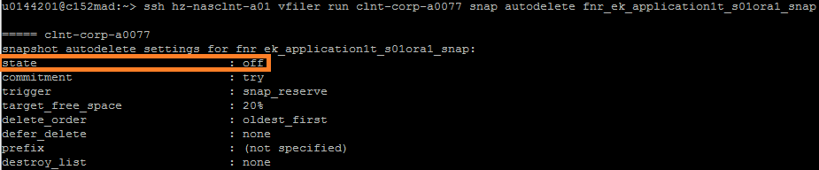

1. Once the baseline is complete and snap autodelete is disabled as needed, click “Apply Configuration”.

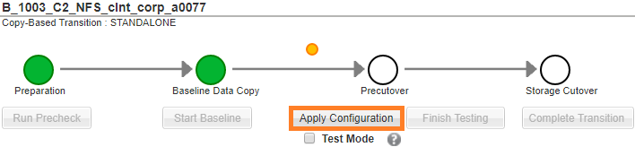

1. Click “Continue” to accept the defaults.

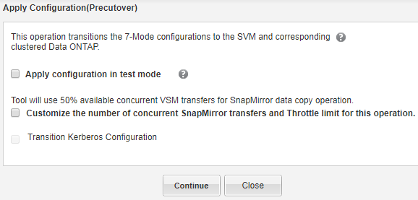

1. It will run through additional prechecks, update and break the transition relationship, apply the selected configurations, and then resync the snapmirror. Review any Errors or Warnings.

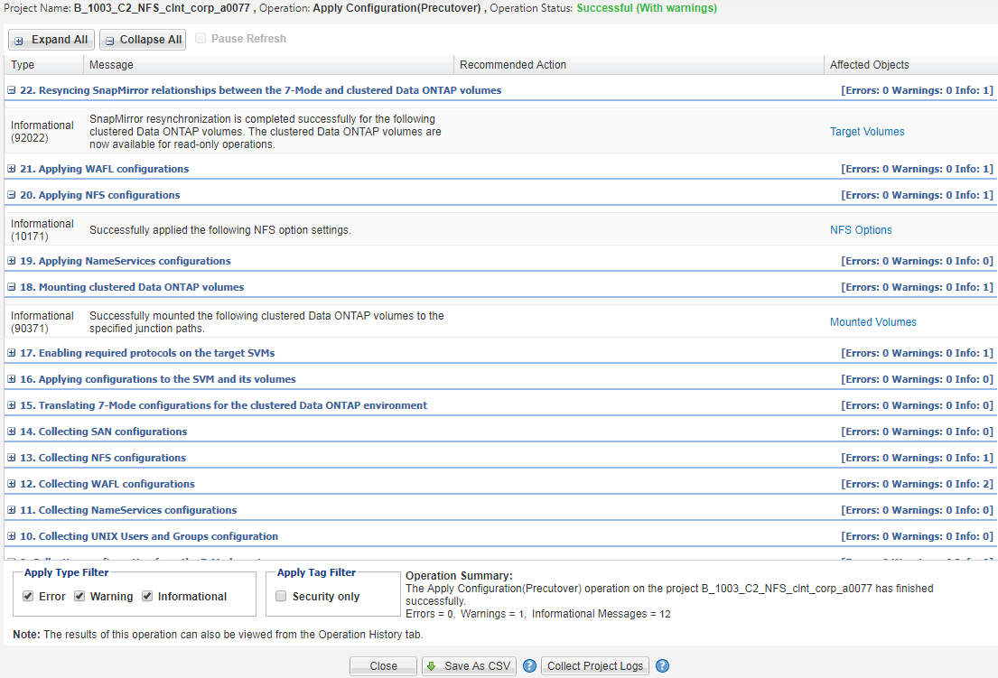

1. If the configuration is applied successfully, turn snap autodelete back on.

ssh <source filer> vfiler run <source vfiler> snap autodelete <source volume>



ssh <source filer> vfiler run <source vfiler> snap autodelete <source volume> on



ssh <source filer> vfiler run <source vfiler> snap autodelete <source volume>



1. The vfiler is now ready for cutover.

