**Setting up a new template for cifs authentication (here h1ecom.com)**

H1ecom.com vfiler examples:

Prod-ecom-f0071

Clnt-ecom-f0048 (dfm-cis)

To create a new H1ecom computer object:

RDP to **eg-h1ws-a01.h1ecom.com**: Active directory users and computers

MMC | SNAPIN |ACTIVE DIRECTORY USERS AND COMPUERS | CONNECT TO H1ECOM.COM |

OU = PROJECTS-COMPUTERS-NAS

DNS for h1ecom.com:

10.215.24.1

10.215.24.2

Commands:

**eg-nastest-e01> vfiler run test-vfiler-jrh1 cifs shares**

**eg-nastest-e01> vfiler run test-vfiler-jrh1 cifs domainfo**

**eg-nastest-e01> vfiler run test-vfiler-jrh1 cifs terminate (to stop cifs. Then run setup again)**

NMC STEPS: (to run set-up)

dfmf-cis NMC | hosts | vfiler units hosts | vfiler units | highlight vfiler | setup | next | next, next | check box for change network settings | next, next | check box for perform cifs setup | select h1ecom for vfiler template | | credentials: [m0089747@mgmt.tlrg.com](mailto:m0089747@mgmt.tlrg.com), next | enter root password | next, next | Finish

Steps:

Have platform team request acl’s to be opened:

For DNS: Open Port 53/tcp/udp is blocking between vfiler and the Active Directory domain (here H1ECOM DNS)

For CIFS\Windows: Open up 137,138,139, 445 (TCP and UDP?) For DNS: open Port 53/tcp/udp

Within NMC:

Policies | Vfiler templates | Add | enter domain and dns information for new domin

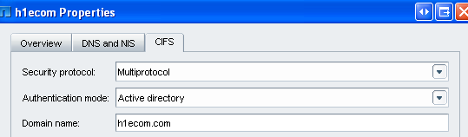

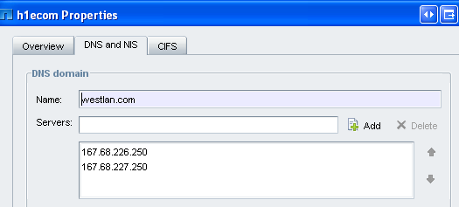

**nidaros:~ # rsh eg-nasclnt-f01-mgmt "vfiler run clnt-ecom-f0048 cifs domaininfo"**

===== clnt-ecom-f0048

NetBios Domain:           H1ECOM

Windows 2003 Domain Name: h1ecom.com

Type:                     Windows 2003

Filer AD Site:            Eagan

Current Connected DCs:    \\EG-H1DC-A01

Total DC addresses found: 3

Preferred Addresses:

                          None

Favored Addresses:

                          10.215.24.1     EG-H1DC-A01      PDC

                          10.215.24.3                      PDC

                          10.215.24.2                      PDC

Other Addresses:

                          None

Connected AD LDAP Server: \\eg-h1dc-a01.h1ecom.com

Preferred Addresses:

                          None

Favored Addresses:

                          10.215.24.1

                           eg-h1dc-a01.h1ecom.com

                          10.215.24.3

                           eg-h1dc-a03.h1ecom.com

                          10.215.24.2

                           eg-h1dc-a02.h1ecom.com

Other Addresses:

                          None

nidaros:~ #

Enter in the domain name:

**ACL’s opened up between host and vfiler (example here for H1ECOM domain):**

10.215.124.56

•  single,ecom-dist-rtf2,ECOM-HUBBARD1-WEB,LAN-CUST,permit tcp traffic from 10.215.24.0 (mask 0.0.3.255) on port >1023 to 10.215.124.56 on port 137

•  single,ecom-dist-rtf2,ECOM-HUBBARD1-WEB,LAN-CUST,permit udp traffic from 10.215.24.0 (mask 0.0.3.255) on port >1023 to 10.215.124.56 on port netbios-ns

•  single,ecom-dist-rtf2,ECOM-HUBBARD1-WEB,LAN-CUST,permit udp traffic from 10.215.24.0 (mask 0.0.3.255) on port >1023 to 10.215.124.56 on port netbios-dgm

•  single,ecom-dist-rtf2,ECOM-HUBBARD1-WEB,LAN-CUST,permit tcp traffic from 10.215.24.0 (mask 0.0.3.255) on port >1023 to 10.215.124.56 on port 139

•  single,ecom-dist-rtf2,ECOM-HUBBARD1-WEB,LAN-CUST,permit tcp traffic from 10.215.24.0 (mask 0.0.3.255) on port >1023 to 10.215.124.56 on port 445

•  single,ecom-dist-rtf2,ECOM-HUBBARD1-WEB,LAN-CUST,permit udp traffic from 10.215.24.0 (mask 0.0.3.255) on port >1023 to 10.215.124.56 on port 445

Also have platform open up port 53! If all these ports are not opened up the NMC will not be able to contact the dns servers.