

**NAS FLATFILE Snapshot Backup & Restore Process**

**Contributors: Dave Baar, Shrinath Kurdekar, Sridhar Chevendra**

**Document Version:** V1.0

**Date:** Aug 2018

**Status:** Draft

**CONFIDENTIAL INFORMATION**

This document contains information proprietary to Refinitiv and may not be reproduced, disclosed or used in whole or part without express permission of Thomson Reuters.

Contents

1 Introduction 3

1.1 Management Summary 3

1.2 Change History 3

1.3 Distribution List 3

1.4 Flatfile Snapshot Creation Request Workflow 3

1.5 Flatfile Snapshot Restore Workflow 4

1.6 Risk of using Snap Restore 4

1.7 Sample Custom Snapshot / Restore / Cleanup Change Request & Task: 5

# Introduction

## Management Summary

This document details the process used for Requesting to Create Flatfile Snapshot Backup & Restore.

## Change History

|  |  |  |  |
| --- | --- | --- | --- |
| **Ver** | **Date** | **Author** | **Key Changes** |
| 1 | August 2018 | Karthic Kulandaivelu | Initial Version |
|  |  |  |  |
|  |  |  |  |
|  |  |  |  |

## Distribution List

|  |  |
| --- | --- |
| **Name** | **Role** |
| Storage-Support-FR |  |
| Storage-Engineering-FR |  |

## Flatfile Snapshot Creation Request Workflow

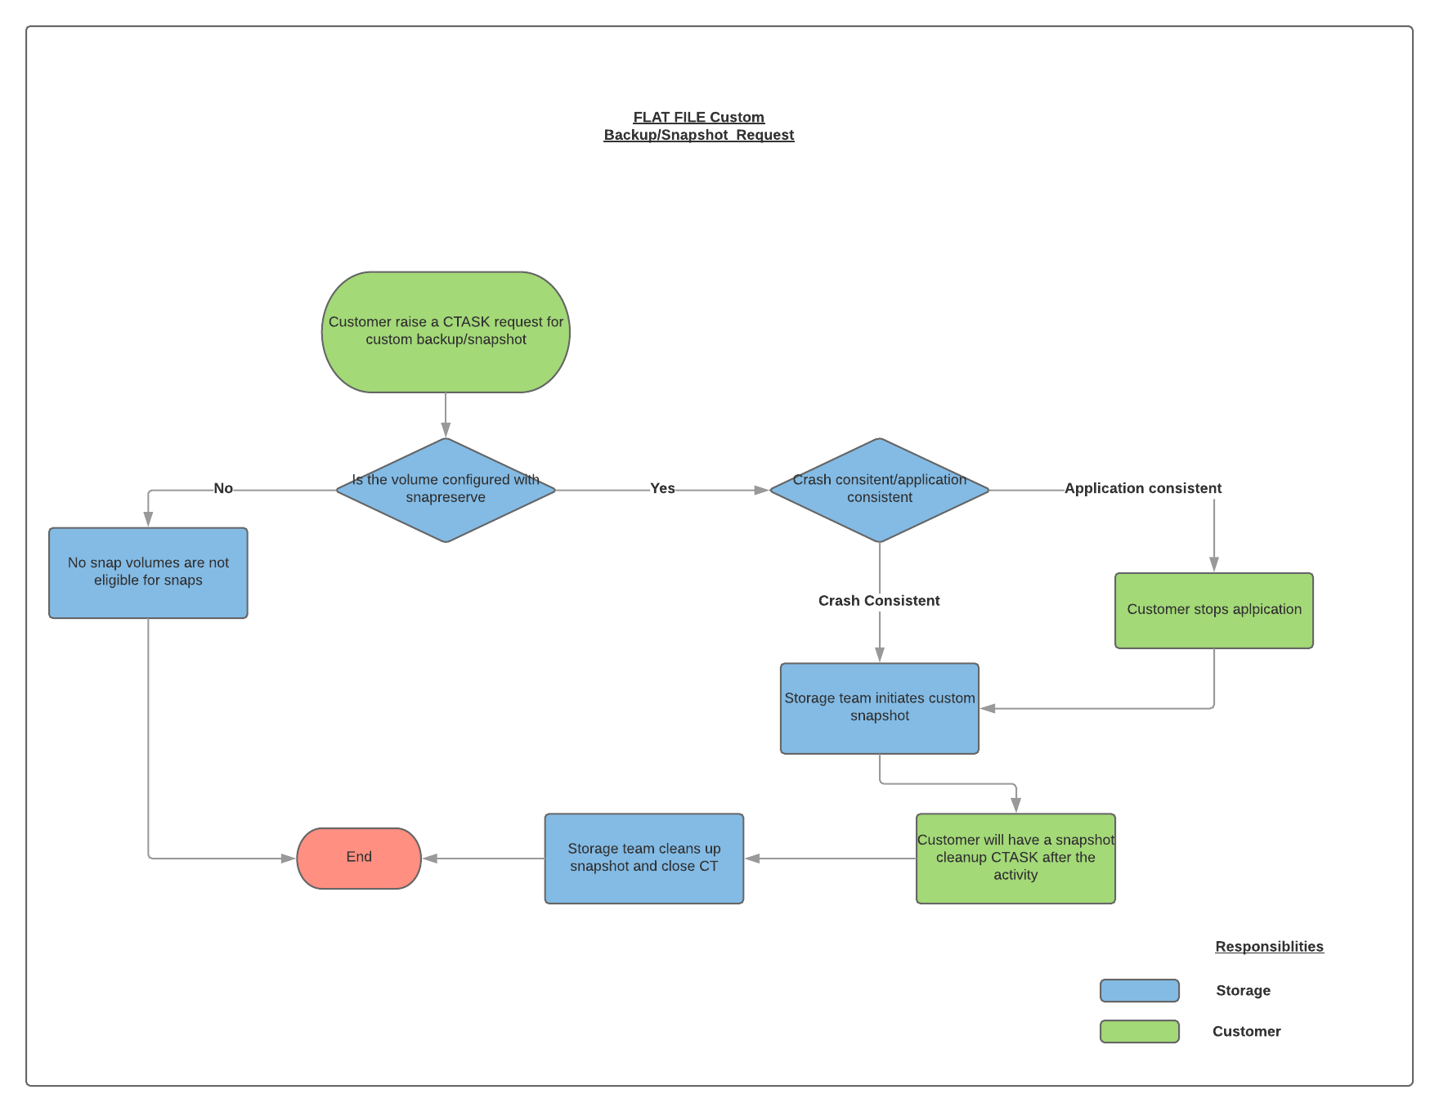

## Flatfile Snapshot Restore Workflow

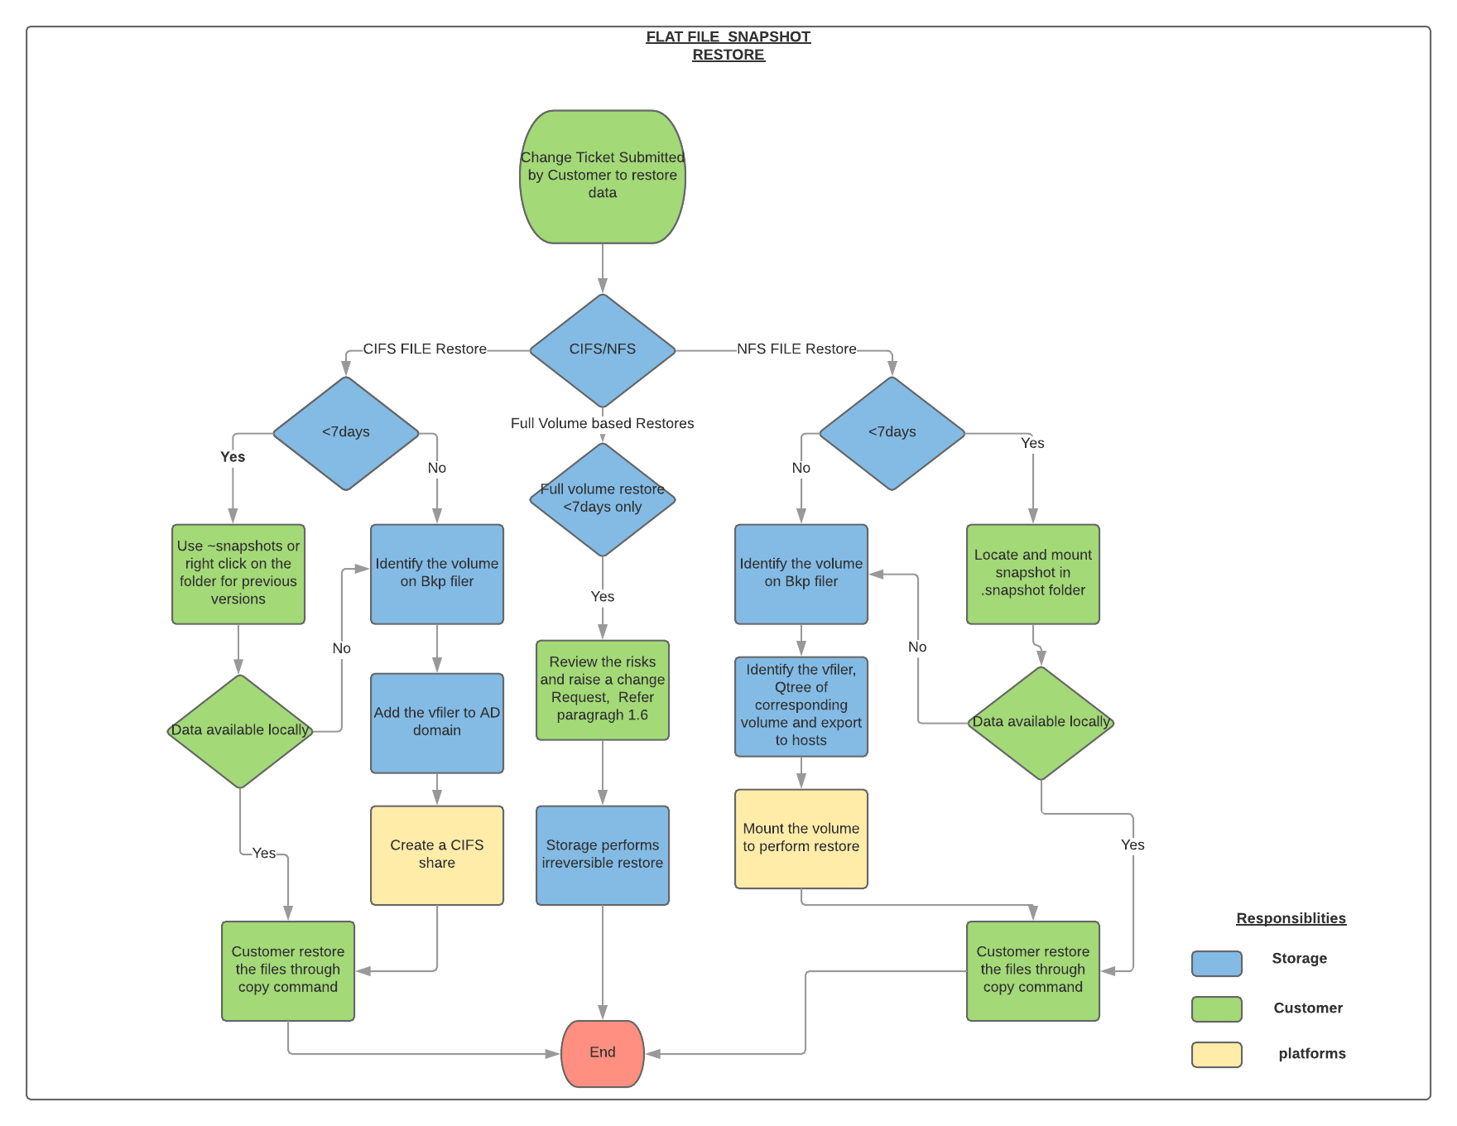

## Risk of using Snap Restore

• SnapRestore overwrites data permanently and might disrupt a SnapMirror relationship if any.

• Snap Restore overwrites all data in the file or volume. After you use SnapRestore to revert to a selected Snapshot copy, you cannot undo the reversion.

• Snapshot copy deletions are irrevocable. If you delete a Snapshot copy, you cannot recover the Snapshot copy by using SnapRestore.

• After you revert a volume to a selected Snapshot copy, you lose all the Snapshot copies that were taken after the selected Snapshot copy.

• Between the time you enter the snap restore command and the time when reversion is complete, Data ONTAP stops deleting and creating Snapshot copies.

## Sample Custom Snapshot / Restore / Cleanup Change Request & Task:

1. Create a storage task in the existing change request for the storage team and add Storage-support team as approver in the same.
2. Storage team to validate the volume details and update the storage steps in CTASK.
3. During the change window, after receiving confirmation from DB team Storage team will create a Custom snapshot.
4. Snapshot restore will be part of the back out plan of the existing CR will have CTASK for restoration, or a new CR will be created to restore. Once after customer is aware of full risk of restore. Storage team will perform Snap Restore of the full volume.
5. Mandatory Clean up CR need to be created by BU to clear the custom snapshot after the completion of activity.

**Screenshot reference to create a task for storage team**

Custom Snapshot Creation Request

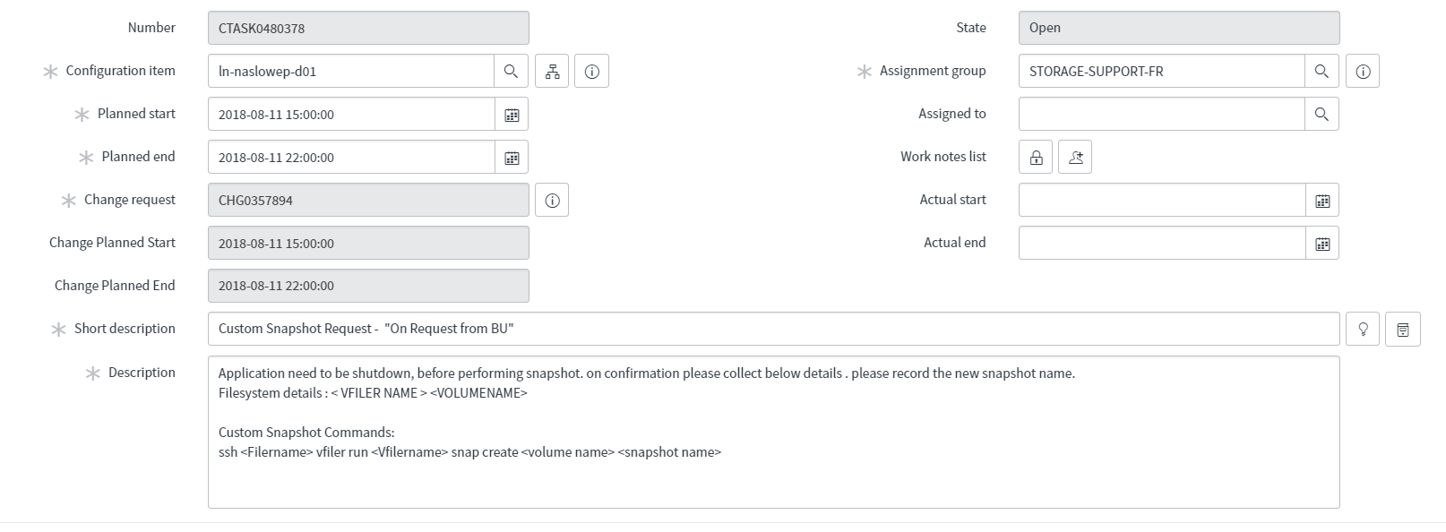

Custom Snapshot Restore Request

Full volume restore will be part of the back out plan in the existing CR or a new CR will be created.

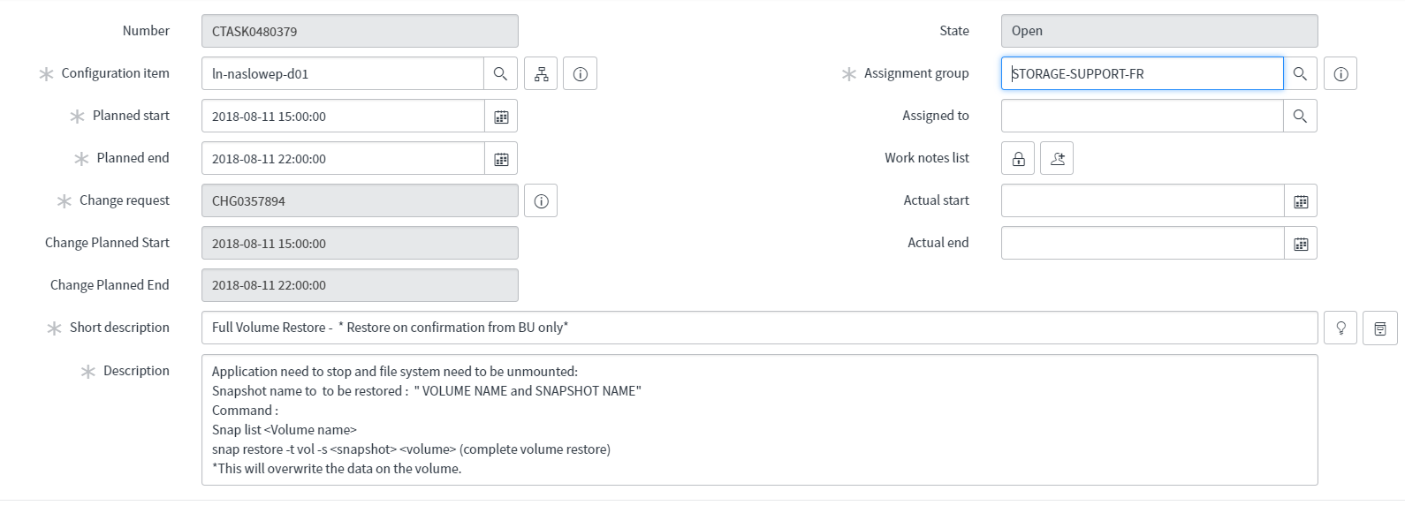

Custom Snapshot Clean up Task:

