

TR Switchless Cluster Conversion

Switchless Cluster Conversion to Switched

Synopsis: The purpose of this document is to outline the steps needed to convert a 2-node switchless cluster into a 2-node switched cluster. This is normally performed so that a 2-node cluster can be grown.

Segment: DCO - Storage

Authors: Craig Goettig

Contributors:

Document Version: V0.1
Date: 04/29/2016
Document Status: Draft

CONFIDENTIAL INFORMATION
This document contains information proprietary to Thomson Reuters and may not be reproduced, disclosed or used in whole or part without express permission of Thomson Reuters.

© Thomson Reuters 2015
Contents
1 Introduction 3
1.1 Management Summary 3
1.2 Document Scope 3
1.3 Assumptions 3
1.4 Change History 3
1.5 Distribution List 3
1.6 Glossary 3
2 Procedure 4
2.1 Disable all node-facing ports on switches 4
2.2 Verify ISL and physical ports are up on both switches 4
2.3 Verify switches can see each other 4
2.4 Verify the cluster port is connected to the same cluster port on the second node 4
2.5 Verify all cluster LIFs are UP and HOME 5
2.6 Turn auto-revert off on all cluster interfaces 6
2.7 Migrate first cluster interface 6
2.8 Verify first cluster interface is migrated 6
2.9 Shutdown cluster port e1a on both nodes 6
2.10 Verify port e1a is shutdown on both nodes 7
2.11 Disconnect cable from port e1a and connect new cable from switch 1 on both nodes 7
2.12 Enable all node-facing ports on switch 1 7
2.13 Start cluster port e1a on both nodes 7
2.14 Verify e1a ports are up 7
2.15 Revert first cluster interface on both nodes 8
2.16 Verify all cluster LIFs are UP and HOME 8
2.17 Verify cluster is healthy 8
2.18 Migrate second cluster interface 8
2.19 Verify second cluster interface is migrated 8
2.20 Shutdown cluster port e2a on both nodes 9
2.21 Verify port e2a is shutdown on both nodes 9
2.22 Disconnect cable from port e2a and connect new cable from switch 2 on both nodes 9
2.23 Enable all node-facing ports on switch 2 9
2.24 Start cluster port e2a on both nodes 10
2.25 Verify e2a ports are up 10
2.26 Revert second cluster interface on both nodes 10
2.27 Verify all cluster LIFs are UP and HOME 10
2.28 Verify that both nodes have two connections to each switch 10
2.29 Verify the cluster nodes can see switches 11
2.30 Disable two node switchless configuration 11
2.31 Verify switchless configuration 11
2.32 Turn auto-revert on for all cluster interfaces 12
2.33 Verify cluster is healthy 12

Introduction

Management Summary
This document will outline the procedure to convert a switchless cluster into a switched cluster so that cluster nodes can be added.

Document Scope
This document will cover what steps the onsite NetApp engineer needs to make in conjunction with the TR Storage Support engineers procedures.

Assumptions
- NetApp Engineer is scheduled to come onsite
- CN1610 switches have been installed by delivery
- Cables have been run from the switch to the cluster nodes
- All cluster ports are in a UP state

Change History
Ver | Date | Author | Key Changes
0.1 | 4-29-2016 | Craig Goettig | Initial version

Distribution List
Name | Role
DCO-STO-SUPP-NAS | Storage Support

Glossary
Term | Definition

Procedure
NetApp Engineer steps in RED
TR Storage Support Engineer in BLUE

Disable all node-facing ports on switches
Do not disable the ISL ports.
Example

The following commands disable node-facing ports 1 through 12 on switch cs1:
(cs1)# configure
(cs1)(Config)# interface 0/1-0/12
(cs1)(Interface 0/1-0/12)# shutdown
(cs1)(Interface 0/1-0/12)# exit
(cs1)(Config)# exit

The following commands disable node-facing ports 1 to 12 on switch cs2:
(cs2)# configure
(cs2)(Config)# interface 0/1-0/12
(cs2)(Interface 0/1-0/12)# shutdown
(cs2)(Interface 0/1-0/12)# exit
(cs2)(Config)# exit

Verify ISL and physical ports are up on both switches
(cs1)# show port-channel 3/1
(cs2)# show port-channel 3/1

Verify switches can see each other
To display the list of neighboring devices use the show isdp neighbors command.
This command provides information to list the devices that are connected to the system.
(cs1)# show isdp neighbors
(cs2)# show isdp neighbors

Verify the cluster port is connected to the same cluster port on the second node
Port e1a on node 1 needs to be connected to port e1a on node 2
Port e2a on node 1 needs to be connected to port e2a on node 2
Command: run * cdpd show-neighbors

Example
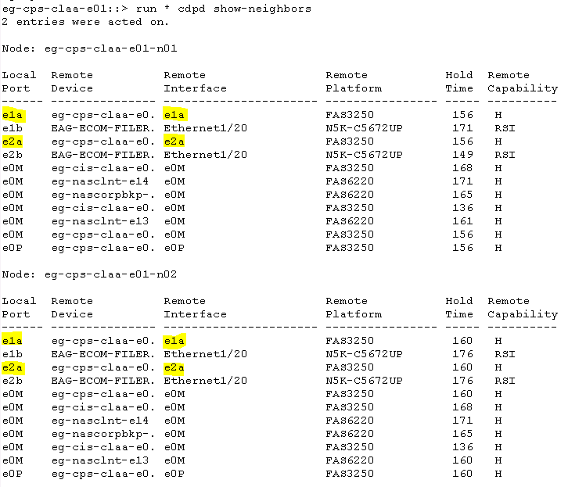

Verify all cluster LIFs are UP and HOME
Command: network interface show –role cluster
Example:
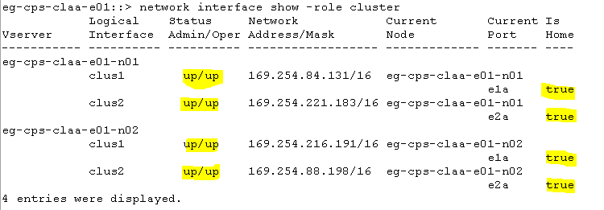

Turn auto-revert off on all cluster interfaces
Example
eg-cps-claa-e01::> network interface modify -vserver eg-cps-claa-e01-n01 -lif clus1 -auto-revert false
eg-cps-claa-e01::> network interface modify -vserver eg-cps-claa-e01-n01 -lif clus2 -auto-revert false
eg-cps-claa-e01::> network interface modify -vserver eg-cps-claa-e01-n02 -lif clus1 -auto-revert false
eg-cps-claa-e01::> network interface modify -vserver eg-cps-claa-e01-n02 -lif clus2 -auto-revert false

Migrate first cluster interface
Migrate LIF clust1 from port e1a to e2a on both nodes
Example
eg-cps-claa-e01::> network interface migrate -vserver eg-cps-claa-e01-n01 -lif clus1 -source-node eg-cps-claa-e01-n01 -destination-node eg-cps-claa-e01-n01 -destination-port e2a
eg-cps-claa-e01::> network interface migrate -vserver eg-cps-claa-e01-n02 -lif clus1 -source-node eg-cps-claa-e01-n02 -destination-node eg-cps-claa-e01-n02 -destination-port e2a

Verify first cluster interface is migrated
Command: network interface show –role cluster
Current port for all interfaces should be e2a
Example
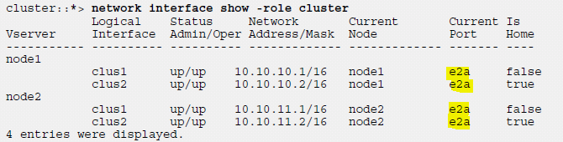

Shutdown cluster port e1a on both nodes
eg-cps-claa-e01::> set -privilege advanced
eg-cps-claa-e01::> network port modify -node eg-cps-claa-e01-n01 -port e1a -up-admin false
eg-cps-claa-e01::> network port modify -node eg-cps-claa-e01-n02 -port e1a -up-admin false
eg-cps-claa-e01::*> set -privilege admin

Verify port e1a is shutdown on both nodes
Command: network interface show –role cluster
Example
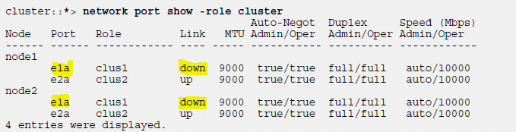

Disconnect cable from port e1a and connect new cable from switch 1 on both nodes

Enable all node-facing ports on switch 1
Example
(cs1)# configure
(cs1)(Config)# interface 0/1-0/12
(cs1)(Interface 0/1-0/12)# no shutdown
(cs1)(Interface 0/1-0/12)# exit
(cs1)(Config)# exit

Start cluster port e1a on both nodes
eg-cps-claa-e01::> set -privilege advanced
eg-cps-claa-e01::> network port modify -node eg-cps-claa-e01-n01 -port e1a -up-admin true
eg-cps-claa-e01::> network port modify -node eg-cps-claa-e01-n02 -port e1a -up-admin true
eg-cps-claa-e01::*> set -privilege admin

Verify e1a ports are up
Command: network interface show –role cluster
Example
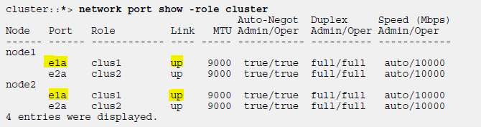

Revert first cluster interface on both nodes
eg-cps-claa-e01::> network interface revert -vserver eg-cps-claa-e01-n01 -lif clus1
eg-cps-claa-e01::> network interface revert -vserver eg-cps-claa-e01-n02 -lif clus1

Verify all cluster LIFs are UP and HOME
Command: network interface show –role cluster
Example
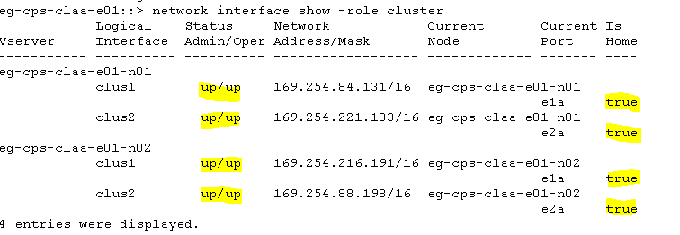

Verify cluster is healthy
Command: cluster show

Migrate second cluster interface
Migrate LIF clust2 from port e1a to e1a on both nodes
Example
eg-cps-claa-e01::> network interface migrate -vserver eg-cps-claa-e01-n01 -lif clus2 -source-node eg-cps-claa-e01-n01 -destination-node eg-cps-claa-e01-n01 -destination-port e1a
eg-cps-claa-e01::> network interface migrate -vserver eg-cps-claa-e01-n02 -lif clus2 -source-node eg-cps-claa-e01-n02 -destination-node eg-cps-claa-e01-n02 -destination-port e1a

Verify second cluster interface is migrated
Command: network interface show –role cluster
Current port for all interfaces should be e1a
Example
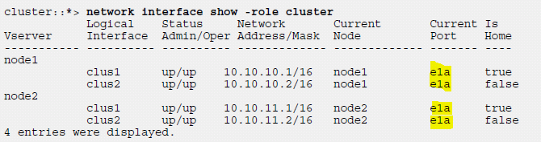

Shutdown cluster port e2a on both nodes
eg-cps-claa-e01::> set -privilege advanced
eg-cps-claa-e01::> network port modify -node eg-cps-claa-e01-n01 -port e2a -up-admin false
eg-cps-claa-e01::> network port modify -node eg-cps-claa-e01-n02 -port e2a -up-admin false
eg-cps-claa-e01::*> set -privilege admin

Verify port e2a is shutdown on both nodes
Command: network interface show –role cluster
Example
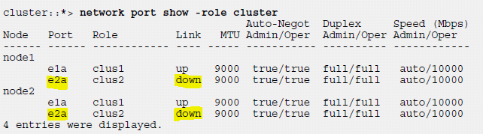

Disconnect cable from port e2a and connect new cable from switch 2 on both nodes

Enable all node-facing ports on switch 2
Example
(cs2)# configure
(cs2)(Config)# interface 0/1-0/12
(cs2)(Interface 0/1-0/12)# no shutdown
(cs2)(Interface 0/1-0/12)# exit
(cs2)(Config)# exit

Start cluster port e2a on both nodes
eg-cps-claa-e01::> set -privilege advanced
eg-cps-claa-e01::> network port modify -node eg-cps-claa-e01-n01 -port e2a -up-admin true
eg-cps-claa-e01::> network port modify -node eg-cps-claa-e01-n02 -port e2a -up-admin true
eg-cps-claa-e01::*> set -privilege admin

Verify e2a ports are up
Command: network interface show –role cluster
Example
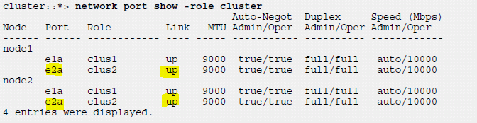

Revert second cluster interface on both nodes
eg-cps-claa-e01::> network interface revert -vserver eg-cps-claa-e01-n01 -lif clus2
eg-cps-claa-e01::> network interface revert -vserver eg-cps-claa-e01-n02 -lif clus2

Verify all cluster LIFs are UP and HOME
Command: network interface show –role cluster
Example

Verify that both nodes have two connections to each switch
(cs1)# show isdp neighbors
(cs2)# show isdp neighbors

Verify the cluster nodes can see switches
eg-cps-claa-e01::> network device-discovery show
Example
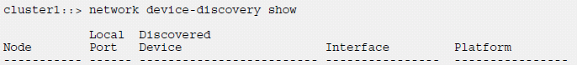
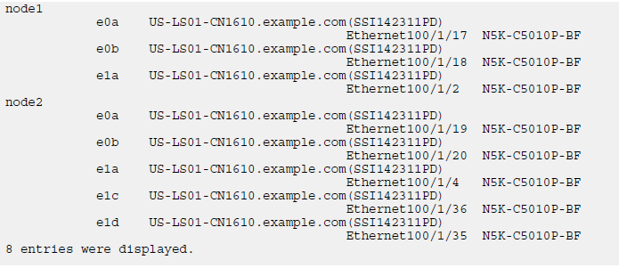

Disable two node switchless configuration
Command:
set -privilege advanced
network options switchless-cluster modify –enable false

Verify switchless configuration
Command:
network options switchless-cluster show
set –privilege admin
Example:
eg-cps-claa-e01::*> network options switchless-cluster show
Enable Switchless Cluster: true

Turn auto-revert on for all cluster interfaces
Example
eg-cps-claa-e01::> network interface modify -vserver eg-cps-claa-e01-n01 -lif clus1 -auto-revert true
eg-cps-claa-e01::> network interface modify -vserver eg-cps-claa-e01-n01 -lif clus2 -auto-revert true
eg-cps-claa-e01::> network interface modify -vserver eg-cps-claa-e01-n02 -lif clus1 -auto-revert true
eg-cps-claa-e01::> network interface modify -vserver eg-cps-claa-e01-n02 -lif clus2 -auto-revert true

Verify cluster is healthy
Command: cluster show

