How to Change a vFiler’s IP Address

Document Scope
The scope of this document is to identify the steps required to change the IP address of a vfiler. This may be necessary if, for instance, a vfiler was configured with an incorrect IP. Please note, this process was confirmed against a filer running DOT v7.3.3P3.

- Add Correct IP to vFiler
  - Launch and log into NMC for the appropriate site your vFiler resides in.
  - From Manage Data > Hosts > vFiler Units: locate the vFiler in the list, select it, and click Setup from the menu bar.
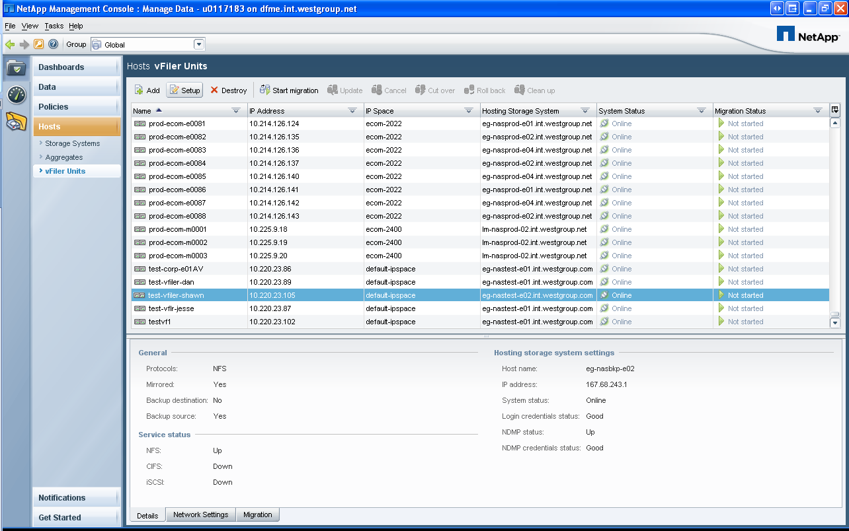

  - Click Next at the vFiler Wizard welcome screen.
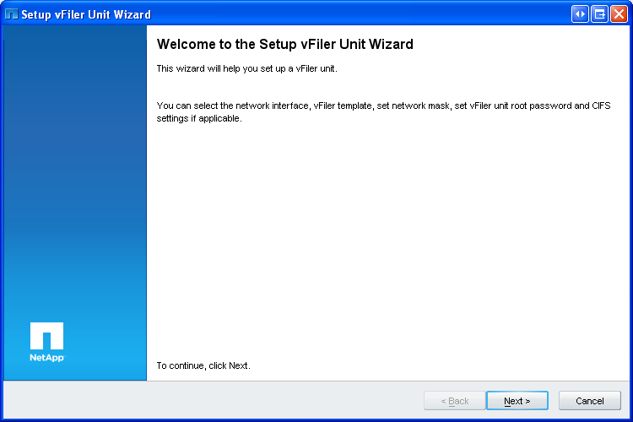

  - Click Next at the vFiler Unit Information screen.
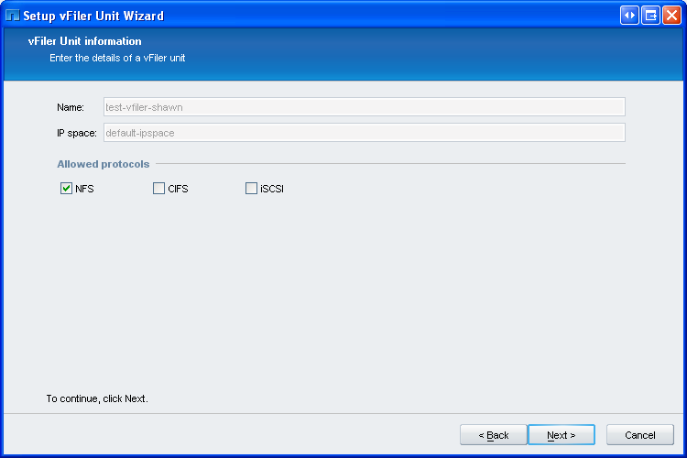

  - Place a check in the Change Network Settings box and click Next.
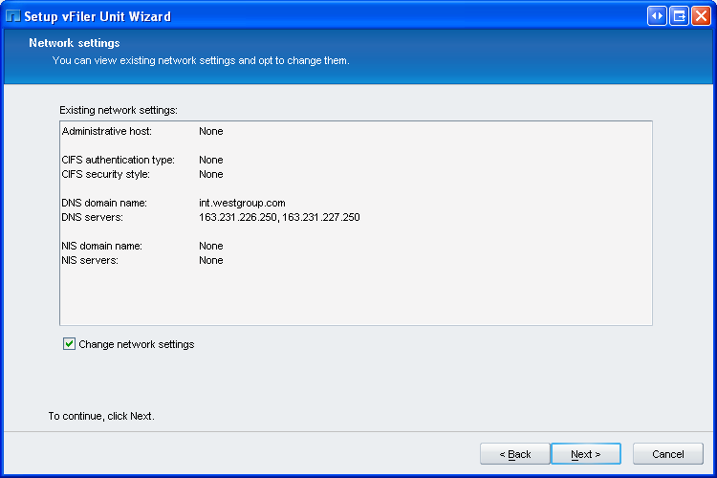

  - Click Add at the Network Interface Setting screen.
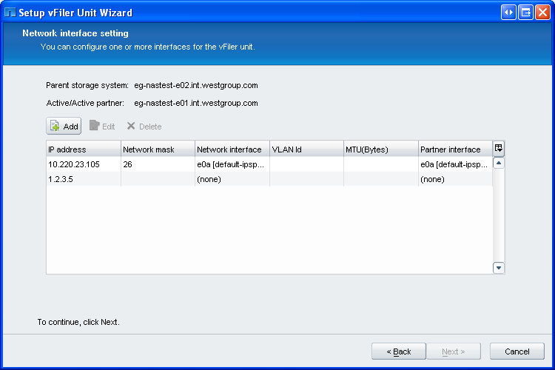

  - Enter the appropriate IP and network interface information at the Add Binding screen and click Add once complete.
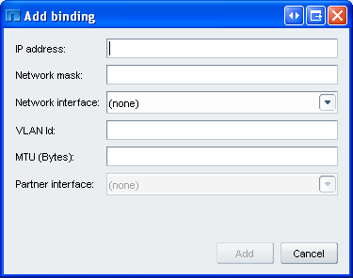

  - Click Next at the Network Interface Setting screen.
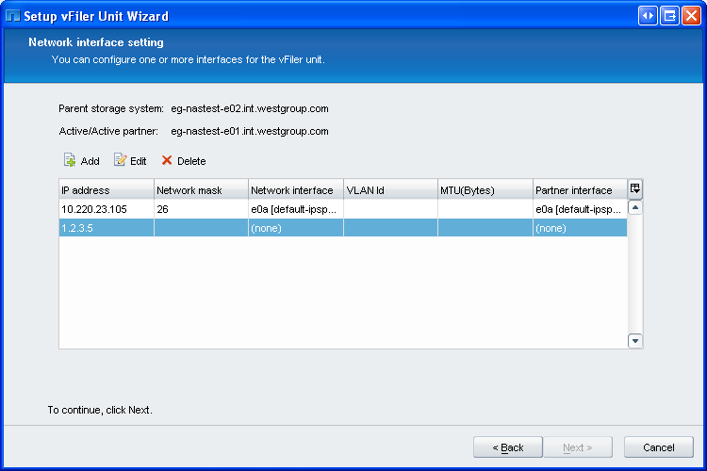

  - Finish out the vFiler Unit Wizard as you normally would when creating a vFiler.

- Remove Incorrect IP (Alias)
  - Establish an SSH PUTTY session to any DFM server and sudo bash.
  - Type the following command to identify the VIF the incorrect IP is bound to. The VIF name will follow the IP which is binding to it. In the example below, ecomvif0-3021 is theVIF to which 10.215.124.32 is bound.
Syntax:
rsh filername “vfiler status –r”

Example:
rsh eg-nasclnt-f01-mgmt “vfiler status –r”

Example Output:
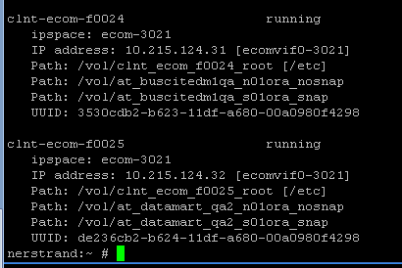

  - Type the following command to remove the incorrect IP (Alias).
Syntax:
rsh filername “ifconfig vifname –alias incorrectipaddress

Example:
rsh eg-nastest-e01-mgmt “ifconfig corpvif0 –alias 1.2.3.4”

  - Type the vfiler status –r command you did above in step #2.2 to confirm the IP now indicates “unconfigured”. It must indicate a state of “unconfigured” for the next command to work.

- Remove Incorrect IP (vFiler Resource)
  - Type the following command to remove the IP Address resource from the vFiler.
Syntax:
rsh filername “vfiler remove vfilername –i incorrectipaddress

Example:
rsh eg-nastest-e01-mgmt “vfiler remove testvfiler 1.2.3.4
  - Confirm the IP resource has been successfully removed by typing the “vfiler status –r” command executed above. The incorrect IP (and its VIF it was bound to) should not be displayed for the vFiler.

