Procedure for Resource Pool creation

Steps:
- NMC | Manager Data | Data | Resource Pools | Click Add on the toolbar | Name the resource pool the same as the filer name | click Next | Drill down to the filer in the left-hand pane| Highlight the 2nd listing of the filer name and all aggregates that you want to add to the Resource Pool (see picture below) | Click the right arrow to move the resource to the right-hand pane |Click Next

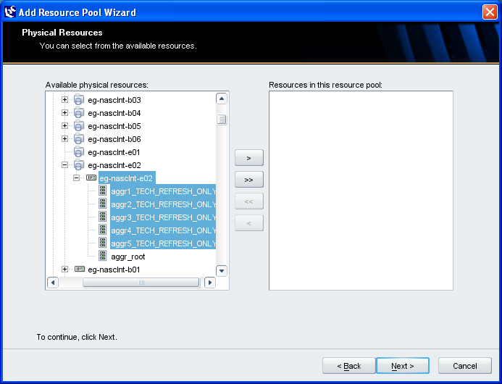

- At the Labels screen, select Next. (Labels are no longer being used)

- Configure the Threshold settings as indicated in the picture below:

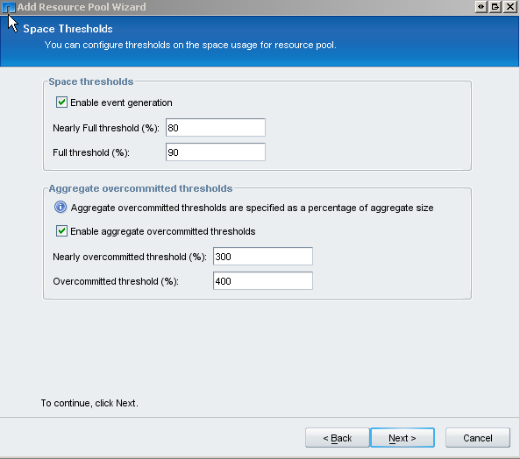

- Select Next and Finish.

Misc Information:
- CLI command to view resource pool’s members:
  - Dfpm respool list –m <filer_name>

