Qtree Allocation on a vFiler via NMC or CLI

Required Software:
- NetApp Management Console (NMC)
  - Log into OM/DFM for any site
    - (i.e. http://dfmh.int.westgroup.net:8080/dfm/report/view/suite)
  - In the Setup drop-down, chose “Download Management Console”
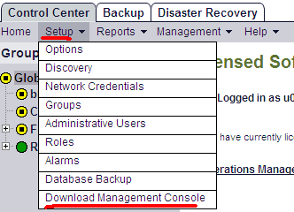

  - Accept all default settings
  - A shortcut to NMC will be created on your desktop

- Instructions for installing NFS Export Manager:
  - Click the following link:
http://nidaros.int.westgroup.net/netapp/nmc_plugins/nfs_export_manager_plugin.zip
  - Verify within WinZip that “Files by folder…” is selected under the View menu.
  - unzip the file and place the “com.netapp.rre.nem-1.0.0” folder containing the plugin into the C:\Program Files\NetApp\Management Console\plugins folder on your PC where the NMC application is already installed.

Qtree Allocation on a vFiler

Note: If your volume will have more than 15 qtrees, run this command on the DFM server that is on the same site as your vFiler:
dfpm dataset set DataSetName maxQtreesPerVolume=70

Also, you can run the following command to determine if the config change was made. The “maxQtreesPerVolume” option will only show up with the following command if it has already been changed from the default of 15: dfpm dataset get DataSetName

- Launch NetApp Management Console (NMC) from your desktop
- Choose the appropriate site (dfme, dfmf, or dfmh)
- Click the “Manage Data” gray folder icon in the top left corner
- Click “Data” in the bottom left corner
- Click “Data Sets” in the top left corner
- Click the “Provisioning” tab
- Highlight the desired volume in the left pane titled Data Set
- Click the “Provision” button in the top left corner
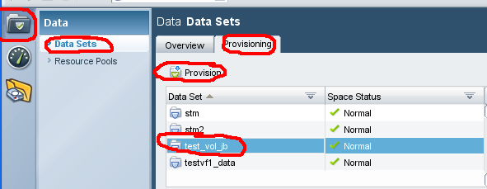

- Read or ignore the Data Set definition and then click Next
- Type the qtree name in the field titled “NFS Export Path” or “Name”
- Type the size of the qtree in the Data Size field (the volume will automatically be grown)
- Review the Details page and click Next if you see no errors. You will not be prompted for verification after this point.
- Click Finish when the wizard is complete
- Open a putty session to any DFM server and run the following command to verify quotas are enabled (the blue text requires editing):
- rsh HostingFiler-mgmt vfiler run vFilerName quota status”
- If quotas are “off” for volumes other than the root volume, run this command:
rsh HostingFiler-mgmt vfiler run vFilerName quota on VolumeName”
- If you have no other qtrees to add, see the “Create/Modify qtree exports” section below for details to configure the permissions.

Create/Modify qtree exports

- Launch NetApp Management Console (NMC) from your desktop
- Choose the appropriate site (dfme, dfmf, or dfmh)
- Click the “NFS Export Manager” yellow folder icon in the top left corner.
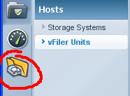
Note: All NFS exports on vFilers should be managed using the NFS Manage Exports NMC Plugin.
- Select the physical filer in the first field titled “Filer” and the vFiler in the second field titled “Vfiler”
- Highlight the volume/qtree in question and click Modify
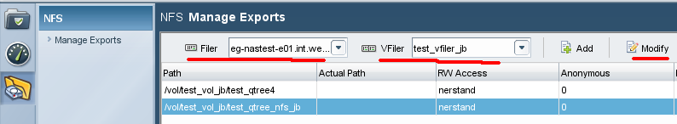
- Read or ignore the Welcome screen and click Next
- Verify the Export Path is accurate and click Next
- Click Add and type the FQDN of the appropriate hosts for Read Only access and click Next
- Click Add and type the FQDN of the appropriate hosts for Read Write access and click Next
- Do not enter any hosts for Root access and click Next
- Leave Anonymous User Id at “0”
- Verify only the “Unix Style” box is checked and click Next
- Verify the summary is accurate and click Finish

Documentation (other resources):
\\Eg-nas-a02\sg$\Procedures\NetApp\vFilers\Multistore_Management_with_Provisioning_Manager_1.9.doc
(NetApp supplied documentation)

http://now.netapp.com/NOW/knowledge/docs/DFM_win/rel371/html/software/protect/index.html

Manual Qtree Creation using CLI on existing Vfiler Volume

Purpose: The instructions below are intended for those instances where NMC cannot be used to create qtrees and their quotas. These same steps could be applied for a physical filer by just removing the “vfiler” components of the command. These instructions were provided by Mike Arndt and Sean Murphy of NetApp.

- From the physical filer CLI (or rsh from DFM server), run the qtree create command for each
qtree:

vfiler run <vfiler_name> qtree create /vol/<vol_name>/<qtree_name>

- On DFM server that’s on the same site as the physical filer, go to the vfiler’s root volume configuration mountpoint. This will create an automount point that will mount the vfiler’s /etc directory:

<dfm_server>:~ # cd /filers/<vfiler_name>

- Make a backup of the /filers/<vfiler_name>/quotas file using the “cp” command. Edit the file using VI (must be logged in with a root level account on the appropriate DFM server). Enter a new line for each qtree that you created, using the same format as the existing lines. Modify the qtree path and the qtree size, and leave all other columns (including "-") as is. Example of a vfiler quotas file is below:

nerstrand:/filers/prod-ecom-e0057 # more quotas
#Auto-generated by setup Tue Apr 20 04:04:44 CDT 2010
/vol/nv_dochaload2p_n01ora1_nosnap/n01oracluster1 tree 2097152 - - - -
/vol/nv_dochaload2p_s01ora1_snap/s01oradata1 tree 44040192 - - - -
/vol/nv_dochaload2p_n01ora1_nosnap/n01oradata1 tree 20971520 - - - -
/vol/nv_dochaload2p_n01ora1_nosnap/n01oraarch1 tree 26214400 - - - -
/vol/nv_dochaload2p_n01ora1_nosnap/n01oraflash1 tree 1048576 - - - -
/vol/nv_dochaload2p_n01ora1_nosnap/n01oraadmin1 tree 10485760 - - - -

- From the <physical_filer> CLI, restart quotas:

vfiler run <vfiler_name> quota off <vol_name>
vfiler run <vfiler_name> quota on <vol_name>

Or
Vfiler run <vfiler_name> quotas resize <vol_name>
(if you’re just modifying/renaming an existing qtree)

NOTE: The qtrees will show up in NMC, but the quotas will not show up or show as “UNKOWN” until DFM updates itself so you may want to wait a day before checking NMC again.

- Continue the rest of the provisioning request for this such as NFS exports, etc, via the normal process. You can do this with NMC at this point, but if you cannot do it through NMC for some reason, you can use the following steps to modify the exports:

  - <dfm_server>:~ # cd /filers/<vfiler_name>
  - Make a backup copy of the exports file using the “cp” command.
  - vi exports (copy one of the lines and change the qtree name as well as the rw= <host> portion)
  - rsh <filer_name> “vfiler run <vfiler_name> exportfs –av”

