NMC: Modify a quota
- Launch NetApp Management Console (NMC) from your desktop
- Choose the appropriate site (dfme, dfmf, or dfmh)
- Click the “Manage Data” gray folder icon in the top left corner
- Click “Data” in the bottom left corner
- Click “Data Sets” in the top left corner
- Click the “Provisioning” tab
- First resize the volume, and then resize the quota using the following steps
- Highlight the desired volume in the left-hand pane titled Data Set
- Highlight the desired volume in the right-hand pane titled Storage
- Click the “Resize Storage” button in the top left corner
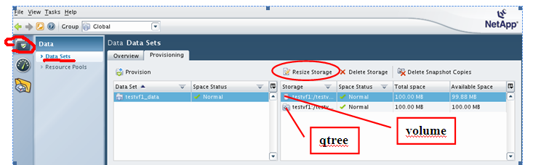
- Type the desired volume size and click Resize
- Highlight the desired volume in the left-hand pane titled Data Set
- Highlight the desired qtree in the right-hand pane titled Storage
- Click the “Resize Storage” button in the top left corner
- Type the quota size and click Resize

(Note: For snap volumes be sure to account for the 20% snap reserve when resizing your volume.)

