Required Software:
- NetApp Management Console (NMC)
  - Log into OM/DFM for any site
    - (i.e. http://dfmh.int.westgroup.net:8080/dfm/report/view/suite)
  - In the Setup drop-down, chose “Download Management Console”
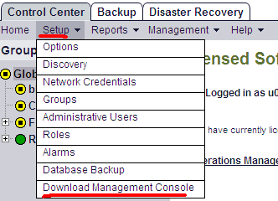

  - Accept all default settings
  - A shortcut to NMC will be created on your desktop

- Instructions for installing NFS Export Manager:
  - Click the following link:
http://nidaros.int.westgroup.net/netapp/nmc_plugins/nfs_export_manager_plugin.zip
  - Verify within WinZip that “Files by folder…” is selected under the View menu.
  - unzip the file and place the “com.netapp.rre.nem-1.0.0” folder containing the plugin into the C:\Program Files\NetApp\Management Console\plugins folder on your PC where the NMC application is already installed.

Volume Allocation on a vFiler
Note: If your volume will have more than 15 qtrees, run this command on the DFM server that is on the same site as your vFiler:
dfpm dataset set DataSetName maxQtreesPerVolume=70

- Launch NetApp Management Console (NMC) from your desktop
- Choose the appropriate site (dfme, dfmf, or dfmh)
- Click the “Manage Data” gray folder icon in the top left corner
- Click “Data” in the bottom left corner
- Click “Data Sets” in the top left corner
- Verify the “Overview” tab is selected
- Click “Add” in the top left corner
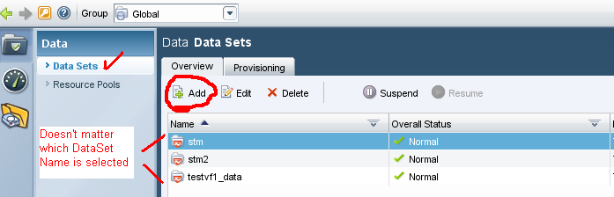

- Read or ignore the Data Set definition and then click Next
- Type the Volume/DataSet name using our standard volume naming convention
- Enter the PPID of the project into the description field
- Accept defaults for remaining fields and click next
- Select the appropriate DFM group/filer and click next
- Select the appropriate Provisioning Policy
(see section 2.2 in the following document for Provisioning Policy descriptions:)
\\Eg-nas-a02\sg$\Procedures\NetApp\vFilers\Multistore_Management_with_Provisioning_Manager_1.9.doc
- For CIFS volumes, skip to step 20
- For NFS volumes, expand the NFS Export Settings field
- Click “Turn on Now” in the NFS Export Settings field
- Change the field for “Map Anonymous Users” to 0
- Select Read Write in the “All Hosts” drop-down
- Click the Add button, choose Read Write, and type “1.1.1.1” in the Hosts field
- Expand the Resource Pool field, select the appropriate physical filer, and click the arrow to move the appropriate physical filer from the left-hand pane to the right-hand pane
- Click next
- Select the name of your vFiler and click Next
- Select Yes when prompted for “Would you like to provision storage now?”
- Enter the qtree name in the field titled “NFS Export Path” or “Name”, depending if you are creating an NFS or CIFS volume.
- Select the capacity for your qtree.
- Click Next
- Verify the summary is accurate and click Finish
- If you created a CIFS volume, you must use CLI to change the qtree security style:
- Open a Putty session to a DFM/OM server (the blue text below requires editing)
- rsh PhysicalFilerName-mgmt “vfiler run vFilerName qtree security /vol/VolumeName ntfs”

- To remove the default snapshot schedule, which is our standard for ALL volumes, you can use the FilerView GUI or the following command:
- Open a Putty session to a DFM/OM server (the blue text below requires editing)
- rsh PhysicalFilerName-mgmt “vfiler run vFilerName snap sched VolumeName 0 0 0”

- Run the following command to enable snap autodelete on ALL volumes you create:
- Open a Putty session to a DFM/OM server (the blue text below requires editing)
- rsh PhysicalFilerName-mgmt “vfiler run vFilerName snap autodelete VolumeName trigger snap_reserve”
- rsh PhysicalFilerName-mgmt “vfiler run vFilerName snap autodelete VolumeName on”

- Follow our standard for configuring the snapvault snap schedule:
For database volumes:
- Open a Putty session to a DFM/OM server (the blue text below requires editing)
- rsh PhysicalFilerName-mgmt “vfiler run vFilerName snapvault snap sched VolumeName volumename _qtreename 7@-“
For flat file volumes:
- Open a Putty session to a DFM/OM server (the blue text below requires editing)
- rsh PhysicalFilerName-mgmt “vfiler run vFilerName snapvault snap sched volname volname 7@sun-sat@10”

For details see our standard snapvaulting documentation
\\Eg-nas-a02\sg$\Procedures\NetApp\snapvault_setup_flatfile_vols.doc
\\Eg-nas-a02\sg$\Procedures\NetApp\snapvault_setup_DB_vols.doc

- If you have no other qtrees to add, see the “Create/Modify qtree exports” section below for details to configure the permissions.

- If you have additional qtrees to add to the volume, see the “Qtree Allocation on a vFiler” section below.

Qtree Allocation on a vFiler

- Launch NetApp Management Console (NMC) from your desktop
- Choose the appropriate site (dfme, dfmf, or dfmh)
- Click the “Manage Data” gray folder icon in the top left corner
- Click “Data” in the bottom left corner
- Click “Data Sets” in the top left corner
- Click the “Provisioning” tab
- Highlight the desired volume in the left pane titled Data Set
- Click the “Provision” button in the top left corner
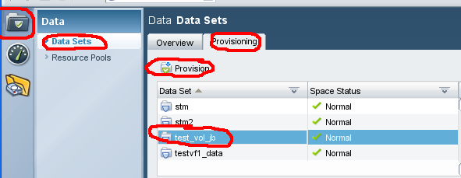

- Read or ignore the Data Set definition and then click Next
- Type the qtree name in the field titled “NFS Export Path” or “Name”
- Type the size of the qtree in the Data Size field (the volume will automatically be grown)
- Review the Details page and click Next if you see no errors. You will not be prompted for verification after this point.
- Click Finish when the wizard is complete
- Open a putty session to any DFM server and run the following command to verify quotas are enabled (the blue text requires editing):
- rsh HostingFiler-mgmt vfiler run vFilerName quota status”
- If quotas are “off” for volumes other than the root volume, run this command:
rsh HostingFiler-mgmt vfiler run vFilerName quota on VolumeName”
- If you have no other qtrees to add, see the “Create/Modify qtree exports” section below for details to configure the permissions.

Create/Modify qtree exports

- Launch NetApp Management Console (NMC) from your desktop
- Choose the appropriate site (dfme, dfmf, or dfmh)
- Click the “NFS Export Manager” yellow folder icon in the top left corner.
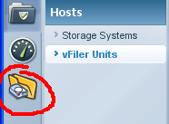
Note: All NFS exports on vFilers should be managed using the NFS Manage Exports NMC Plugin.
- Select the physical filer in the first field titled “Filer” and the vFiler in the second field titled “Vfiler”
- Highlight the volume/qtree in question and click Modify
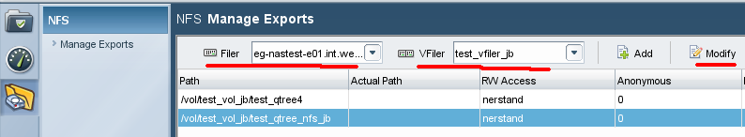
- Read or ignore the Welcome screen and click Next
- Verify the Export Path is accurate and click Next
- Click Add and type the FQDN of the appropriate hosts for Read Only access and click Next
- Click Add and type the FQDN of the appropriate hosts for Read Write access and click Next
- Do not enter any hosts for Root access and click Next
- Leave Anonymous User Id at “0”
- Verify only the “Unix Style” box is checked and click Next
- Verify the summary is accurate and click Finish

Documentation (other resources):
\\Eg-nas-a02\sg$\Procedures\NetApp\vFilers\Multistore_Management_with_Provisioning_Manager_1.9.doc
(NetApp supplied documentation)

http://now.netapp.com/NOW/knowledge/docs/DFM_win/rel371/html/software/protect/index.html

