vFiler: rename volume
- Use FilerView on the physical filer to rename a volume (see this documented procedure: \\Eg-nas-a02\sg$\Procedures\NetApp\RenameVolume.doc)
- Please note that the “dataset” name will not change when you change the volume name. The volume is the “physical resource” in the dataset. To rename the dataset:
  - Login to Provisioning Manager
  - Click on the grey “data management” folder in the left pane.
  - Select “Data/Datasets” in the center pane and make sure the “Overview” tab is selected.
  - Highlight the dataset you would like to rename and click “edit”. Select “General Properties” in the left pane.
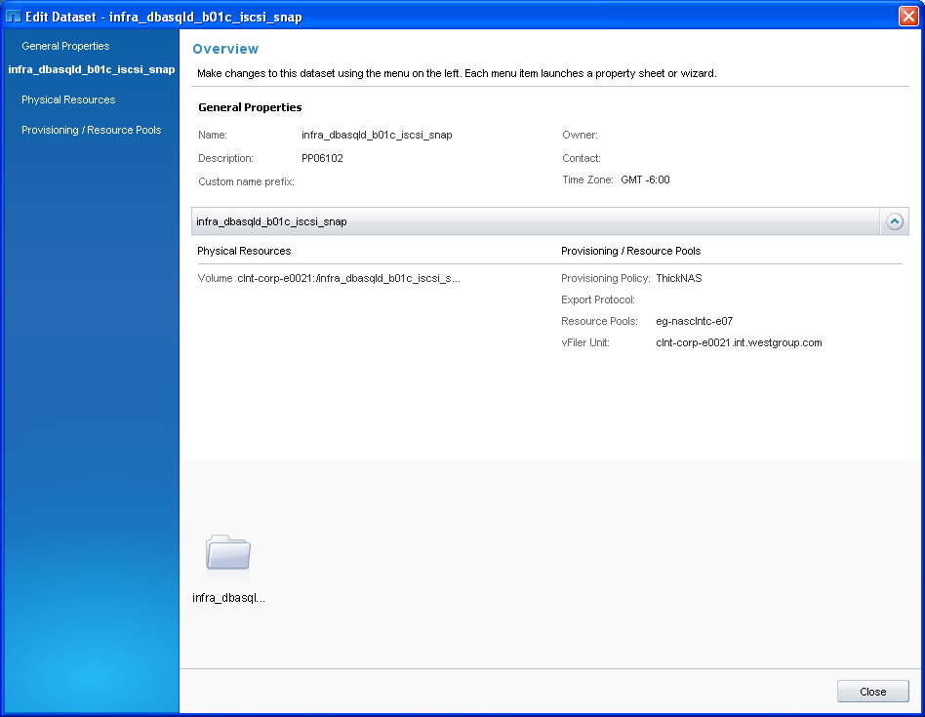

  - Then modify the dataset “Name” field and click “OK”:
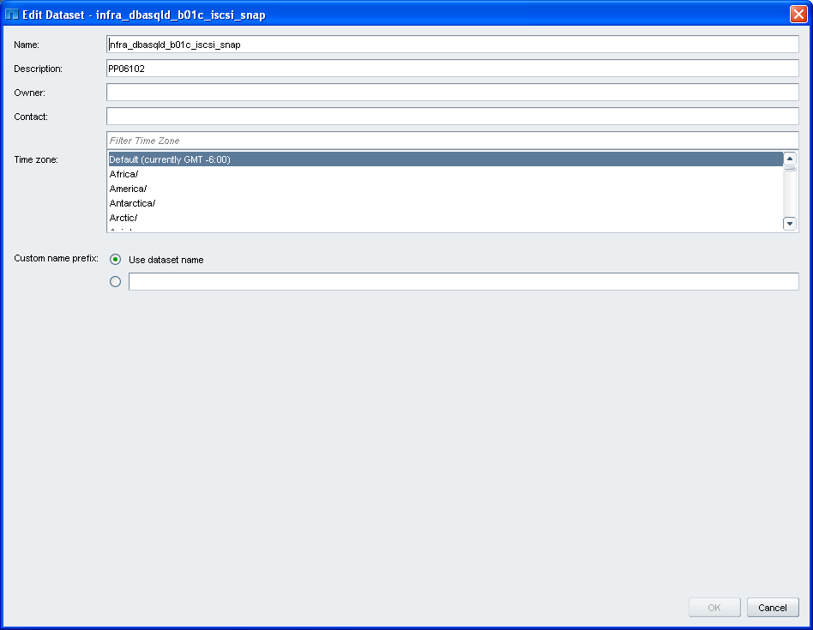

  - Then click close on the properties dialog box.

- You can’t rename qtrees that are in a vFiler

