MANAGEMENT OF MULTISTORE VFILERS WITH PROVISIONING MANAGER

Version 1.9
April 2009

Prepared by:
Michael Arndt
arndt@netapp.com

Contributions from:
-NetApp onsite PS team for Thomson Reuters Professional
-Thomson Reuters Professional Storage Team

Abstract
This paper documents tasks for provisioning NetApp Multistore Virtual Filers (vFilers) and storage associated with them using the policy based features of NetApp Provisioning Manager. Configurations are documented specific to the Thomson Reuters Professional environment.
TABLE OF CONTENTS

1 INTRODUCTION 3
1.1 Conventions 3
1.2 Provisioning Manager concepts 3
2 Configuring templates, policies, and resource pools 4
2.1 Creating vfiler templates 4
2.2 Creating provisioning policies 5
2.3 Creating resource pools 8
3 Provisioning vFilers and storage 9
3.1 Provisioning a new vFiler 9
3.2 Provisioning a data set for a vFiler 11
3.3 Making changes to your data set configuration 13
3.4 Administrative tasks that are performed outside of Provisioning Manager 14
3.5 Modifying NFS export configuration 15
4 Importing existing data into vFilers and Provisioning Manager 16
5 Resources 17

1 INTRODUCTION
This paper documents tasks for provisioning NetApp Multistore Virtual Filers (vFilers) and storage associated with them using the policy based features of NetApp Provisioning Manager. This document assumes that the reader is familiar with basic NetApp storage management concepts such as vfilers, aggregates, flexible volumes (flexvols), quotas, CIFS configuration, and NFS exports. The configurations are documented as they should be configured for the Thomson Reuters Professional (TRP) environment in Eagan, MN.

1.1 Conventions
The following conventions are used throughout this document:

NMC -> list-> list
The convention above indicates a list of links to click on in order to accomplish a task using the Provisioning Manager interface in the Network Management Console software that is available in conjunction with Operations Manager.

om-cli#
The convention above indicates a command to run on the Operations Manager server.

netapp>
The convention above indicates a command to run on a NetApp storage system.

1.2 Provisioning Manager concepts
The Provisioning Manager software from NetApp provides a policy and workflow based methodology for provisioning vfilers and their associated storage. In this section we will draw parallels from the terminology used within Provisioning Manager to the more familiar concepts of a NetApp storage system.

Provisioning Manager Concept | NetApp Storage System Equivalent
Vfiler Unit | A single NetApp vfiler.
Resource Pool | A group of physical storage related resources such as NetApp storage systems and/or aggregates.
Data Set | When creating a data set within Provisioning Manager, a corresponding flexvol of the same name as the data set is created on the NetApp storage system.
Provision storage on a Data Set | When provisioning storage on a data set, a qtree is created within the flexvol every time you provision new storage on that data set.
Provisioning Policy | A collection of various storage system attributes that must be met when selecting objects within a Resource Pool on which to provision storage using a given Provisioning Policy.
Resource Label | A tag that is associated with a policy or resource in order to provide finer granularity during provisioning.

2 Configuring templates, policies, and resource pools
In the context of this section, we discuss some of the configuration tasks that would typically be done up front in order to enable policy based provisioning. These tasks are typically performed infrequently and results in templates and policies that can be applied during a number of more repetitive provisioning tasks associated with day to day management of the storage environment.

2.1 Creating vfiler templates
Creating vfiler templates will allow you specify standard vfiler settings for things like DNS servers, the Microsoft Windows AD domain name, and the administrative host for the vfilers that are provisioned using this template. A typical scenario would involve creating multiple vfiler templates – one for each logical network on which vfilers might be provisioned. To create vfiler templates:

- NMC -> Manage Data -> Policies -> vFiler Templates -> Add

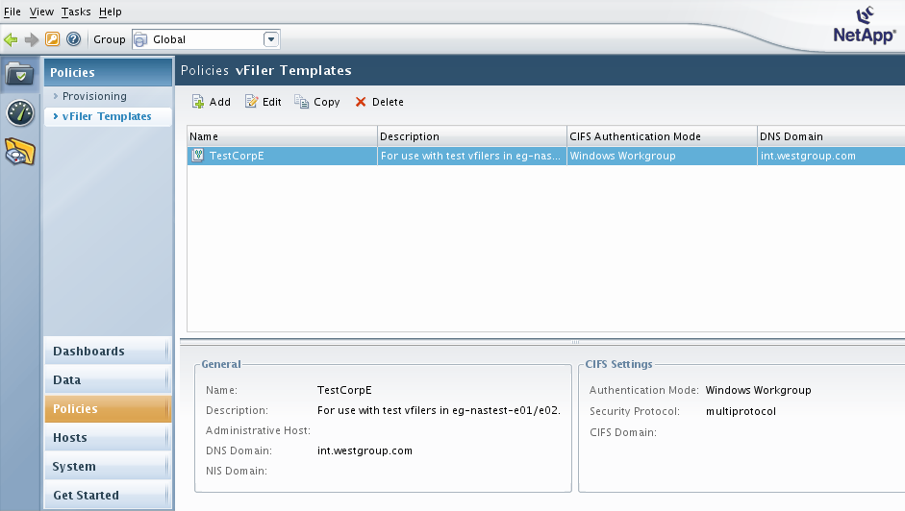

TRP Standard vFiler Templates
The TRP environment will have one vFiler Template configured per network environment:
- Ecom
- Corp

The vFiler Templates will contain the following information:
- DNS domainname
- DNS servers
- AD domain name (even though CIFS will be manually configured)

2.2 Creating provisioning policies
Creating provisioning policies will allow you specify various properties about the NetApp storage systems that should be followed when selecting physical storage objects from the resource pools that will be defined next. For example, you could specify a policy such that clustered NetApp storage systems with RAID-DP aggregates should be used when selecting storage from a resource pool. In addition, you can specify that a policy should only use resource pool members that are labeled as you specify in the provisioning policy. Other properties that apply to a provisioning policy include whether this will be NAS or SAN storage, whether to use thin provisioning or not, and what the default user and group quotas should be. To create a provisioning policy:

- NMC -> Manage Data -> Policies -> Provisioning -> Add

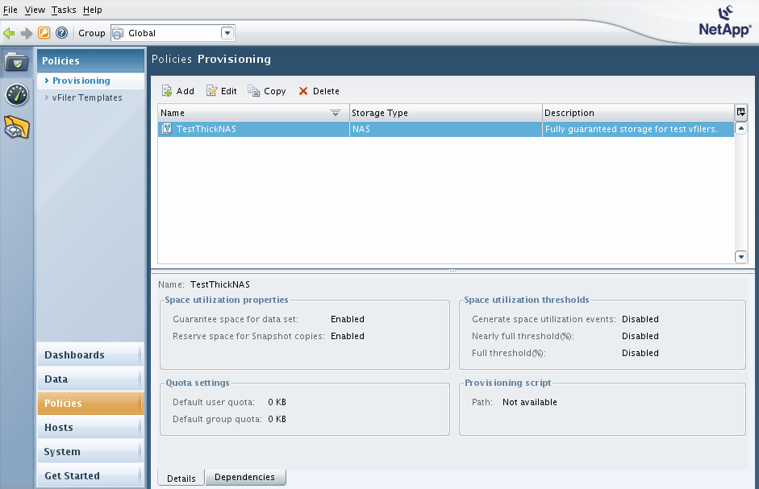

TRP Standard Provisioning Policies
The following provisioning policies, and their characteristics, are to be in place at TRP:

- ThickNAS

Policy Setting | Value
Disk failure protection | RAID-DP
Storage subsystem failure (aggregate SyncMirror) | Unchecked
Storage controller failure (active/active configuration) | Checked
Resource label | ThickNAS
Default user quota | 0
Default group quota | 0
Guarantee space for data and snapshot copies | Checked
Reserve space for snapshot copies | Checked
Space utilization thresholds (*) | Unchecked

- ThickNAS_nosnap

Policy Setting | Value
Disk failure protection | RAID-DP
Storage subsystem failure (aggregate SyncMirror) | Unchecked
Storage controller failure (active/active configuration) | Checked
Resource label | ThickNAS
Default user quota | 0
Default group quota | 0
Guarantee space for data and snapshot copies | Checked
Reserve space for snapshot copies | Unchecked
Space utilization thresholds (*) | Unchecked

- ThinNAS

Policy Setting | Value
Disk failure protection | RAID-DP
Storage subsystem failure (aggregate SyncMirror) | Unchecked
Storage controller failure (active/active configuration) | Checked
Resource label | ThinNAS
Default user quota | 0
Default group quota | 0
Guarantee space for data and snapshot copies | Unchecked
Reserve space for snapshot copies | Checked
Space utilization thresholds (*) | Unchecked

- ThinNAS_nosnap

Policy Setting | Value
Disk failure protection | RAID-DP
Storage subsystem failure (aggregate SyncMirror) | Unchecked
Storage controller failure (active/active configuration) | Checked
Resource label | ThinNAS
Default user quota | 0
Default group quota | 0
Guarantee space for data and snapshot copies | Unchecked
Reserve space for snapshot copies | Unchecked
Space utilization thresholds (*) | Unchecked

- VMwareNAS

Policy Setting | Value
Disk failure protection | RAID-DP
Storage subsystem failure(aggregate SyncMirror) | Unchecked
Storage controller failure (active/active configuration) | Checked
Resource label | VMwareNAS
Default user quota | 0
Default group quota | 0
Guarantee space for data and snapshot copies | Unchecked
Reserve space for snapshot copies | Checked
Space utilization thresholds (*) | Unchecked

- VMwareNAS_nosnap

Policy Setting | Value
Disk failure protection | RAID-DP
Storage subsystem failure(aggregate SyncMirror) | Unchecked
Storage controller failure (active/active configuration) | Checked
Resource label | VMwareNAS
Default user quota | 0
Default group quota | 0
Guarantee space for data and snapshot copies | Unchecked
Reserve space for snapshot copies | Unchecked
Space utilization thresholds (*) | Unchecked

Notes:
- (*) The Space utilization thresholds in the provisioning policies apply to volume and qtree utilization, which is why we do not use these within TRP.

2.3 Creating resource pools
A resource pools is a collection of physical NetApp storage systems and all the aggregates that you want to use when provisioning storage with the resource pool. For example, you could create a resource pool that contains one controller of a clustered NetApp storage system and all of the aggregates on that controller. In addition, resource labels can then be applied to individual aggregates within the resource pool. If the same resource labels are present in the provisioning policy that is being applied to a data set, only those aggregates with this resource label will be used for the data set. You also can set some properties of a resource pools, such as that the nearly overcommitted and overcommitted values should be when operating in a thin provisioned environment. To create a resource pool:

- NMC -> Manage Data -> Data -> Resource Pools -> Add

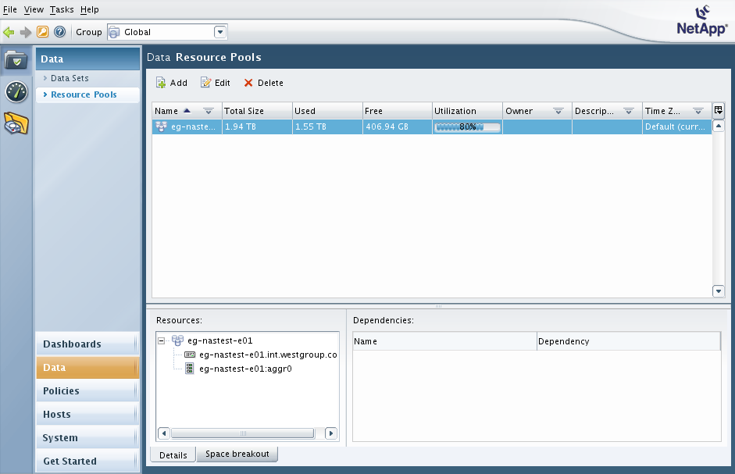

TRP Standard Resource Pool Guidelnes
- There will be one resource pool per storage controller, and the resource pool name will be the same as the storage controller name.
- The Physical Resources for the resource pool will be controller as well as all aggregates attached to that controller.
- The Resource Pool Label should be left blank.
- Thick provisioned aggregates should be labeled with a resource label of “ThickNAS”.
- Thin provisioned aggregates should be labeled with a resource label of “ThinNAS”.
- Aggregates for VMware should be labeled with a resource label of “VMwareNAS”.
- Enable event generation: unchecked.
- Enable aggregate overcommitted thresholds: Checked.
  - Nearly overcommitted threshold (%): 125
  - Overcommitted threshold (%): 150

3 Provisioning vFilers and storage
Once the templates, policies, and resource pools have been defined for an environment, vFilers and storage can be provisioned. The ability to apply the templates and polices, plus use the defined resource pools, will streamline the provisioning process.

3.1 Provisioning a new vFiler
To create a new vFiler, you will use a wizard that will allow you to choose a previously created resource pool on which to store the vFiler, and choose a vFiler template that is used to customize the vFiler. The vFiler root volume, which is only 40MB in size, is placed on an arbitrary aggregate of a storage system that belongs to the selected resource pool. To create a new vFiler:

- NMC -> Hosts -> vFiler Units -> Add

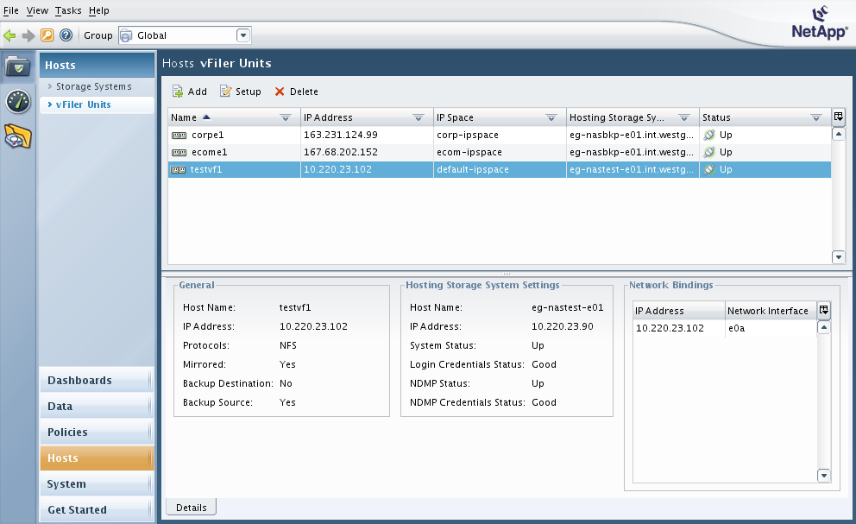

Use the following parameters when creating a new vFiler:

vFiler Unit Setting | Value
Name (see vFiler naming convention below) | <varies>
IP Space (see IPspace and VLANs naming convention below) | <varies>
Allowed protocols | NFS, CIFS
Select a Resource Pool | Checked
Resource Pool (choose resource pool for storage system) | <varies>
Add IP address (*), netmask, and interface | <varies>
vFiler Template | <varies>
Perform CIFS Setup (**) | Unchecked

Notes:
- (*) The vFiler IP address must not be the first IP address assigned to the VLAN tagged interface being used. An administrative vFiler with an IP must first be configured, per the Notes on administrative vFilers section below.
- (**) If CIFS connectivity to a vFiler is required, this will be setup in conjunction with the TRP Windows Platform team using the following command:
netapp> vfiler run vfilername cifs setup

Naming convention for vFilers within TRP:
- The naming convention for vFilers will be as follows:
  - environment-network-site<number>
- Options for environment:
  - ded (dedicated, or dedicated prod for dedicated systems serving both prod and clnt)
  - dedc (dedicated clnt, for dedicated systems serving both prod and clnt)
  - prod (shared production)
  - clnt (shared client)
- Options for network:
  - ecom
  - corp
- Options for site:
  - e
  - f
  - h
- Other naming considerations:
  - Start with the lowest available number.
  - Avoid duplicate vFiler names.
  - You can use a duplicate number as long as at least one part of the vFiler name is unique.
  - The vFiler name should be 15 characters or less in length.
- Dedicated vFiler examples:
  - ded-ecom-e1.westlan.com
  - ded-ecom-e142.westlan.com
  - ded-ecom-f142.westlan.com
  - ded-ecom-h7.westlan.com (dedicated prod ecom in H)
  - dedc-ecom-h8.westlan.com (dedicated client ecom in H)
  - ded-corp-h9.int.westgroup.com (dedicated prod corp in H)
  - dedc-corp-h7.int.westgroup.com (dedicated client corp in H)
- Shared vFiler examples:
  - prod-ecom-e17.westlan.com
  - prod-corp-e17.int.westgroup.com
  - clnt-corp-e17.int.westgroup.com
  - clnt-corp-h2421.int.westgroup.com

Naming convention for IPspaces and VLANs within TRP:
- The IPspace and network interface that should be used for a vFiler will have a postfix that includes the VLAN ID of the network being used for the IP address of the vFiler per the build sheet. For example:
  - ecom-2022 (IPspace for IPs using the 2022 VLAN)
  - ecom10g-2022 (10GbE VLAN tagged network interface for IPs using the 2022 VLAN)
Notes on administrative vFilers:
- The following steps will be performed by NetApp Professional Services Engineers, and is documented here only for the sake of completeness. These steps are not required for day to day provisioning of vFilers.
- Each VLAN tagged interface on the physical storage system that is being used for vFilers will have the following requirements prior to provisioning any vFilers for general use:
  - Create an ipspace for the vlan tagged interface. The syntax and an example is given:
netapp> ipspace create ipspace-name interface-name
netapp> ipspace create ecom-2522 ecom10g-2522
  - Create an administrative vFiler that uses this ipspace and assign an IP address to it. The syntax and an example is given:
netapp> vfiler create –s ipspace –i ipaddr path
netapp> vfiler create eg-nasapp-h10-vsip –s ecom-2522 –i 10.216.126.4 \
/vol/vol0_vsip_2522
  - Make sure that the /etc/rc file of vfiler0 has the correct vlan create statement as well as the correct ifconfig statement for the IP of the administrative vFiler, including the partner argument for the ifconfig command. For example:
vif create single ecom10g e1a e1b
vlan create ecom10g 2522
ifconfig ecom10g-2522 10.216.126.4 netmask 255.255.254.0 mtusize 9000 \
partner ecom10g-2522
  - Edit the /etc/rc file of vfiler0 to contain a command to set the default route for the administrative vFiler via a “vfiler run” command. For example:
vfiler run eg-nasapp-h10-vsip route add default 10.216.127.254 1

3.2 Provisioning a data set for a vFiler
The first step in provisioning storage is to create a data set that will belong to your vFiler. The data set name will be the name of the flexvol when storage is provisioned. When you create the data set, the volume is not created on the storage system until the first unit of storage is provisioned from the data set, which also creates a qtree. Part of creating a data set involves the selection of an appropriate provisioning policy and resource pool that was previously defined. One can also set the default NFS exports for all storage that will be provisioned on this data set. The data set wizard will also allow you to attach the data set to the vFiler of your choice. When provisioning storage, the NFS export path you input into the wizard will be the name of the qtree. You do not need to give the full path for the NFS export, just give the name that you would like your qtree to have. To create a data set and provision storage on it:

- NMC -> Data -> Data Sets -> Overview -> Add

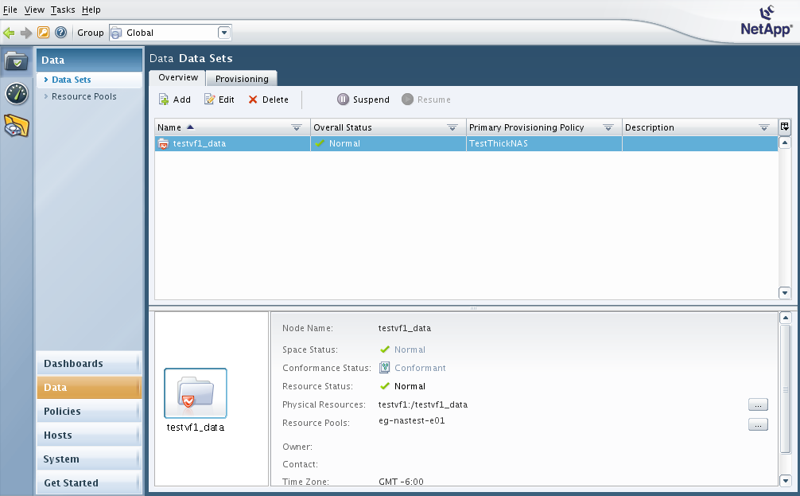

Use the following parameters when creating a new dataset:

Add Data Set Wizard Setting | Value
Name (volname = standard naming convention) | <volname>
Time Zone | Default
Group (Choose ThickNAS, ThinNAS, or VMwareNAS) | <varies>
Use a provisioning policy | Checked
Provisioning policy | <varies>
NFS export settings | Turn on now
Resource Pools | <varies>
Select a vFiler unit | <varies>
Would you like to provision storage now? | Yes
NFS export path | <qtree name>
Data size (note: this is the tree quota size) | <varies>
.
Rules for grouping datasets on vFilers:
- Remember that each dataset created in Provisioning Manager will create a flexible volume on the storage system. The term dataset can be used interchangeably with the term flexible volume.
- Datasets for the same LOON database should belong to the same vFiler.
- Datasets for the same VMware ESX cluster should belong to the same vFiler.
- Datasets that are part of the same storage provisioning request, and exported to the same list of clients, should belong to the same vFiler.
- In all other cases, there should be a one to one mapping between the dataset and the vFiler.

3.3 Making changes to your data set configuration
Provisioning Manager will allow some configuration changes to be made to your data sets and the storage provisioned on them after the initial provisioning has been completed. Common tasks include:

To add another qtree to a volume:

- NMC -> Data -> Data Sets -> Provisioning -> Provision

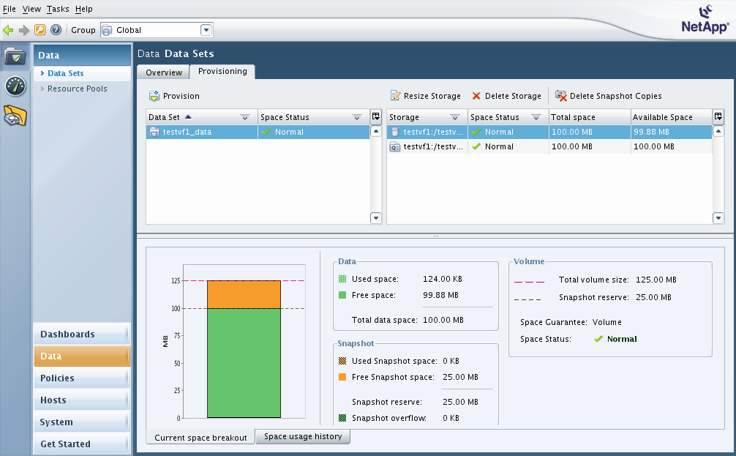

To modify the volume size or snap reserve settings, select the Resize Storage button after navigating to the following link and selecting the volume of your choice.

To modify a tree quota, select the Resize Storage button after navigating to the following link and selecting the qtree of your choice.

- NMC -> Data -> Data Sets -> Provisioning -> Resize Storage

volumeTo modify the volume size, snap reserve settings, or tree quota settings select the Resize Storage button after navigating to the following link and selecting the volume or qtree of your choice: e
qtree modify the volume size, snap reserve settings, or tree quota settings select the Resize Storage button after navigating to the following link and selecting the volume or qtree of your choice: e

3.4 Administrative tasks that are performed outside of Provisioning Manager
A number of administrative tasks will continue to be performed using either the CLI or FilerView, just as they were prior to the implementation of MultiStore with Provisioning Manager. These tasks include:
- Removing the standard snapshot schedule from a new volume that was provisioned (since snapshots are taken via the snapvault snap sched interface). This can be done via FilerView, or via the following CLI:
netapp> vfiler run <vfilername> snap sched <volname> 0
- Creating the snapvault snapshot schedule on a new volume that was provisioned. This can be done via the following CLI:
netapp> vfiler run <vfilername> snapvault snap sched <volname> <snapbasename> <schedule>
- Modifying the snapshot schedule on the vFiler root volume. This will be set just as the physical filer root volume snapshot schedules are defined, and can be done via FilerView or via the CLI.
- Modifying the size of the vFiler root volume can be done via FilerView or via the CLI.
- Creating the oraapi_backup account and associated group/role, which is required in order to enable Oracle database backups on vFilers.

3.5 Modifying NFS export configuration

To modify a NFS export after storage was already provisioned, use the custom NMC plugin. The NFS Manage Exports wizard will guide you through the familiar options available for a NFS export.

The NFS Manage Exports NMC plugin can be downloaded from the following link:

http://nidaros.int.westgroup.net/netapp/nmc_plugins/nfs_export_manager_plugin.zip

To install the NFS Manage Exports NMC plugin, unzip the file and place the com.netapp.rre.nem-1.0.0 folder containing the plugin into the C:\Program Files\NetApp\Management Console\plugins folder on your PC where the NMC application is already installed.

Notes:
- All NFS exports on vFilers should be managed using the NFS Manage Exports NMC Plugin.
- When provisioning a new vFiler, please use this plugin to export the vFiler root volume to all DFM servers with read-write and root privileges.

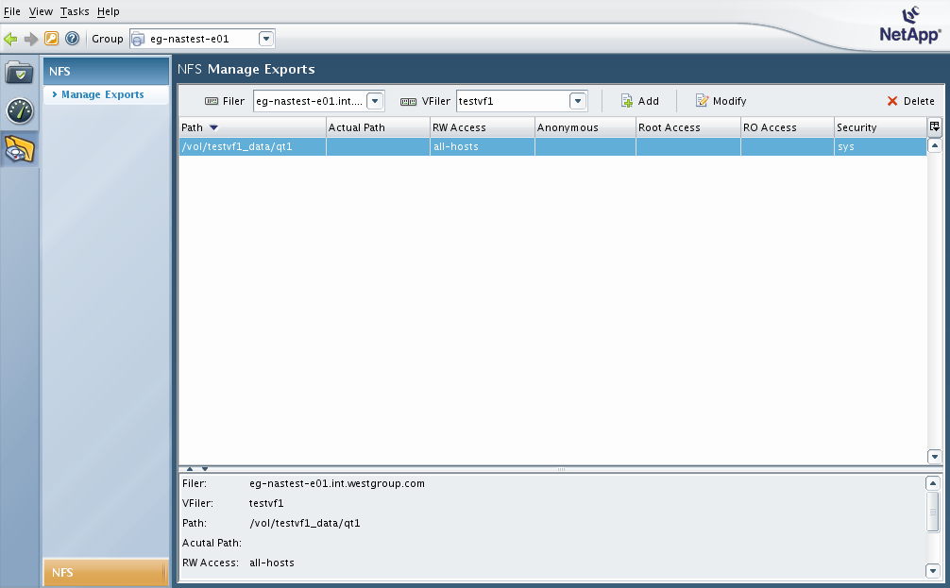
4 Importing existing data into vFilers and Provisioning Manager

In case there is a need to import an existing data into a vFiler configuration that is managed by Provisioning Manager, the following steps can be used:

- Create the vFiler as you normally would with Provisioning Manager.
- If the storage system on which you wish to create the vFiler has only 100% full aggregates, as may be the case when converting old volumes into the vFiler model, use the following steps:
  - Create the vFiler by hand using the CLI.
  - Run the following command on the appropriate Operations Manager server:
om-cli# dfm vfiler add –H hosting_filer_name vfiler_name
The viler will now show up in the Prov Mgr, and the status will change from “Unknown” to “Up” within about 5 to 10 minutes.
- If CIFS access to the vFiler will be required, work with the Windows platform team to join the vFiler to the AD domain.
- Add the existing volumes in question to the vFiler using the NetApp storage system CLI:
netapp> vfiler add vfiler_name /vol/volume_name
- If tree quotas are being used for the qtrees that exist in the volumes added to the vFiler:
  - Manually add tree quotas for all qtrees into the vFiler’s /etc/quotas file. This can be done via a NFS mount of the vFiler root volume.
  - Turn on quotas within the vFiler.
netapp> vfiler run vfiler_name quota on /vol/volname
- If snapvault backups are required for the volumes added to the vFiler:
  - Setup snapvault snap schedules within the vFiler.
netapp> vfiler run vfiler_name snapvault snap sched volname snapbasename schedule
  - Remove snapvault snap schedules and quota entries from hosting filer.
netapp> snapvault snap unsched volname snapbasename
  - If a new snapvault relationship needs to be created, do so specifying the vFiler FQDN:
netapp-bkp> vfiler run secondary_vfiler_name snapvault start –S primary_vfiler_FQDN:/vol/volname secondary_vfiler_name:/vol/secondary_volname/1.
  - If an existing snapvault relationship needs to be pointed at the vFiler instead of a physical filer, restart the snapvault updates from the new primary location using the –r option:
netapp-bkp> vfiler run secondary_vfiler_name snapvault start -r –S primary_vfiler_FQDN:/vol/volname secondary_vfiler_name:/vol/secondary_volname/1.
- Run the following command to refresh the Operations Manager server managing the volumes added to the vFiler:
om-cli# dfm host discover hosting_filername
- Monitor progress of the refresh with the following command:
om-cli# dfm host diag hosting_filername
Do not continue until all Monitoring Timestamps have been updated, otherwise you will not be able to associate the datasets with the vFiler.
- Use the Provisioning Manager GUI to add a data set for each volume (except the vFiler root volume) added to the vFiler via:
NMC -> Data -> Data Sets -> Overview -> Add
  - Choose *not* to provision storage at this time.

- After adding the data set, associate the volume with the data set and the data set with the vFiler via the following steps:
NMC -> Data -> Data Sets -> Overview -> <select data set> -> Edit -> Provisioning / Resource Pools
  - Edit the data set and select the Physical Resources link:
    - Add the appropriate volume to the dataset.
  - Edit the data set and select the Provisioning / Resource Pools link:
    - Select the appropriate Provisioning policy.
    - Select the appropriate Resource Pool.
    - Enable NFS.
    - Enable CIFS if required.
    - Assign the dataset to the correct vFiler.
- Use the NMC NFS Export Manager plugin to modify the NFS export configuration for the volumes (and qtrees contained within) that were added to the vFiler:
  - Add an appropriate NFS export to the vFiler.
  - Remove any NFS exports that still reference these volumes from the hosting filer.

5 Resources

Provisioning Manager Administration Guide:
http://now.netapp.com/NOW/knowledge/docs/DFM_win/rel371/html/software/protect/index.html

