NFS Export Creation

Index:
Important NFS Export Caveats
Creating new NFS exports
Updating existing NFS exports

Important NFS export caveats:
- Do not confuse the three NFS export entry screens: Read-Only Access, Read-Write Access, and Root Access. Insure you are entering in the appropriate NFS export on the appropriate screen. The number of screens can vary by what checkboxes have been selected upon initial set-up.

- If someone is requesting that additional Read-Only Access hosts be added to an existing NFS export, pay close attention if a checked box for “All Hosts” already exists. If this is the case, do not manually add a new Read-Only Access host, as it will automatically uncheck the “All Hosts” checkbox. In addition, there is no need to add the additional host, as all hosts are already Read-Only Access.)

- Do not uncheck an “All Hosts” check box on any of the screens unless directed to do so.

(These caveats are discussed in more detail here: Updating existing NFS exports )

Creating new exports
A typical NFS export request requires Read\Write access for certain hosts. For Read\Write access check the following two boxes as seen in the bitmap below.

Once you check those two boxes, you will be presented with an entry field for Read\Write Access host entry, then a field for Root Access host entry.

If this is a loon build make sure you enter in <host>-nas, to insure data is trafficked on the correct interface. For additional NAS interface information see:
\\eg-nas-a02\sg$\Procedures\NetApp\ DB cannot access NAS Troubleshooting.doc

Note, there are physical export file limitations. See the following for more information:
\\eg-nas-a02\sg$\Procedures\NetApp\ Restores_ExportsFile_FromSnapshot.doc
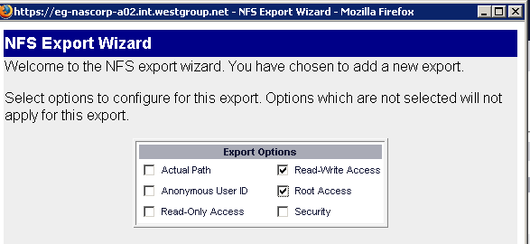

In the event that Read-Only Access is required for hosts, in addition to R\W access, also check the “Read-Only Access field as seen below:

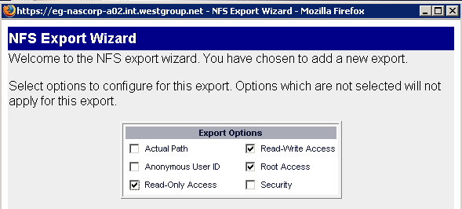

Note that you can either add individual hosts for Read-Only access, once the “Read-Only” box has been checked as in Bitmap #1 below, or you can check the box for “All Hosts” as seen in Bitmap #2 below:

Bitmap #1
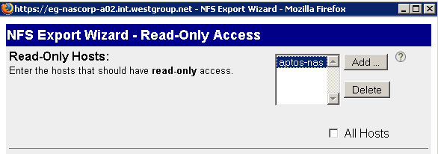

Bitmap #2
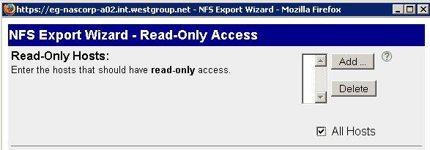

Updating existing NFS exports:

When editing NFS permissions, you bring up the following screen by clicking on an existing NFS export entry. Note that in the bitmap below Read-Only Access has been checked, thus you will be presented with 3 different fields to enter in host information (not just Read-Write Access and Root.) Having Read-Only access is not the norm, but it is not uncommon so do not confuse the three NFS export entry screens: Read-Only Access, Read-Write Access, and Root Access. Insure you are entering in the appropriate NFS export on the appropriate screen. The number of screens can vary by what checkboxes have been selected upon initial set-up.

Also, please note the important Read-Only Access caveats below.

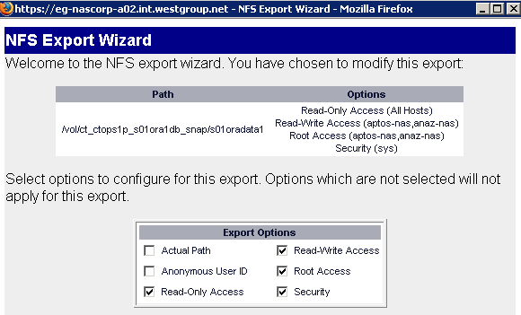

Please see the bitmap below. If someone is requesting that additional Read-Only Access hosts be added to an existing NFS export, pay close attention if a checked box for All Hosts already exists. If this is the case, do not manually add a new Read-Only Access host, as it will automatically uncheck the “All Hosts” checkbox. In addition, there is no need to add the additional host, as all hosts are already Read-Only Access.)

