Create/Modify qtree exports

Required Software:
- NetApp Management Console (NMC)
  - Log into OM/DFM for any site
    - (i.e. http://dfmh.int.westgroup.net:8080/dfm/report/view/suite)
  - In the Setup drop-down, chose “Download Management Console”
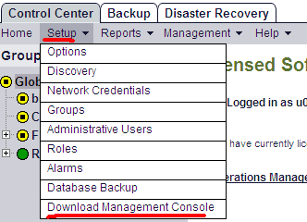

  - Accept all default settings
  - A shortcut to NMC will be created on your desktop

- Instruction for installing NFS Export Manager:
  - Click the following link:
http://nidaros.int.westgroup.net/netapp/nmc_plugins/nfs_export_manager_plugin.zip
  - Verify within WinZip that “Files by folder…” is selected under the View menu.
  - unzip the file and place the “com.netapp.rre.nem-1.0.0” folder containing the plugin into the C:\Program Files\NetApp\Management Console\plugins folder on your PC where the NMC application is already installed.

Create/Modify qtree exports

- Launch NetApp Management Console (NMC) from your desktop
- Choose the appropriate site (dfme, dfmf, or dfmh)

- Click the “NFS Export Manager” yellow folder icon in the top left corner.
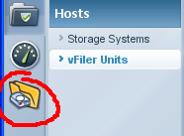
- Select the physical filer in the first field titled “Filer” and leave the second field titled “Vfiler” empty
- Highlight the volume/qtree in question and click Modify
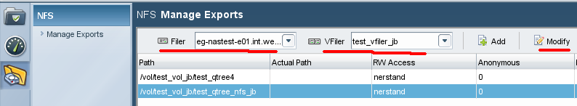
- Read or ignore the Welcome screen and click Next
- Verify the Export Path is accurate and click Next
- Click Add and type the FQDN of the appropriate hosts for Read Only access and click Next
(or highlight the host you want to remove and click Delete)
- Click Add and type the FQDN of the appropriate hosts for Read Write access and click Next
(or highlight the host you want to remove and click Delete)
- Click Add and type the FQDN of the appropriate hosts for Root access and click Next
(or highlight the host you want to remove and click Delete)
- Accept the default setting for Anonymous User ID (unless a change is required) and click Next
- Accept the default setting for Security (unless a change is required) and click Next
- Verify the summary is complete and click Finsh

