

Work Instructions

OCUM 6.3: Volume Full Alert Configuration

Synopsis: Configuration instruction

Segment: DCIS - Storage

Authors: David Ng

Contributors:

Document Version: V0.1
Date: 02/15/2017
Document Status: valid

CONFIDENTIAL INFORMATION
This document contains information proprietary to Thomson Reuters and may not be reproduced, disclosed or used in whole or part without express permission of Thomson Reuters.

© Thomson Reuters 2015
Contents
1 Introduction 3
2 Configuring Volume Full Alert 4
3 Testing Volume Full Alert 8
4 Add Volume to Alert 9

Introduction

Management Summary
This document provides instruction for configuring Volume Full alerts in Oncommand Unified Manager 6.3. Global setting will be used for thresholds.

Document Scope

Assumptions
The read is familiar with OCUM 6.3

References
 | Document | Version | Date | Author
1 | OCUM 6.3 Online Help |  |  | Netapp

Change History
Ver | Date | Author | Key Changes
0.1 | 02/15/2017 | David Ng | initial

Distribution List
Name | Role
Storage Support | Implementers

Configuring Volume Full Alert

Login to web UI via browser

Click ‘Administration (top right)’ -> ‘Alerts’

Click ‘Add’ button

Click the ‘Name’ tab

Update the ‘Alert Name’ & ‘Alert Description’
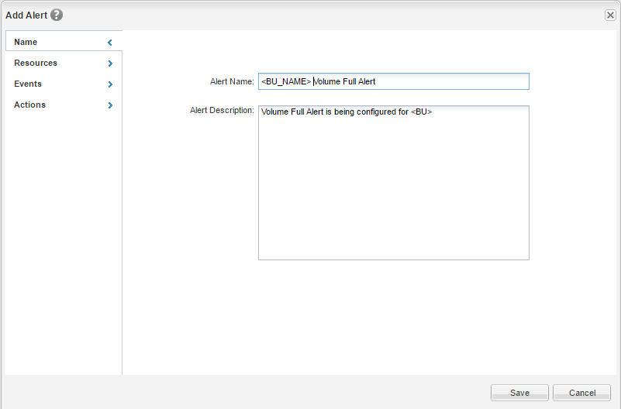

Click the ‘Resources’ tab

Select the ‘Volume’ resource in dropdown box

Select volume(s) to be monitored

Move them to ‘Selected Resources’ window pane
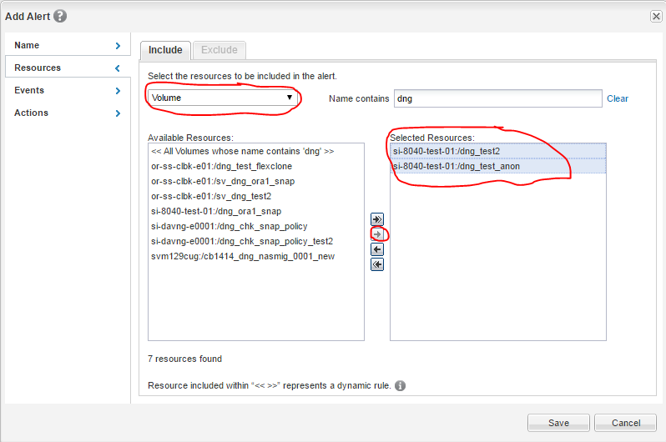

Click on the ‘Events’ tab

Select ‘Errors’ from ‘Event Severity’

Select ‘Volume Space Full’

Move it to the ‘Selected Events’ window pane
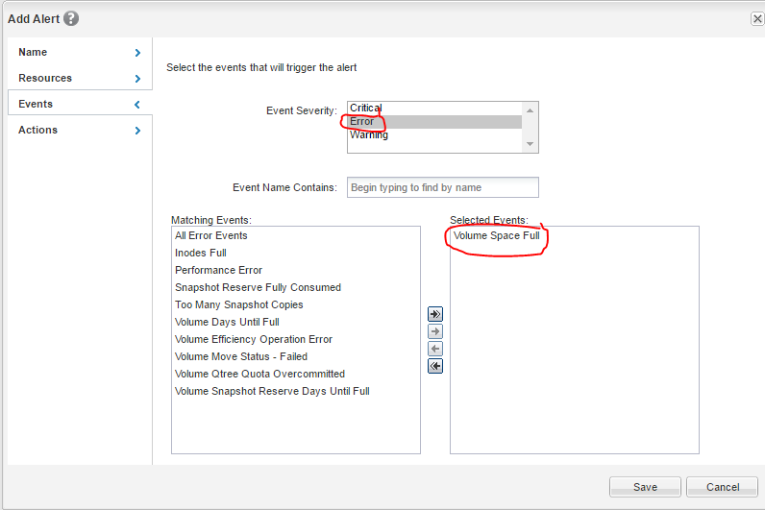

Click on the ‘Actions’ tab

Enter EMAT email if we need generates alerts which needs to be parsed for ticket creation

Select ‘Once’ as the ‘Notification Frequency’

Click ‘Save’
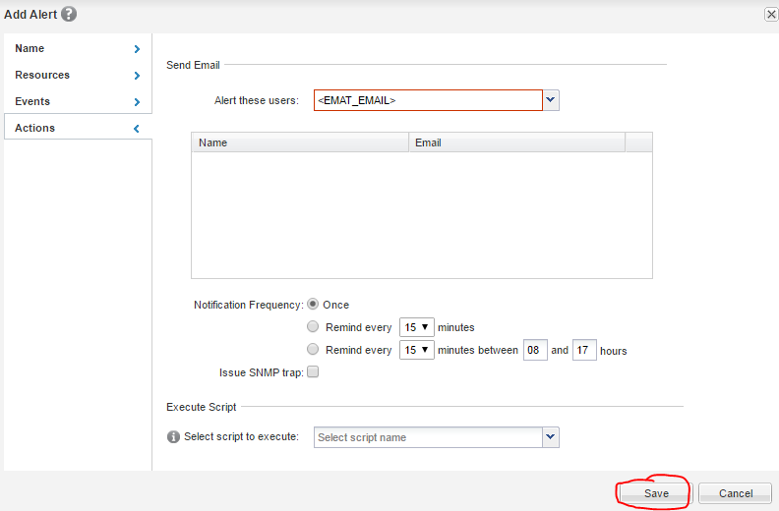

Testing Volume Full Alert
- Click ‘Administration’ -> ‘Manage Alerts’
- Select the checkbox on the alert being tested
- Click ‘Test’
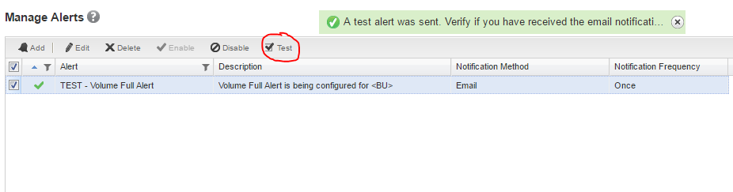

Add Volume to Alert
- Click ‘Administration’ -> ‘Manage Alerts’
- Select checkbox of alert you are adding volumes to
  - Click Edit
- Click ‘Resource’ tab
- Select ‘Volume as resource to be included
- Highlight volume(s) which need to be monitored
  - Move to ‘Selected Resources’ window pane
- Click ‘Save’
