**7Mode**

VLANs must be deployed to both nodes of a HA pair. Repeat steps for both nodes.

First identify which base VIF (virtual interface) the VLAN will be added to, i.e. ecomvif0, corpvif0, colovif0, etc. Most filers have one base VIF, but some may have multiple. In addition to the base VIF, VLAN VIFs may also be seen, i.e. corpvif0-2502.

Format: ssh <filer> ifconfig -a

Example: ssh eg-naslowcp-h03 ifconfig -a

This example is for eg-naslowcp-h03 which shows the base VIF corpvif0 which we will add the new 2504 VLAN to. A VLAN VIF already exists for VLAN 2502 named corpvif0-2502. Our new VLAN VIF will follow this same naming convention. Note that no vfiler IPs are listed under the base VIF. All vfiler IPs will belong to a VLAN VIF.

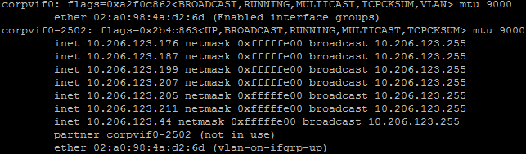

[Request an IP in ServiceNow](https://thomsonreuters.service-now.com/nav_to.do?uri=%2Fcom.glideapp.servicecatalog_cat_item_view.do%3Fv%3D1%26sysparm_id%3D44de0fbe136cfa00f05c7e276144b0dd) for the new VLAN, 1 per filer. Use Banana to create a DNS entry for each IP in the format of “<filer>-<VIF>vsip-<VLAN>.int.thomsonreuters.com”, the <VIF> being the ecom/corp/colo, etc, from the base VIF name.

Examples below are as seen in Zipper tool, showing the vsip entries for the existing 2502 VLAN and the new 2504 VLAN. IPs will not be pingable by Zipper until the vsip vfiler is created. Keep in mind some special VLANs will never be shown pingable by Zipper.

[https://zipper.int.thomsonreuters.com/images/global.gif](https://banana.int.thomsonreuters.com/cgi-bin/banana/request_search.pl?search=10.206.123.176)**10.206.123.176**  [https://zipper.int.thomsonreuters.com/images/network.jpg](https://zipper.int.thomsonreuters.com/cgi-bin/zipper/subnet_search.pl?ip=10.206.123.176)  https://zipper.int.thomsonreuters.com/images/nomonitor.png  
        [https://zipper.int.thomsonreuters.com/images/dns.jpg](https://banana.int.thomsonreuters.com/cgi-bin/banana/request_search.pl?search=eg-naslowcp-h03-corpvsip-2502.int.westgroup.com)eg-naslowcp-h03-corpvsip-2502.int.westgroup.com    
[https://zipper.int.thomsonreuters.com/images/global.gif](https://banana.int.thomsonreuters.com/cgi-bin/banana/request_search.pl?search=10.206.123.177)**10.206.123.177**  [https://zipper.int.thomsonreuters.com/images/network.jpg](https://zipper.int.thomsonreuters.com/cgi-bin/zipper/subnet_search.pl?ip=10.206.123.177)  https://zipper.int.thomsonreuters.com/images/nomonitor.png  
        [https://zipper.int.thomsonreuters.com/images/dns.jpg](https://banana.int.thomsonreuters.com/cgi-bin/banana/request_search.pl?search=eg-naslowcp-h04-corpvsip-2502.int.westgroup.com)eg-naslowcp-h04-corpvsip-2502.int.westgroup.com    
[https://zipper.int.thomsonreuters.com/images/global.gif](https://banana.int.thomsonreuters.com/cgi-bin/banana/request_search.pl?search=10.206.125.1)**10.206.125.1**  [https://zipper.int.thomsonreuters.com/images/network.jpg](https://zipper.int.thomsonreuters.com/cgi-bin/zipper/subnet_search.pl?ip=10.206.125.1)  https://zipper.int.thomsonreuters.com/images/nomonitor.png  https://zipper.int.thomsonreuters.com/images/sonar.gif  
        [https://zipper.int.thomsonreuters.com/images/dns.jpg](https://banana.int.thomsonreuters.com/cgi-bin/banana/request_search.pl?search=eg-naslowcp-h03-corpvsip-2504.int.thomsonreuters.com)eg-naslowcp-h03-corpvsip-2504.int.thomsonreuters.com    
[https://zipper.int.thomsonreuters.com/images/global.gif](https://banana.int.thomsonreuters.com/cgi-bin/banana/request_search.pl?search=10.206.125.2)**10.206.125.2**  [https://zipper.int.thomsonreuters.com/images/network.jpg](https://zipper.int.thomsonreuters.com/cgi-bin/zipper/subnet_search.pl?ip=10.206.125.2)  https://zipper.int.thomsonreuters.com/images/nomonitor.png  https://zipper.int.thomsonreuters.com/images/sonar.gif  
        [https://zipper.int.thomsonreuters.com/images/dns.jpg](https://banana.int.thomsonreuters.com/cgi-bin/banana/request_search.pl?search=eg-naslowcp-h04-corpvsip-2504.int.thomsonreuters.com)eg-naslowcp-h04-corpvsip-2504.int.thomsonreuters.com

Add the vlan to the filer

Format: ssh <filer> vlan add <base VIF> <VLAN>

Example: ssh eg-naslowcp-h03 vlan add corpvif0 2504

Create ipspace with

Format: ssh <filer> ipspace create <ipspacename> <VLAN VIF>

Example: ssh eg-naslowcp-h03 ipspace create corp-2504 corpvif0-2504

Wait at least 30 minutes for WFA to update. The vsip vfiler cannot be created until the new interface and ipspace are selectable in the WFA workflow.

Use WFA 7Mode workflow “TR Create vFiler Only - NFS Enabled” and select the appropriate options. Vfiler will be named <filer>-<VIF>vsip-<VLAN> which was used in the DNS request. In this example, vfiler name is eg-naslowcp-h03-corpvsip-2504.

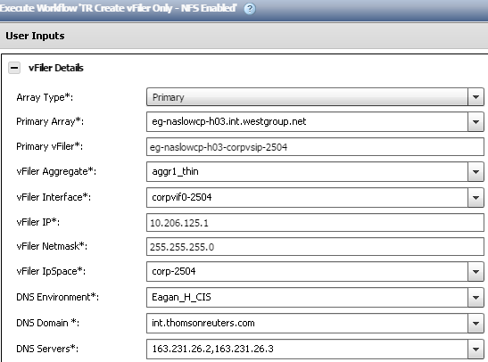

Mount the filer to a temp location and back up the /etc/rc file

sudo mount eg-naslowcp-h03:/etc temp

sudo cp temp/rc temp/rc_<CHG#>_<MMDDYYYY>

Edit the rc file to add the new VLAN

sudo vim temp/rc

Enter edit mode with the “i” key. Be extremely careful when editing the rc file.

RC file section 1

There are two lines to look for at the top of the rc file, “vlan create” and “vlan add”. If no vlan lines exist, add the “vlan create” line. If “vlan create” already exists, add the “vlan add” line instead. If both exist, append the new vlan number to the “vlan add” line.

This example shows vlan create for 2502, and vlan add for both 2504 and 2506.

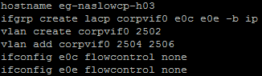

RC file section 2

There will be a list of ifconfig statements in the rc file. Find the entry for the new vlan, it will be listed under the new VLAN VIF name and the vsip vfiler IP will be associated. It will only list the netmask. At the end of the line, add the mtusize (typically 9000) and partner VLAN VIF name as shown in the example below.

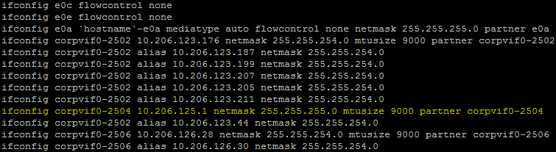

RC file section 3

After the ifconfig statements are the default route statements. Add the default route for the new VLAN. The IP address will be the default gateway which was provided in the IP request confirmation email.

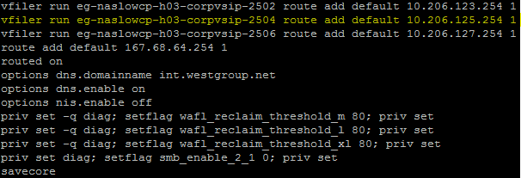

Once the changes to the file are complete, exit edit mode by pressing “ESC” key and then “:wq” to write and quit the file.

Unmount the filer.

sudo umount temp

Add the ifconfig update to the running configuration on the filer.

Format: ssh <filer> ifconfig <VLAN VIF> <vsip vfiler IP> netmask <netmask> mtusize <mtusize> partner <VLAN VIF>

Example: ssh eg-naslowcp-h03 ifconfig corpvif0-2504 10.206.125.1 netmask 255.255.255.0 mtusize 9000 partner corpvif0-2504

Add the default route update to the running configuration on the filer.

Format: ssh <filer> vfiler run <vsip vfiler> route add default <default gateway IP> 1

Example: ssh eg-naslowcp-h03 vfiler run eg-naslowcp-h03-corpvsip-2504 route add default 10.206.125.254 1

Test connectivity by pinging the default gateway and DNS from the vsip vfiler.

Format:

ssh <filer>

vfiler context <vsip vfiler>

ping <default gateway>

ping <partner vsip vfiler>

ping <jumpbox, dfm, vfiler on another system in the same VLAN, etc>

Example:

ssh eg-naslowcp-h03

vfiler context eg-naslowcp-h03-corpvsip-2504

ping 10.206.125.254

ping 10.206.125.2

ping c152mad

ping c152mad.int.thomsonreuters.com

**CDOT**

VLANs must be deployed to all nodes in the cluster. Repeat steps for all nodes.

First identify which ifgrp port (interface group) will be used. All filers will have an “a0a” ifgrp, but some might also have a second ifgrp call “a0b”. This is common for filers which use VLANs other than the standard shared networks (such as COLO, SECOM, and CLEAR networks).

List the ifgrps:

* ssh <cluster> network port ifgrp show

This shows the nodes in cluster eg-cis-clsn-f01 have two ifgrps.

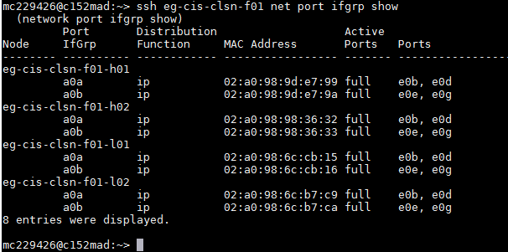

List the VLANs:

* ssh <cluster> network port vlan show
* ssh <cluster> network port vlan show -port <port>

These examples use the port switch to show the VLANs configured on port a0a as compared to port a0b. Notice they are different VLANs.

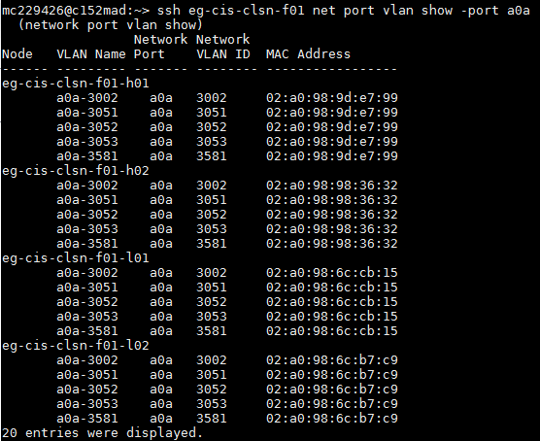

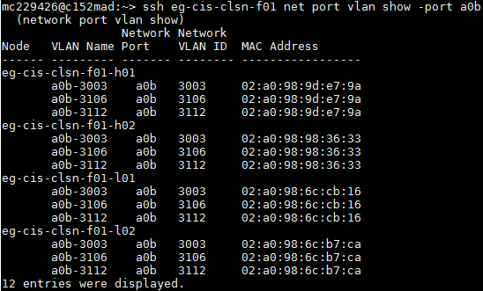

An easy way to determine if VLANs are shared or secure is to identify existing vservers using the existing VLANs and look up their IPs in Zipper to see the network information. Most special VLANs will have a special name like “SECOM” for secure ecom or a special description stating “secure”.

List the vservers using a given VLAN.

* ssh <cluster> network interface show -curr-port <VLAN name>
* ssh <cluster> network interface show -curr-port <VLAN name> -fields address,curr-port -role data

The first example shows vserver cisclnt-f0308 with IP 10.181.56.21 is configured to use VLAN a0b-3003 which is part of the a0b ifgrp. The second output shows vserver cisclnt-f0003 (amongst others) with IP 10.205.126.50, using VLAN a0a-3051 as part of the a0a ifgrp.

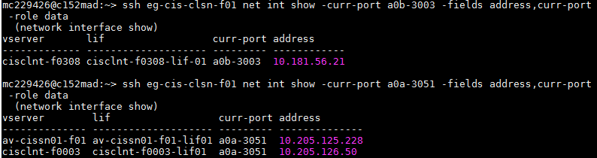

Looking up these vservers in Zipper the network icon will show the network details in hovertext. The icon can also be clicked to open up the information in a standalone webpage.

The 3051 VLAN used by cisclnt-f0003 is indicated as a standard shared VLAN because of its name following the standard naming convention for shared storage VLANs:

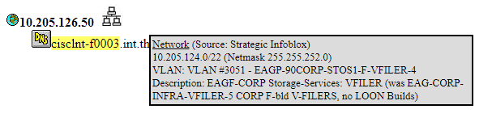

Looking at the 3003 VLAN used by cisclnt-f0308, it is a special VLAN. It is named “COLO” for colo space - EAGP-90COLO-STOS1-F-VFILER-2 and has a description indicating colo space. Special VLANs will have identifying names and often descriptions pointing out that they are not standard VLANs.

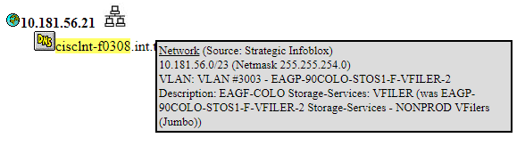

If we want to add a new standard shared VLAN to this cluster, we would use the a0a port.

**Create the VLAN on each node:**

ssh <cluster> network port vlan create -node <node> -vlan-name <VLAN name>

Example:

ssh eg-cps-clsp-f01 network port vlan create -node eg-cps-clsn-f01-h01 -vlan-name a0a-2700

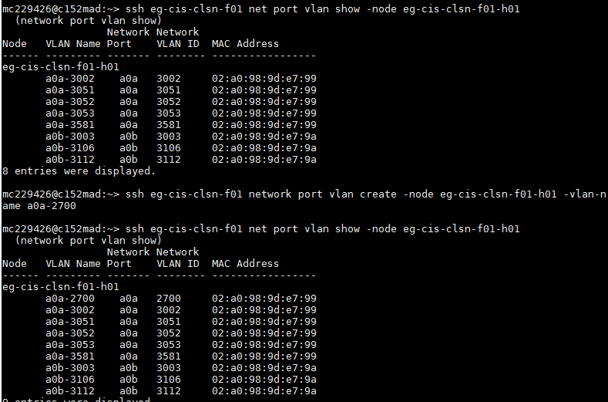

If not already known, identify what the new VLAN will be used for, such as ECOM, CORP, COLO, SECOM. This will be used for the failover-group name. (Old VLANs will use the name “data” but that is no longer standard.)

CDOT 8 and CDOT9 use different networking models, requiring different configuration for the failover groups:

**Create the failover-group on the cluster (CDOT 8 ONLY):**

To show the failover groups, use these commands. The -node allows viewing the failover groups a node is a member of.

ssh <cluster> network interface failover-groups show

ssh <cluster> network interface failover-groups show -node <node>

ssh <cluster> network interface failover-groups create -failover-group <ecom/corp/colo>-<VLAN> -node <node> -port <VLAN name>

Example (CDOT 8):

ssh eg-cis-clsp-f01 network interface failover-groups create -failover-group corp-2700 -node eg-cis-clsp-f01-h02 -port a0a-2700

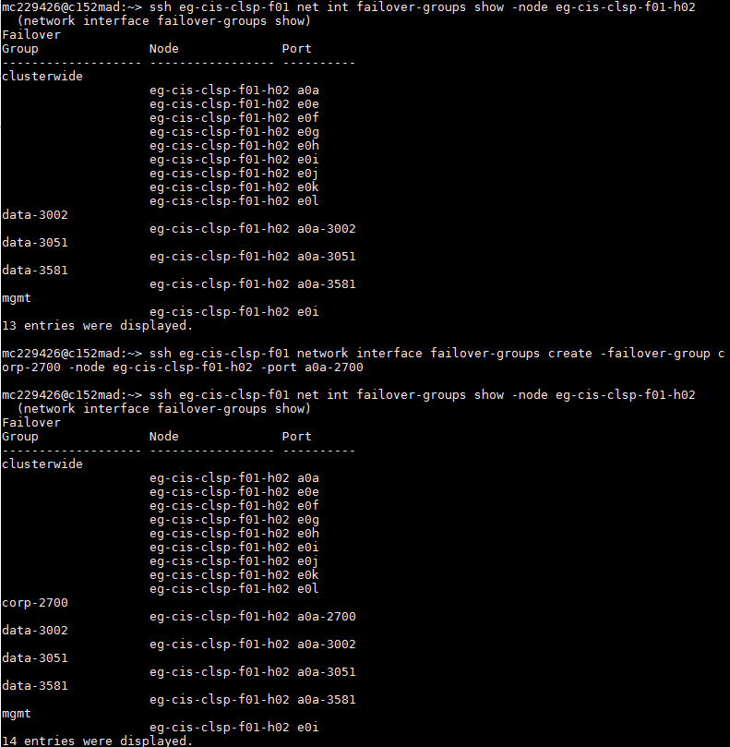

**Configure the broadcast domain and failover group on the cluster (CDOT 9):**

CDOT 9 requires configuration of a broadcast domain to create a failover group. The failover group appears to be configured automatically along with the failover group.

To determine if the broadcast domain already exists:

ssh <cluster> network port broadcast-domain show -broadcast-domain <ecom/corp/colo>-VLAN

If the broadcast domain does **NOT** already exist, use the following command to create it:

ssh <cluster> network port broadcast-domain create -broadcast-domain <ecom/corp/colo>-<VLAN> -mtu 9000 -ports <node>:<port>

Example:

ssh eg-cis-clsn-f01 network port broadcast-domain create -broadcast-domain corp-2700 -mtu 9000 -ports eg-cis-clsn-f01-h01:a0a-2700

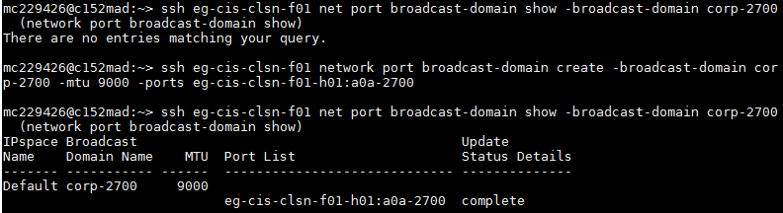

If the broadcast domain DOES already exist, use the following command to add a new port:

ssh <cluster> network port broadcast-domain add-ports -broadcast-domain <ecom/corp/colo>-<VLAN> -ports <node>:<port>

Example:

ssh eg-cis-clsn-f01 network port broadcast-domain add-ports -broadcast-domain corp-2700 -ports eg-cis-clsn-f01-h02:a0a-2700

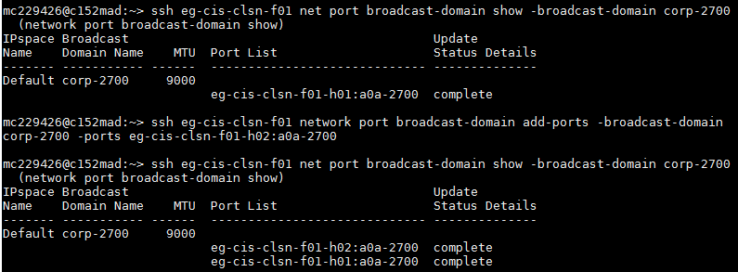

To view the failover group (which should be created automatically) use the following command:

ssh <cluster> network interface failover-groups show -failover-group <ecom/corp/colo>-<VLAN>

Example:

ssh eg-cis-clsn-f01 network interface failover-groups show -failover-group corp-2700

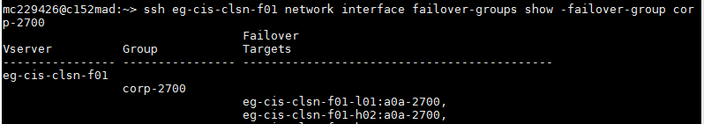

MODIFY/REMOVE COMMANDS:

**This is how to rename a failover-group if it was named wrong (CDOT 8):**

ssh <cluster> network interface failover-groups rename -failover-group <current-name> -new-name <ecom/corp/colo>-<VLAN>

Example:

ssh eg-cis-clsp-f01 network interface failover-groups rename -failover-group data-2700 -newname corp-2700

**This is how to delete a failover-group if needed (CDOT 8):**

ssh <cluster> network interface failover-groups delete -failover-group <failover-group name> -node <node> -port <VLAN name>

Example:

ssh eg-cis-clsp-f01 network interface failover-groups delete -failover-group corp-2700 -node eg-cps-clsp-f01-h01 -port a0a-2700

**This is how to remove a port from a broadcast domain if needed (CDOT 9):**

ssh <cluster> network port broadcast-domain remove-ports -broadcast-domain <corp/colo/ecom>-VLAN -ports <node>:<port>

Example:

ssh eg-cis-clsn-f01 network port broadcast-domain remove-ports -broadcast-domain corp-2700 -ports eg-cis-clsn-f01-h01:a0a-2700

**This is how to delete a broadcast domain if needed (CDOT 9):**

ssh <cluster> network port broadcast-domain delete –broadcast-domain <corp/colo/ecom>-<VLAN>

Example:

ssh eg-cis-clsn-f01 network port broadcast-domain delete –broadcast-domain corp-2700

**This is how to delete a VLAN if needed (CDOT 8 and 9):**

ssh <cluster> network port vlan delete -node <node> -vlan-name <VLAN name>

Example:

ssh eg-cis-clsp-f01 network port vlan delete -node eg-cps-clsp-f01-h01 -vlan-name a0a-2700

After the failover groups are created, wait at least 30 minutes for WFA to update. The vsip vfiler cannot be created until the new port and failover groups are selectable in the WFA workflow.

[Request an IP in ServiceNow](https://thomsonreuters.service-now.com/nav_to.do?uri=%2Fcom.glideapp.servicecatalog_cat_item_view.do%3Fv%3D1%26sysparm_id%3D44de0fbe136cfa00f05c7e276144b0dd) from the new VLAN for each filer node. Use Banana to create a DNS entry for each IP. Use names like test-<node>-vlan<VLAN>, for example test-eg-cps-clsp-h01-h01-vlan1234.

Use WFA CDOT workflow “Create Vserver Only” to create the test vserver on each node named for the DNS which was applied in the last step.

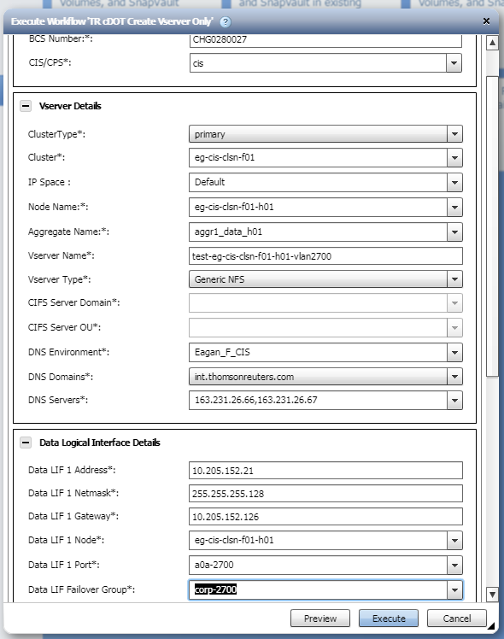

Once created, collect the LIF (logical interface) details for each vserver. The vserver list can be comma-separated to select multiple vservers.

ssh <cluster> network interface show -vserver <vserver>

ssh <cluster> network interface show -vserver <vserver1>,<vserver2>,<vserver3>

Test network connectivity through the vserver LIFs. Default gateway for the VLAN can be found in the Banana request confirmation email.

ssh <cluster> network ping -lif-owner <vserver> -lif <vserver lif> -destination <default gateway>

ssh <cluster> network ping -lif-owner <vserver> -lif <vserver lif> -destination <jumpbox, dfm, vfiler on another cluster using the same VLAN, etc>

Example:

ssh eg-cps-clsp-h01 network ping -lif-owner test-eg-cps-clsp-h01-h01-vlan1234 -lif test-eg-cps-clsp-h01-h01-vlan1234-lif01 -destination c152mad