**Vfiler Troubleshooting error guide**

**Also see SSH errors**

**Error:**

Add Data Set Wizard error: Resource label of aggregate on "xyz" does not match the one specified in the policy

*Example:*

*“Attention: could not select volume or aggreregate to satisfy provisioning request.”*

*“Resource label of aggregate eg-nasecom-h06:aggr3 (17920) does not match the one specified in the policy.”*

Solution:

See \\Eg-nas-a02\sg$\Procedures\NetApp\vFilers\vfiler_AggregateCreation.doc to add aggregates into the resource pool.

**Error:**

vfiler _ ssh _ create . bash can’t mount and run

Solution:

Run vfiler status –r. See if the interface is unconfigured:

Example:

clnt-corp-e0177 running

ipspace: corp-2002

IP address: 10.204.121.113 [unconfigured]

Path: /vol/clnt_corp_e0177_root [/etc]

UUID: 53b3ec7c-2bbe-11e0-ae97-00a0980ad7d7

**Error:**

“snapvault is not turned on”, when trying to create a new schedule on a vfiler.

Solution: run the bash setup script

**Error:**

Volume appears in the NMC with "Space Status" normal. However, qtrees for the volume appear with "Space Status" of unknown. Trying to modify the quota using "Resize Storage" results in the error "This option is not possible without hard quota limit."

Solution:

Run vfiler resfresh targeting vfiler:

nerstrand:/ # dfm vfiler list |grep eg-nasapp-e28

135707 ded-ecom-e0026.westlan.com eg-nasapp-e28.int.westgroup.net 10.214.126.108 No

137278 eg-nasapp-e28-vsip eg-nasapp-e28.int.westgroup.net 10.214.126.37 No

nerstrand:/ #

nerstrand:/ # dfm host discover 135707

Refreshing data from host ded-ecom-e0026.westlan.com (135707) now.

nerstrand:/ #

Also try this refresh:

"dfm host discover hosting_filername"

dfm host discover PhysicalFilerName (two numbers will be listed, rerun the command using the lower number)

nidaros:~ # dfm host discover eg-nasclnte-h03

Error: Multiple objects (ids=11783,16903) are named 'eg-nasclnte-h03'. Use objec

t ids to disambiguate.

nidaros:~ # dfm host discover 11783

Refreshing data from host eg-nasclnte-h03.westlan.com (11783) now.

**Error:**

Cifs “slowness”, or inability to write files to a NAS destination. Or developer is reporting “access denied” errors

Solution: Have Windows platform check share and file level permissions. If cifs share is on a unix style qtree have Unix platform make sure permissions are wide open – chmod 777 (as they control security). You can also check CIFS latency in the NMC, but also insure mandatory scanning is OFF

nerstrand:~ # rsh eg-nasprod-e02-mgmt "vfiler run prod-ecom-e0060 vscan options"

===== prod-ecom-e0060

vscan options timeout: 10 sec

vscan options abort_timeout: 10000 sec

vscan options mandatory_scan off

vscan options use_host_scanners on

vscan options client_msgbox off

nerstrand:~ #

**Error:**

NMC won’t let you select an aggregate (it has red “x”’s on it)

Solution: verify there is not a “label” conflict between what the resource pool is labeled, and what the aggregate is labeled.

(Resource pools | edit | | labels)

**Error:**

Vfiler is not pingable

Solution:

Run vfiler status –r. If the vfiler says “unconfigured” (below in red), go into the NMC, vfiler units | select vfiler in question | setup | check box for “change network settings” | see if interface says “none”, if it does select the correct interface (e.g. change from none to correct interface (e.g. corpvif0-2502), and proceed through wizard and click finish | wait a bit and then try to ping. (you might have to select the correct template, network too (corp) etc…)

nidaros:~ # rsh eg-naslowpc-h01 "vfiler status -r"

vfiler0 running

ipspace: default-ipspace

IP address: 10.206.120.1 [corpvif0-2501]

IP address: 10.213.24.30 [e4a]

Path: / [/etc]

UUID: 00000000-0000-0000-0000-000000000000

eg-naslowpc-h01-vsip running

ipspace: corp-2502

IP address: 10.206.122.5 [corpvif0-2502]

Path: /vol/vol0_vsip_2502 [/etc]

UUID: 2192716a-86a5-11de-a4e8-00a0980acd53

clnt-corp-h0001 running

ipspace: corp-2502

IP address: 10.206.122.9 [corpvif0-2502]

Path: /vol/clnt_corp_h0001_root [/etc]

Path: /vol/westtech_cbdraftingasstdevf_snap

UUID: 5b0bed0c-b7ab-11de-9d12-00a0980acd53

clnt-corp-h0002 running

ipspace: corp-2502

IP address: 10.206.122.10 [unconfigured]

Path: /vol/clnt_corp_h0002_root [/etc]

Path: /vol/westtech_cbdraftingassttestf_snap

UUID: dbf0c3bc-b7ab-11de-9d12-00a0980acd53

**Error:** In the NMC | Provisioning tab | you cannot see quotas listed

Solution: Attach the physical resource to the dataset. See instructions below.

Instructions:

In the NMC, Preview tab | Highlight the Dataset | click edit | click on Physical Resources | With "Global" group selected, and Resource type of Hosts Drill down in the left frame underneath Available resources to the physical filer (not the vfiler) | From physical filer drill into the aggregate then select the volume name (see bitmap below) |

Click the error to move it into the “Resources in Dataset” frame and click next, check for warnings and click next, click finish, click close

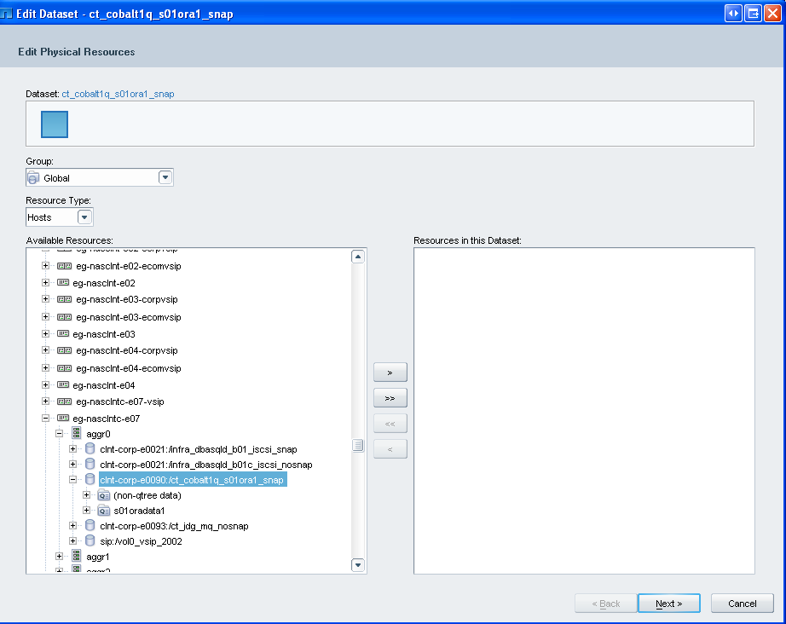

You will note in the bitmap below that following the change you can now see an entry next to the “Physical Resources” field (and you can click on the “Provisioning tab within the NMC and can see quotas.)

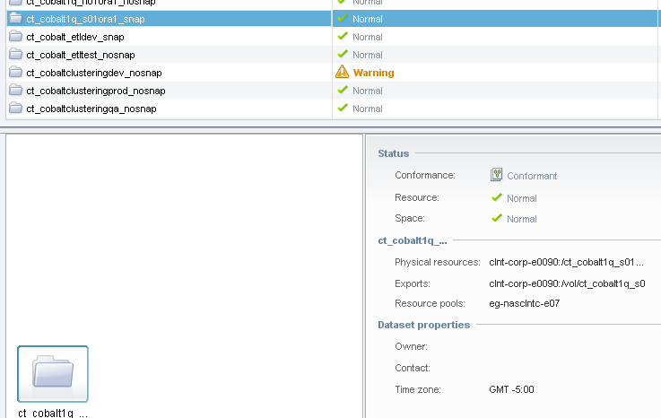

**Error:**

Error received when trying to run cifs setup on a vfiler: (text of error approximate)

“vfiler is currently being run on this system so the command timed out after 60 seconds.  The command will continue to try to run and may succeed later.”

Solution:

Vfilers can only have one administrative command running at a time (serial not parallel). This can be as simple as dfm already running a stats gathering command, etc. You need to simply verify that your command completed and/or try again.

To determine if CIFS setup completed, run this command:

“vfiler run VFILERNAME cifs sessions”

You should see it in TLR or the “other domain” .  See example below.

newnan:~ # rsh eg-nascorp-f02 "vfiler run prod-corp-f0004 cifs sessions"

===== prod-corp-f0004

Server Registers as 'PROD-CORP-F0004' in Windows 2000 domain 'TLR'

Root volume language is not set. Use vol lang.

Selected domain controller \\EG-TLRDC-B13, \\EG-TLRDC-A14, and \\EG-TLRDC-H16 for authentication

Or run vfiler run "vfilername cifs domaininfo". Either command will confirm that cifs is correctly setup.

**Error:**

Could not reuse existing volume(s) in dataset node or selecting a new aggregate for provisioning a volume.

Solution:

See \\Eg-nas-a02\sg$\Procedures\NetApp\vFilers\vfiler_AggregateCreation.doc to add aggregates into the resource pool.

Or also, check the protocols for the vfiler (add the NFS protocol if missing)

(It may be possible for you to click the next button in NMC to get the error and suggestions to fix the issue)

**Error:**

You are trying to create a vfiler and you are not seeing the correct interface in the drop-down menu.

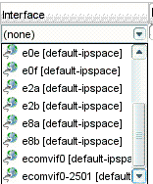

Solution:

Verify you are entering in the correct entry in the IP Space field.

In the example below “ecom-2523” in the IP Space field should be “clnt-2523”. Once this is changed, “ecomvif0-2523 (clnt-2523)” will appear in the drop-down menu.

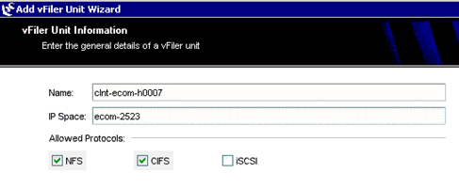

**Error:**

It appears you don’t have any resource pools.

Solution:

Checking CIFS as an available protocol if a CIFS license is not installed will make it appear as if you do not have any resource pools. Step 10 of the following document:

\\Eg-nas-a02\sg$\Procedures\NetApp\vFilers\vfiler_creation.doc

If you are creating a volume that requires cifs, a cifs license should be installed on the physical filer.

**Error:**

After clicking the finish button when adding a vfiler to a domain (TLR or MGMT), the following error, (bitmap below), and status output occurs:

nidaros:~ # rsh eg-naslowpc-h02 vfiler status

vfiler is being run from another connection; try again later.

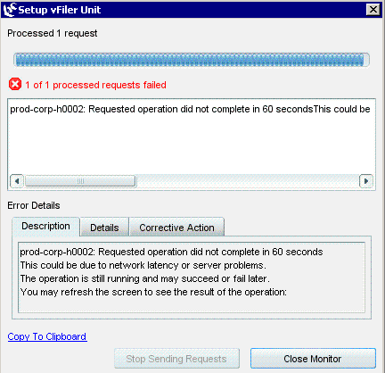

Solution:

Wait for completion, it could take up to 30 minutes.

**Error:**

“Permission denied” when Unix tries to mount

Solution:

Verify exports. Hosts for loon volumes in vfilers must have static routes (also non-loon hosts if the hosts are on dedciated cobalt switches). Also, make sure a pipe (|) doesn’t appear in the exports (so two host entries appear as one) See NMC bitmap below. You can also see this output from the command line:

GOOD OUTPUT

nerstrand:~ # rsh eg-nasclnte-h04 "vfiler run clnt-ecom-h0001 exportfs"

===== clnt-ecom-h0001

/vol/nv_kcsrchablenorm1a_n01ora1_nosnap/n01oraflash1    -sec=sys,rw=kirbyville-nas.westlan.com:kernville-nas.westlan.com,anon=0

/vol/clnt_ecom_h0001_root       -sec=sys,rw=nerstrand.int.westgroup.net:newnan.int.westgroup.net:nidaros.int.westgroup.net,anon=0

/vol/nv_kcsrchablenorm1a_n01ora1_nosnap/n01oraadmin1    -sec=sys,rw=kirbyville-nas.westlan.com:kernville-nas.westlan.com,anon=0

/vol/nv_kcsrchablenorm1a_n01ora1_nosnap/n01oradata1     -sec=sys,rw=kirbyville-nas.westlan.com:kernville-nas.westlan.com,anon=0

/vol/nv_kcsrchablenorm1a_n01ora1_nosnap/n01oraarch1     -sec=sys,rw=kirbyville-nas.westlan.com:kernville-nas.westlan.com,anon=0

/vol/nv_kcsrchablenorm1a_s01ora1_snap/s01oradata1       -sec=sys,rw=kirbyville-nas.westlan.com:kernville-nas.westlan.com,anon=0

/vol/nv_kcsrchablenorm1a_n01ora1_nosnap/n01oracluster1  -sec=sys,rw=kirbyville-nas.westlan.com:kernville-nas.westlan.com,anon=0

nerstrand:~ #

BAD OUTPUT

===== ded-ecom-e0010

/vol/nv_erdnorm8p_n01ora1_nosnap/n01oraflash1   -sec=sys,rw=powellton-nas.westlan.com|provencal-nas.westlan.com,anon=0

/vol/ded_ecom_e0010_root        -sec=sys,rw=nerstrand.int.westgroup.net:newnan.int.westgroup.net:nidaros.int.westgroup.net,anon=0

/vol/nv_erdnorm8p_n01ora1_nosnap/n01oraadmin1   -sec=sys,rw=powellton-nas.westlan.com|provencal-nas.westlan.com,anon=0

/vol/nv_erdnorm8p_n01ora1_nosnap/n01oracluster  -sec=sys,rw=powellton-nas.westlan.com|provencal-nas.westlan.com,anon=0

/vol/nv_erdnorm8p_n01ora1_nosnap/n01oradata1    -sec=sys,rw=powellton-nas.westlan.com|provencal-nas.westlan.com,anon=0

/vol/nv_erdnorm8p_n01ora1_nosnap/n01oraarch1    -sec=sys,rw=powellton-nas.westlan.com|provencal-nas.westlan.com,anon=0

/vol/nv_erdnorm8p_s01ora1_snap/s01oradata1      -sec=sys,rw=powellton-nas.westlan.com|provencal-nas.westlan.com,anon=0

eg-nasapp-e26>

BAD OUTPUT (See pipe between host names)

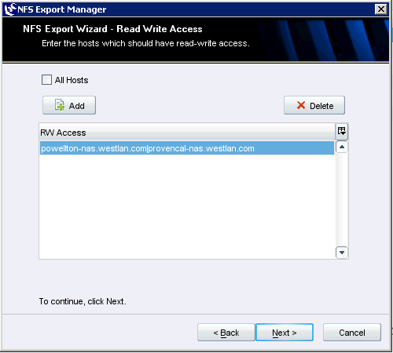

**Error:** receive the error "There are no storage systems in the resource pool"

Solution:

In the NMC | Resource pools | Highlight the resource pool | Edit | Physical resources | Under "Resources in this resource pool" | make sure the filer itself (e.g. "eg-nasclntc-f08")is a member (not just the <filer>:<aggr names>) See bitmap below.

Also, you can also get this error when the options you've selected for the new vfiler don't match the provisioning policy.

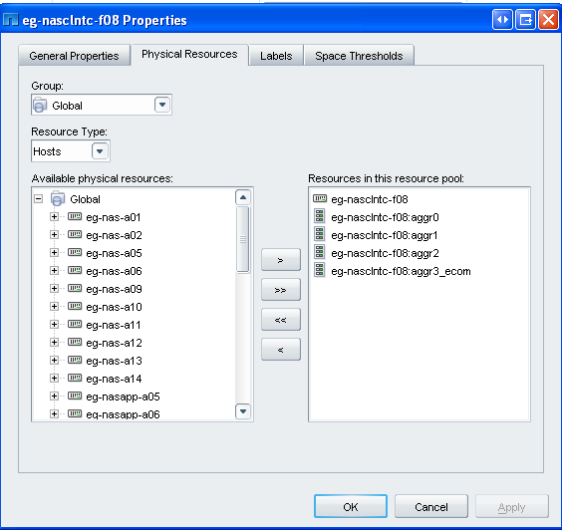

**Error: various SSH errors…**

The following troubleshooting section covers SSH and vfilercmd general information and troubleshooting: (errors have been highlighted below in red)

Additional information on vfilercmd, which is used by dba’s for taking snapshots instead of ssh on vfilers is here:

\\Eg-nas-a02\sg$\Procedures\NetApp\vFilers\vfilercmd_Information_and_MeetingNotes.doc

DBA BACK-UP SCRIPT LOGIC FOR VFILERS:

There is a dba back-up script, used by some of the DBA groups below (*), which uses logic in the script to determine if vfilers:

*TLRTS PATH_DBA_ORACLE – Jon Helsel, Danielle Tsai

TLRTS CT_DBA_ORACLE – Joe Least, Boris Belous

BSI DBA – Tony Pahl, Todd Hansen

*TLRTS NSS DBA – Kristen Spain, Jeff Heidelberg, Debbie George

The majority of the script is database logic which is outside of the filer. The script snippet below relevant to vfilers uses commands to determine whether the script is talking with a physical filer or a vfiler. Basically, the script will use a SSH "snapvault snap create" command. If it succeeds, subsequent commands will use SSH. If it fails, subsequent script commands will use vfilercmd commands. (Failure gives: "snapvault command does not exist")

vFilercmd is a NetApp supplied utlity which uses API commands to allow DBA’s to take snapshot back-ups, as SSH is not supported by vFilers

*Script snippet:*

*vfilercmd $nasdevice snapvault snap create $volsnap sv_$qtree 2>&1 | tee -a $LOGOUT*

*We do not want to use “vfilercmd” long term, so the following function is used to determine if a vfiler is present.  This logic is straight from NetApp.*

*FILER_NAME=$1*

*ssh -i ~/.ssh/nssdba.snapvault $FILER_NAME snapvault status 2>&1 | grep -i "snapvault not found" > /dev/null*

*if [ $? -eq 0 ]; then*

*IS_VFILER=TRUE*

*else*

*IS_VFILER=FALSE*

*fi*

*export IS_VFILER*

*When the actual snapshot is taken, ssh is used for filers and vfilercmd is used for vfilers.*

*if [[ $IS_VFILER = "TRUE" ]]; then*

*echo "** $nasdevice detected as vfiler" | tee -a $LOGOUT*

*else*

*echo "** $nasdevice detected as traditional filer" | tee -a $LOGOUT*

If the dba gets this error: THE SCRIPT IS WORKING

ssh nv-kcsrchablenorm1a-nash -i ~/.ssh/nssdba.snapvault

Received disconnect from 10.216.124.1: 2: Shell not supported on vfilers

If the dba gets the following error it means SECUREADMIN SETUP HAS NOT BEEN RUN:

ssh nv-kcsrchablenorm1p-nash -i ~/.ssh/nssdba.snapvault

ssh: connect to host nv-kcsrchablenorm1p-nash port 22: Connection refused

________________________________________________

IF THE DBA SAYS THEY ARE PROMPTED FOR A PASSWORD

Then ssh is "working" and secureadmin has been run

1. Check that the bash script has been run;

Insure that authorized_keys2 file exists and is in the correct location:

nidaros:/mnt/ded-ecom-e3/sshd/oracle/.ssh

nidaros:/mnt/ded-ecom-e4/sshd/oracle/.ssh

Insure permissions are correct: (you can compare them to qa vfiler that is "working"

nidaros:/mnt/ded-ecom-e4/sshd/oracle/.ssh # ls -l authorized_keys2 works

-rw-r--r-- 1 root root 1714 2009-04-07 10:42 authorized_keys2

nidaros:/mnt/ded-ecom-e3/sshd/oracle/.ssh # ls -l authorized_keys2 doesn't work

-rw-r--r-- 1 root root 1714 2009-04-07 10:34 authorized_keys2

2. Have the DBA check permissions on their end

_________________________________________________

BAD RESPONSE:

To check if secureadmin has been run:

eg-nasapp-h10> vfiler run ded-ecom-h1 secureadmin status

===== ded-ecom-h1

ssh2 - inactive

ssh1 - inactive

eg-nasapp-h10>

_________________________________________________

GOOD RESPONSE:

eg-nasapp-h10> vfiler run ded-ecom-h1 secureadmin status

===== ded-ecom-h1

ssh2 - active

ssh1 - inactive

eg-nasapp-h10>

__________________________________________________

To check if the bash script has been run: (and users have been added)

eg-nasapp-h10> vfiler run ded-ecom-h1 useradmin user list

===== ded-ecom-h1

Name: oraapi_backup

Info:

Rid: 131074

Groups: oraapi_backup_group

Name: oracle

Info:

Rid: 131076

Groups: oracle_admin

Name: root

Info:

Rid: 131072

Groups: Administrators

___________________________________

**TO RUN SECURADMIN SETUP:**

eg-nasapp-h10> vfiler run ded-ecom-h2 secureadmin setup ssh

===== ded-ecom-h2

SSH Setup

---------

Determining if SSH Setup has already been done before...no

SSH server supports both ssh1.x and ssh2.0 protocols.

SSH server needs two RSA keys to support ssh1.x protocol. The host key is

generated and saved to file /vol/ded_ecom_h2_root/etc/sshd/ssh_host_key during setup. The server

key is re-generated every hour when SSH server is running.

SSH server needs a RSA host key and a DSA host key to support ssh2.0 protocol.

The host keys are generated and saved to /vol/ded_ecom_h2_root/etc/sshd/ssh_host_rsa_key and

/vol/ded_ecom_h2_root/etc/sshd/ssh_host_dsa_key files respectively during setup.

SSH Setup will now ask you for the sizes of the host and server keys.

For ssh1.0 protocol, key sizes must be between 384 and 2048 bits.

For ssh2.0 protocol, key sizes must be between 768 and 2048 bits.

The size of the host and server keys must differ by at least 128 bits.

Please enter the size of host key for ssh1.x protocol [768] :

Please enter the size of server key for ssh1.x protocol [512] :

Please enter the size of host keys for ssh2.0 protocol [768] :

You have specified these parameters:

host key size = 768 bits

server key size = 512 bits

host key size for ssh2.0 protocol = 768 bits

Is this correct? [yes] yes

Setup will now generate the host keys. It will take a minute.

After Setup is finished the SSH server will start automatically.

**Error** – Question mark on the aggregate when trying to complete an allocation (see picture below):

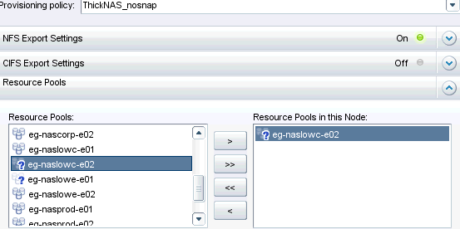

**Resolution**: Correct the label on the aggregate within the NMC:

In NMC, select Resource Pools -> Highlight the Resource Pool in question and click Edit -> click the Labels tab -> configure as seen in the picture below:

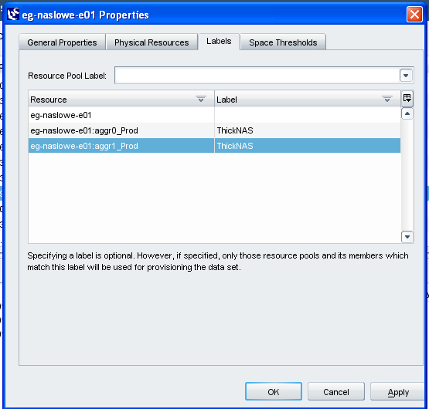

**Error:** You receive an error that there is not sufficient free space in your targeted aggregate to complete an allocation or volume growth.

**Solution:** DFM/NMC should refresh every 15 minutes. If not, here is the document to manually refresh the NMC/DFM \\Eg-nas-a02\sg$\Procedures\NetApp\vFilers\Refresh NMC_DFM.doc

**Error:**

**Timout error when creating vfiler (see output below).**

**Solution:**

Vfiler may actually have been created. However Verify vfiler created successfully.

*Example*

*nerstrand:~ # rsh eg-nasapp-h18 "vfiler status -r"*

If it says “unconfigured” next to the vfiler, search for the solution in this document (search for “unconfigured”). Also try to ping the destination ip from dfm.

=== CLIENT ===

Version=2.3.0.3018

Build=2.3

OS Name=Windows XP

OS Arch=x86

OS Version=5.1

=== ERROR ===

com.netapp.nmf.userinterface.error.DefaultNamedErrorDetails

=== MESSAGE ===

ded-ecom-h0014: Requested operation did not complete in 60 seconds.

This could be due to network latency or server problems.

The operation is still running and may succeed or fail later.

You may refresh the screen to see the result of the operation

=== DETAILS ===

No additional details are available.

=== CORRECTIVE ACTION ===

No suggested corrective action is available.

=== STACK TRACE ===

netapp.sumo.toolkit.zephyr.dfm.DFMResultException: Requested operation did not complete in 60 seconds.

This could be due to network latency or server problems.

The operation is still running and may succeed or fail later.

You may refresh the screen to see the result of the operation

at netapp.sumo.toolkit.zephyr.field.AbstractJAPI.executeSyncApi(AbstractJAPI.java:362)

at netapp.sumo.toolkit.zephyr.field.AbstractJAPI.executeSyncApi(AbstractJAPI.java:406)

at netapp.sumo.toolkit.zephyr.dfm.vfiler.VFiler.create(VFiler.java:147)

at com.netapp.nmf.datam.hosts.vfilers.wizards.VFilerWizardUtilities$2.call(VFilerWizardUtilities.java:307)

at com.netapp.nmf.datam.hosts.vfilers.wizards.VFilerWizardUtilities$2.call(VFilerWizardUtilities.java:303)

at java.util.concurrent.FutureTask$Sync.innerRun(Unknown Source)

at java.util.concurrent.FutureTask.run(Unknown Source)

at java.util.concurrent.ThreadPoolExecutor$Worker.runTask(Unknown Source)

at java.util.concurrent.ThreadPoolExecutor$Worker.run(Unknown Source)

at java.lang.Thread.run(Unknown Source)

**Error:**

When running the vfiler_ssh_creation script, it fails with the error ““vfiler root volume failed” error message”

**Solution:**

Make sure you can ping the vfiler. If not check the routing on the vfiler.

**Error =**

Failed to resize flexible volume X. Reason: Hosting aggregate X does not have enough space to resize volume X.

Nearly full threshold of the aggregate will exceed: 'eg-nasprod-e01:aggr1'(110385)[Used space grows to: 70.2639 % (4.67 TB), Nearly full threshold: 60 % (3.99 TB)].

 Suggestion: Add more disks or free more space in aggregate X to increase the capacity of the aggregate by at least 375 GB to satisfy this provisioning operation.  You may be able to increase the aggregate nearly full threshold to utilize maximum available space.  Please ensure the aggregate full threshold is set equal or higher in order to avoid confusion. Job completed with errors.

**Solution =**

There are two basic thresholds:

1. Standard aggregates:  nearly full = 100%, full = 101%.  This is the primary standard at Thomson Reuters.
2. Thin provisioned primary aggregates:  :  nearly full = 60%, full = 70%.  This is to allow enough free space to migrate data as needed since there are no controls in place to limit data growth other than the size of the aggregate.

You can view the per aggregate thresholds by logging into the site correct DFM server, drill into the group tree until you find the desired hosting filer.  Click the filer name.  Select the “Member Details” tab.  Select “Aggregates” located immediately below the “Member Details” tab.  Click on the desired aggregate.  In the lower left corner is a section called “Aggregate Tools”.  Click on “Edit Settings”.   The aggregate specific thresholds are in the lower section of the main screen.  Adjust as needed as per the above information.  ****Only change settings for the specific aggregate****

**Error:**

unable to do cifs setup of vfiler unit prod-corp-x0009. Reason: CIFS - Primary Domain Controller must be active for installation.

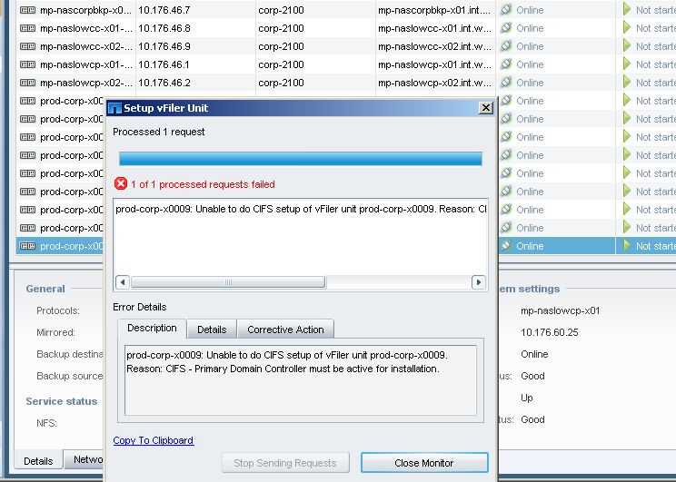

Solution:

In Domain Name field modify the corp vfiler in the xo dfm from int.westgroup.com to tlr.thomson.com (which matches vfiler template in dfme) [hosts |policies | vfiler templates]

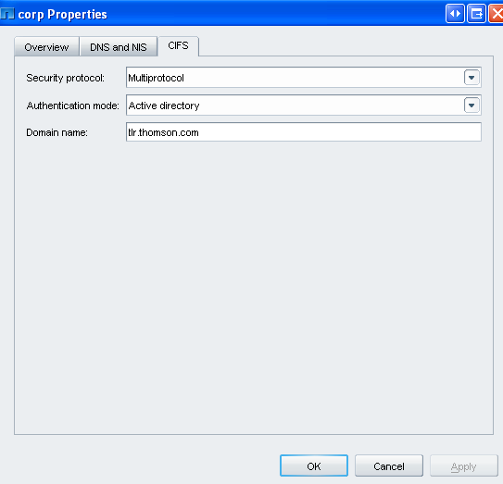

**Error:**

Windows admin says they do not have permissions to create cifs share:

Solution:

Make sure the following commands are run (here for ecomqc)

rsh eg-naslowc-e04-mgmt vfiler run clnt-corp-e0352 useradmin domainuser add m-eaganserveradmins -g Administrators

rsh eg-naslowc-e04-mgmt vfiler run clnt-corp-e0352 useradmin domainuser add svcAVNas -g Administrators

rsh eg-naslowc-e04-mgmt vfiler run clnt-corp-e0352 vscan on

**Error:**

Red x ‘s in the NMC which don’t allow you to allocate

(During an NMC allocation, the radio button for “manually select a resource from the attached resource pool(s)”)

Solution:

Add the aggregate to the resource pool

Example:

dfpm respool add  eg-nasecom-f02 eg-nasecom-f02:aggr3_thin_vm