**vFiler Creation**

Important Notes:

1. Upgrade your NMC!
   1. Make sure your NMC is up to date (v3.0D2 as of 2/10/2011)

1.2 Make sure enable polling is unchecked in your NMC! (Performance Advisor >> Performance Settings)

2. ***If you are creating a data vfiler for a BKP filer,*** ***you need to ensure the size of the root volume for the vfiler is 1 GB going forward (per Dan Mack)***. This is due to the possible large amount of log files that can be created on these BKP vfilers.

**Index:**

Required Software (NMC- NetApp Mgmt Console Install and “Active Directory Users and Computers”)

Definitions

Rules for grouping datasets on vFilers

vFiler Creation steps (Provisioning Manager)

vFiler Naming Convention

If CIFS is required

Volume Allocation on a vFiler

Qtree Allocation on a vFiler

Create/Modify qtree exports

Documentation (other resources)

Miscellaneous (Commands and other information)

Troubleshooting

NetApp Management Console (NMC)

1. Download the NMC from using the following link:

<http://nerstrand.int.westgroup.net/netapp/nmc_nfs_mgr/nmconsole-setup-3-0D2-win32.exe>

1. An application will be downloaded; it should be called: nmconsole-setup-3-0D2-win32.exe. Launch this application and accept all default settings to complete the installation. Say “yes” to the replace existing version question.
2. A shortcut to NMC will be created on your desktop. Launch NMC by using the shortcut and verify that you are running the correct version:

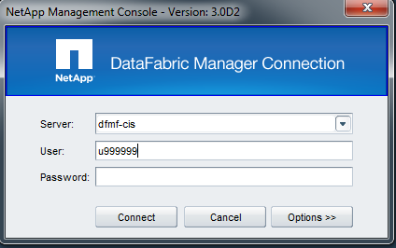

**Valid DFM Server Options:**

Any DFM server

**Options (Set as follows:):**

Protocol: HTTP

Port: 8088

**Use your MGMT-U Account.**

**Verify NMC Version:** 3.0D2

1. After installing it on your machine, please login to a DFM server with it and select "Performance Advisor" -> "Performance Settings". This will give you a window as shown in the attached screenshot. Please uncheck the "Enable polling for object status in hierarchy tree" option, as shown in the attached screenshot. Also please remember to modify the "Computation Type from Views" from "Average" to "Maximum", also as shown in the attached screenshot. Then close NMC completely and reopen it before proceeding.

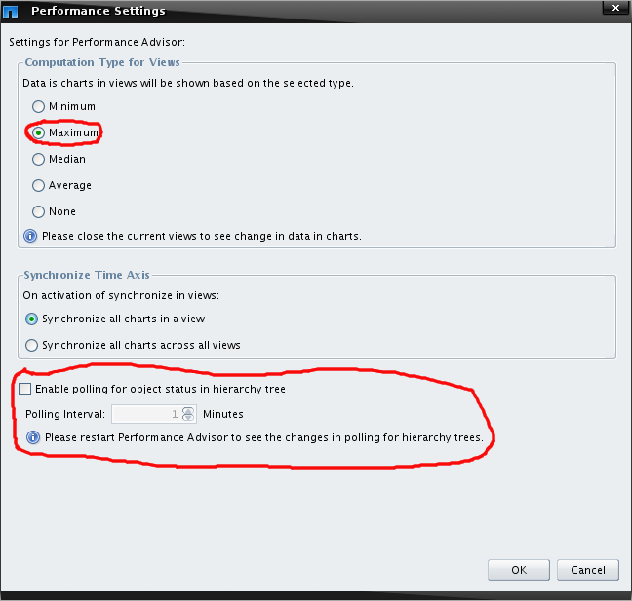

1. Quit the NMC and prepare to install the NFS exports manager.

Installing the NFS Exports Manager

The NFS Exports Manager is a custom plug-in for NMC. This plug-in gives us the capability of The NFS Instructions for installing NFS Export Manager. Quit any running instance of NMC and then perform the following tasks to install the correct version of the NFS Exports Manager Plug-In:

1. Download the plugin, which is available here:

<http://nerstrand.int.westgroup.net/netapp/nmc_nfs_mgr/nmc_3.0D1_nfs-mgr.zip>

1. This plugin with "3.0D1" in the filename will work fine with the NMC version 3.0D2. To install the NFS Manage Exports NMC plugin, unzip the file and place the com.netapp.rre.nem-1.0.2 folder containing the plugin into the C:\Program Files\NetApp\Management Console\plugins folder on your PC where the NMC application is already installed.

Installing the active directory users and computers

For vFilers that require CIFS, we must pre-create the computer account in AD before running CIFS setup. Microsoft “Active Directory Users and Computers” is needed for pre-creating the accounts. Active Directory Users and Computers for the Ecom AD is accessed via your Citrix session and for the TLR AD it is accessed via your desktop.

1. For Ecom/Citrix, log into Citrix and if the icon is not on your desktop or under Start -> Programs -> Administrative Tools, call 4help to request the program be available via your Citrix session.
2. For TLR, if it is not under Start -> Programs -> Administrative Tools, you can install it from the following location. Accept all defaults and the TLR AD should automatically be detected.

\\Eg-nas-a02\sg$\Software\Microsoft_server_admin_tools

**Definitions:**

Administrative Filer:

Same as Virtual Seed IP “vsip” (see below)

Virtual seed ip**:**

The Vsip (virtual seed ip) dns name is used for the seed IP interface.

Example vsip name: e.g. eg-nasapp-b09-vsip.westlan.com. It is required in order to make sure the route for the ipspace is kept intact even if all vfilers are migrated off the physical filer.

So unlike the vFiler which is not tied to a physical filer head, the vsip ip is tied to a head to keep the ip space running. It must always exist as it is tied to all routing information for the vFilers. It can be thought of as a “template” for the networking information. “vsip” is production, while “vsipc” is the naming convention designated for client.

To see resource pools by site:

1. Launch NetApp Management Console (NMC) from your desktop
2. Choose the appropriate site (dfm**e**, dfm**f**, or dfm**h**)
3. Click the “Manage Data” gray folder icon in the top left corner
4. Click “Data” in the bottom left corner
5. Click “Resource Pools” in the top left corner
6. All physical filer names listed in the “Name” column are available for vFiler allocations

Resource Pool:

The onsite NetApp PSE's should be creating the resource pool.

Dataset:

Is a representation of a volume within NetApp Provisioning Manager. Every volume should correspond to, and be attached to, a dataset. Datasets are created automatically during the NPM vFiler creation process. If for some reason you have migrated existing volumes to the vFiler model you’ll need to create a dataset for each volume, and attach the existing volume to the dataset.

**Rules for grouping datasets on vFilers:**

Remember that each dataset created in Provisioning Manager will create a flexible volume on the storage system. The term dataset can be used interchangeably with the term flexible volume.

* Dedicated filers should have the same configuration as filers in the shared environment.
* Index files, (both snap and nosnap volume), should belong to the same vFiler.
* Datasets for the same LOON database, (snap and nosnap volume), should belong to the same vFiler.
* Datasets for the same VMware ESX cluster should belong to the same vFiler.
* Flat files: datasets that are part of the same storage provisioning request, and exported to the same list of clients, should belong to the same vFiler.
* CIFS volumes should have a one to one mapping between the dataset and the vFiler.
* In all other cases, there should be a one to one mapping between the dataset and the vFiler.

**vFiler Creation Steps:**

1. Launch NetApp Management Console (NMC) from your desktop
2. Choose the appropriate site (dfm**e**, dfm**f**, or dfm**h**)
3. Click the “Manage Data” gray folder icon in the top left corner
4. Click “Hosts” in the bottom left corner
5. Click “vFiler units” in the top left corner

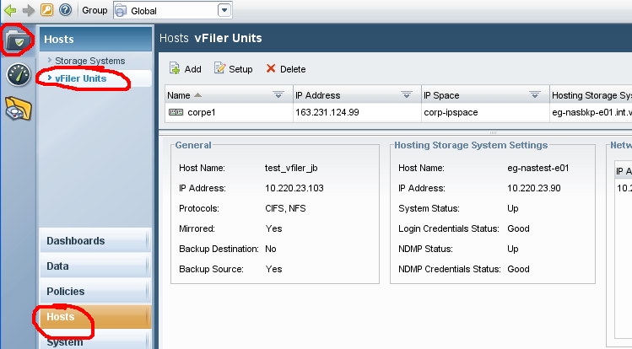

1. Within the NMC, click “add” 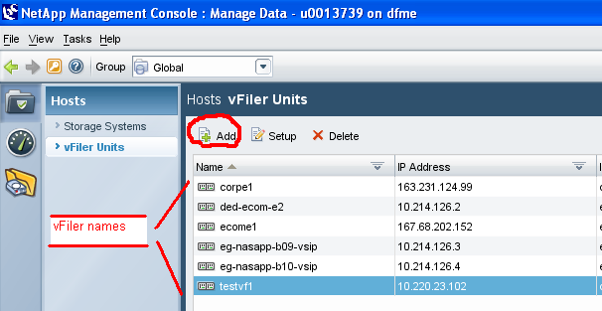
2. **EFFECTIVE 11/1/2011, IP AND DNS A RECORD REQUESTS FOR VFILERS REQUIRED FOR BUILD CENTER SOLUTIONS WILL BE COMPLETED DURING SOLUTION APPROVAL. THE TASK OF REQUESTING THE IP AND DNS WILL NO LONGER BE PERFORMED AT THE TIME OF THE NAS BUILD/PROVISIONING. THIS CHANGE IN PROCEDURE WILL ELIMINATE THE DELAY IN PROVISIONING NEW NAS ASSOCIATED WITH WAITING THE 1-2 DAYS FOR THE DNS A RECORD TO BE CREATED.**

**ENGINEERS RESPONSIBLE FOR NAS NEW PROVISIONING REQUIRING THE CREATION OF VFILERS WILL NEED TO REFERENCE THE NAS FILER NAME FIELD WITHIN THE CORRESPONDING BUILD CONFIG FOR THE VFILER NAME THAT WAS ASSIGNED TO THE SOLUTION.**

1. Reference the NAS Filer Name field within the build config for the solution you will be provisioning to. Locate and make a note of the vFiler name that was assigned during Solution Approval. The NAS Notes section should also include the vFiler name, IP, subnet mask, IP space and VLAN information to use during the vFiler creation. If not, this information can be found by following steps 9), 10) and 11) below.

In the “VFiler Unit information”:

* Enter the vFiler name:
* Enter the IP space: (Note: If the IP space was not found in the NAS Notes section of the build config, this information can be found by following steps 9), 10) and 11) below.)
* Allowed protocols: Select the applicable protocol.
  + NFS: Used for standard Unix volumes
  + CIFS: Select CIFS only if your vfiler will need CIFS, and the physical filer has a CIFS license. All shared filers have a CIFS license. Run the command “license” on the physical filer to determine if CIFS is licensed.
  + NFS and ISCSI: Both protocols must be enabled for **WISP** allocations.
* Click next to advance to the next screen

IMPORTANT 12/2011 NOTE: vfiler dns names should contain no capitalization. This is especially true for iSCSI vfilers as a bug was uncovered in NetApp’s SnapDrive software that causes connectivity to the vfiler to fail if any part of the vfiler name in DNS is capitalized.

(e.g. DNS record should be prod-ecom-h0137.clrrs.loc not **P**rod-ecom-h0137.clrrs.loc)

1. Go to <http://zipper.int.thomson.com> and enter the vFiler noted from the previous step into the Search Expression field of Zipper and click Search.

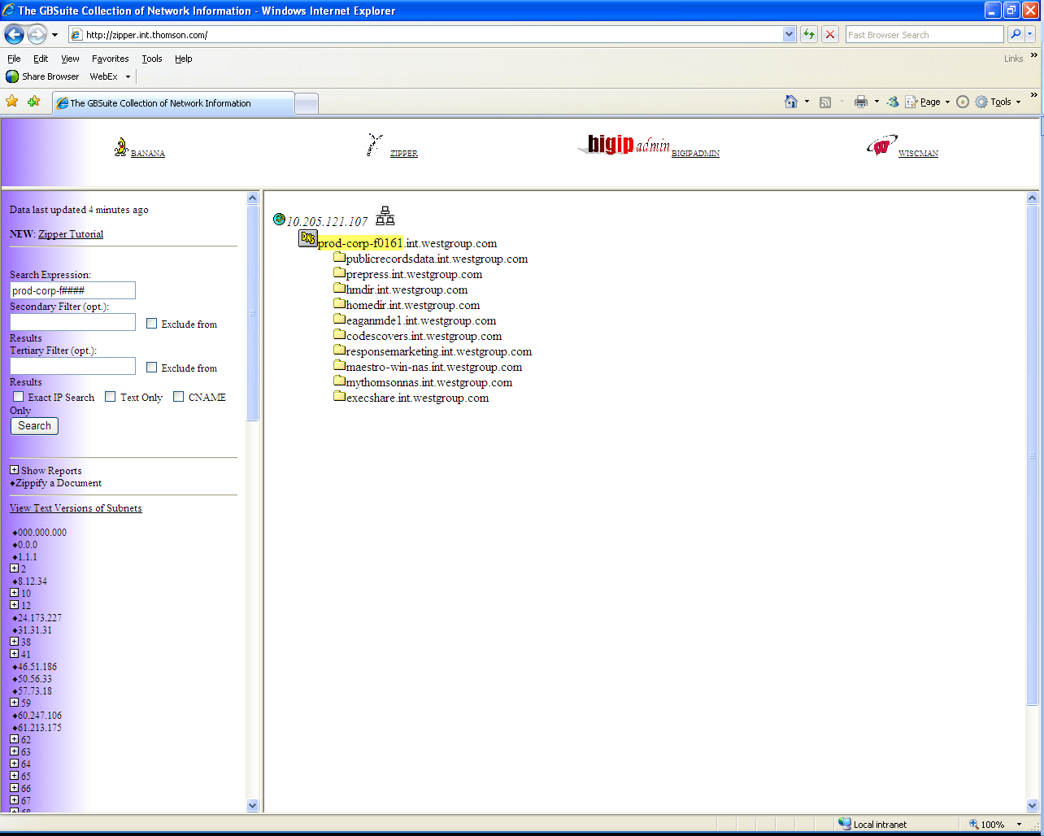

1. The results of the search will be displayed in the right-hand pane of the window. Note the IP, subnet mask, and VLAN to use during the vFiler creation. The subnet mask and VLAN may be obtained by hovering the mouse over the networked computer icon illustrated below.

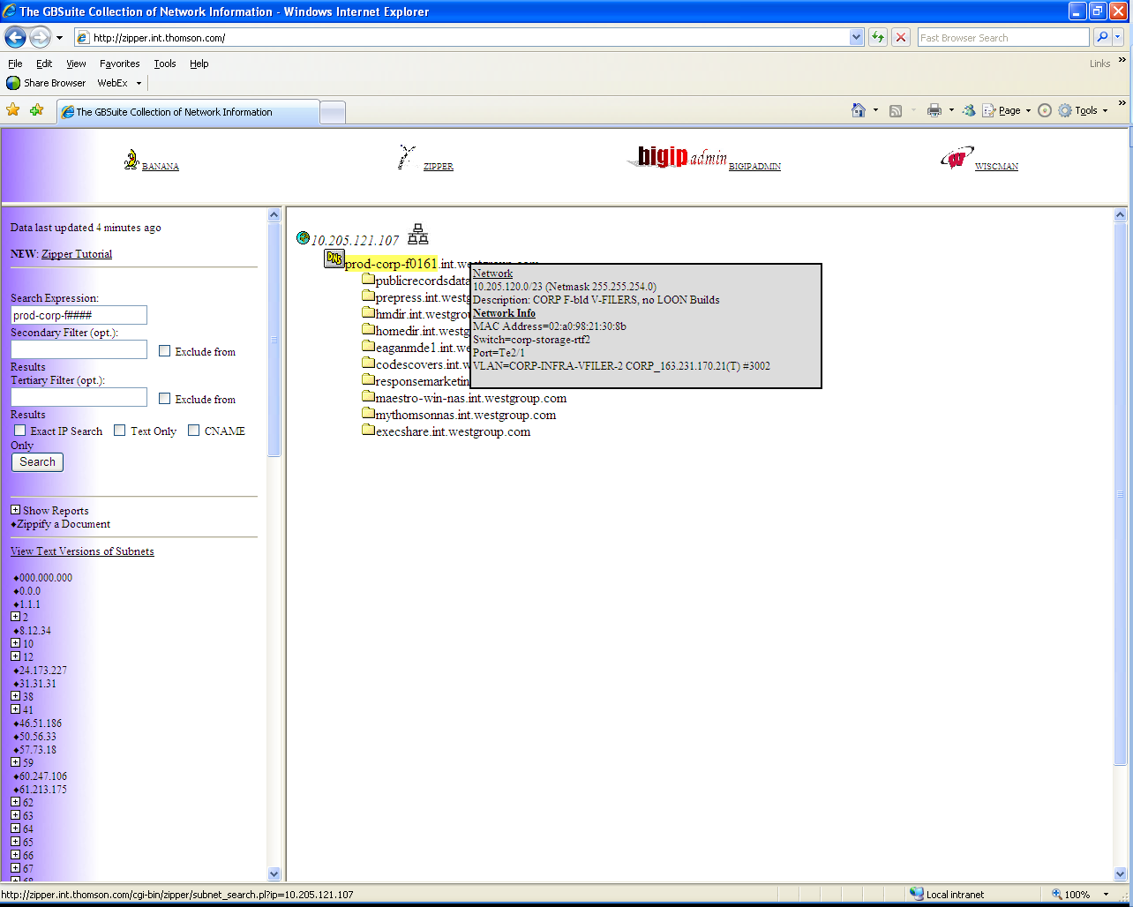

1. Reference the NAS/HNAS/SNAS VLAN Mapping Tables contained in Storage Implementation Master Document to determine which IP Space you’ll need to type in the IP Space field. <http://sharepoint.thomson.com/sites/ie/storage/NonShared%20Documents/Storage%20Implementation%20Internal%20MASTER.docx>
2. Click the “Select a Resource Pool” radio button
3. Click the appropriate Resource Pool (Note: This is the name of the pfiler for the vfiler you are creating.)
4. Click Next
5. Select the “Create and Setup vFiler unit” radio button, click Next.
6. You should be at the Network interface setting dialog.
   1. Click “Add”, this will bring up the “Add binding” dialog box.
   2. Enter the “IP address:” and “Network mask:” noted in step 8) above.
   3. For the “Network Interface” drop-down, select the interface that has the VLAN ID in the name matching the one noted in step 8) above.
   4. DO NOT enter or try to select:
      1. VLAN id:
      2. MTU (Bytes):
      3. Partner interface:

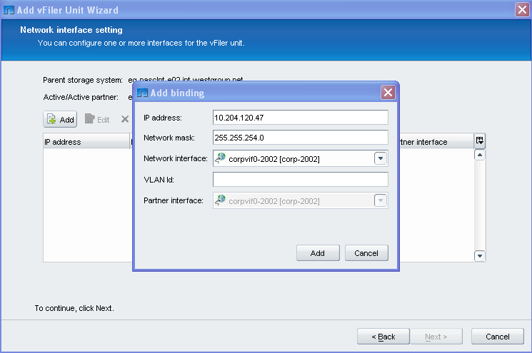

1. Click Add and verify Network Interface information
2. Click Next
3. Choose the vfiler template that relates to the environment in scope (ecom, corp, etc.)
4. If present, Uncheck the “Perform CIFS setup” checkbox (this will be done later if you are setting up a CIFS capable vfiler)
5. Click Next
6. If prompted, Enter our standard password, click Next
7. Click Next, leaving the script path blank
8. Verify the vFiler attributes summary is accurate and then click Finish
9. Open a putty session to any DFM server and run the following command (the blue text requires editing):
   1. Rename the root volume for the vfiler to the standard name. Prov Mgr 5.0 and 5.1 changes – (hyphens) to x instead of _(underscores)

ssh filername vol rename clntxcorpxd0013_root clnt_corp_d0013_root

* 1. Change the root volume to the standard 20% (or use filerview or OnCommand)

snap reserve <vol_name> <percent>.

**NOTE**: Due to snapvault.access option character limitations, the vfiler create scripts have been separated by locale. It is imperative that the appropriate script be run. For example, a CIS vFiler to residing in Docklands would have the script, “vfiler_create_cis_docklands.bash” run.

**/filers/admin/scripts/delivery/logical/vfiler_create*_<cis or cps>_<location>*.bash *VfilerName PhysicalFilerName*-mgmt VfilerIP**

The Script performs these steps:

Enables snapvault in options (snapvault.enable on)

Gives vFilers access to the bkp filers (snapvault.access host=)

Exports the vFiler root volume to all location-specific primary and secondary DFM servers

Configures the root volume for autosize w/ 50MB increments up to 500MB

Adds Oracle and SSH user names and roles.

Adds SSH generic key and BSI-DBA key. (If you’re interested in learning more about this piece, there is more information about the Oracle and SSH roles in the following document):

\\Eg-nas-a02\sg$\Procedures\NetApp\SSH_CreatingGenericKey.doc

Sets vscan options mandatory_scan off (sjc 10/20/10)

Enables snap autodelete trigger to snap_reserve for vfiler root volumes and enables it. (sjc 11/17/10)

Example command and output:

nidaros:/ # /filers/admin/bin/storimp/vfiler_create.bash clnt-ecom-h0002 eg-nasclnte-h04-mgmt.int.westgroup.net 10.216.124.5

PING eg-nasclnte-h04-mgmt.int.westgroup.net (10.213.29.250) 56(84) bytes of data.

64 bytes from eg-nasclnte-h04-mgmt.int.westgroup.net (10.213.29.250): icmp_seq=1 ttl=250 time=0.230 ms

--- eg-nasclnte-h04-mgmt.int.westgroup.net ping statistics ---

1 packets transmitted, 1 received, 0% packet loss, time 0ms

rtt min/avg/max/mdev = 0.230/0.230/0.230/0.000 ms

===== clnt-ecom-h0002

===== clnt-ecom-h0002

===== clnt-ecom-h0002

===== clnt-ecom-h0002

===== clnt-ecom-h0002

===== clnt-ecom-h0002

===== clnt-ecom-h0002

Role <oracle_backup> added.

===== clnt-ecom-h0002

Group <oracle_admin> added.

===== clnt-ecom-h0002

User <oracle> added.

===== clnt-ecom-h0002

Role <oraapi_backup_role> added.

===== clnt-ecom-h0002

Group <oraapi_backup_group> added.

===== clnt-ecom-h0002

User <oraapi_backup> added.

nidaros:/ #

**Note: Generic Database Backup Vfiler Account for MySQL (and other future DB technologies**) to allow DBAs to take snapshots on their volumes. (NOT created as part of the .bash script above. However, WFA workflows that create vfilers have already been updated to add this user at the time of vfiler creation.

This user is similar to the existing ‘oracle’ user in nature and functionality but has a different username, password, and SSH key.

Vfiler Configuration

• vfiler run $1 useradmin role add db_backup_role -a cli-snapvault*,cli-snap*,cli-ndmpcopy*,login-ssh,cli-df*

• vfiler run $1 useradmin group add db_backup_admins -r db_backup_role

• vfiler run $1 useradmin user add db_backup_user -g db_backup_admins -p st0rage1

• Additionally, a new SSH public key was generated for this user and is placed in the appropriate sshd/.ssh directory of the vfiler. A copy of this public key is located at :

/filers/admin/source/logical/db_backup_user_keys/authorized_keys2

1. Run the following command from the hosting filer to determine if ssh secureadmin has been set up (the blue text requires editing):

**eg-nasapp-f08> vfiler run *VfilerName* secureadmin status**

*Example:*

*eg-nasapp-f08> vfiler run ded-ecom-f0001 secureadmin status*

If secureadmin has been set-up you should get: (ssh1 should be inactive)

eg-nasapp-f08> vfiler run ded-ecom-f0001 secureadmin status

===== ded-ecom-f0001

ssh2 - active

ssh1 - inactive

**If BOTH are inactive run the following command and press enter four times to accept all defaults:**

eg-nasapp-f08> vfiler run *VfilerName* secureadmin setup ssh

*Example:*

*eg-nasapp-f08> vfiler run ded-ecom-f0001 secureadmin setup ssh*

1. Run the following command to disable stale RPC CIFS cleanup functionality.
   1. **vfiler run <vfilername> options cifs.rpcfd_timeout -1**
   2. Excerpt from 1/25/12 email from Mike Arndt: Bug 490774 was introduced by a change in ONTAP 7.3.6 and 8.0.2 (and is present in 7.3.6P1 and 8.0.2P3), with a feature put in to help cleanup stale RPC requests in a CIFS environment. There is an issue with this feature that can cause a panic in some situations, and the advice at this point is to just disable the feature.  The feature was meant to be a minor enhancement that detected misbehaving CIFS clients, so we really are not missing anything (as compared to 7.3.3P3) by disabling it.
2. Run the following commands, standard for net new CIFS/SMB vfilers.
   1. **vfiler run <vfilername> options** cifs.smb2.client.enable  off
   2. **vfiler run <vfilername> options**  cifs.smb2.durable_handle.enable off
   3. **vfiler run <vfilername> options** cifs.smb2.enable  on
   4. **vfiler run <vfilername> options** cifs.smb2.signing.required off
3. Complete the following step from the Vfiler’s controlling DFM server to add the Vfiler’s root volume to the **Vfiler_root_volume** DFM group. This DFM group is used for threshold monitoring.

SCRIPT METHOD:

**Example:**

**u0089747@cmp111cwq:/filers/admin/scripts/support> ./DFM_rootvol.sh clnt-corp-f0342**

clnt-corp-f0342

171937 clnt-corp-f0342:/clnt_corp_f0342_root Flexible 32_bit No

171943 clnt-corp-f0342:/infra_caspershareqa_snap Flexible 32_bit No

Added 1 member to group Vfiler_root_volume.

-------------Add-Completed for clnt_corp_f0342_root of clnt-corp-f0342------------------------------------------

Changed volume nearly full threshold (%) for volume clnt-corp-f0342:/clnt_corp_f0342_root (171937) to 90.

-------------Option-set-completed for clnt_corp_f0342_root of clnt-corp-f0342 -----------------------------------

###########################

RESULTS

###########################

volNearlyFullThreshold=90

---------------------------End-----------------------

u0089747@cmp111cwq:/filers/admin/bin>

MANUAL METHOD:

***NOTE: You can use the volume ID or full name (Vfiler:/volume_name) to add the volume to the DFM group and update settings for the volume. (information commands are non-bolded. The two actual commands you run have been bolded below.)***

* 1. Collect the volume ID and volume name from dfm:

dfm volume list |grep –i *<newly-created-VSIP-volumename>*

*Example:dfm volume set*

*cmp111mgc:~ # dfm volume list |grep -i clnt_corp_e0445_root*

*188074 clnt-corp-e0445:/clnt_corp_e0445_root Flexible 32_bit No*

*cmp111mgc:~ #*

* 1. Add the new root volume to the group (Vfiler_root_volume) :

**dfm group add Vfiler_root_volume *<newly-created-VSIP-volumename>***

*cmp111mgc:~ # dfm group add Vfiler_root_volume clnt-corp-e0445:/clnt_corp_e0445_root*

*Added 1 member to group Vfiler_root_volume.*

*cmp111mgc:~ #*

* 1. Get the default alerting set for this volume:

dfm volume get –q *<newly-created-VSIP-volumename>*

Example:

cmp111mgc:~ # dfm volume get -q clnt-corp-e0445:/clnt_corp_e0445_root

volume=clnt-corp-e0445:/clnt_corp_e0445_root

volFullThreshold=98

volNearlyFullThreshold=99

volFullThresholdInterval=00:00:00

userEnableAlerts=No

userFullThreshold=98

userNearlyFullThreshold=99

volSnapshotFullThreshold=90

volNearlyNoFirstSnapThreshold=80

volNoFirstSnapThreshold=90

volReserveNearlyDepletedThreshold=80

volReserveDepletedThreshold=95

volGrowthEventMinChangePct=20

volNearlyOvercommittedThreshold=95

volOvercommittedThreshold=100

volSnapshotCountThreshold=250

volSnapshotTooOldThreshold=52 weeks

cmp111mgc:~ #

* 1. Set the alerting threshold:

**dfm volume set *<newly created root volumename>* volNearlyFullThreshold=90**

*cmp111mgc:~ # dfm volume set clnt-corp-e0445:/clnt_corp_e0445_root volNearlyFullThreshold=90*

*Changed volume nearly full threshold (%) for volume clnt-corp-e0445:/clnt_corp_e0445_root (188074) to 90.*

*cmp111mgc:~ #*

**CIFS setup --Complete the following steps (if CIFS is not required, skip to the “Volume Allocation on a vFiler” section below).**

1. Pre-Create the computer account in AD
   1. **For the TLR AD**, from your desktop click Start -> Programs -> Administrative Tools. Hold the shift key and right-click the “Active Directory Users and Computers” icon, choose Run As, and enter your tlr\m account credentials.
      1. Select this folder from the window pane on the left side: TLR.Thomson.com/West-TLRCorp/Storage/NAS
   2. **For the Ecom AD**, access “Active Directory Users and Computers” from your Citrix session using your mgmt\m account.
      1. In the left window pane, if “mgmt.tlrg.com” is listed instead of “ecom.tlrg.com”, right-click on “Active Directory Users and Computers” and choose “Connect to Domain…” -> enter “ecom.tlrg.com” in the Domain field and click ok.
      2. Select this folder from the window pane on the left side: ecom.tlrg.com/Storage/NAS
   3. **For the EcomQC AD**, access “Active Directory Users and Computers” from your Citrix session using your mgmt\m account.
      1. In the left window pane, if “mgmt.tlrg.com” is listed instead of “ecomqc.tlrg.com”, right-click on “Active Directory Users and Computers” and choose “Connect to Domain…” -> enter “ecomqc.tlrg.com” in the Domain field and click ok.
      2. Select this folder from the window pane on the left side: ecomqc.tlrg.com/Storage/NAS
   4. **For the CLRRS.LOC AD**, access “Active Directory Users and Computers” from your Citrix session using your mgmt\m account.
      1. In the left window pane, if “mgmt.tlrg.com” is listed instead of “clrrs.loc”, right-click on “Active Directory Users and Computers” and choose “Connect to Domain…” -> enter “clrrs.loc” in the Domain field and click ok.

Select this folder from the window pane on the left side:

CLRRS.LOC /Storage /NAS

* 1. **For the ten.thomsonreuters.com computer account creation, see the following document: (Use ARS to create computer objects in TEN domain):**

<https://theshare.thomsonreuters.com/sites/ie/storage/_layouts/WordViewer.aspx?id=/sites/ie/storage/NonShared%20Documents/Physical%20Implementation/Active%20Directory/Ten%20Domain%20Computer%20Account%20Creation%20for%20CIFS.docx&Source=https%3A%2F%2Ftheshare%2Ethomsonreuters%2Ecom%2Fsites%2Fie%2Fstorage%2FNonShared%2520Documents%2FForms%2FAllItems%2Easpx%3FRootFolder%3D%252Fsites%252Fie%252Fstorage%252FNonShared%2520Documents%252FPhysical%2520Implementation%252FActive%2520Directory%26InitialTabId%3DRibbon%252EDocument%26VisibilityContext%3DWSSTabPersistence&DefaultItemOpen=1>

* 1. **For the Abacus-app.com AD**, access “Active Directory Users and Computers” by remote desktop to **abs-appts-02.abacus-app.com** using your abacus-app.com\m account.

**NOTE:** When you first logon to the abs-appts-a02 server noted above, you will need to use an initial password created by Weibo Shieh (Directory Services) as there is no trust with the Abacus-app.com domain and other domains. You will then need to change your password. The initial password created by the Directory Services team for all Abacus M accounts is located at [PSTS_Storage_Credentials.xls](https://theshare.thomsonreuters.com/sites/ie/storage/NonShared%20Documents/PSTS%20Storage%20Credentials.xls).

* + 1. Go to Start >> run >> dsa.msc to access AD Users and Computers

Select this folder from the window pane on the left side:

ABACUS-APP.COM/Storage /NAS

* + 1. Right-Click on the folder listed above and select New -> Computer
    2. Type your vFiler name in the Computer Name filed and use default settings while clicking Next -> Finish
  1. **For the ERFQC.ThomsonQC.Com**, access from your desktop click Start -> Programs -> Administrative Tools.
     1. Hold the shift key and right-click the “Active Directory Users and Computers” icon, choose Run As, and enter your tlr\m account credentials.
     2. Change the domain in the window frame in the left hand side to the erfeqc.thomsonqc.com domain by right clicking on the existing domain and selecting “Connect to Domain.” Enter the domain you need to connect to.
     3. Select this folder from the window pane on the left side: ERFQC.THOMSONQC.COM/Thomson/TLR/West-TLR Corp/Storage/NAS
     4. Right-Click on the folder listed above and select New -> Computer
     5. Type your vFiler name in the Computer Name filed and use default settings while clicking Next -> Finish
  2. **For the ERF.Thomson.Com**, access from your desktop click Start -> Programs -> Administrative Tools.
     1. Hold the shift key and right-click the “Active Directory Users and Computers” icon, choose Run As, and enter your tlr\m account credentials.
     2. Change the domain in the window frame in the left hand side to the erfeqc.thomsonqc.com domain by right clicking on the existing domain and selecting “Connect to Domain.” Enter the domain you need to connect to.
     3. Select this folder from the window pane on the left side: ERF.thomson.com/Thomson/TLR/West-TLR Corp/Storage
     4. Right-Click on the folder listed above and select New -> Computer
     5. Type your vFiler name in the Computer Name filed and use default settings while clicking Next -> Finish
  3. **For the MGMT.TLRG.Com**, access from MGMT Citrix farm and once logged in, from your desktop click Start -> Programs -> Administrative Tools.
     1. Change the domain in the window frame in the left hand side to the mgmt.tlrg.com domain by right clicking on the existing domain and selecting “Connect to Domain.” Enter the domain you need to connect to.
     2. Select this folder from the window pane on the left side: mgmt.tlrg.com/West-TLRCorp/Storage/NAS
     3. Right-Click on the folder listed above and select New -> Computer
     4. Type your vFiler name in the Computer Name filed and use default settings while clicking Next -> Finish
  4. **For the LHTRP.LOC & LHTRQA.LOC (Hosted Litigation) domains**, access “Users & Computers” (c:\windows\system32\dsa.msc) from one of the jump servers: You’re your MGMTsec.loc\Mxxxxxxx credentials for both domains)

QA Jump servers:

C538PGA.LHTRQA.LOC or C755EKT. LHTRQA.LOC

Prod Jump servers:

C577NGS.LHTRP.LOC or C892TZE.LHTRP.LOC

* 1. **For the TAXSTREAM.LOCAL domain**,
     1. access “Users & Computers” (c:\windows\system32\dsa.msc) from one of the jump servers, using your MGMTsec.loc\Mxxxxxxx credentials.

LHTRP.LOC Prod Jump servers:

C577NGS.LHTRP.LOC, C892TZE.LHTRP.LOC, C214rxd.lhtrp.loc, C432key.lhtrp.loc

* + 1. In the left window pane of AD Users and Computers, if “LHTRP.loc” is listed instead of “taxstream.local”, right-click on “Active Directory Users and Computers” and choose “Connect to Domain…” -> enter “taxstream.local” in the Domain field and click ok.

Select this folder from the window pane on the left side:

Taxstream.local /Storage /NAS

* 1. **For the ePropertyTax.tlrg.com AD**, access “Active Directory Users and Computers” from your Citrix session using your mgmt\m account.
     1. In the left window pane, if “mgmt.tlrg.com” is listed instead of “ePropertyTax.tlrg.com”, right-click on “Active Directory Users and Computers” and choose “Connect to Domain…” -> enter “ePropertyTax.tlrg.com” in the Domain field and click ok.
     2. Select this folder from the window pane on the left side: ePropertyTax.tlrg.com /Storage/NAS
  2. **For the tfprod.com AD**, access “Active Directory Users and Computers” from tfprod.com Citrix session using your mgmt\m account. (for tfprod citrix access submit an IM follow InQuira below:
  3. <http://inquira.thomsonreuters.com/search/index?page=content&id=SO61832&actp=search&viewlocale=en_US&searchid=1294068688767>
     1. In the left window pane, if “mgmt.tlrg.com” is listed instead of “tfprod.com”, right-click on “Active Directory Users and Computers” and choose “Connect to Domain…” -> enter “tfprod.com” in the Domain field and click ok.
     2. Select this folder from the window pane on the left side: tfprod.com/Storage/NAS

***NOTE:*** *You may want to wait ~30 minutes before proceeding with the next step of running CIFS setup since it may take ~30 minutes for the computer account to be available.*

***NOTE:******For vfilers in the CLRRS.LOC domain that need CIFS setup completed,*** *we are doing the setup via command line as we have no vfiler template yet. There is also an authentication issue with the CIFS setup and our MGMT\M accounts, so you must request a Windows engineer use their CLRRS.LOC\M account during the CIFS setup as shown below:*

*Enter the name of the Windows user [Administrator@CLRRS.LOC]:* ***<MXXXXXX@CLRRS.LOC>***

*Password for* ***<MXXXXX@CLRRS.LOC>***

*Please contact PSTS-Implementation-Storage team and David Mulder (Windows team) with any questions.*

1. Run CIFS setup on the vFiler from within the NMC.
   1. Click the “Manage Data” gray folder icon in the top left corner
   2. Click “Hosts” in the bottom left corner
   3. Click “vFiler units” in the top left corner
   4. Right-Click on your vFiler and choose SetUp
   5. Click Next on the Welcome screen
   6. Verify NFS and CIFS is selected on the vFiler Unit Info screen and click Next
   7. On the Network settings dialog box, check the “Change network settings” checkbox and click next
   8. On the Network interface setting dialog box, verify the info is accurate for your vFiler and click next.

***NOTE:*** *The Netmask setting consistently changes to an inaccurate value. Change it so it’s accurate by highlighting the network info and clicking “edit”. Click Next when finished.*

* 1. Choose the vfiler template that relates to the environment in scope ***(ecom, ecomqc or corp)***
  2. Check the box to run CIFS setup
  3. In the Domain User field, enter **your** M Account as follows

(see screenshot below Corp example)

* + 1. For ecom, ecomqc, or clrrs.loc: MGMT domain M account

(ex. m0013739@mgmt.tlrg.com)

* + 1. For TLR: TLR domain M account (ex., m0013739@tlr.thomson.com)
  1. Enter your password and click Next .
  2. Enter the vfiler root password and click Next.
  3. Leave the script path blank and click Next.
  4. Verify the summary and click finish.

1. Open a putty session to any DFM server and run the following commands

(the blue text requires editing):

See the "[CIFS Domain Quick Reference](https://theshare.thomsonreuters.com/sites/ie/storage/NonShared%20Documents/Physical%20Implementation/Active%20Directory/CIFS%20Domain%20Quick%20Reference.xls)" spreadsheet on Sharepoint for more general info about CIFS.

Note: to verify what group(s) have already been added to a vfiler:

rsh <filer> vfiler run <vfiler> useradmin domainuser list -g Administrators

rsh <filer> vfiler run <vfiler> cifs lookup <SID>

**For Corp\TLR vFilers**

1. rsh HostingFiler-mgmt vfiler run *vFilerName* useradmin domainuser add m-eaganserveradmins -g Administrators
2. rsh HostingFiler-mgmt vfiler run *vFilerName* useradmin domainuser add M-Storage-admins.g -g Administrators
3. rsh HostingFiler-mgmt vfiler run *vFilerName* useradmin domainuser add svcAVNas **(Rochester vfilers use SVCTrendSP)** -g Administrators

**NOTE:** For Rochester filers/vfilers, Weibo Shieh (Directory Services) and Philip Ferrera (EA-RSSG-Roc-Server) have requested we use the **TLR\SVCTrendSP** account instead of the TLR\svcAVNas account for AV scanning.

1. rsh HostingFiler-mgmt vfiler run *vFilerName* vscan on

**For Ecom vFilers:**

1. rsh HostingFiler-mgmt vfiler run *vFilerName* useradmin domainuser add m-eaganserveradmins -g Administrators
2. rsh HostingFiler-mgmt vfiler run *vFilerName* useradmin domainuser add M-Storage-admins.g -g Administrators
3. rsh HostingFiler-mgmt vfiler run *vFilerName* useradmin domainuser add svcAVNas -g Administrators
4. rsh HostingFiler-mgmt vfiler run *vFilerName* vscan on

**For EcomQC vFilers:**

1. rsh HostingFiler-mgmt vfiler run *vFilerName* useradmin domainuser add m-eaganserveradmins -g Administrators
2. rsh HostingFiler-mgmt vfiler run *vFilerName* useradmin domainuser add M-Storage-admins.g -g Administrators
3. rsh HostingFiler-mgmt vfiler run *vFilerName* useradmin domainuser add svcAVNas -g Administrators
4. rsh HostingFiler-mgmt vfiler run *vFilerName* vscan on

**For CLRRS.LOC vFilers:**

1. rsh HostingFiler-mgmt vfiler run *vFilerName* useradmin domainuser add m-eaganserveradmins -g Administrators
2. rsh HostingFiler-mgmt vfiler run *vFilerName* useradmin domainuser add M-Storage-admins.g -g Administrators
3. rsh HostingFiler-mgmt vfiler run *vFilerName* useradmin domainuser add svcAVNas -g Administrators
4. rsh HostingFiler-mgmt vfiler run *vFilerName* vscan on

**For h1ecom.com vFilers:**

1. rsh HostingFiler-mgmt vfiler run *vFilerName* useradmin domainuser add m-eaganserveradmins -g Administrators
2. rsh HostingFiler-mgmt vfiler run *vFilerName* useradmin domainuser add M-Storage-admins.g -g Administrators
3. rsh HostingFiler-mgmt vfiler run *vFilerName* useradmin domainuser add svcAVNas -g Administrators
4. rsh HostingFiler-mgmt vfiler run *vFilerName* vscan on

**For MGMT.tlrg.com vFilers:**

1. rsh HostingFiler-mgmt vfiler run *vFilerName* useradmin domainuser add m-eaganserveradmins -g Administrators
2. rsh HostingFiler-mgmt vfiler run *vFilerName* useradmin domainuser add M-Storage-admins.g -g Administrators
3. rsh HostingFiler-mgmt vfiler run *vFilerName* useradmin domainuser add svcAVNas -g Administrators
4. rsh HostingFiler-mgmt vfiler run *vFilerName* vscan on

**For ten.thomsonreuters.com domain vfilers:**

1. rsh HostingFiler-mgmt vfiler run *vFilerName* useradmin domainuser add "tlr\m-eaganserveradmins" -g Administrators (NOTE: TLR not TEN as you would suspect)
2. rsh HostingFiler-mgmt vfiler run *vFilerName* useradmin domainuser add "ten\-DG-BUS-Admin-CTO-DCO-CISPlatforms" -g Administrators (NOTE: dash “-“ in front of DG!)
3. rsh HostingFiler-mgmt vfiler run *vFilerName* useradmin domainuser add M-Storage-admins.g -g Administrators
4. rsh HostingFiler-mgmt vfiler run *vFilerName* useradmin domainuser add svcAVNas -g Administrators
5. rsh HostingFiler-mgmt vfiler run *vFilerName* vscan on

**For abacus-app.com domain vfilers: (NOTE:** additional “-“ in m-eagan-serveradmins)

1. rsh HostingFiler-mgmt vfiler run *vFilerName* useradmin domainuser add m-eagan-serveradmins -g Administrators
2. rsh HostingFiler-mgmt vfiler run *vFilerName* useradmin domainuser add M-Storage-admins.g -g Administrators
3. rsh HostingFiler-mgmt vfiler run *vFilerName* useradmin domainuser add svcAVNas -g Administrators
4. rsh HostingFiler-mgmt vfiler run *vFilerName* vscan on

**For ERFQC.ThomsonQC.com vFilers:**

1. rsh HostingFiler-mgmt vfiler run *vFilerName* useradmin domainuser add m-eaganserveradmins -g Administrators
2. rsh HostingFiler-mgmt vfiler run *vFilerName* useradmin domainuser add M-Storage-admins.g -g Administrators
3. rsh HostingFiler-mgmt vfiler run *vFilerName* useradmin domainuser add svcAVNAS -g Administrators
4. rsh HostingFiler-mgmt vfiler run *vFilerName* vscan on

**For ERF.Thomson.com vFilers:**

1. rsh HostingFiler-mgmt vfiler run *vFilerName* useradmin domainuser add m-eaganserveradmins -g Administrators
2. rsh HostingFiler-mgmt vfiler run *vFilerName* useradmin domainuser add M-Storage-admins.g -g Administrators
3. rsh HostingFiler-mgmt vfiler run *vFilerName* useradmin domainuser add svcAVNAS -g Administrators
4. rsh HostingFiler-mgmt vfiler run *vFilerName* vscan on

**For lhtrqa.loc domain vfilers:** (notice you need to preface group names with “MGMTsec.loc\”)

1. rsh HostingFiler-mgmt vfiler run *vFilerName* useradmin domainuser add MGMTsec.loc\m-eaganserveradmins -g Administrators
2. rsh HostingFiler-mgmt vfiler run *vFilerName* useradmin domainuser add MGMTsec.loc\M-Storage-admins.g -g Administrators
3. rsh HostingFiler-mgmt vfiler run *vFilerName* useradmin domainuser add MGMTsec.loc\svcAVNas -g Administrators
4. rsh HostingFiler-mgmt vfiler run *vFilerName* vscan on

**For lhtrp.loc domain vfilers:** (notice you need to preface group names with “MGMTsec.loc\”)

1. rsh HostingFiler-mgmt vfiler run *vFilerName* useradmin domainuser add MGMTsec.loc\m-eaganserveradmins -g Administrators
2. rsh HostingFiler-mgmt vfiler run *vFilerName* useradmin domainuser add MGMTsec.loc\M-Storage-admins.g -g Administrators
3. rsh HostingFiler-mgmt vfiler run *vFilerName* useradmin domainuser add MGMTsec.loc\svcAVNas -g Administrators
4. rsh HostingFiler-mgmt vfiler run *vFilerName* vscan on

**For portalqa-uk.local domain vfilers:**

1. rsh HostingFiler-mgmt vfiler run *vFilerName* useradmin domainuser add M-PlatformTaxProfessional -g Administrators
2. rsh HostingFiler-mgmt vfiler run *vFilerName* useradmin domainuser add M-Storage-admins.g -g Administrators
3. rsh HostingFiler-mgmt vfiler run *vFilerName* useradmin domainuser add <domain>\svcAVNas -g Administrators – Anti-virus does not currently exist in portal domains, and trusts do not exist that would allow using “shared” svcNAS user accounts
4. rsh HostingFiler-mgmt vfiler run *vFilerName* vscan on – do not perform until AV servers exist in portalqa-uk.local domain.

**For portal-uk.local domain vfilers:**

1. rsh HostingFiler-mgmt vfiler run *vFilerName* useradmin domainuser add M-PlatformTaxProfessional -g Administrators
2. rsh HostingFiler-mgmt vfiler run *vFilerName* useradmin domainuser add M-Storage-admins.g -g Administrators
3. rsh HostingFiler-mgmt vfiler run *vFilerName* useradmin domainuser add <domain>\svcAVNas -g Administrators – Anti-virus does not currently exist in portal domains, and trusts do not exist that would allow using “shared” svcNAS user accounts
4. rsh HostingFiler-mgmt vfiler run *vFilerName* vscan on do not perform until AV servers exist in portal-uk.local domain.

**For ePropertyTax.tlrg.com vFilers:**

1. rsh HostingFiler-mgmt vfiler run *vFilerName* useradmin domainuser add m-eaganserveradmins -g Administrators
2. rsh HostingFiler-mgmt vfiler run *vFilerName* useradmin domainuser add M-Storage-admins.g -g Administrators
3. rsh HostingFiler-mgmt vfiler run *vFilerName* useradmin domainuser add svcAVNas -g Administrators
4. rsh HostingFiler-mgmt vfiler run *vFilerName* vscan on

**For Taxstream.local vFilers:**

1. rsh HostingFiler-mgmt vfiler run *vFilerName* useradmin domainuser add m-eaganserveradmins -g Administrators
2. rsh HostingFiler-mgmt vfiler run *vFilerName* useradmin domainuser add M-Storage-admins.g -g Administrators
3. rsh HostingFiler-mgmt vfiler run *vFilerName* useradmin domainuser add svcAVNas -g Administrators
4. rsh HostingFiler-mgmt vfiler run *vFilerName* vscan on

**For tfprod.com vFilers:**

1. rsh HostingFiler-mgmt vfiler run *vFilerName* useradmin domainuser add m-eaganserveradmins -g Administrators
2. rsh HostingFiler-mgmt vfiler run *vFilerName* useradmin domainuser add REST-StorageSupportServerAdmins -g Administrators
3. rsh HostingFiler-mgmt vfiler run *vFilerName* useradmin domainuser add svcavnas -g Administrators
4. rsh HostingFiler-mgmt vfiler run *vFilerName* useradmin domainuser add “server administrators” -g Administrators (This is Steve Perez’s group)
5. rsh HostingFiler-mgmt vfiler run *vFilerName* vscan on

**Volume Allocation on a vFiler**

1. Launch NetApp Management Console (NMC) from your desktop
2. Choose the appropriate site (dfm**e**, dfm**f**, or dfm**h**)
3. Click the “Manage Data” gray folder icon in the top left corner
4. Click “Data” in the center pane
5. Click “Data Sets” in the top left corner
6. Verify the “Overview” tab is selected
7. Click “Add / Add” in the top left corner

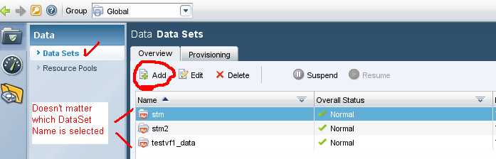

1. The “Add Dataset Wizard” splash screen will appear, click Next
2. Type the Volume/DataSet name using our standard volume naming convention (Note: /vol/ not required when adding volume name.)
3. Enter the PPID of the project into the description field
4. Accept defaults for remaining fields and click next
5. Select the appropriate DFM group/filer and click next (e.g. Global | Filers | Filers/High Tier/Prod/Ecom etc…)
6. Select the appropriate Provisioning Policy

(see section 2.2 in the following document for Provisioning Policy descriptions:)

\\Eg-nas-a02\sg$\Procedures\NetApp\vFilers\Multistore_Management_with_Provisioning_Manager_1.9.doc

1. For CIFS volumes, skip to step 20
2. For NFS volumes, expand the NFS Export Settings field
3. Click “Turn on Now” in the NFS Export Settings field
4. Change the field for “Map Anonymous Users” to 0
5. Select Read Write in the “All Hosts” drop-down
6. Click the Add button, choose Read Write, and type “1.1.1.1” in the Hosts field (You can remove this entry later as you’re creating your exports to reduce confusion on the platform side.)
7. Expand the Resource Pool field, select the appropriate physical filer, and click the arrow to move the appropriate physical filer from the left-hand pane to the right-hand pane. (NOTE: DO NOT TURN ON CIFS AT THIS SCREEN. This will cause automatic creation of the CIFS share and that should be done by the windows platform teams.)
8. Click next
9. Select the name of your vFiler and click Next (Note: do not check the box for “Enable automated online migration”. )
10. Select Yes when prompted for “Would you like to provision storage now?” and click next.
11. Enter the qtree name in the field titled “Name”.
12. Select the usable capacity for your **qtree**.
13. Click next
14. Leave the Member level export settings dialog box at the defaults and click Next.
15. Select the “Manually select a resource from the attached resource pool(s)” radio button.
16. Expand the filer and locate the target aggregate for your dataset/volume. Highlight the desired aggregate. (Note: if there is a red ‘x’ on the aggregate, the provisioning policy of your dataset may not match the provisioning policy on the aggregate)
17. Click Next
18. Review the conformance results and click next.
19. Verify the summary is accurate and click Finish
20. If this is a “snap” volume, verify the snap reserve is 20% (nosnap should be 0%). if not do the following
    1. Change the volume snap reserve to the standard 20% (or use filerview or OnCommand)

snap reserve <vol_name> <percent>.

1. If you created a CIFS volume, you must use CLI to change the qtree security style for both the volume and qtree:

**Note: for mixed NFS \ CIFS DO NOT CHANGE THE SECURITY STYLE TO NTFS (CIFS). The security style should remain UNIX for both the volume and qtree:**

Open a Putty session to the appropriate DFM/OM server (the *blue text* below requires editing)

* rsh *PhysicalFilerName*-mgmt “vfiler run *vFilerName* qtree security /vol/*VolumeName*  ntfs”
* rsh *PhysicalFilerName*-mgmt “vfiler run *vFilerName* qtree security /vol/*VolumeName/QtreeName*  ntfs”

1. Create a hidden administrative share that points to the volume called *VolumeName****$***

rsh *PhysicalFilerName* vfiler run *vFilerName*> cifs shares -add *VolumeName$* /vol/*VolumeName*

1. To remove the default snapshot schedule, **which is our standard for ALL volumes**, you can use the FilerView GUI or the following command:

* Open a Putty session to a DFM/OM server (the *blue text* below requires editing)
* rsh *PhysicalFilerName*-mgmt “vfiler run *vFilerName* snap sched *VolumeName* 0 0 0”

1. For **nosnap** volumes, go to FilerView on the hosting filer and uncheck the “Snapshot Directory Visible” box or:

* rsh *PhysicalFilerName*-mgmt “vfiler run *vFilerName* vol options *VolumeName* nosnapdir on”

1. Run the following command to enable snap autodelete on any snap volume you create:

* Open a Putty session to a DFM/OM server (the *blue text* below requires editing)
* rsh *PhysicalFilerName*-mgmt “vfiler run *vFilerName* snap autodelete VolumeName trigger snap_reserve”
* rsh *PhysicalFilerName*-mgmt “vfiler run *vFilerName* snap autodelete VolumeName on”

1. Follow our standard for configuring the snapvault snap schedule (the schedule should be on the vFiler, not on the hosting filer):

**For database volumes:**

* Open a Putty session to a DFM/OM server (the *blue text* below requires editing)
* rsh *PhysicalFilerName*-mgmt “vfiler run *vFilerName* snapvault snap sched *VolumeName sv_volumename_qtreename 7@-“*

**For flat file volumes:**

* Open a Putty session to a DFM/OM server (the *blue text* below requires editing)
* rsh *PhysicalFilerName*-mgmt “vfiler run *vFilerName* snapvault snap sched *volname* sv_*volname 7@sun-sat@10”*

*For details see our standard snapvaulting documentation*

*\\Eg-nas-a02\sg$\Procedures\NetApp\snapvault_setup_flatfile_vols.doc*

*\\Eg-nas-a02\sg$\Procedures\NetApp\snapvault_setup_DB_vols.doc*

1. If your volume will have more than 15 qtrees, run this command on the DFM server that is on the same site as your vFiler:

dfpm dataset set *DataSetName* maxQtreesPerVolume=70

To verify that your config change was made:

dfpm dataset get dataset-name-or-id

1. If you have no other qtrees to add, see the “Create/Modify qtree exports” section below for details to configure the permissions.
2. If you have additional qtrees to add to the volume, see the “Qtree Allocation on a vFiler” section below.

**Qtree Allocation on a vFiler**

1. Launch NetApp Management Console (NMC) from your desktop
2. Choose the appropriate site (dfm**e**, dfm**f**, or dfm**h**)
3. Click the “Manage Data” gray folder icon in the top left corner
4. Click “Data” in the bottom left corner
5. Click “Data Sets” in the top left corner
6. Click the “Provisioning” tab
7. Highlight the desired volume in the left pane titled Data Set
8. Click the “Provision” button in the top left corner

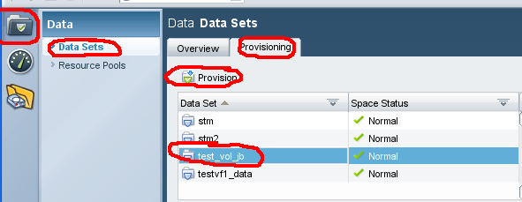

1. Read or ignore the Data Set definition and then click Next
2. Type the qtree name in the field titled “Name”
3. Type the size of the qtree in the Data Size field (the volume will automatically be grown)
4. Click next
5. Leave the “Allow the system to automatically select a resource from the attached resource pool(s)” radio button selected. Click Next.
6. Review the Details page and click Next if you see no errors or warnings. You will not be prompted for verification after this point.
7. Click Finish when the wizard is complete. (Note it may take a minute or two for a newly created qtree to appear in the NMC. Don’t be alarmed if it doesn’t immediately appear after you click finish.)
8. Open a putty session to any DFM server and run the following command to verify quotas are enabled (the blue text requires editing):

* rsh HostingFiler-mgmt vfiler run *vFilerName* quota status”
* If quotas are “off” for volumes other than the root volume, run this command:

rsh HostingFiler-mgmt vfiler run *vFilerName* quota on *VolumeName*”

1. If you have no other qtrees to add, see the “Create/Modify qtree exports” section below for details to configure the permissions.

**Create/Modify qtree exports**

1. Launch NetApp Management Console (NMC) from your desktop
2. Choose the appropriate site (dfm**e**, dfm**f**, or dfm**h**)
3. Click the “NFS Export Manager” yellow folder icon in the top left corner. (Note: If NMC hangs here, exit out of NMC and log back in)

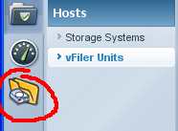

**Note**: All NFS exports on vFilers should be managed using the NFS Manage Exports NMC Plugin.

1. Select the physical filer in the first field titled “Filer” and the vFiler in the second field titled “Vfiler” (do not select “vfiler0” unless that is your intention.)
2. Highlight the volume/qtree in question and click Modify

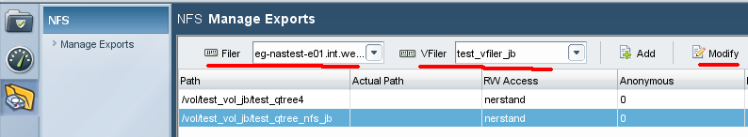

1. Read or ignore the Welcome screen and click Next
2. Verify the Export Path is accurate and click Next
3. Click Add and type the FQDN of the appropriate hosts for Read Only access and click Next
4. Click Add and type the FQDN of the appropriate hosts for Read Write access and click Next

(Delete the 1.1.1.1 host)

*NOTE: For LOON use this format <FQDN server name>-nas (e.g. hasty-nas.westlan.com or fenner-nas.int.westgroup.com) for all dual-homed LOON builds add both servers if clustered (see build spreadsheet loon tab.)*

*NOTE: For all LION builds, use only the FQDN of the server. (no “-nas”).*

1. Do not enter any hosts for Root access and click Next
2. Leave Anonymous User Id at “0”
3. Verify only the “Unix Style” box is checked and click Next
4. Verify the summary is accurate and click Finish

**Documentation (other resources):**

vFiler Procedures:

\\Eg-nas-a02\sg$\Procedures\NetApp\vFilers\vFiler_procedures.docx

NetApp supplied documentation:

\\Eg-nas-a02\sg$\Procedures\NetApp\vFilers\Multistore_Management_with_Provisioning_Manager_1.9.doc

<http://now.netapp.com/NOW/knowledge/docs/DFM_win/rel371/html/software/protect/index.html>

**Miscellaneous:**

To confirm a vFiler volume size:

NMC | Manage Data icon in upper left | Data set icon in lower left | Datasets in upper left | Provisioning tab | Click on Data set in the left pane | click on the volume name in the right pane | Total volume size is listed below (and snapshot reserve size if it exists)

To get a list of vfiler exports:

In NMC | Exports icon | Pick filer | pick vfiler | highlight the export |click control + C on your keyboard | paste your output

Example output:

/vol/nv_kcsrchablenorm1p_n01ora1_nosnap/n01oraarch1

rarden-nas.westlan.com:ramona-nas.westlan.com rarden-nas.westlan.com:ramona-nas.westlan.com

all-hosts sys

Performance Reserves:

For filers (dedicated) that require performance reserves, create the reserve on the physical filer.

Vfiler to Physical filer Mapping:

<http://storageoptreports.int.westgroup.com/ReportServer/Pages/ReportViewer.aspx?%2fStorageReports%2fvFilerFilers>

OR,

Bipul’s Vfiler Filer and Volume Mapping files

*I have created a centralize database of Vfiler-Physical-filer-Volume mappings  and put it in our script configuration directory . Now we do not have to login to each dfm server or any web url just to find out many vital information like Vfiler physical-filer mapping or  volume to vfiler mapping*

*Secondly , we can use this files in scripts rather than pulling information from dfm server each time , It will reduce the loads on the DFM server and also  make scripts efficient .*

*Locations are :*

*/filers/admin/conf/Vfiler_physical.map*

*/filers/admin/conf/Vfiler_volume.map*

*These files  will be updated each night by a script.  A simple “grep” command from any dfm server will now give you all the information you need on for any  vfiler or volume J*

*Example :*

*nerstrand:/filers/admin/conf # grep clnt-corp-m0005 /filers/admin/conf/*.map |uniq*

*Vfiler_physical.map:clnt-corp-m0005.int.westgroup.com:lm-nasprod-01.int.westgroup.net*

*Vfiler_volume.map:clnt-corp-m0005:clnt_corp_m0005_root*

*Vfiler_volume.map:clnt-corp-m0005:trs_lifescience_middlewareqa_nosnap*

*Hope this helps….*

*Thanks*

*Bipul*

**Troubleshooting:**

See:

\\Eg-nas-a02\sg$\Procedures\NetApp\vFilers\vfiler_Troubleshooting.docx