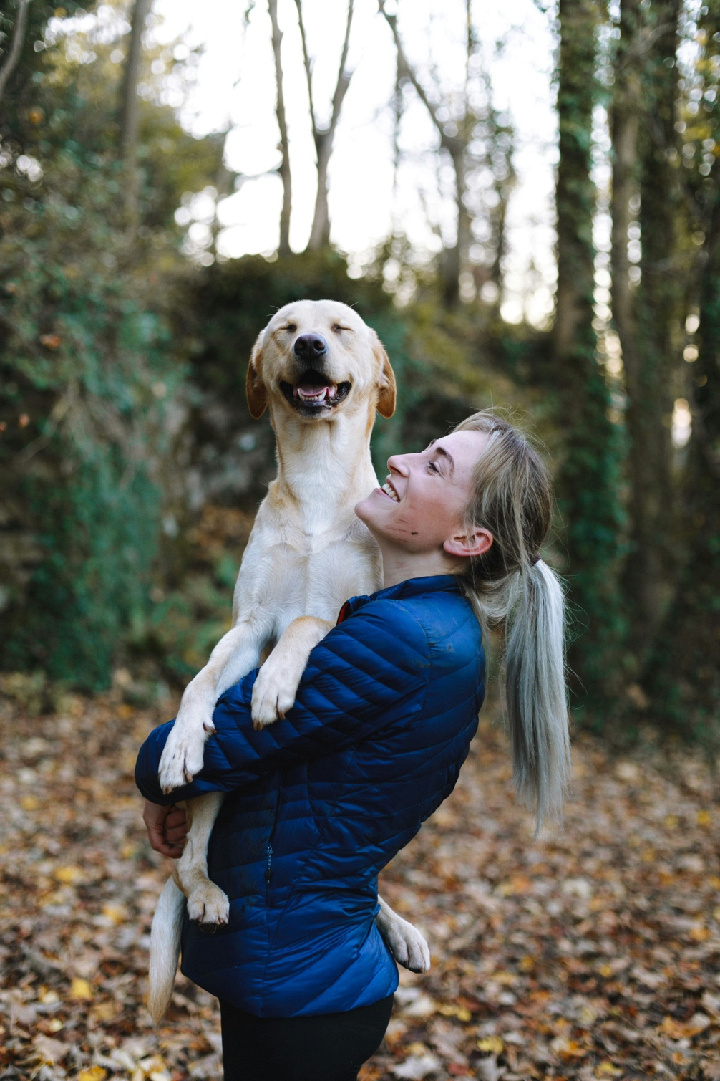https://unsplash.com/photos/woman-carrying-dog-while-standing-Y6EIP03u_wY 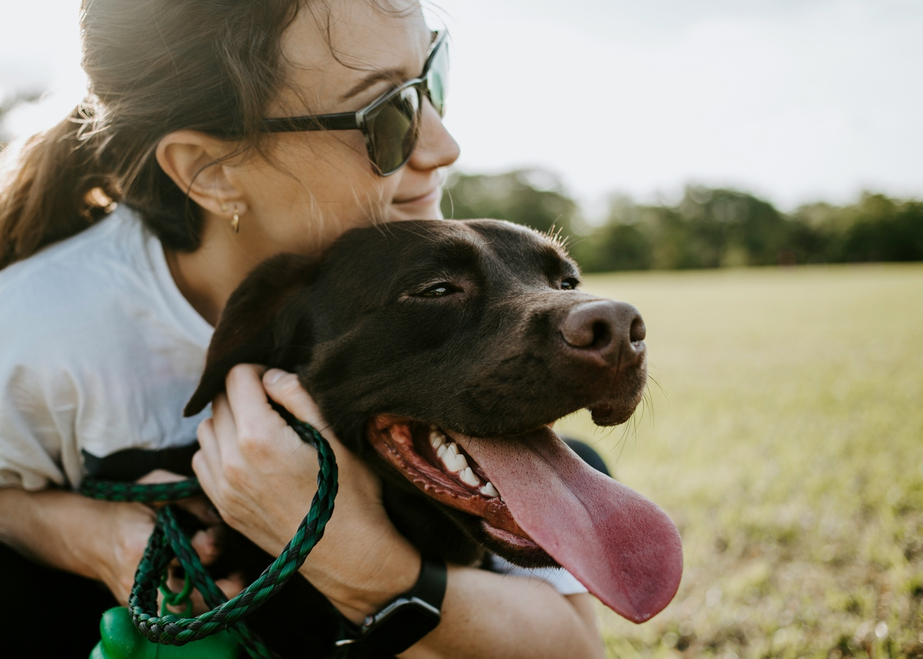
https://unsplash.com/photos/woman-hugging-a-dog-FtuJIuBbUhI
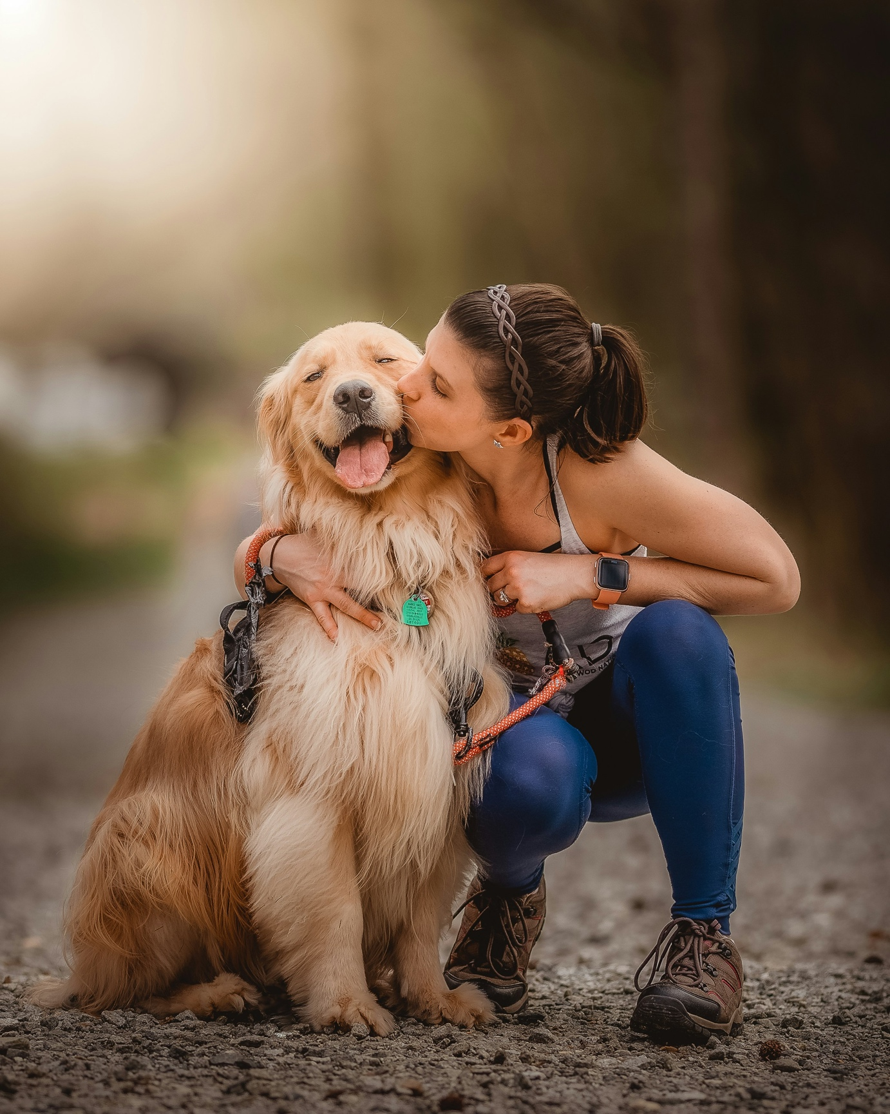 https://unsplash.com/photos/a-woman-kissing-her-dog-on-the-cheek-lx_KwA7hlLU 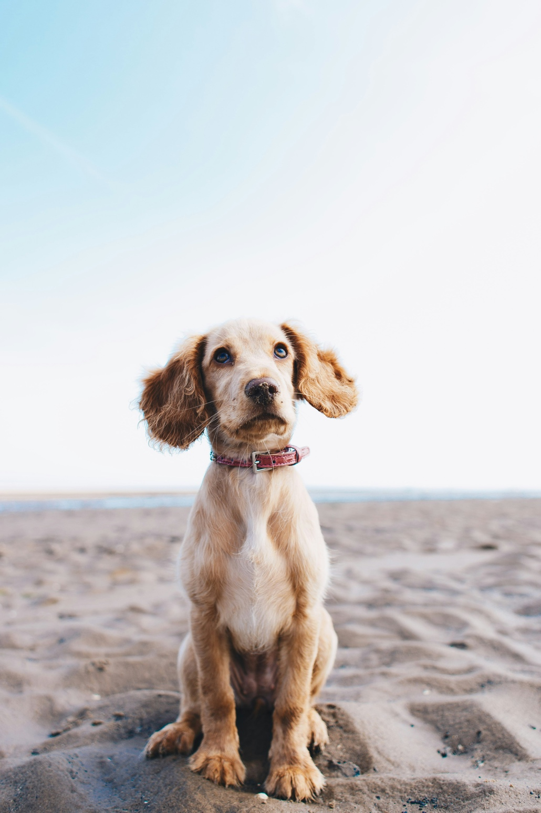 https://unsplash.com/photos/a-brown-dog-sitting-on-top-of-a-sandy-beach-AbNO2iejoXA
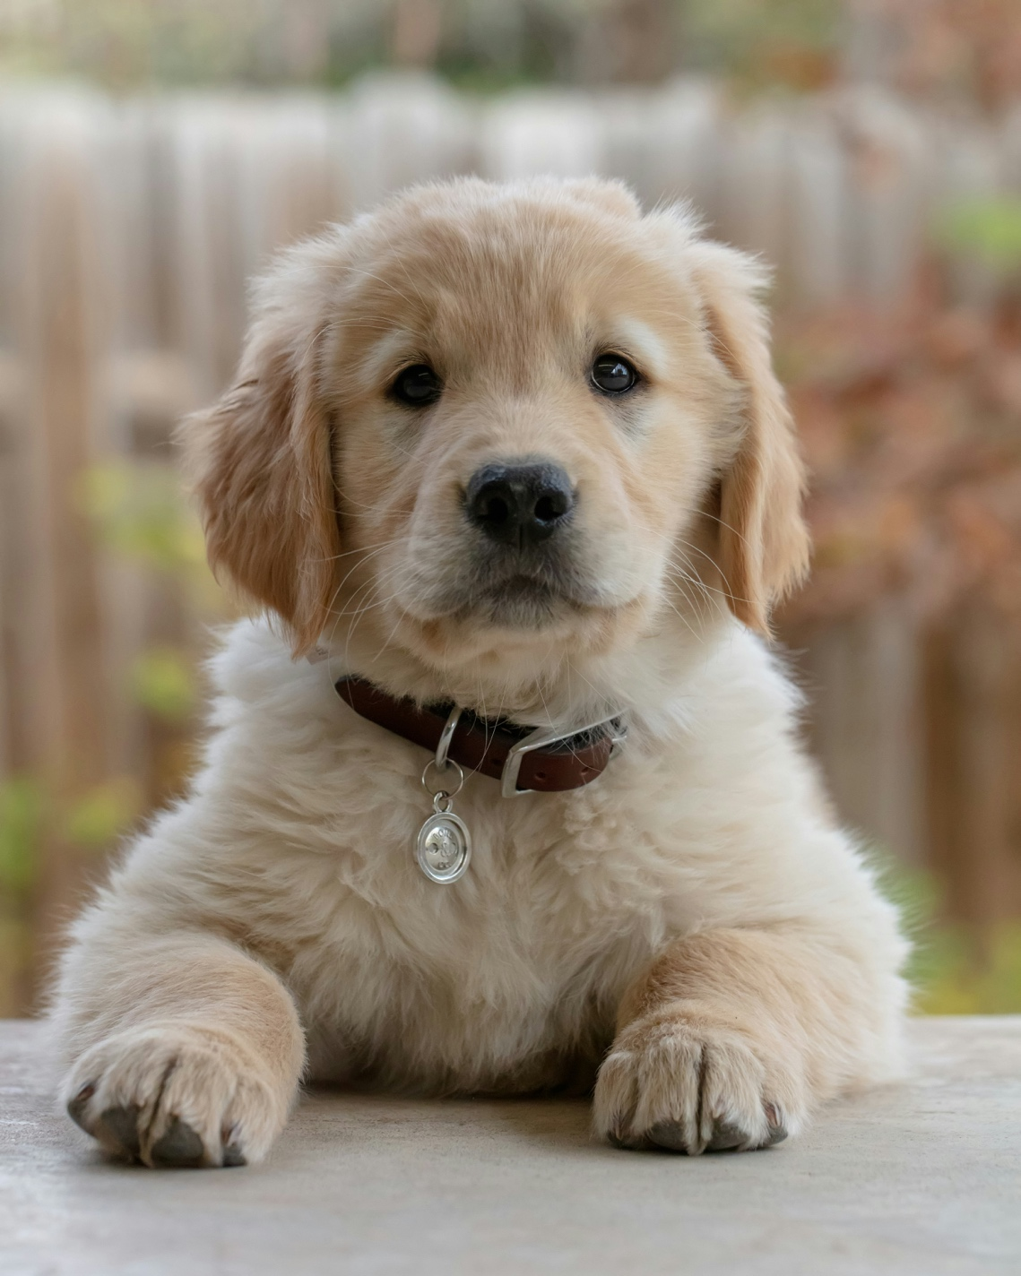 https://unsplash.com/photos/golden-retriever-puppy-on-focus-photo-9LkqymZFLrE
 https://unsplash.com/photos/brown-and-white-short-coated-dog-lying-on-black-and-red-textile-lOZA06Lj1Nw 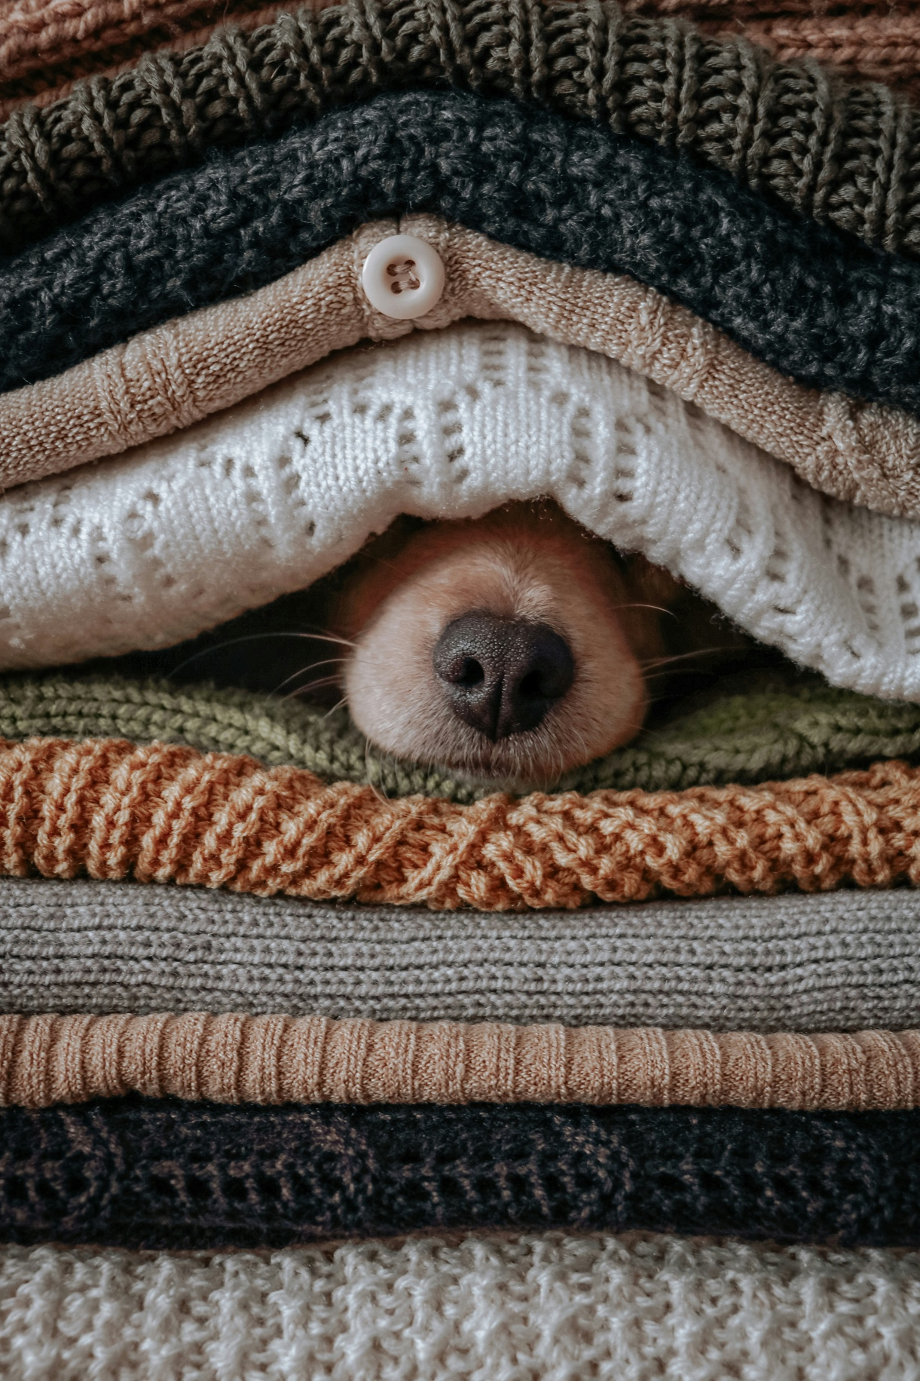 https://unsplash.com/photos/brown-and-white-dog-covered-with-green-and-white-blanket-XMla4ZtB-BU
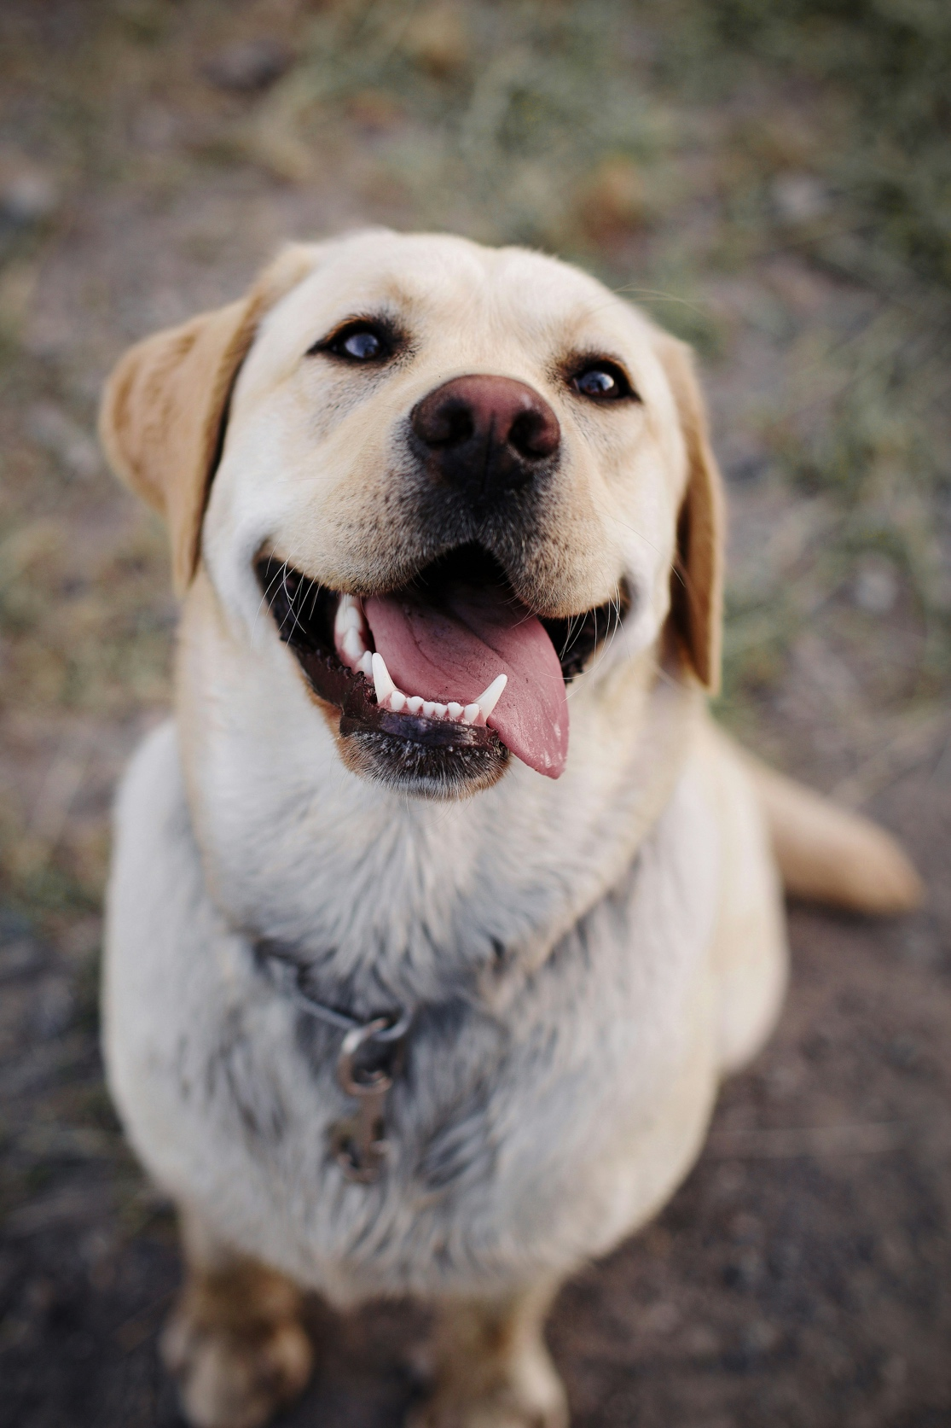 https://unsplash.com/photos/adult-yellow-labrador-retriever-c7bUIRBqapA 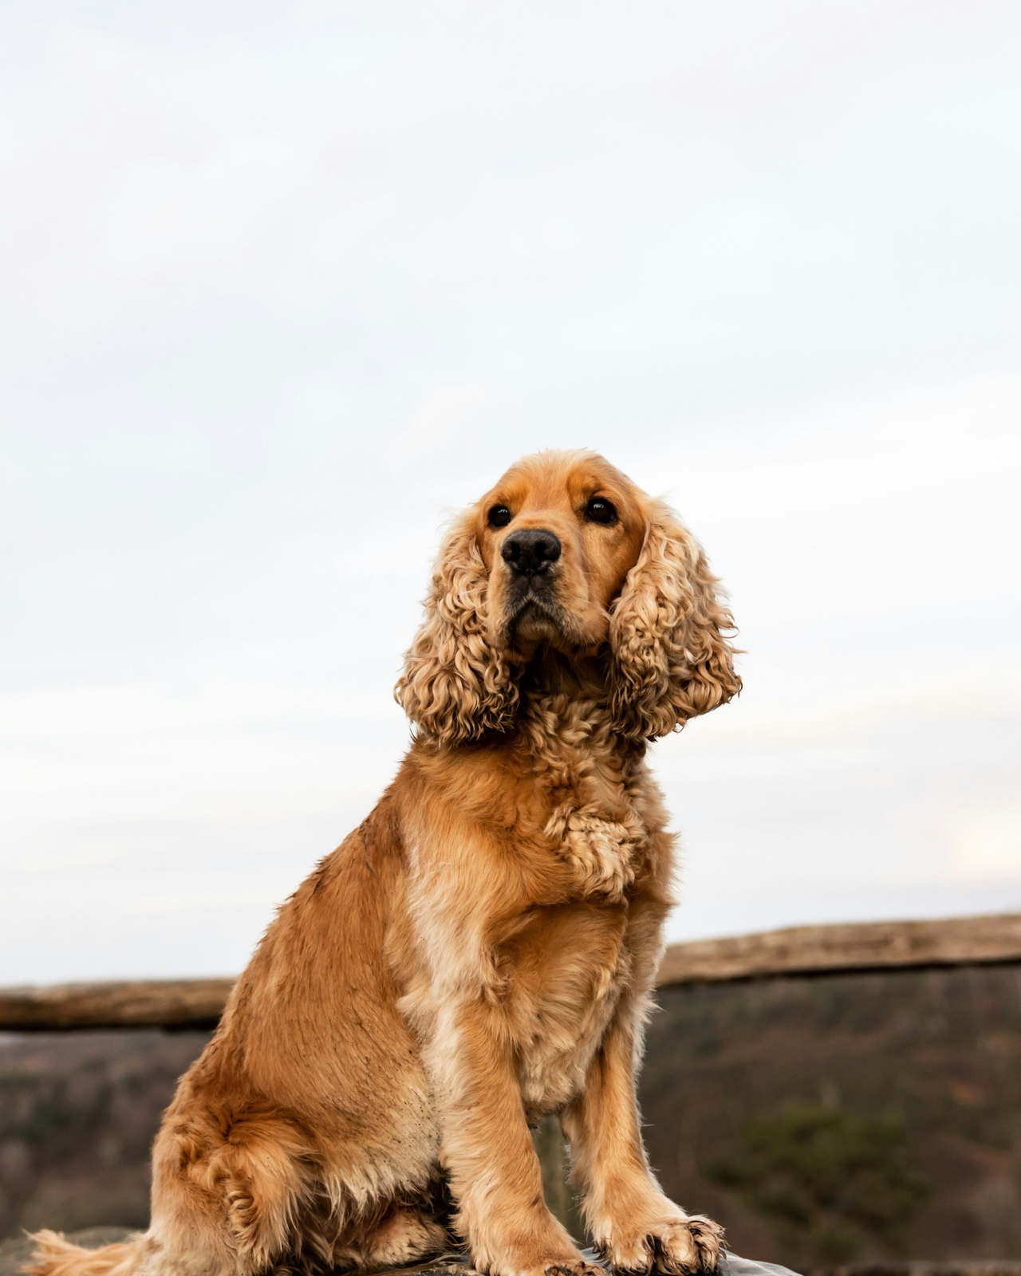 https://unsplash.com/photos/brown-short-coated-dog-on-brown-wooden-dock-during-daytime-ylTPNeXPzws 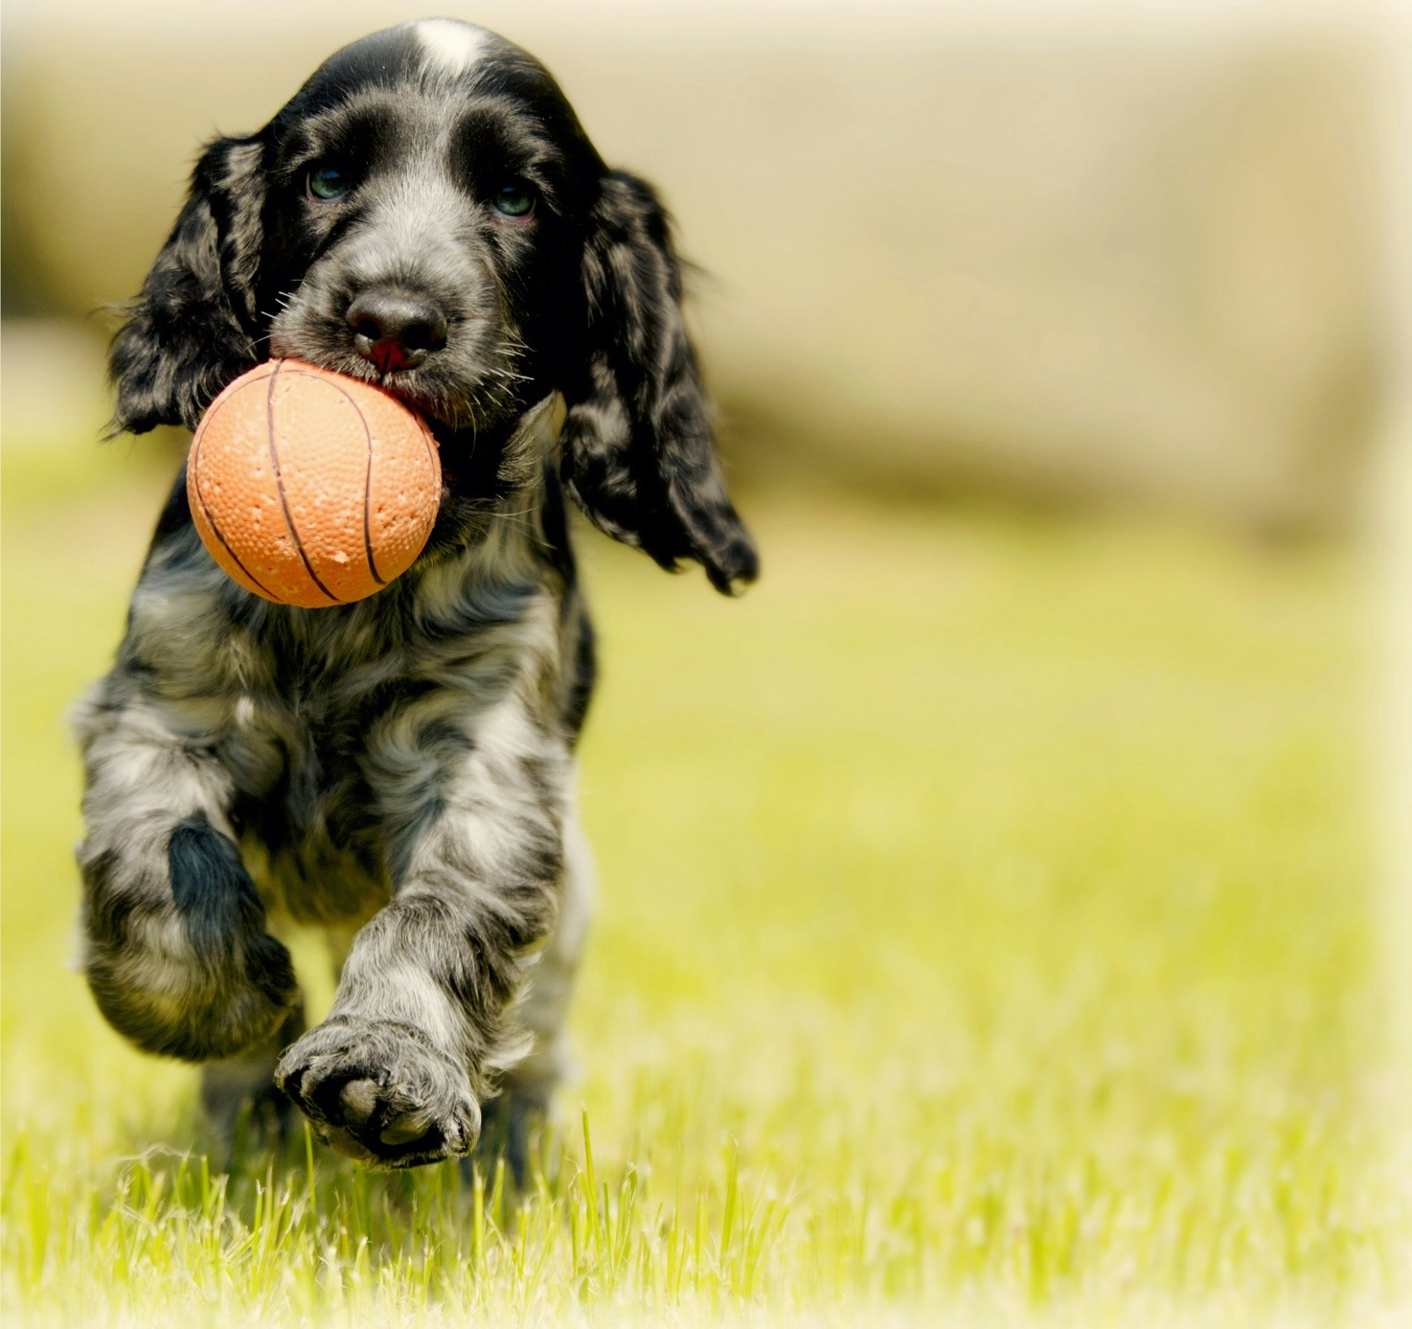 https://unsplash.com/photos/depth-photography-of-black-and-white-dog-carry-red-ball-RUgbGfdma6U 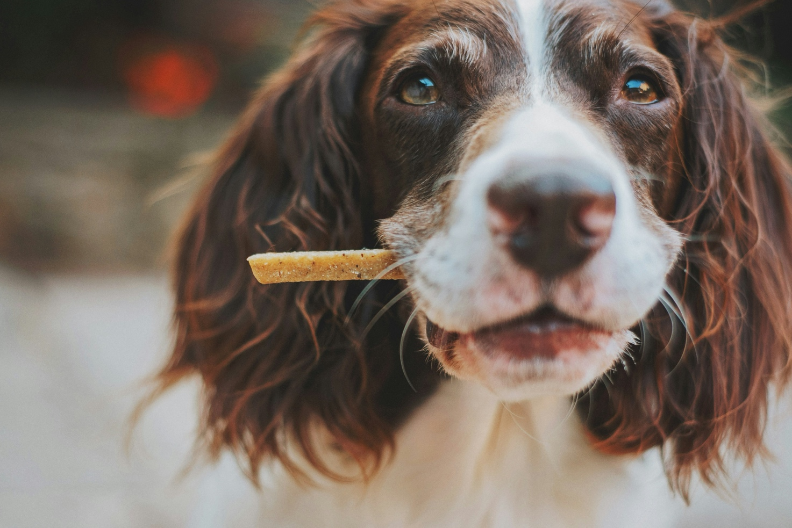 https://unsplash.com/photos/brown-and-white-short-coated-dog-biting-brown-wooden-stick-5w3oIN-0Lzs 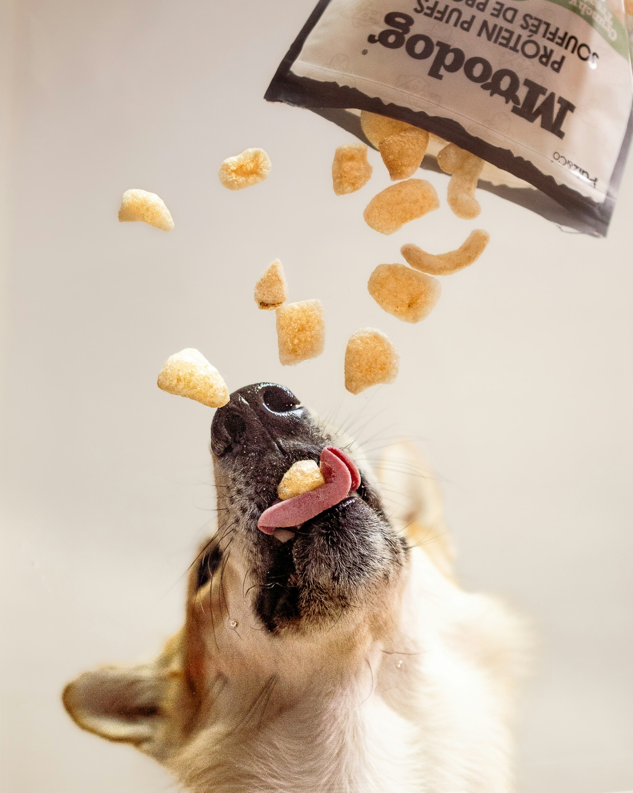 https://unsplash.com/photos/dog-eagerly-catches-protein-puffs-falling-from-a-bag-xZsxkBtyD8A 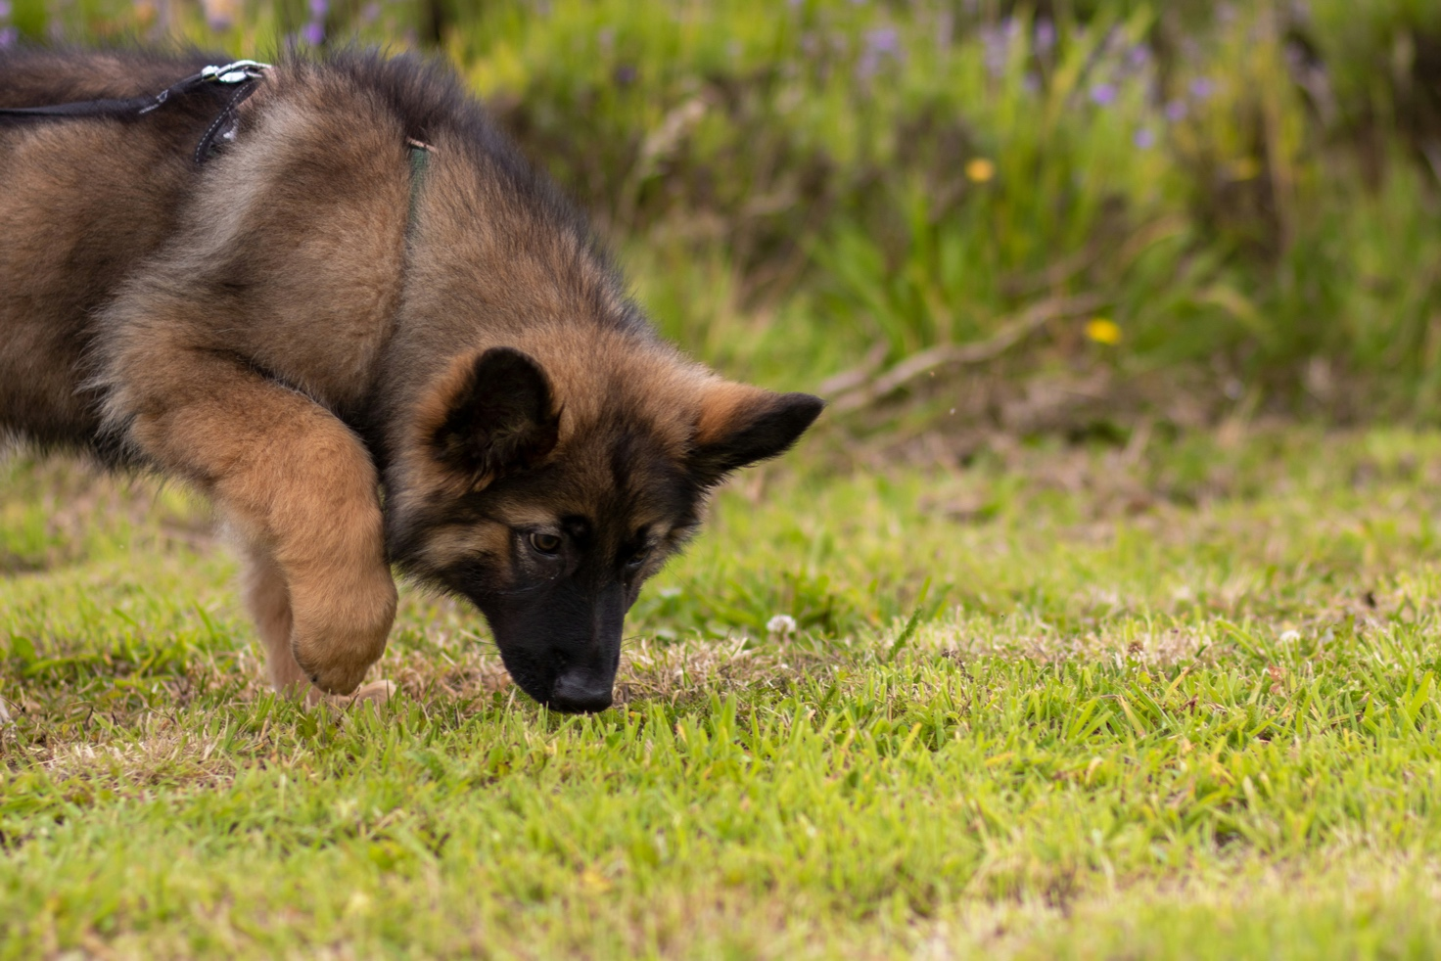 https://unsplash.com/photos/a-dog-walking-on-grass-7IvcP5BZ5HE 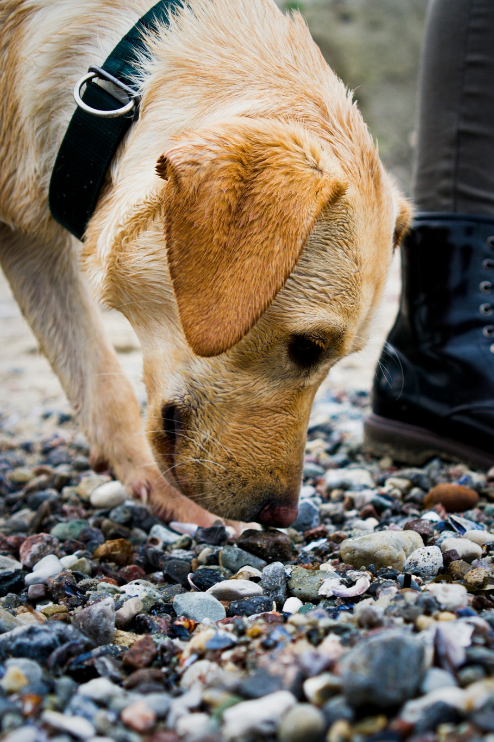
https://unsplash.com/photos/short-coated-brown-dog-5bAIYHYaFAw
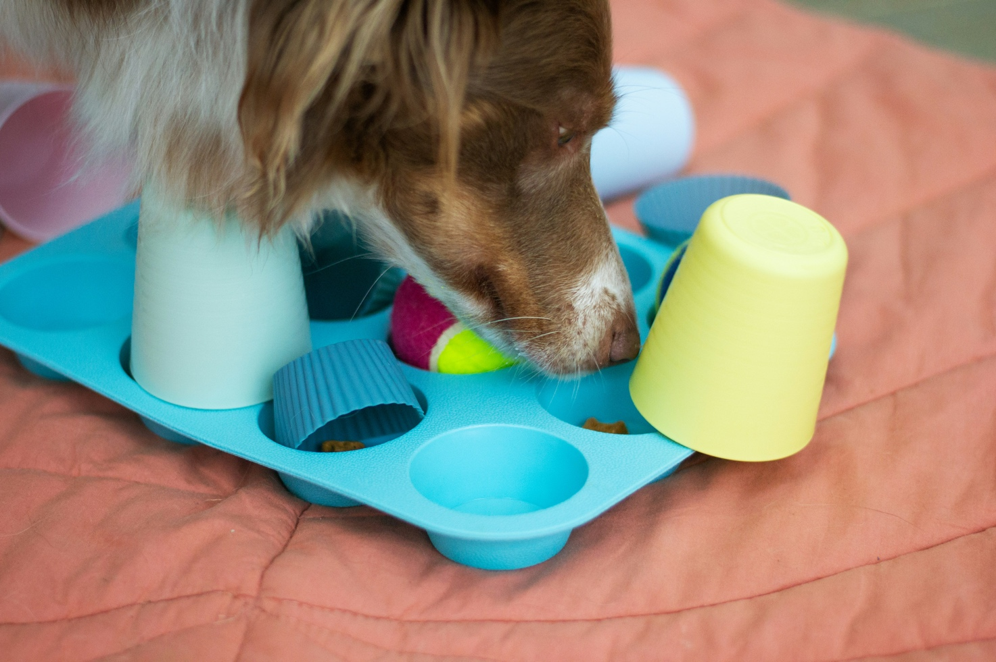
https://unsplash.com/photos/a-dog-playing-with-toys-on-a-bed-xuKLNbSvovg

Foto: Cirkeline Onsberg Lassen, brugt med tilladelse
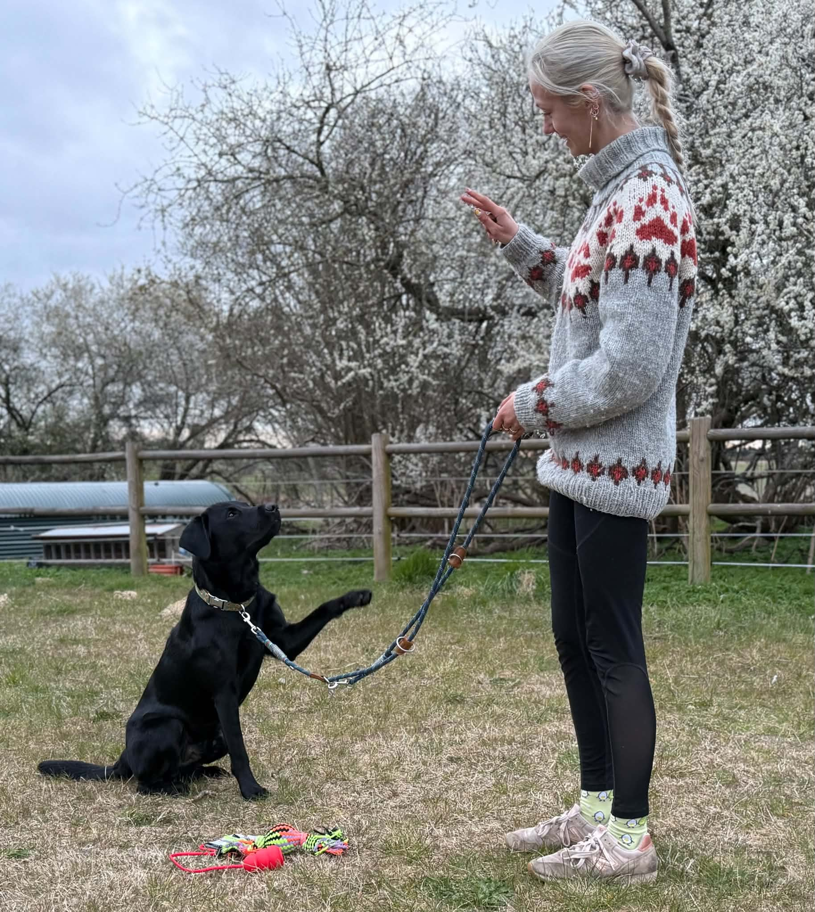
Foto: Cirkeline Onsberg Lassen, brugt med tilladelse

