E911 Provisioning System
Software Architecture Document

Version 1.7

Revision History
Date | Version | Description | Author
2/14/03 | 1.0 | Creation | Kevin Francis
2/18/03 | 1.1 | Filled in some sub-sections | Derrick Hudson
2/27/03 | 1.2 | Filled in all sections | The Team
2/28/03 | 1.3 | Reviewed entire document | Kevin Francis
3/12/03 | 1.4 | Made fixes at Jon’s request. Updated diagrams, moved old section 7 into section 4.2. | The Team
3/19/03 | 1.5 | Improved Quality section, updated diagrams | Kevin Francis
3/24/03 | 1.6 | Added section 7.2 | Kevin Francis
5/18/03 | 1.7 | Update entire document to reflect final state of code and project after completion | The Team

Table of Contents
1. Introduction 4
1.1 Purpose 4
1.2 Scope 4
1.3 Definitions, Acronyms, and Abbreviations 4
1.4 References 5
2. Architectural Goals and Constraints 5
3. Use-Case View 5
4. Logical View 8
4.1 Overview 8
4.2 Architecturally Significant Design Packages 9
4.3 Persistence 12
5. Data Flow 13
6. Deployment View 14
7. Data Views 15
7.1 Logical Data Model 15
7.2 Relational Database Model 16
8. Size and Performance 16
9. Quality 17
10. Requirements Matrix 17

Software Architecture Document

Introduction

Purpose
This document provides a comprehensive architectural overview of the E911 Provisioning System, using a number of different architectural views to depict different aspects of the system. It is intended to capture and convey the significant architectural and design decisions that have been made for this project. The development team and the customer contact, Jon Templin, will use this document to understand how the system will be implemented.

Scope
This software architecture document applies to the E911 Provisioning System being developed for PaeTec Communications by Royal Flush Software. It describes the overall design considerations and architectural views for the system to be implemented.

Definitions, Acronyms, and Abbreviations
Also see Software Requirements Specification document section 5.1 for additional terms.

ALI – Automatic Location Identification

E911 (Enhanced 911) – Version of 911 emergency system that provides the dispatcher a visual display of the caller’s name, telephone number, and address.

EJBs (Enterprise Java Beans) – Reusable J2EE software components that work with Java and encapsulate data or functionality.

ESN – The Emergency Service Number is a three to five digit number representing a unique combination of emergency service agencies designated to serve a specific range of addresses within a specific geographical area.

ILEC (Incumbent Local Exchange Carrier) – A major telecommunications company that PaeTec must send E911 flat files to. They are responsible for maintaining the main E911 databases.

J2EE (Java 2 Enterprise Edition) – Software platform specification created by Sun Microsystems that manages infrastructure to enable development of secure, robust and interoperable business applications.

Location – A specific street address, corresponding to an MSAG entry.

MSAG (Master Street Address Guide) – A listing of all street and house number ranges within a 911 service area detailing the ESN for each location.

NPA-NXX-XXXX – Format for a complete telephone number.

NNX – The same as NXX. Obsolete.

NPA – First digits of a TN, also commonly referred to as the area code.

NXX – The format for the middle portion of a complete telephone number.

Record Types (I, M, C, D, U) – The valid types for records sent to the ILEC. I = Insert, M = Migrate, C = Change, D = Delete, U = Unlock.

TN (Telephone Number) – A complete telephone number.

References
Software Requirements Specification – SRS.doc

Architectural Goals and Constraints
Maintainability and scalability will be promoted through the use of EJBs and the J2EE specification. The system will be constructed in such a way that the different major components may be distributed over multiple machines. The use of Java promotes portability to different operating systems since the development system will be Windows 2000 based and the final deployment OS is unknown.

Use-Case View
The use cases in this system are listed below. Use cases in bold are significant to the architecture. A description of the use cases can be found later in this section.

- Search MSAG
- Create Customer
- Add Location
- Add TN
- Change Location
- Change TN Settings
- Search Community
- Search Customer
- Change Customer
- Modify User Account
- Create User
- Remove User
- Reset User Password

The following diagrams depict the use cases in the system.

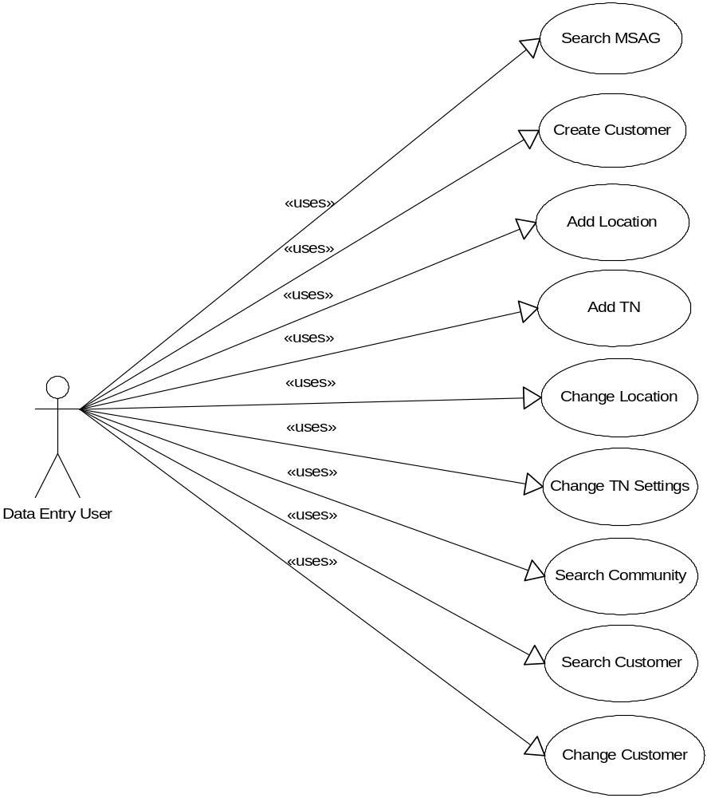
Figure 1 – Data Entry user use cases

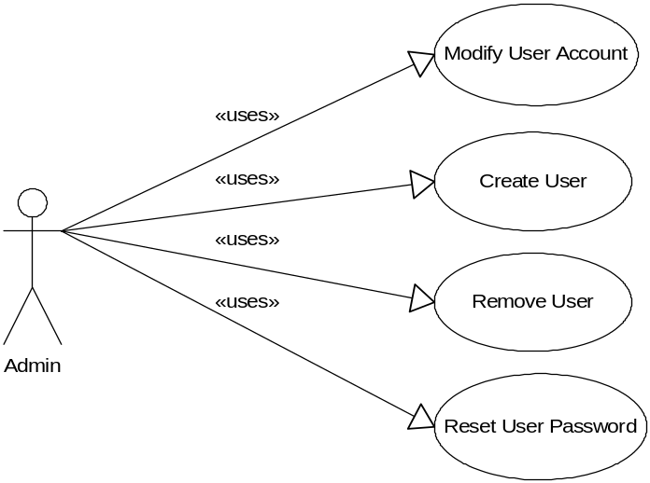
Figure 2 – Admin user use cases

Significant Use Case Descriptions

Search MSAG
This use case occurs when a user wishes to receive information on an MSAG address based on their selected search criteria.

Create Customer
This use case occurs when a user wishes to enter a new PaeTec customer into the 911 system.

Add Location
This use case occurs when a user wishes to enter a new location under an existing customer.

Add TN
This use case occurs when a user wishes to enter one or more new TNs within a specific customer and location.

Change Location
This use case occurs when a user wishes to change details for an existing location for a customer.

Change TN Settings
This use case occurs when a user wishes to change settings for an existing TN owned by a customer.

Search Community
This use case occurs when a user wishes to receive the exact abbreviations of communities matching their search criteria.

Search Customer
This use case occurs when a user wishes to receive information on a customer based on search criteria.

Change Customer
This use case occurs when a user wishes to change an existing customer’s data.

Modify User Account
This use case occurs when an administrator wishes to change an existing user account.

Create User
This use case occurs when an administrator wishes to add a new user account.

Remove User
This use case occurs when an administrator wishes to remove an existing user account.

Reset User Password
This use case occurs when an administrator wishes to reset an existing user’s password.

Logical View

Overview
The logical view of the E911 system is comprised of 5 main packages.
- Presentation
  - Contains all of the interfaces with which users interact with the data entry portion of the system. These interfaces will be web-based and implemented using Java Server Pages. Pages include support for MSAG and Community Searching, customer searching, creation and modification of customers, locations, and telephone numbers, as well as user and account management.
- Business Logic
  - Contains classes to control major functionality of the system based on business rules. The classes process user input and control output to the user. They are the link between the user interface and the Domain Entities.
- Domain Specific Entities
  - Contains Enterprise Java Beans to support customers, locations, telephone numbers, users, and MSAG addresses. Provide methods for the modification of any properties of these entities, and methods for locating and constructing, from the persistence package, a specific entity or sets of entities. This package also includes session beans for isolating remote calls to the entity beans.
- Fabrication
  - The Fabrication Package’s responsibility is to generate files for informing the ILEC of changes to ALI records. It will exist with the intent that automated scripts will execute this program nightly and process the generated files. The Fabrication Package depends on the Business Logic package to provide all the data necessary for building the files. This package will not access the database directly and will be isolated from any future schema changes.
- Persistence
  - Persistence of the domain specific entities is managed by J2EE classes within the Resin Enterprise Application Server. The application server will decide when to create and destroy the entities as well as the details of loading and saving them to and from the Oracle database.

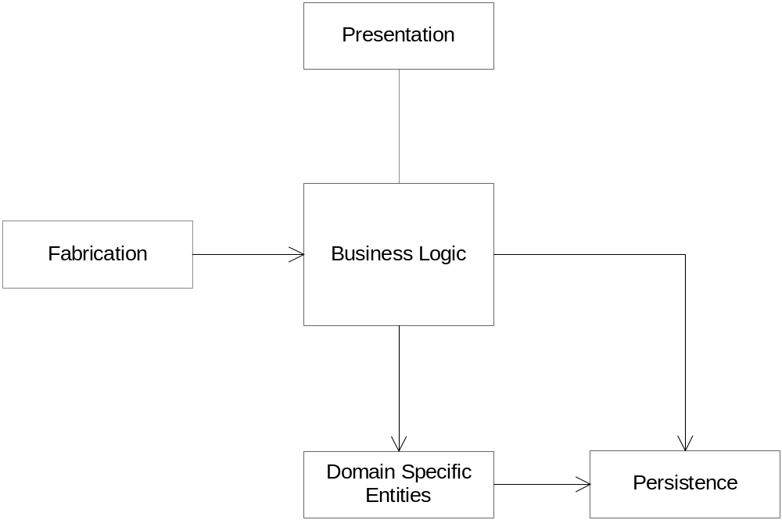
Figure 3 – Main logic packages

Architecturally Significant Design Packages

Presentation Package
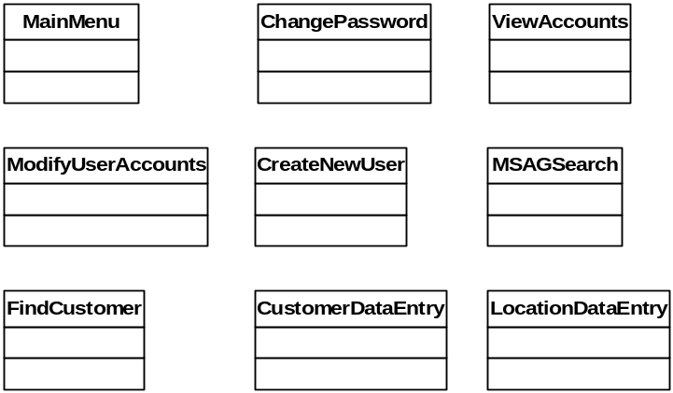
Figure 4 – JSPs in the presentation package

JSP pages will be used to generate dynamic HTML content. This content will be constructed from static HTML and data sent to the JSP from an associated Servlet. JavaScript will be incorporated into the pages to provide functionality such as error checking and minor client side functionality.

Business Logic
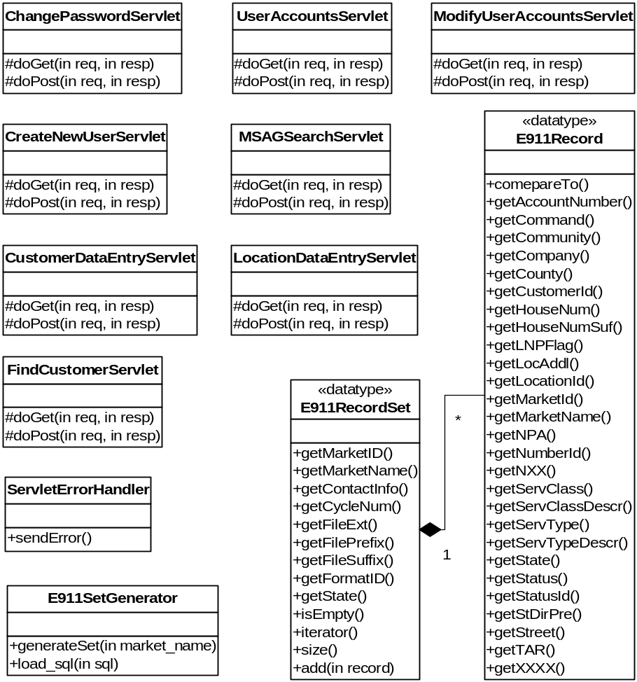
Figure 5 – Servlets and other classes of the business logic package

The Business Logic package is composed mostly of servlet classes that will retrieve data from the EJBs, perform any necessary calculations or business operations, and send relevant data to a related JSP page for display on the user interface. The responsibility of the E911SetGenerator is to query the database and provide the Fabrication package with the results in a conveniently structured format. The E911RecordSet and E911Record classes encapsulate the data passed to the Fabrication package. The E911RecordSet object will provide access to the top-level data such as MarketID and the filename the ILEC requires. The E911RecordSetSet will also provide an iterator allowing a client to access each of the E911Record objects in the set. The E911Record object will encapsulate all of the information the ILEC needs regarding a TN provisioned by PaeTec. The E911Record will also inform the file generator what type of record needs to be sent (I, M, C, D, U).

Domain Specific Entities
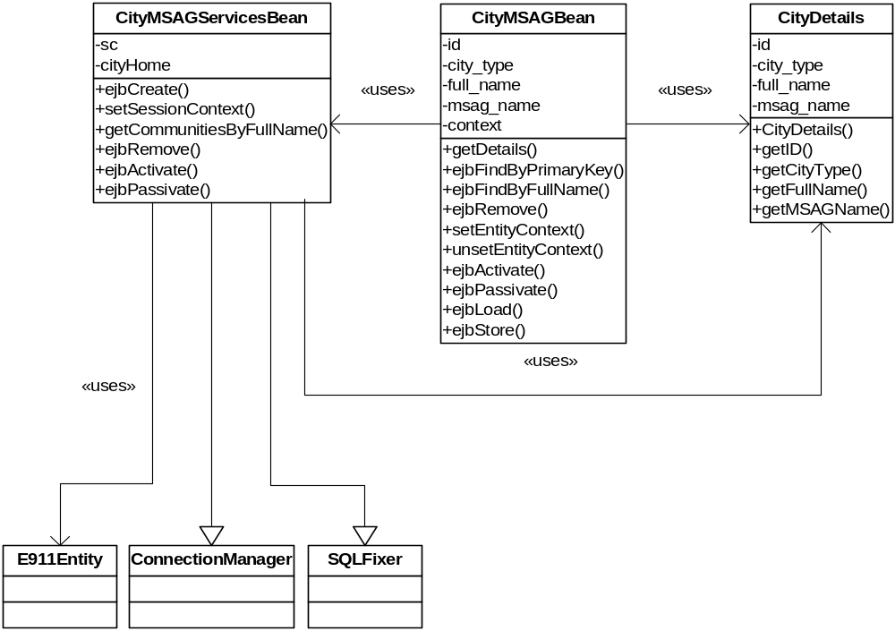
Figure 6 – City MSAG part of the entities package

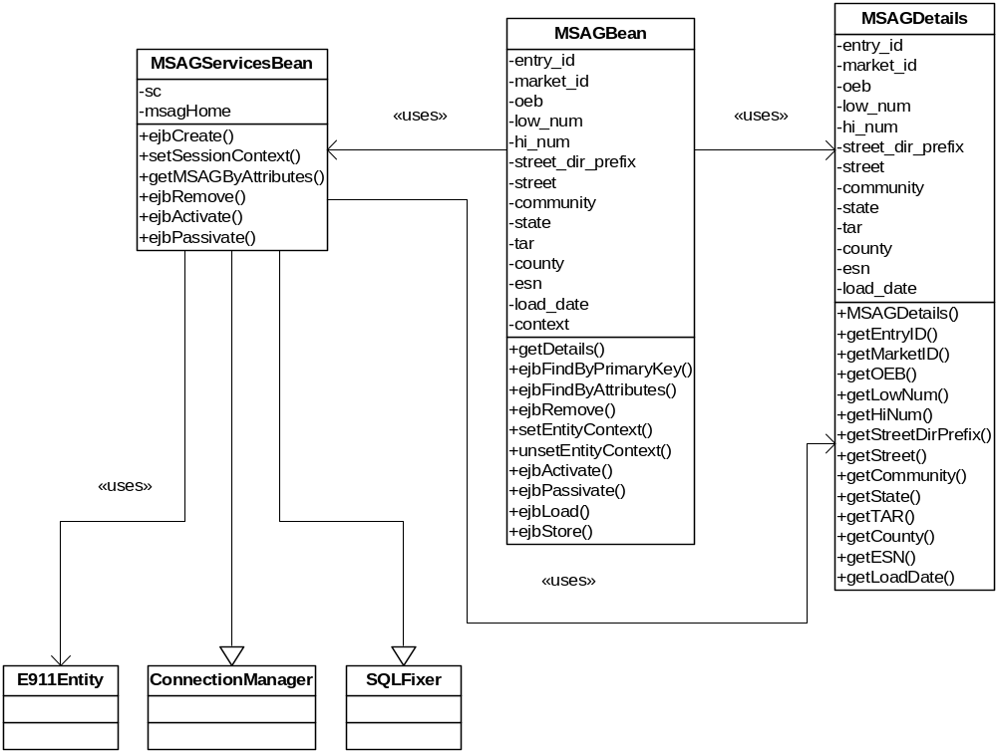
Figure 7 – MSAG address part of the entities package

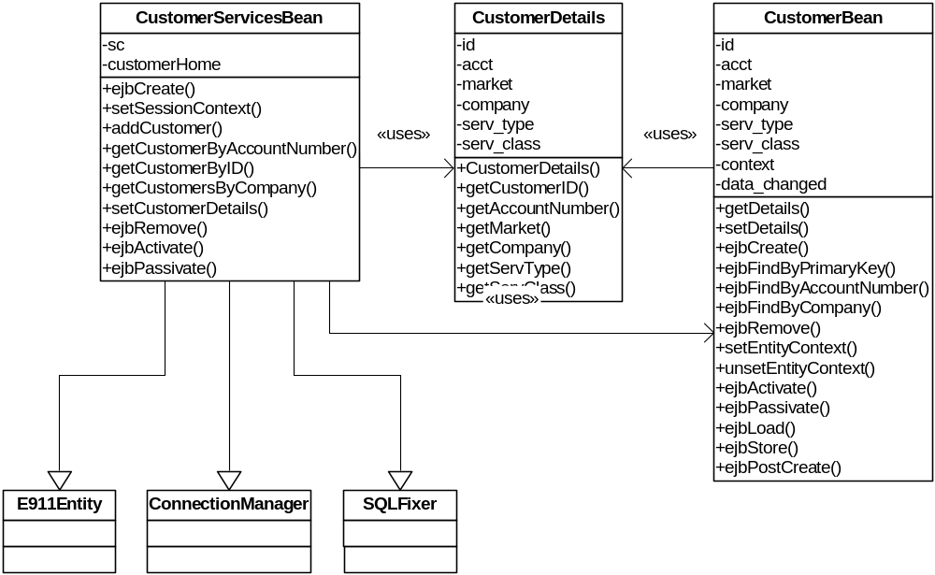
Figure 8 Customer part of the entities package

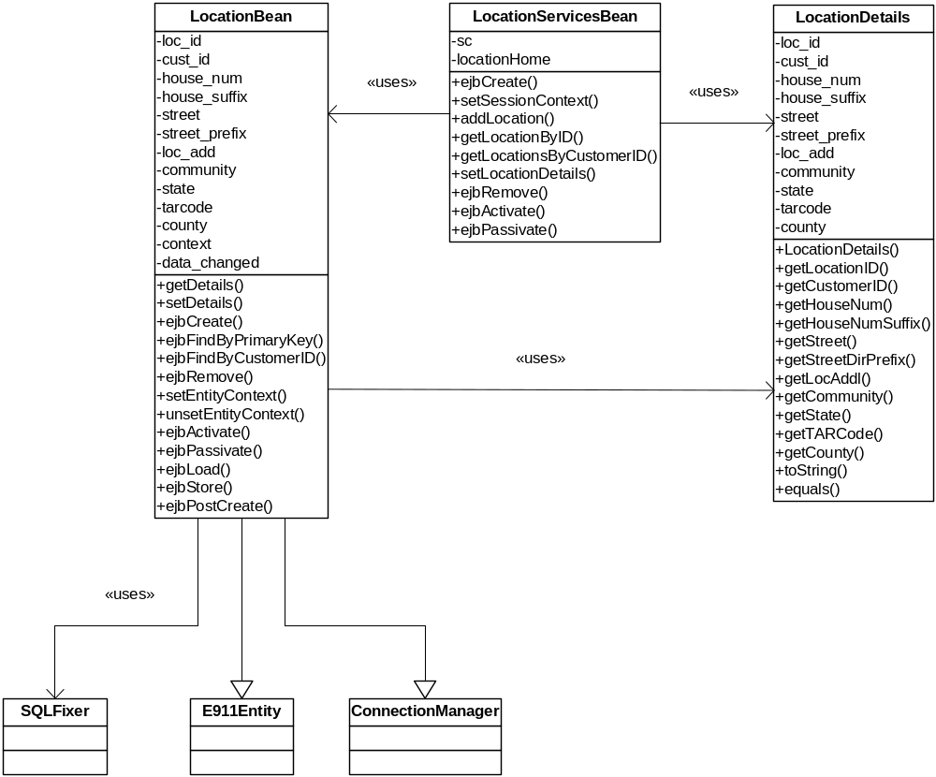
Figure 9 – Location part of the entities package

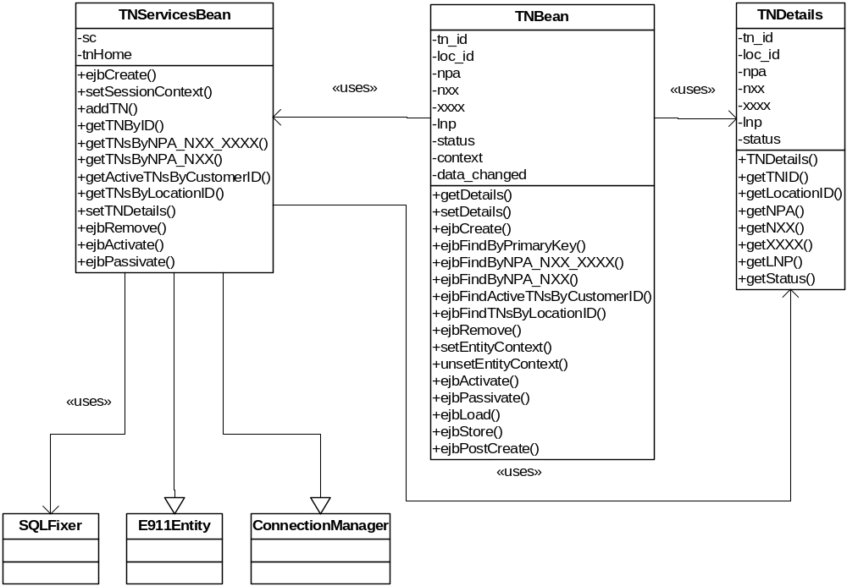
Figure 10 – Telephone Number part of the entities package

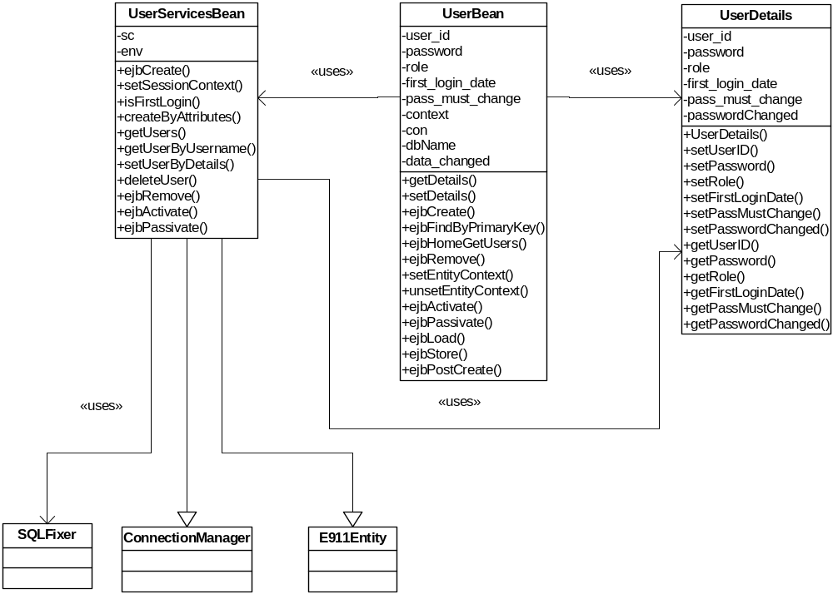
Figure 11 – User part of the entities package

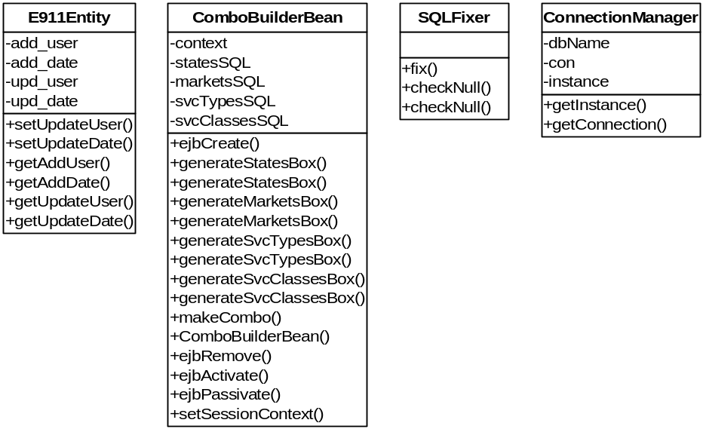
Figure 12 – Tools for the entities package

EJBs will be used to manage data persistence to the database. The EJBs will use bean-managed persistence and will provide all functionality for modifying data in the entity represented. Find, Load, and Store functions will be implemented manually within each bean and include the exact SQL statements to interact with the database.

Fabrication Package
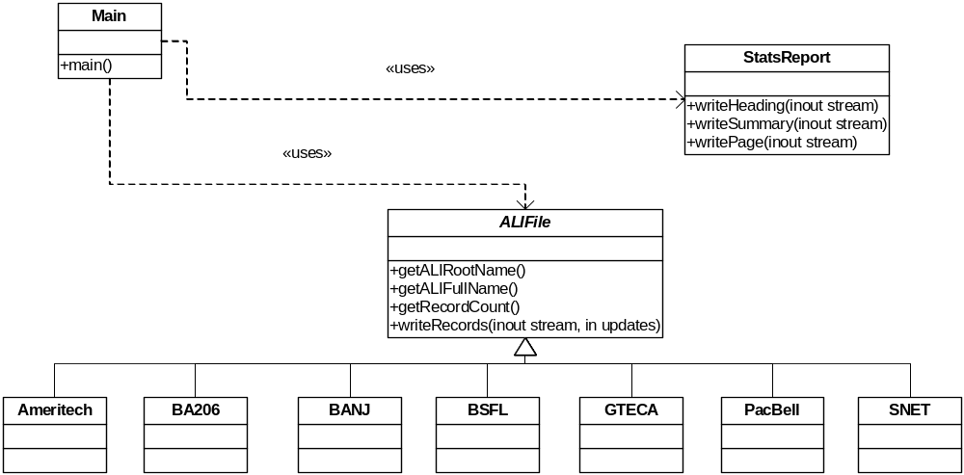Figure 13 – Classes of the fabrication package

The Fabrication Package will consist of a Main control class and a class for each type of report file. The report files consist of an informational statistics report for the system’s operator in addition to the record file(s) required by the ILEC. The Main class will request the set of changes from the E911SetGenerator component of the Business Logic package. Based on the data provided by the E911SetGenerator, the Main control will instantiate the proper record file generator and instruct it to store the records in the file. Additionally, the Main control will instantiate a StatsReport object for compiling and reporting statistics to the system’s operator.

Persistence
The Resin Enterprise Application Server handles session state, management and deployment of the beans and servlets, and communication of data to and from the Oracle database.

Data Flow
There is a bidirectional layered data flow from the HTML to the database with all data passing through JSPs, Servlets, Session Beans, and Entity Beans. With very few exceptions there is no direct communication between non-adjacent layers.

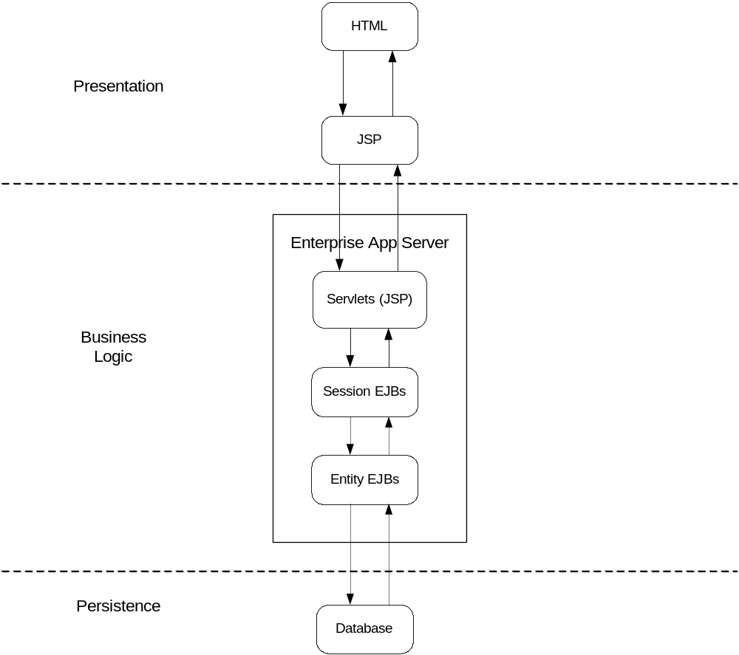
Figure 14 – Layered data flow of the system

Deployment View
The system will be deployed throughout PaeTec’s corporate LAN/WAN. Clients can be any desktop/laptop capable of running a web browser. The Web Server, Enterprise Server and database server software may be deployed on the same or different physical machines.

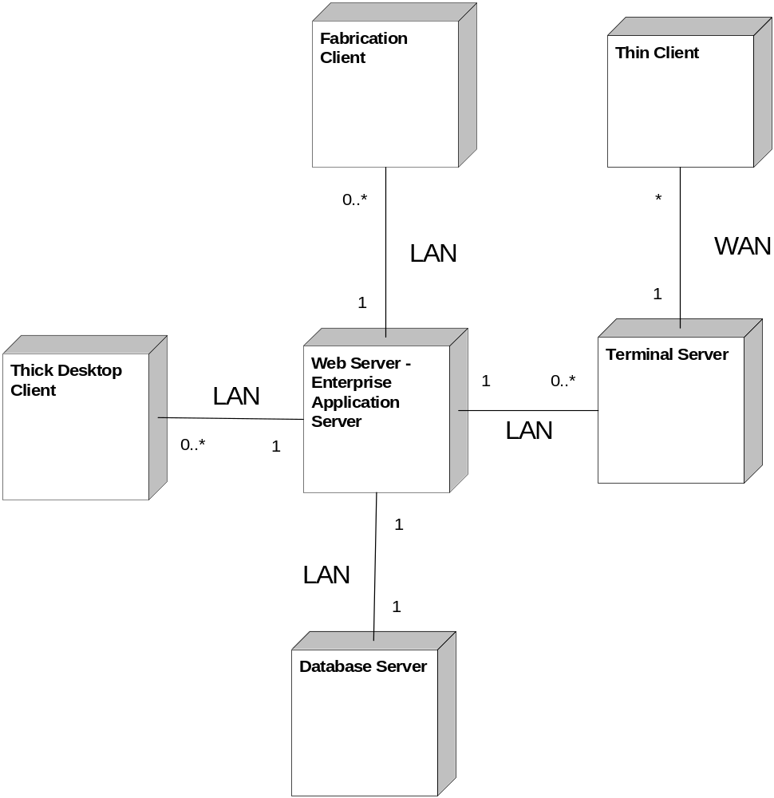

Figure 15 – Physical system deployment

Data Views

Logical Data Model
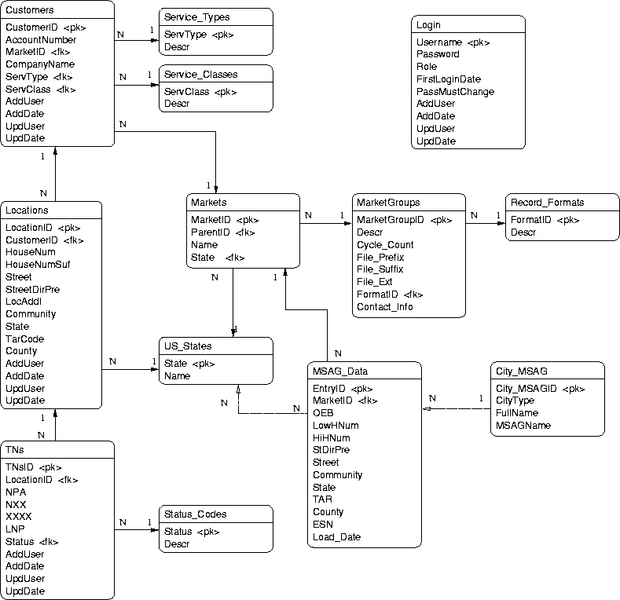
Figure 16 – Logical Data Model

Relational Database Model
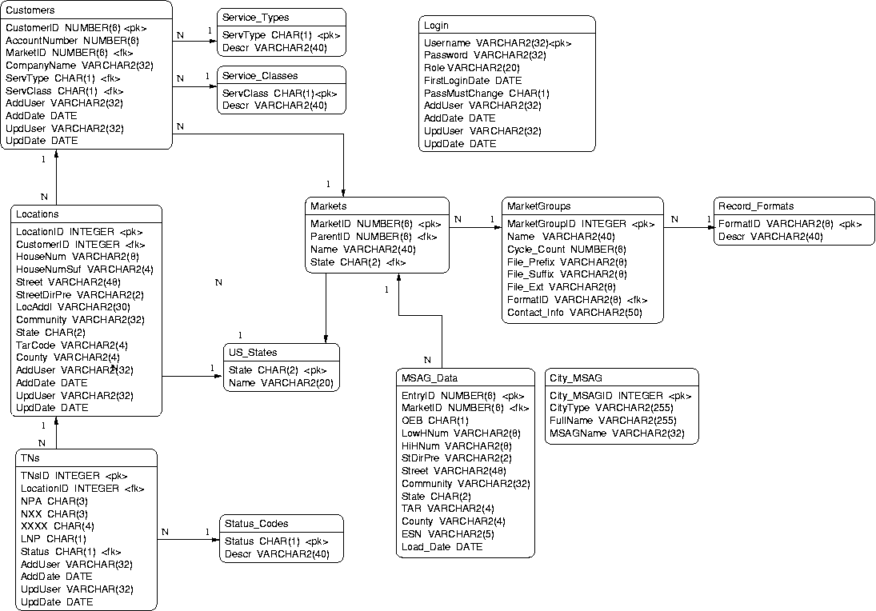
Figure 17 – Relational Database Model

Size and Performance
The product must be able to handle at least 50 simultaneous users at any time during its operation. The response time between any user interface request and completion of the response must be no longer than 20 seconds. Execution of the data extraction program must take no longer than 600 seconds. Implementation will allow proper use of the program from any client running Internet Explorer.

Quality
The product should attempt to minimize data entry errors by comparing against existing information in the database. Records created by the fabrication package will match specifications supplied by various ILECs, and upon testing, exactly duplicate the output of the existing system using the same inputs. The user interface will be designed to user-friendly to both new and experienced users.

To ensure coverage of this product’s design and architecture based requirements in this document, a requirements matrix is included in section 10. The requirements displayed in the matrix were chosen by examining the Software Requirements Specification document and evaluating each requirement to see if it could, or should, affect the design or architecture in any way. All such requirements were placed in the matrix and the Software Architecture and Design document was evaluated to ensure that there was at least one location for each requirement in which that requirement was reflected and enforced. The software test document will include a similar matrix in which all requirements must be present and tested as part of the quality assurance plan.

The quality of the final product in accordance with the software requirements specification laid out previously, and approved by the customer, will be ensured through agreed upon test coverage including full functional requirements coverage, a formal test document, and a detailed requirements vs. test case matrix. Code reviews, inspections, and testing will be performed according to the forth-coming test plan. The baseline for quality acceptance of the test plan, and of this system, will be the approval of the customer contact from PaeTec Communications, Jon Templin. Quality for this document, the test plan, and the subsequent product to be developed from it must at the very least meet the approval of Mr. Templin in his expert opinion based on his software development, project, and managerial experience.

Requirements Matrix
Requirements ID | SAD Sections
100 | 3, 4.2.3
200 | 3
205 | 3, 4.2.3, 7
206 | 3, 4.2.3, 7
207 | 3, 4.2.3, 7
401 | 3, 4.2.3, 7
404 | 4.2.2, 4.2.3
455 | 4.2.3
456 | 3, 4.2.3, 7
458 | 9
500 | 4.1
501 | 4.1
552 | 7
553 | 7
700 | 8
701 | 8
752 | 8
993 | 8

