

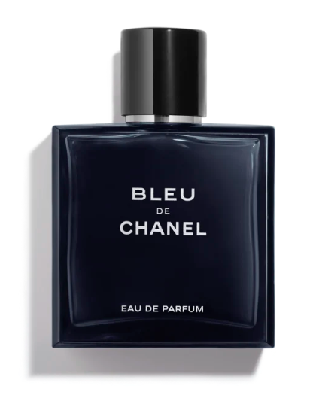

Chanel Allure Homme Sport Eau de Toilette is a dynamic fragrance from the renowned brand Chanel. This perfume is celebrated for its fresh spicy scent with medium longevity, embodying energy and sophistication. It is presented in a 50ml bottle.

**History:** Chanel Allure Homme Sport Eau de Toilette was introduced as a fragrance that captures the essence of an active, adventurous man. It's a scent that combines freshness with a spicy edge, showcasing Chanel's ability to create fragrances that are both invigorating and refined.

**Design:** The design of the Chanel Allure Homme Sport Eau de Toilette bottle is modern and athletic. The sleek, silver bottle with a hint of transparency and the Chanel logo represents the energy and elegance of the fragrance. This design is a perfect match for the dynamic spirit of the scent.



**General Information:**

* Brand: Chanel
* Origin: France
* Concentration: Eau de Toilette
* Fragrance Group: Fresh Spicy
* Longevity: Medium
* Price Range: Luxury
* Suitable for: Day and Night
* Style: Energetic, sophisticated

**About the Fragrance:** Chanel Allure Homme Sport Eau de Toilette is a fresh spicy fragrance that offers an energetic and sophisticated scent. It provides a medium-lasting fragrance experience, ideal for both daytime and evening wear. This perfume is perfect for men who appreciate a scent that is both invigorating and elegant.

**Storage:** Store in a cool, dry place, away from direct sunlight.