

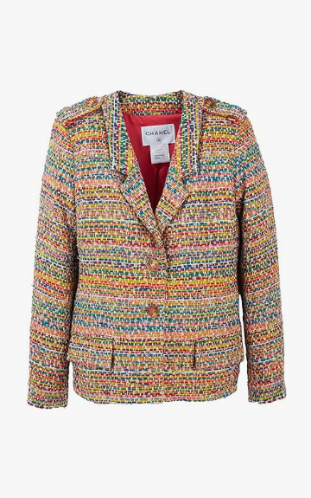

Chanel Casual Chic is a stylish casual wear from the renowned brand Chanel. This piece is crafted from a comfortable cotton blend, ideal for all-season wear. It is available in various sizes, making it accessible to a wide audience

**History:** The Chanel Casual Chic represents Chanel's venture into casual yet fashionable attire. Known for its luxury and elegance, Chanel has designed this piece to offer a chic style that blends casual comfort with high fashion.

**Design:** The Chanel Casual Chic features a design that is both modern and comfortable. The cotton blend material ensures both comfort and durability, making it suitable for everyday wear. The chic style of this piece makes it versatile for various casual settings.



**General Information:**

* **Brand:** Chanel
* **Material:** Cotton Blend
* **Size:** Various
* **Weather Suitability:** All-Season
* **Special Feature:** Chic Style
* **Image:** /ao/aocn3.png
* **Price:** $490

**About the Garment:** The Chanel Casual Chic is a testament to Chanel's ability to blend comfort with style. Suitable for all-season wear, this piece is perfect for those who seek a casual yet fashionable look. The quality material and chic design make it a standout choice in casual fashion.

**Care Instructions:** Machine washable at a moderate temperature. Do not bleach. Tumble dry low and iron on a low setting if needed.