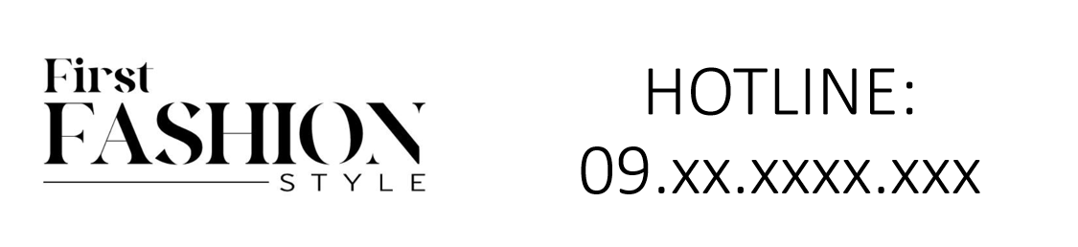

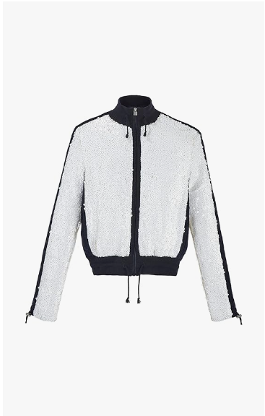

Chanel Elegance Gown is a luxurious gown from the prestigious brand Chanel. This gown features an elegant design, crafted from high-quality silk, embodying the essence of formal wear. It is available in various sizes, catering to a diverse range of body types.

**History:** The Chanel Elegance Gown is a part of Chanel's exquisite collection, known for its timeless elegance and sophistication. Chanel, a brand synonymous with luxury, has designed this gown to reflect the classic and refined style that the brand is celebrated for.

**Design:** The design of the Chanel Elegance Gown is characterized by its simplicity and elegance. The silk material provides a smooth and luxurious feel, while the elegant design highlights the wearer's sophistication. This gown is a perfect blend of traditional style and modern fashion sensibilities.



**General Information:**

* **Brand:** Chanel
* **Material:** Silk
* **Size:** Various
* **Weather Suitability:** Formal
* **Special Feature:** Elegant Design
* **Image:** /ao/aocn1.png
* **Price:** $450

**About the Garment:** The Chanel Elegance Gown is a silk gown that exudes luxury and sophistication. It is perfect for formal occasions, offering a timeless look that is both classic and contemporary. The gown's elegant design and high-quality material make it a must-have for those who appreciate luxury fashion.

**Care Instructions:** To maintain the quality of the gown, dry clean only. Avoid exposure to extreme temperatures and store in a cool, dry place.