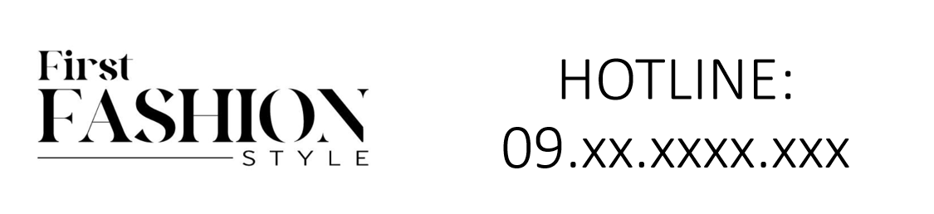

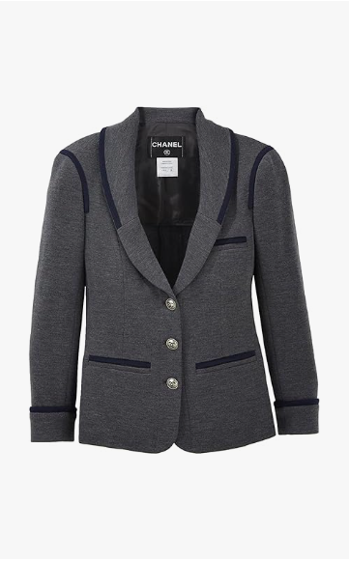

Chanel Modern Elegance is a contemporary piece from the esteemed brand Chanel. This garment, crafted from high-quality fabric, is designed for all-season wear and comes in various sizes to accommodate a range of body types.

**History:** The Chanel Modern Elegance is a reflection of Chanel's innovation in blending modern trends with classic elegance. This piece is a part of Chanel's efforts to stay at the forefront of fashion, offering stylish and contemporary designs.

**Design:** The design of the Chanel Modern Elegance is a perfect mix of modernity and sophistication. The high-quality fabric ensures both comfort and durability, making it suitable for various occasions. The modern style of this garment is both chic and timeless.



**General Information:**

* **Brand:** Chanel
* **Material:** High-Quality Fabric
* **Size:** Various
* **Weather Suitability:** All-Season
* **Special Feature:** Elegant Modern Look
* **Image:** /ao/aocn8.png
* **Price:** $580

**About the Garment:** The Chanel Modern Elegance is a testament to Chanel's ability to create fashion that is both elegant and contemporary. Suitable for all-season wear, this piece is perfect for those who seek a modern yet sophisticated look. The quality material and stylish design make it a standout choice in contemporary fashion.

**Care Instructions:** Machine washable at a moderate temperature. Do not bleach. Tumble dry low and iron on a low setting if needed.