

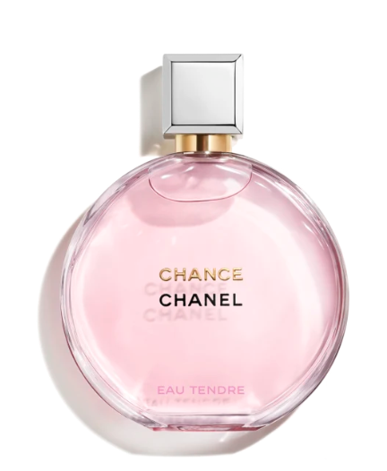

Chanel Chance Eau Tendre Eau de Toilette is an exquisite fragrance from the iconic brand Chanel. This perfume offers a floral fruity scent with medium longevity, embodying a blend of delicacy and freshness. It is presented in a 50ml bottle.

**History:** Chanel Chance Eau Tendre Eau de Toilette was launched as a vibrant and youthful addition to Chanel's fragrance collection. It captures the essence of a joyful, optimistic woman. The fragrance is a delightful mix of floral and fruity notes, reflecting Chanel's commitment to creating memorable and distinctive scents.

**Design:** The bottle design of Chanel Chance Eau Tendre Eau de Toilette is modern and playful. The round glass bottle, symbolizing the wheel of fortune, is both elegant and whimsical. The pink hue of the perfume and the silver cap with the Chanel logo add a touch of femininity and charm.



**General Information:**

* Brand: Chanel
* Origin: France
* Concentration: Eau de Toilette
* Fragrance Group: Floral Fruity
* Longevity: Medium
* Price Range: Luxury
* Suitable for: Day and Night
* Style: Youthful, fresh

**About the Fragrance:** Chanel Chance Eau Tendre Eau de Toilette is a floral fruity fragrance that combines playful and fresh scents. It offers a medium-lasting fragrance experience, ideal for both daytime and evening wear. This perfume is perfect for those who love a youthful, fresh, and playful fragrance.

**Storage:** Store in a cool, dry place, away from direct sunlight.