

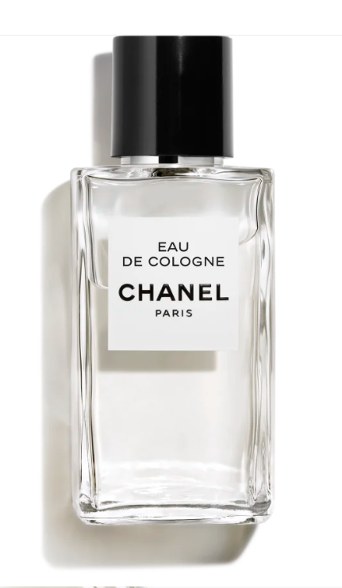

Chanel Chance Eau Vive Eau de Toilette is a vibrant fragrance from the esteemed brand Chanel. This perfume is celebrated for its citrus scent with medium longevity, embodying a sense of freshness and vitality. It is presented in a 50ml bottle.

**History:** Chanel Chance Eau Vive Eau de Toilette was introduced as a fragrance that encapsulates the joy and spontaneity of life. It's a scent that combines the freshness of citrus with a lively spirit, showcasing Chanel's expertise in creating fragrances that are both refreshing and spirited.

**Design:** The design of the Chanel Chance Eau Vive Eau de Toilette bottle is playful and energetic. The round glass bottle, symbolizing the wheel of fortune, is both elegant and vibrant. The red hue of the perfume and the silver cap with the Chanel logo add a touch of dynamism and zest.



**General Information:**

* Brand: Chanel
* Origin: France
* Concentration: Eau de Toilette
* Fragrance Group: Citrus
* Longevity: Medium
* Price Range: Luxury
* Suitable for: Day and Night
* Style: Fresh, vibrant

**About the Fragrance:** Chanel Chance Eau Vive Eau de Toilette is a citrus fragrance that offers a fresh and vibrant scent. It provides a medium-lasting fragrance experience, ideal for both daytime and evening wear. This perfume is perfect for those who love a fragrance that is both refreshing and full of life.

**Storage:** Store in a cool, dry place, away from direct sunlight.