

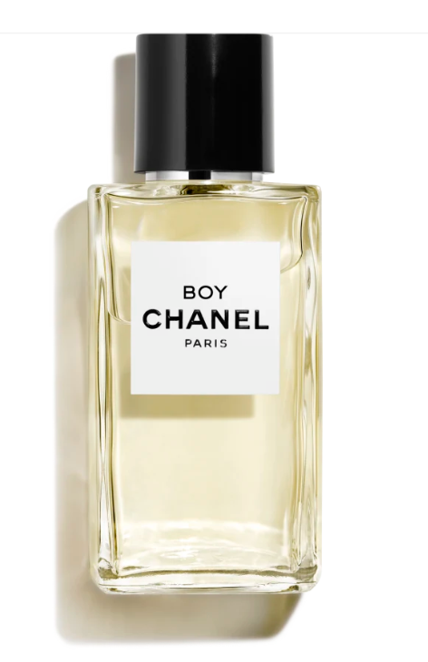

Chanel Coco Mademoiselle Eau de Parfum is a luxurious fragrance from the prestigious brand Chanel. This perfume encapsulates an oriental floral scent with long-lasting longevity, exuding a sense of sophistication and elegance. The product is available in a 50ml bottle.

**History:** Chanel Coco Mademoiselle Eau de Parfum, introduced as a modern classic, quickly became a symbol of elegance in the fragrance world. Chanel crafted this perfume to capture the essence of a bold, free woman. Its scent is a harmonious blend of oriental and floral notes, showcasing Chanel's expertise and innovation in perfumery.

**Design:** The design of the Chanel Coco Mademoiselle Eau de Parfum bottle is both classic and contemporary. The sleek glass bottle radiates luxury, while the cap, adorned with the Chanel logo, adds a touch of timeless elegance. This design highlights the perfume's luxurious nature.



**General Information:**

* Brand: Chanel
* Origin: France
* Concentration: Eau de Parfum
* Fragrance Group: Oriental Floral
* Longevity: Long
* Price Range: Luxury
* Suitable for: Day and Night
* Style: Sophisticated, elegant

**About the Fragrance:** Chanel Coco Mademoiselle Eau de Parfum is an oriental floral fragrance that combines exotic scents with a touch of elegance. It offers a long-lasting fragrance experience, making it suitable for both daytime and evening wear. Chanel Coco Mademoiselle represents sophistication and elegance, appealing to those who admire luxurious and refined styles.

**Storage:** Store in a cool, dry place, away from direct sunlight.