

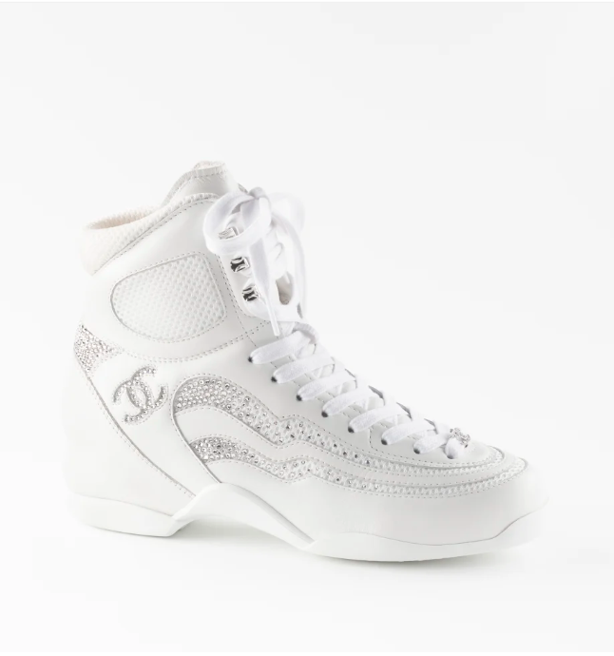

Chanel Classic Flap Shoes are a luxurious footwear option from the prestigious brand Chanel. These shoes embody elegance and sophistication, crafted with high-quality leather to ensure both comfort and durability. The style is characterized by its iconic flap design, making it a statement piece in any wardrobe.

**History:** The Chanel Classic Flap Shoes are inspired by the timeless elegance of Chanel's fashion legacy. They are designed to complement the classic Chanel look, blending traditional craftsmanship with modern style. These shoes have become a symbol of luxury and are favored by fashion enthusiasts worldwide.

**Design:** The design of the Chanel Classic Flap Shoes is both classic and contemporary. The flap style adds a unique touch, while the high-quality leather ensures a luxurious feel. The shoes are versatile, suitable for various occasions, from formal events to casual outings.



**General Information:**

* **Brand:** Chanel
* **Material:** Leather
* **Style:** Flap
* **Size:** Various
* **Price:** $450
* **Image:** Chanel Classic Flap Shoes

**About the Shoes:** Chanel Classic Flap Shoes are not just a fashion statement but also a testament to Chanel's commitment to quality and style. The flap design is a nod to the brand's iconic handbags, making these shoes a must-have for Chanel enthusiasts. They are perfect for those who appreciate luxury and elegance in their footwear.

**Care Instructions:** To maintain the quality and appearance of these shoes, it is recommended to clean them regularly with a soft, dry cloth and store them in a cool, dry place away from direct sunlight.