

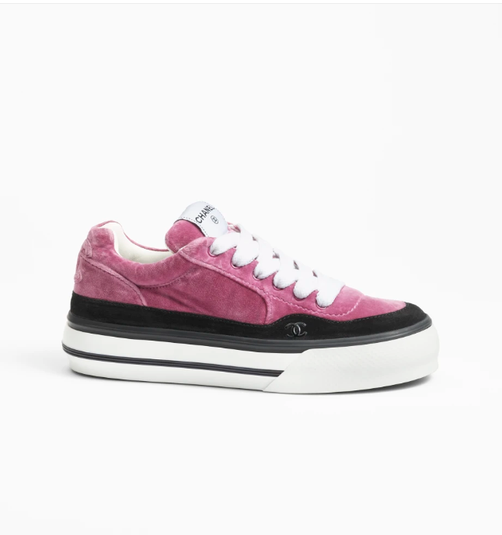

Chanel Dad Sandals are a unique and trendy addition to Chanel's footwear collection, crafted from high-quality leather. These sandals combine comfort with a fashionable edge, making them a sought-after item for style-conscious individuals.

**History:** Chanel Dad Sandals are a modern interpretation of the classic sandal design, infused with Chanel's luxurious touch. They have quickly gained popularity for their unique style and comfortable fit, becoming a favorite among fashion enthusiasts.

**Design:** The design of the Chanel Dad Sandals is both bold and comfortable. The leather material adds a touch of luxury, while the sandal style ensures a relaxed and trendy look. These sandals are perfect for adding a fashionable edge to any casual outfit.



**General Information:**

* **Brand:** Chanel
* **Material:** Leather
* **Style:** Sandals
* **Size:** Various
* **Price:** $560
* **Image:** Chanel Dad Sandals

**About the Shoes:** Chanel Dad Sandals are ideal for those who appreciate a mix of comfort and contemporary style. They represent Chanel's ability to stay ahead of fashion trends while maintaining its signature elegance.

**Care Instructions:** Regular cleaning with a soft, dry cloth is recommended to maintain the appearance of these sandals. Store them in a cool, dry place, away from direct sunlight, to preserve their quality.