

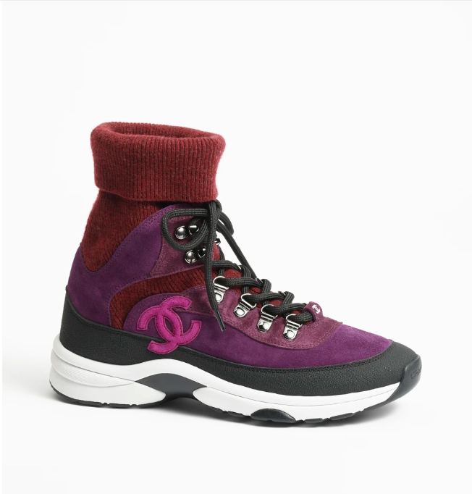

Chanel Gabrielle Shoes are a testament to the brand's designer heritage, offering a blend of luxury and style. Made from premium leather, these shoes are a symbol of elegance and are designed to provide both comfort and a high fashion statement.

**History:** Named after Chanel's founder, Gabrielle Chanel, these shoes embody the spirit of the brand's pioneering designer. They are a tribute to her legacy and reflect the innovative and timeless style that Chanel is known for.

**Design:** The design of the Chanel Gabrielle Shoes is a perfect mix of designer flair and practicality. The leather material ensures durability, while the unique style makes them a versatile choice for various fashion looks.



**General Information:**

* **Brand:** Chanel
* **Material:** Leather
* **Style:** Designer
* **Size:** Various
* **Price:** $490
* **Image:** Chanel Gabrielle Shoes

**About the Shoes:** Chanel Gabrielle Shoes are ideal for those who admire designer fashion and want to make a statement. They are a nod to the brand's rich history and are perfect for adding a touch of luxury to any outfit.

**Care Instructions:** To maintain the beauty of these shoes, clean them with a soft, dry cloth and store in a cool, dry place away from sunlight.