

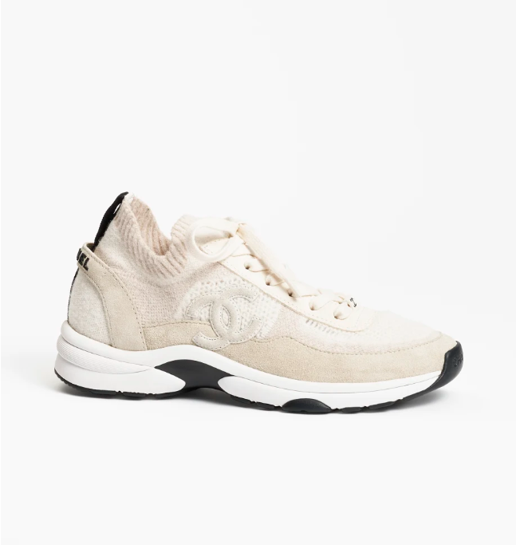

Chanel Slingback Shoes are a distinctive and elegant footwear choice from the renowned brand Chanel. Made with high-quality leather, these shoes are designed for style and comfort, embodying the essence of the slingback design.

**History:** Chanel Slingback Shoes are inspired by the classic Chanel fashion ethos, offering a timeless design that has been popular for decades. They represent the brand's commitment to elegance and sophistication in footwear.

**Design:** The design of the Chanel Slingback Shoes is both elegant and practical. The slingback style provides a secure fit, while the leather material ensures a luxurious look and feel. These shoes are versatile and can be paired with a variety of outfits.



**General Information:**

* **Brand:** Chanel
* **Material:** Leather
* **Style:** Slingback
* **Size:** Various
* **Price:** $520
* **Image:** Chanel Slingback Shoes

**About the Shoes:** Chanel Slingback Shoes are perfect for those who appreciate classic style with a modern twist. They offer a unique combination of comfort and luxury, making them a must-have in any fashion enthusiast's collection.

**Care Instructions:** To maintain the quality of these shoes, clean them regularly with a soft, dry cloth and store them in a cool, dry place away from direct sunlight.