

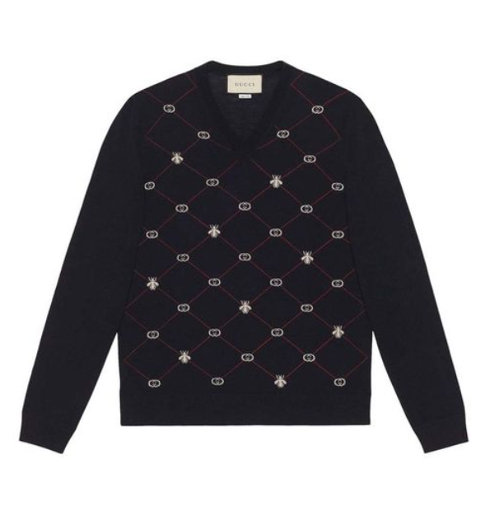

**Gucci Classic Suit** is an epitome of elegance and sophistication from the renowned brand Gucci. Crafted from the finest wool, this suit is designed for all-season wear, offering both comfort and style. The classic design of the suit makes it a timeless piece for formal occasions.

**History:** The Gucci Classic Suit is a testament to Gucci's long-standing tradition of creating high-quality, stylish clothing. This suit, with its classic design, is a reflection of the brand's dedication to timeless elegance and craftsmanship.

**Design:** The design of the Gucci Classic Suit is both elegant and timeless. Made from high-quality wool, it offers a perfect fit and sophisticated look. The suit's classic design is a nod to traditional tailoring, making it a must-have for those who appreciate classic fashion.



**General Information:**

* Brand: Gucci
* Material: Wool
* Style: Suit
* Size: Various
* Weather Suitability: All-Season
* Special Feature: Classic Design
* Price: $370

**About the Suit:** The Gucci Classic Suit is ideal for individuals who value elegance and a timeless look. The wool material ensures comfort and durability, making it suitable for various occasions. This suit is a perfect choice for formal events, business meetings, or any occasion where a sophisticated appearance is desired.

**Care Instructions:** To maintain the suit's quality and appearance, it is recommended to follow Gucci's care instructions. Dry clean only, and store in a cool, dry place to prevent any damage to the fabric.