

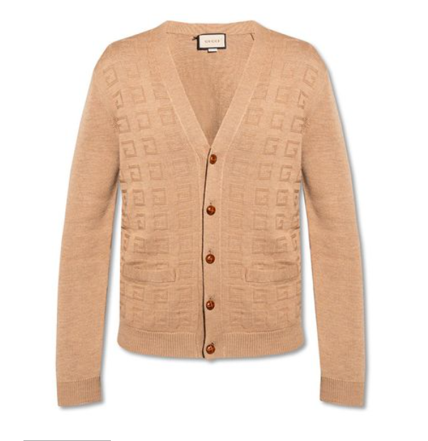

**Gucci Night Outfit** is an elegant and sophisticated evening wear piece from the luxurious brand Gucci. Made from a blend of silk, this outfit is designed for all-season wear, offering both comfort and an elegant style. The outfit's special feature is its elegance, making it perfect for night events and special occasions.

**History:** The Gucci Night Outfit is a demonstration of Gucci's expertise in creating high-end fashion that caters to special occasions. This outfit reflects the brand's commitment to elegance and sophistication in its designs.

**Design:** The design of the Gucci Night Outfit is both elegant and modern. The silk blend material provides a luxurious feel and comfort, while the outfit's elegant design makes it a standout piece for evening events. The outfit showcases Gucci's ability to blend luxury with contemporary fashion.



**General Information:**

* Brand: Gucci
* Material: Silk Blend
* Style: Evening Wear
* Size: Various
* Weather Suitability: All-Season
* Special Feature: Elegant
* Price: $380

**About the Outfit:** The Gucci Night Outfit is ideal for those who seek elegance and sophistication in their evening wear. The silk blend material ensures a comfortable and luxurious experience, while the elegant design makes it perfect for night events, galas, or any occasion where a sophisticated appearance is desired.

**Care Instructions:** To maintain the outfit's quality and appearance, it is recommended to follow Gucci's care instructions. Dry clean only, and store in a cool, dry place to prevent any damage to the fabric.